Compilers

Introduction:
In this collection of notes, we will be exploring a general high level understanding of compilers. As you are likely aware, there are various different compilers for various different languages, and no two compilers are identical. This is why we will be reviewing the core principles that most compilers implement rather than an in depth low-level analysis. Note that compilers and interpreters, while using many of the same techniques, are different enough that they can be considered different things. Dynamically/weakly typed languages such as python, JavaScript, PHP, etc. all use interpreters.

Differences Between Interpreters and Compilers:
The aim of compilers and interpreters is the same: translating some input language, A, to some output language, B. The output language is always a lower level language. For example, C compiles to assembly, and Java compiles to Bytecode, which is a meta language that can be understood by the JVM. The primary difference between the two is that the interpreter is ran at program runtime, interpreting and excecuting each line of the program one by one, whereas the compiler must compile the entire source code of the input language and output it as files that take up actual hard drive space. If you’ve programmed in C you will be aware of this, since compiling your source files produces object files (.o) which are essentially machine code that can then be linked with external libraries to create an excecutable. Compiling code takes time, but the program often runs much faster since the code can be optimized. Interpreting a language does not need time for any such compilation phase, however, the programs often run slower at runtime since they are interpreting the code as CPU instructions in real time, and excecuting those instructions all at once. One last difference between the two is that compilers often need to go through a linking phase to link external libraries, however, languages like python do not need to go through such a process since those libraries can be interpreted at runtime along with the source code.

Terminology:
There are a few terms that need to be defined when discussing compilers:
- Programming Language: A notational system for describing computations in human-readable and machine-readable form.
- Language Processors: Compilers are a subset of language processors. Other subsets of language processors include interpreters, text editors, text-to-speech, grammar checkers, etc. Essentially anything that interprets some character stream to something else.

- Interpreters: We’ve already discussed interpreters, but it should be noted that they are a subset of compilers (which is a subset of language processors).

Language Paradigms:
Perhaps you’ve heard of language paradigms. These are abstract concepts that express a particular “kind” of language. One such paradigm, with which you are familiar, is OOP. Other kinds of paradigms include: procedural, functional, logical, parallel, scripting, markup, and specification. Here is a summary of each:

- OOP: Object Oriented Programming languages are built upon the principle of objects, their attributes (instance variables), and behaviours (methods). They often benefit from having polymorphism as a central doctrine.

- Procedural/Imperative: Procedural languages (sometimes also called Imperative languages) are a bit of a higher level paradigm, since many languages that with within other paradigms might also be defined as being procedural. Essentially, procedural languages specify “what to do” and “how to do it” in a step by step fashion (a procedure). Some procedural languages include: C, COBOL, FORTRAN, ALGOL, BASIC, and Pascal. Easier than understanding what qualifies as a procedural langauge is to understand which languages aren’t procedural. Languages that aren’t procedural include SQL, Prologue, and Lisp.

- Functional: Functional programming languages are related to mathematics and are almost always dynamically typed. Since they do not support type safety (state), they rarely crash or have bugs. They also have other advantages such as efficient parallel programming, nested functions, and lazy evaluation. Such languages include Python, Erlang, Haskell, Clojure, Lisp, etc.

- Logical: Logical languages are based on formal logic. Rules are written in the form of logical clauses. The famous syllogism in philosophy goes as follows: Premise 1) all men are mortal; premise 2) socrates is a man; premise 3) therefore socrates is mortal. This modal logic follows the dedective predicate: P or Q; not P, therefore Q. This same logic is employed in logical programming languages as follows: man(socrates); mortal(X) :- man(X); mortal(socrates).

- Parallel/Concurrent: Parallel/Concurrent programming languages utilize threads to excecute various parts of a program in parallel ie. At the same time. Since parallel languages rely on this paradigm, programmers often need to consider more carefully the libraries that they implement.

- Scripting: Scripting languages are often interpreted languages that run procedurally. While not always, they often rely on system core utilities/binaries such as the GNU core utils to excecute instructions. Bash, Batch, PowerShell, Visual Basic, and BASIC, are examples of scripting languages that do this. However, languages like Python, R, Perl, Ruby, PHP, and JavaScript are all examples of standalone scripting languages.

- Markup: Markup languages include things like SGML, HTML and XML. They typically use some sort of parent child relationship between tags called elements. For instance in HTML, you might have a paragraph element wrapped inside a bold element. The bold element would be the parent of the paragraph element in this case. Markup languages are not compiled.

- Specification: Similar to functional languages, specification languages are often based on mathematical principles such as algebraic or model-theoretic structures that include sets of data with functions to operate on such sets. Honestly, the details of these go a bit over my head, and you probably wont have to deal with them in your life, so we’ll skip over it.

An Overview of the Compilation Process:
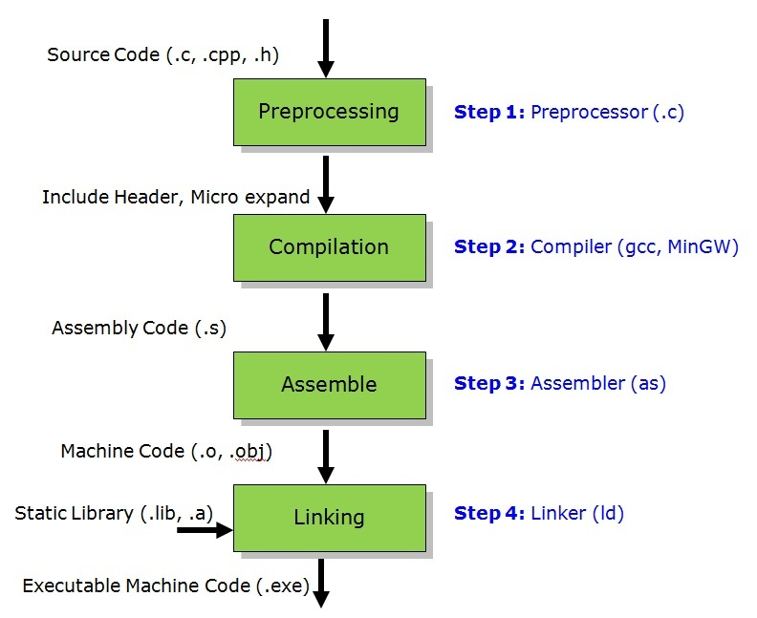
The compilation process includes all of the steps above (plus the loader as well), meaning that the process goes through preprocessing, then compiling, then assembling, linking, and finally, loading. We will only be focusing our attention on the actual compilation process. Typically, compilers such as GCC come included with external or internal preprocessors, assemblers, and linkers. In otherwords, GCC, Clang, MSVC, etc. are more than just compilers.
Internals of the Compiler:
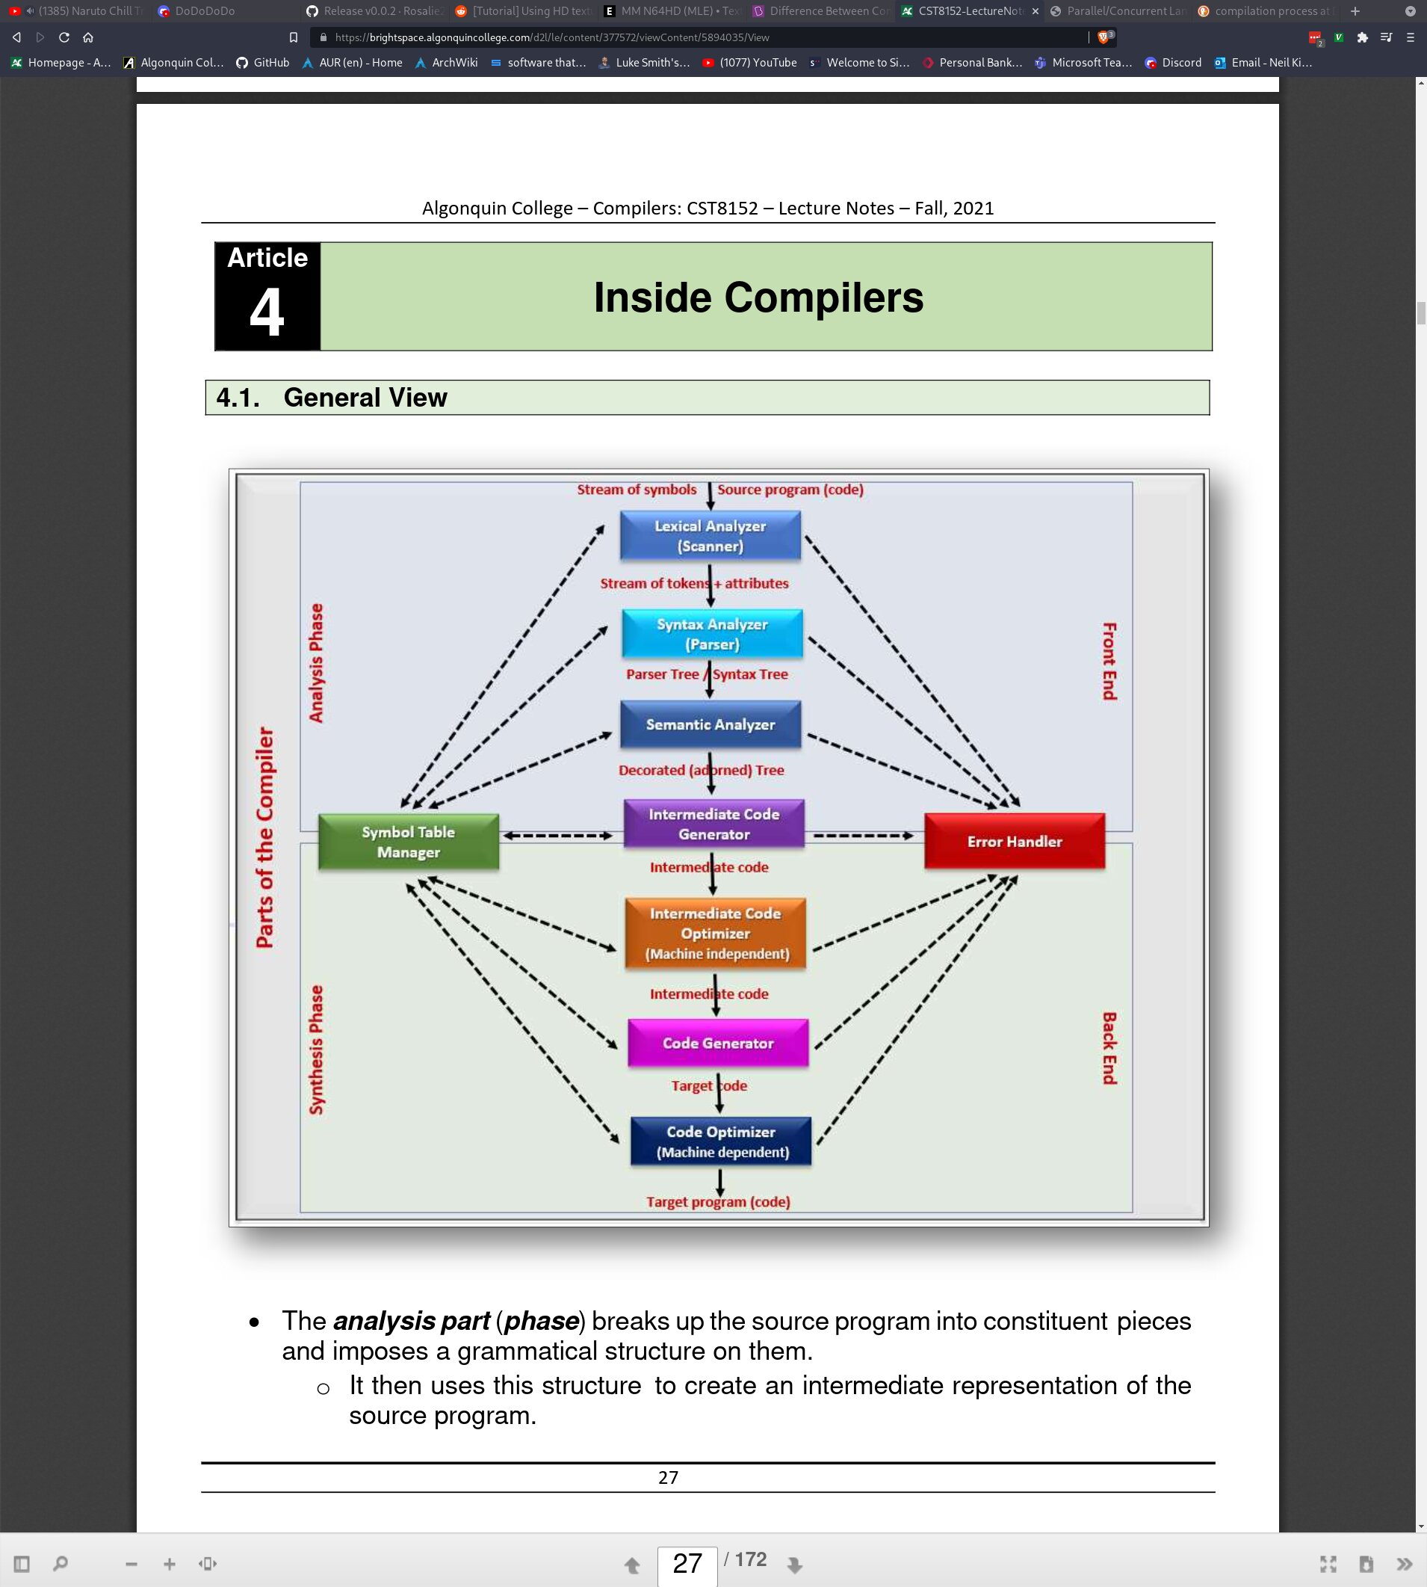
The internals of the compiler can be broken up in to 2 primary subcategories: The font end, called the Analysis Phase, and the back end, called the Synthesis Phase. The Analysis Phase is concerned with breaking up characters into words or symbols called lexemes and creating an intermediate language that is not yet ready for execution. The Synthesis Phase is concerned with taking comparing the intermediate language with the symbol table to create our output language.

We will only be reviewing the front end of the compiler in depth, though perhaps one day I will write notes for the back end as well at some point. As you can tell from the chart, the flow goes from top to bottom, from the Lexical Analyser, to the target program. Technically, there is an additional step which we will be analysing, called the buffer, which simply copies the raw stream of characters from our program source file to a buffer which we allocate in memory. Here is an overview of each step in the compilation process:

- Buffer: The buffer is a simple program that allocates the appropriate amount of memory in the heap and then reads the source code, copying each character into the buffer one by one. This is done so that we can easily manipulate the data contained within the buffer since we want to leave the source code file untouched. In C, this might be accomplished by creating a struct with a const char* that will represent the buffer itself, and can be dynamically resized using realloc() if it ever gets full. Another function might read from the file one character at a time, and yet another that might write the character into the buffer. Various other functions might need to be considered, such as how to clear the buffer, resize the buffer, move the read and write position of the file pointer, etc.

- Lexical Analyser/Scanner: The lexical analyser is in charge of taking the buffer (which is really just a long string of characters), and parsing them into different lexemes. The challenge with the scanner is deciding on what counts as a lexeme; when to create a new lexeme, and when to end it. We will discuss methods of doing this soon.

- Syntax Analysis/Parsing: The syntax analyser creates a tree structure called a parse tree with lexemes as nodes. This is not necesarily a binary tree, and does not share similarities with binary trees that we’ve discussed in data structures. The parse tree is not ordered by any numeric value, but rather by a grammatical structure akin to an actual spoken language.

- Semantic Analyser: The semantic analyser is what actually checks that our parse tree is grammatically correct and makes sense. It does this by comparing the parse tree with the information in the symbol table. Technically the semantic analyser is also responsible for creating the intermediate language representation. Taking C as an example, the semantic analyser will translate it to assembly language. Our target language is not assembly, it is machine code (the actual binary representation of assembly), so we are not done yet. This is where we get into the back end of the compiler though.

- Code Optimization: The optimization phase will take the intermediate langauge (we’ll stick to assembly as our example), and will optimize it as best as it can. This can often produce very significant increases in performance since assembly has many ways of saving cycles and even executing multiple instructions at once. In a compiler like GCC, you can specify the -O flag with a number between 0 and 3 to specify the level of optimization. Level 3 often breaks the code since it attempts to use the most clever but dangerous tricks to save cycles.

- Code Generator: The code generator is a bit strange, but essentially, when we declare variables in the source language, the compiler is meant to record information about these variables, such as their data type, name, value, size in bytes, and address in memory. The code generator will look at the optimized intermediate language and search for variables, and map them to the correct variable definition in the appropriate namespace.
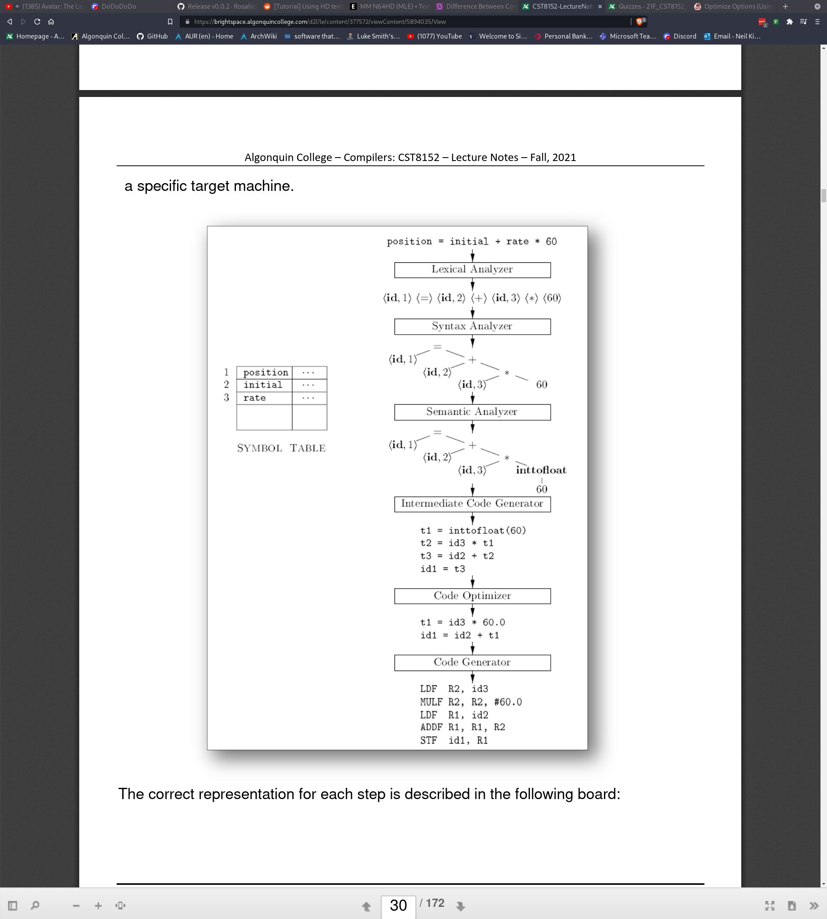
As you can see from the image above, we have the symbol table on the left. Recall that this will contain all of our variable names and information about them such as datatype, size in bytes, address, and value. The first line is source code from the input language (we’ll use C again as an example). The buffer allocates enough space on the heap to copy each character from the source file into. Next, the lexical analyser (the scanner), splits the string into multiple lexemes (denoted by the “<>” brackets) and assigns an ID to each variable so that it can be accessed from the symbol table. The syntax analyser (parser) places each lexeme into a parse tree according to a grammar structure that we will discuss shortly. The semantic analyser then ensures that the code complies with the grammatical structure defined by the compiler. It might may minor changes implicitely, such as converting the int literal 60 to be a float. It also produces the intermediate assembly code (keep in mind, this does not necesarilly need to be assembly). The code optimizer makes changes to produce more efficient code. And finally, the code generator outputs the target language (in out case, machine code).

Bootstrapping:
I’d like to discuss one more thing before I delve into the stuff above in a bit more in depth. Bootstrapping is the process of creating a compiler for the language that the compiler is being written in (meta, I know). The original assembler was written in raw machine code; 1s and 0s. From there, we could assemble assembly back to machine code. Using assembly, we were able to create a compiler for C. It’s sort of a game of which came first, the chicken or the egg, except that the chicken is the compiler, the egg is the target language (C), and the chicken came first ie. The compiler needs to be written before the language is able to actually do anything. Compilers like GCC and Clang are written in C. Writing a compiler that outputs the source language as the target language is called bootstrapping after the English expression “Pulling oneself up by their bootstraps”.

It also needs to be noted that the first compiler for C (or any language for that matter) cannot possibly implement the entire language. For example, think about how many libraries are used in C that had to be written in C. These could not have existed when first compiling C code. Therefore, we generally create what’s called a subset of the language (let’s call it C0). C0 is not the full implementation of C, and does not have all of the features, keywords, or libraries, but we don’t care. We want to write a compiler in C0 for C. This is typically shown in a diagram called T-diagrams. I will try to explain an example to you but honestly, I feel like T-diagrams are super forced and don’t actually make sense; schools just want them to make sense...

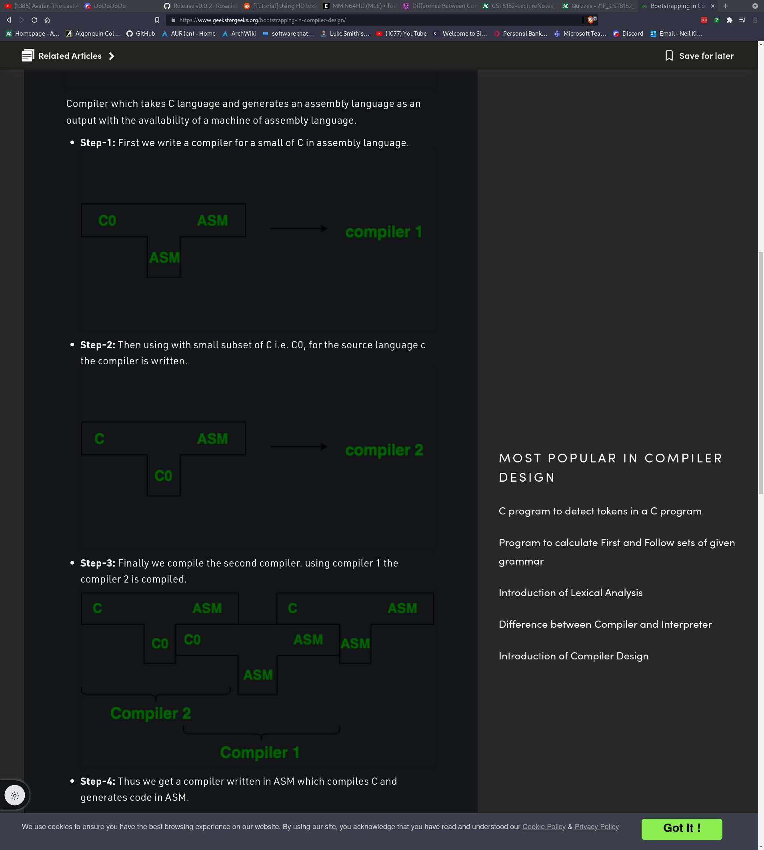
Here you can see some T diagrams. The idea is that the input language is on the left, the output/target language is on the right, and the bottom means that it was “written in” that language. So compiler 1 was written in assembly, it took in the subset of C, C0, and it output assembly. Compiler 2 was written in C0, took in C, and output assembly. Now that we can output C code to assembly code, we can write our compiler in C, and turn it into a binary executable which is denoted on the right. As for the wack ordering of the T-diagrams? I have no clue. The idea is that the language that the compiler was written in (bottom of the T) needs to be aligned next to the input language of another T-diagram, and they must match. Notice C0 touches another C0 between compiler 2 and compiler 1, and that ASM touches ASM between compiler 1 and... compiler 3? I’m not even really sure what the right T-diagram denotes. T-diagrams are dumb, but school makes you learn them, so whatever.

Grammar:
I’ll bet you didn’t think you’d ever be going back to english class and yet here we are. Compilers require a bit of language theory, which might sound boring to you if language isn’t something that interests you, but in my opinion, I happen to find language quite facinating.
If you aren’t aware of Noam Chomsky, I recommend that you read a bit of his biography, as he is the father of a lot of linguistic theory, as well as a phillosopher, cognitive scientist, historian and more. He proposed 4 types of grammar: type 0 (unrestricted), type 1 (context sensitive), type 2 (regular grammar) and type 3 (regular grammar).
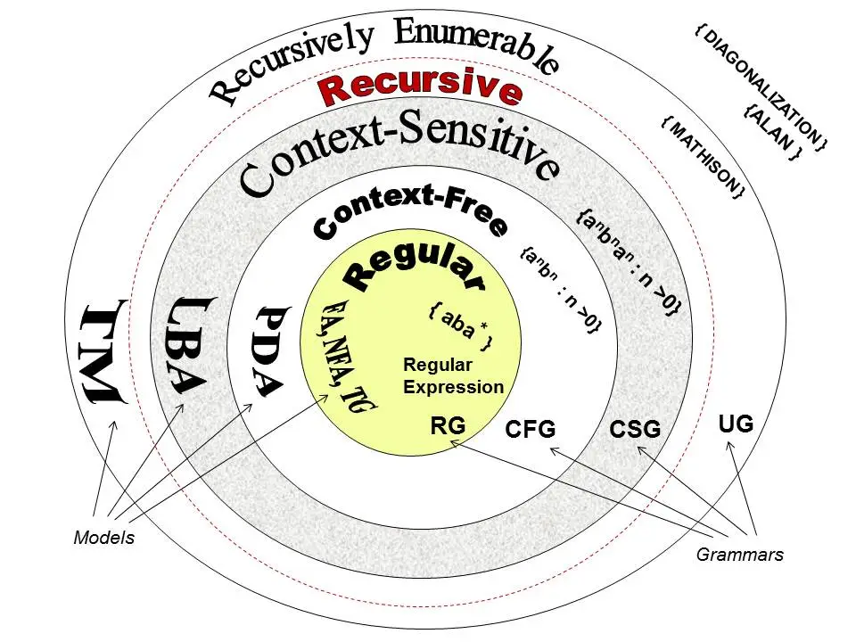

Grammar Type | Grammar Accepted | Language Accepted | Automaton
Type 0 | Unrestricted Grammar | Recursively Enumerable | Turing machine
Type 1 | Context-Sensitive Grammar | Context-Sensitive Language | Linear-Bounded Automaton
Type 2 | Context-Free Grammar | Context-Free Language | Pushdown Automaton
Type 3 | Regular Grammar | Regular Language | Finite State Automaton

Unfortunately, this gets quite complicated and I will probably need to explain some basic mathematical notations quickly. This section will have to assume that you’re familiar with regex because I do not have the time to go into that here. First of all, a set in mathematics is a collection of numbers. They are placed in between curly braces to indicate a set. Certain sets you may already be aware of without knowing it. For example, the set of all natural numbers is represented as N where N is the set of all numbers between 0 – Infinity. This would appear as N = {0,1,2,3,4,5,6,7,8,9 .... } In order to say that something belongs to a set we say n ∈ N which means n is found in the set N ie. It must be some non-negative integer. Things get more complicated with set operators. The union symbol ‘U’ (can also be written as ‘^’) essentially means OR. Given a set A = {1,2,3} and B = {4,5,6}, then A U B would be {1,2,3,4,5,6}.

Coming back to grammar and compilers now, we also need to define “terminal” and “non-terminals”. If we consider a parse tree such as the following, we can see that the leaf-
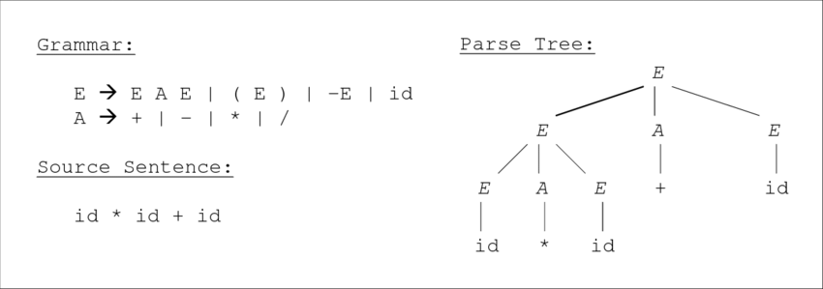
nodes (nodes without parents) are ‘id’, ‘*’, and ‘+’. These are the “terminal” symbols. Terminal symbols cannot be changed; they are sort of like constants. The non-terminals would be A and E. These can be changed according to their definitions in the grammar table.

Flip-flopping back to Chomsky now, let’s look at type 0 grammar: Recursively Enumerable Languages. Type 0s need to be in the form α → β where α is a string of terminals and non-terminals with at least one non-terminal and where α is not NULL. β is a string of non-terminals.

Type 1 grammars generate context-sensitive languages. They must be in the form α A β → α γ β
where:
A ∈ N (the set of non-terminals)
T U N is the set of terminals OR non-terminals
α, β, γ ∈ (T ∪ N)* ie. α, β, γ are all either terminals or non-terminals
The strings α and β may be empty
γ must be non-empty
Context-sensitive languages are recognized by linear bound automaton.

Type 2 grammars generate context-free languages. They must be in the form A → γ
where A ∈ N(Non terminal)
γ ∈ (T ∪ N)* (String of terminals and non-terminals)
These grammars are recognized by non-deterministic pushdown automaton.

Finally, type 3 grammars generate regular languages. They must be either in the form X → a or X → aY
where X, Y ∈ N (Non terminal)
a ∈ T (Terminal)
These grammars are recognized by finite state automaton.

What The Heck Are You Talking About:
The above likely made little sense to you (it made little sense to me at least). This is mostly because I didn’t describe automaton. I’m sure you’re familiar with the turing machine. This is the most powerful automaton out of the 4 that I mentioned. Automaton are state machines that can “automate” computations given an input and produce an ouput. We call the set of inputs ‘/’ = {x1, x2, x3, x4 ... k} where k is the number of inputs. The set out outputs, called Z = {y1, y2, y3, y4 ... m} where m is the number of outputs. Finally, the set Q is equal to a finite set of states wich depend on the type of automaton. The simplest automaton is the finite-state machine. This is expressed as / → Z ie. Given inputs x, produce outputs y. It has no ability to maintain memory. For example, take an elevator. It’s states, Q, is the finite set of customer requests. The inputs are equal to the finite number of floors, k. The outputs are the resulting movement up or down given the input. A Turing machine has the ability to alter it’s own state, meaning that whereas a finite-state machine has finite inputs and finite outputs, a Turing machine has infinite possibilities. It operates the same as a finite-state automaton in that there are limited ways someone can interact with the computer, but because the user can alter programs using other programs, it can theoretically compute anything. This article describes what I just described a bit better and more in depth https://cs.stanford.edu/people/eroberts/courses/soco/projects/2004-05/automata-theory/basics.html.

How This Applies to Compilers:
We’ve covered a bit of Chomsky’s grammar theory, and which automaton can understand which types of grammar; now how does this apply to compilers. Well, grammar needs to be considered during the syntax analysis phase of the compiler in order to create our parse tree. Consider the sentence: “The geeky student wrote the program”. The lexemes that make up this sentence can be ordered heirarchically into a parse tree
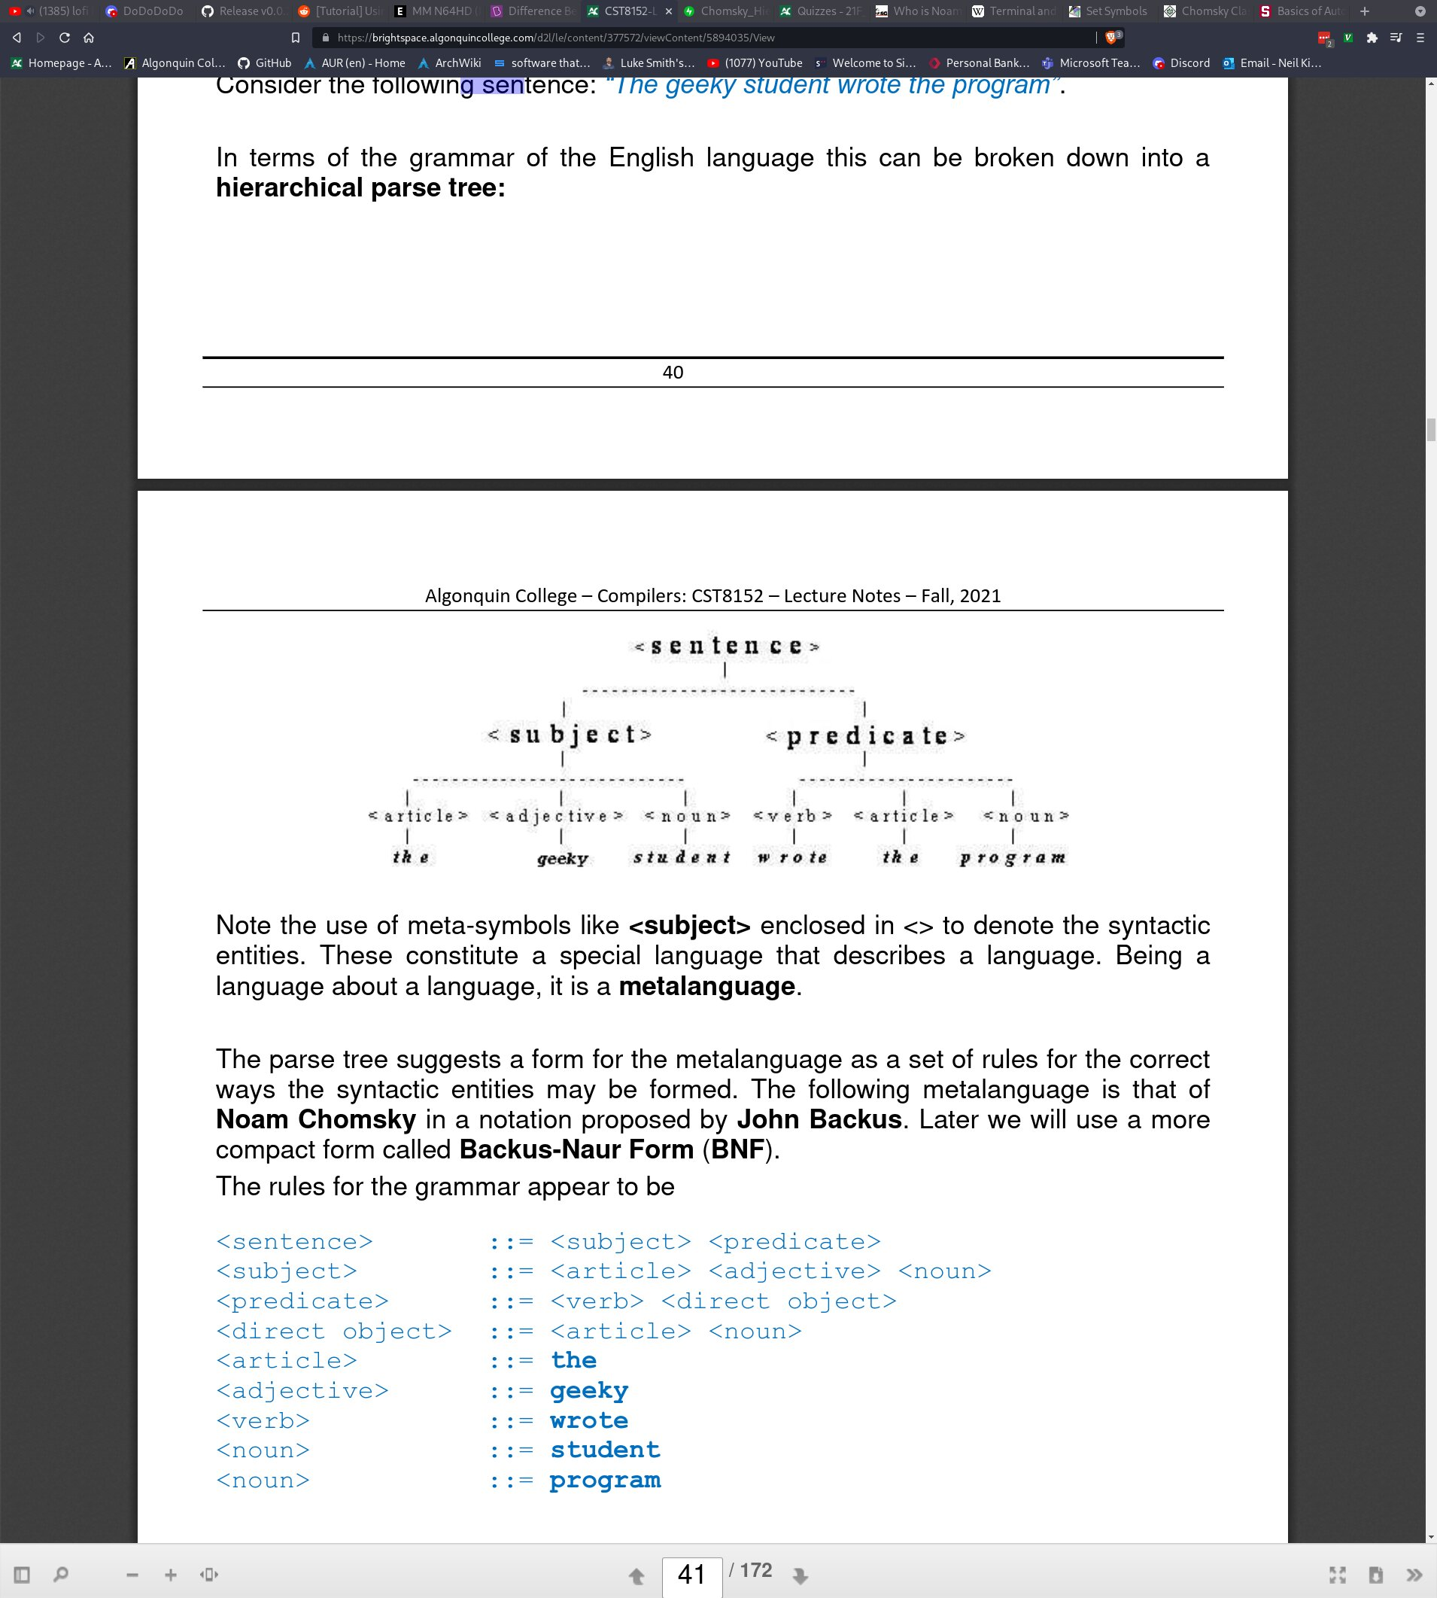
The words enclosed in brackets <> are considered as syntactic entities. They are part of a meta-language used to describe the grammar of the language which we are compiling. The following meta-language was created by Noam Chomsky, and it’s notation proposed by John Backus. Later, we will use a more compact form called Backus-Naur Form (BNF).

Non-terminals
<sentence> ::= <subject><predicate>
<subject> ::= <article><adjective><noun>
<predicate> ::= <verb><direct object>

Terminals
<article> ::= The
<adjective> ::= geeky
<verb> ::= wrote
<noun> ::= student
<noun> ::= program

The “::=” symbol indicates that the entity “has the form of” or “is comprised of” the entities after it. This is equivellant to the arrow (→) that we were using earlier. Each line is considered to be a production ie. A rule (think for example of makefiles in C and how each rule is made up of the target, prerequisites, and recipe). All syntactic entities (things in triangle brackets) are non-terminals, and anything that is plain text is a terminal eg. The, geeky, wrote, student, program. Notice that each terminal is either comprised of other terminals, a non terminal, or sometimes both.

Backus-Naur Notation:
The BNF notation is a bit different than the previously used notation, but looks very similar. BNF is a notation for context-free grammars (readable by pushdown automata). Here is the above written in BNF format:

<sentence> ::= <subject><predicate>
<subject> ::= <article><adjective><noun>
<predicate> ::= <verb><direct object>

<article> ::= The
<adjective> ::= geeky
<verb> ::= wrote
<noun> ::= student | program

Notice the only real difference aside from removing the ::= symbols is that we now have a sort of regex. The set of nouns N = {student, program}. Given the grammar above, the only two possible strings are “The geeky student wrote the program” or “The geeky program wrote the student” since a noun could be either “student” or “program”. In this case, our meta-language fails because it would consider both sentences to be syntactically correct when only the first is. Checking that the syntax is correct would be the job of the syntactic analyser (parser).

The lexical analysis (scanner), which is concerned with creating the parse tree, will have some sort of code to attribute lexemes with their syntactic entities. Once the scanner is finished, we might end up with a sort of table that ressembles the following:
Token | Lexeme
ARTICLE | The
ADJECTIVE | geeky
NOUN | student
VERB | wrote
ARTICLE | the
NOUN | program

Whilst it is the job of the scanner to check that the parse tree is syntactically correct, the parser (along with splitting the buffer into lexemes and putting them in the table above) must reject invalid tokens eg. “Tje geelu stidint wore teh groparam”. This means creating another, simpler grammar to define what each lexeme can be comprised of. This is where regular expressions come in handy.

Validating Lexemes Via Regex:
In order to identify a sequence of characters as being a valid lexeme, we can use regular expressions which are essentially rules used for matching a particular pattern. This mostly applies to literals and operators, and not so much keywords. For keywords, we can just have a list of all the keywords, and check if the lexemes are equivellant to any of the keywords in said list. However, since the user is able to enter an infinite sequence of characters, identifying particular patterns can come in very handy to determine if a lexeme is valid. Regular expressions can be used to identify Deterministic Finite Automata (DFA) which are able to recognize strings.

The Alphabet:
A string is a finite set of symbols from an alphabet. The alphabet ∑ = {a,b,c} can create the strings {a, b, c, a, ab, ac, ba, bc, ca, cb, abc, acb, bac, bca, cab, cba}. As we breifly looked at before, there is a symbol which denotes an empty string “ε”. Closely related, there is the symbol for empty set “Φ”, which is not the same as empty string. Empty string means that the string is able to be empty eg. “”, but not an empty set.

A good example of a regular expression might be determining what counts as a valid floating point number. For example, in the language that you’d like to implement, perhaps you must begin the float with “0.” or perhaps “.” is sufficient. Same with trailing digits; perhaps “9.” is enough to count as a float, or maybe even the number 9 by itself. Assuming that at least one digit is required on both sides of the decimal, and that the decimal itself is necesarry, we could define an alphabet containing all of the numeric characters and call it digits, and then create a regular expression for that alphabet that would enforce the rules we’ve defined:

<digit> -> 0 | 1 | 2 | 3 | 4 | 5 | 6 | 7 | 8 | 9
<digits> -> <digit>|<digits><digit>
<float_literal> -> <digits>.<digits>

In this case we use recursive enumeration on to define digits (plural). By stating that digits can be a single digit, or digits followed by a single digit, we create a recursive function since digits refers to itself. This allows digits to either be a single digit, or many digits. To ellaborate on this concept, lets say that a single digit by itself is acceptable (or more), as well as a decimal followed by some digit(s), or some digit(s) with a decimal at the end (just not decimal point by itself). This can be demonstrated as follows:

<digit> -> 0 | 1 | 2 | 3 | 4 | 5 | 6 | 7 | 8 | 9
<digits> -> <digit>|<digits><digit>
<float_literal> -> <digits> | <digits>.<digits> | <digits>. | .<digits>

Here we state that a float literal can be one or more digits without a decimal place, one or more digits, then a decimal place followed by one or more digits, one or more digits followed by a decimal place and nothing afterwards, or a leading decimal place with one or more digits afterwards. Note that the recursive function used in digits is equivellant to the kleane closure (*) in normal regexes. Recursive enumeration is very powerful, however, if we wanted, this could be written a bit more concisely if needed:

D = {0 | 1 | 2 | 3 | 4 | 5 | 6 | 7 | 8 | 9}
FL = D+ | D*.D+ | D+.D*

Notice that we were able to remove the production of digits entirely, as well as reduce 4 OR statements to 3. The plus denotes one or more, and the kleane closure 0 or more. Therefore, we can have one or more digits with no decimal place, 0 or more digits followed by a decimal and then 1 or more digits, or one or more digits followed by a decimal place and 0 or more digits. This and the above are equivellant.

