Hardware and Circuitry

Intro:
Welcome to the introduction to hardware and circuitry. We have already covered computer essentials in a separate document. In that course we looked at how the parts of a computer work in unison to accomplish tasks. The difference between that class and this one is that in this class, we will learn about the very basics of how circuits work. We will talk about electrical components, voltage, resistance, and current, as well as micro-controllers and microprocessors. Technically these notes could include my notes on assembly language, but I feel that there is enough content to cover to justify separating them. My notes on interfacing are probably what you are looking for if you would like to see out code interact with the hardware. Without further ado, let’s get introduced to the basics of hardware and circuits.

Circuits
A circuit can be defined as a route or path. Cars race around circuits, and similarly, electrons travel through electric circuits. Electric circuits are made from conductive material (usually copper as it is highly conductive), in order for the electrons to travel as fast as possible. A PCB (plastic circuit board) is created by taking a very thin layer of plastic, and 2 layers of copper, and sandwiching the plastic sheet between the two copper ones. Typically, it then undergoes a process that will make the copper susceptible to some chemical using light or lasers. The path for the circuit is not made susceptible to the chemical, meaning all of the copper surrounding it is corroded while the circuit remains intact. Some modern circuit boards contain even more layers of copper so that we can fit more pathways into one board. You will hear of the term closed circuit vs an open circuit as we go through this course. A closed circuit is simply a circuit that has no openings ie. there is always a route for the electrons to take. An open circuit is a circuit which cannot return back to its power source, thus no electrons flow.

Voltage, Resistance, Current
You are probably aware of what all of these are, but you may not understand each one conceptually. Essentially, voltage, resistance and current are all attributes of a circuit and measure different things about circuits. Voltage for instance, is measured in volts (capital V), and measures the electric potential difference of a circuit or component. If you measure the electric potential difference of the entire circuit, then you are really measuring the voltage of the power source, such as a battery. If a battery has 12V, it means that the entire circuit must share that voltage. This means careful consideration is required before building a circuit because if certain components make the voltage drop, there is no way to regain it. If the components in our circuit draw a total of more than 12V, the components and battery can be damaged. Current is the amount of electrons actually flowing through our circuit. Just because we have a reservoir of 12V doesn’t mean that all of the battery’s electrons are flowing at once. Current is measured in Amperes (capital A) and tells us how much charge we are dealing with. Too little current across a component may not be enough to have it function properly, and too much current can damage the component. Voltage and current measure electricity, but resistance measures the resistance of the current in a circuit. Components called resistors are small wires which are tightly coiled up and encased in plastic and are used to bottleneck the flow of current. Resistance is measured in Ohms Ω. It is important to note that resistance and current are inversely proportional to each other. This relationship is referred to as Ohm’s law and has an equation that we will look at in just a minute. This means that the less current you have, the greater resistance you have, and vice versa. This is intuitive when you think about it, but it is easy to forget that simple fact sometimes. The best analogy for all of these attributes in my opinion is that of a river. The river is comprised of a few things: it’s source, its force and its path. The path which the river follows is like our circuit. It may branch out sometimes creating a division in the amount of water before the split. It’s source is like voltage. In other words, it is the total amount of available water (or electrons in our case), and similar to how rivers only want to flow if there is gravity, electrons only wish to flow if there is an imbalance of charge. The force is like the current. There may only be a bit of water coming from a large reservoir, or we might have rushing rapids, as tons of water flows from its source. Resistance can be a beaver dam for example. The force or current of the water is reduced as it tries to pass through the dam. Resistance, Voltage, and Current are represented by the letters R, V, and I. Notice current is represented by capital I, but it is measured in amperes which is capital A. The variables do not equate to the measurement constants. These three variables are related through the equation: $\frac{V}{IR}$ (ohm’s law) Notice that this is one of those fancy math triangles, making it very easy to solve for each variable. For instance, if we need to find V, but we only have I and R, we can multiply I and R to get V. To get I, we divide V by R, and to get R, we divide V by I. If that is confusing to you, just cover the variable that you are trying to solve with your finger and perform the operation between the other two variables. Be sure to memorize this equation (I remember it by remembering the word VIR), as it will come in handy often while dealing with circuits.

Measurement Conversions
Unfortunately, we really need to practice some boring stuff if we want to properly learn electronics. Something which is very important to know is measurement conversions. As you now know, voltage is measured in volts, current in amperes, and resistance in ohms. Sometimes, however, these numbers get really, really small, and it becomes difficult to represent them. This is why we convert measurements. You should be aware that our counting system is done in base 10. This means that each time we reach 9 in our placeholder, adding 1 to it increments the placeholder to the left. We use scientific notation to abbreviate numbers using 10 as out base, and the exponent of 10 to move our decimal point left or right by n amount of placeholders. 1x10^1 = 10, 1x10^2 = 100 or 1x10^-1 = 0.1, 1x10^-2 = 0.01. You can see that if the exponent is positive, the placeholder moves right, and if it is negative, the placeholder moves left. Here is a chart for the different measurement prefixes that we can apply. And these are not only used for voltage, current, and resistance, but virtually any measurement you can think of, so it is good to memorize these as well.
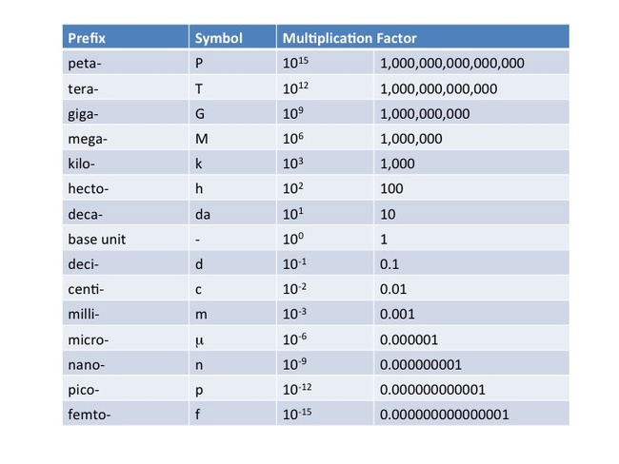
In this course, we do not require the use of hecto, deca, deci, or centi, as these are primarily used for measuring length, not any of the attributes we are learning about. So, let’s say that I need to convert 13 ohms to milli-ohms. Well, if I am just converting from a base measurement like ohms (no prefix), then all I have to do is apply the multiplication factor. In this case, I know that milli is 10^-3, so we can simply apply this to 13. The result is 13x10^-3 = 0.013. All we had to do was move the decimal 3 places to the left. Now let’s say that we are dividing two numbers with different prefix measurements. For instance, 0.125 kA / 1.2 mA. Well, if you know exponent laws, you know that dividing two exponents means subtracting them. Since killo is 10^3, and milli is 10^-3, subtracting -3 from 3 yields 6. 10^6 is the prefix mega. Therefore 0.125kA/1.2mA = 0.104 MA or we could simplify our answer by converting further. I can move the decimal place 3 to the right, knowing that giga comes after mega. Therefore, the answer would be 104 giga Amps (not a very realistic number in a real life scenario). The same is true for multiplication, only that when we multiply two values, we add their exponents, not subtract.

Series Circuits
Earlier we discussed circuits, however we did not go into a series circuit vs a parallel circuit. A series circuit is one which does not have multiple paths leading to the same place. On the other hand, parallel circuits may have 2 or more routes leading to the same wire. We must learn these two kinds of circuits separately because they function differently, thus our methods of measuring voltage, current and resistance will be different as well. In order to measure voltage, we use a voltmeter, a device capable of reading how much potential energy is in the circuit across a given component. Notice that I say across. This is because when we measure voltage, we measure starting on one side of the component, and end on the other side. This is not the same for current. For current, we use a similar device called an ammeter (note that a third device called a multimeter, does voltage, current, and resistance). The ammeter must be place either before, or after a component (ie. not across it) since we must break the circuit to measure it. The reason that we cannot measure current like we do voltage is because if we measure across a component with an ammeter, the circuit becomes parallel, and the current is given an alternate path, thus splitting the current and giving us an inaccurate measurement. An ohmmeter is used for resistance. This device is measured like voltage ie. across a component. The power should be off when measuring resistance. The ohmmeter will send out the required current necessary to read the resistors resistance.

When you have 2 components one after another in a series circuit, the result is usually that their properties get added. For instance, 2 batteries or power sources in series will combine voltage. AA batteries contain 1.5V. Most small components require somewhere around 3 volts of potential energy to function; thus, you often see electrical appliances requiring 2 AA batteries. The same is true with resistors. When resistors are placed in series, the total resistance of the circuit is the combined resistances of each resistor. When we want to measure the total of voltage, current, or resistance, we place a lowercase t as a subscript after the symbol. For example, total current is represented as $I_{t}$.
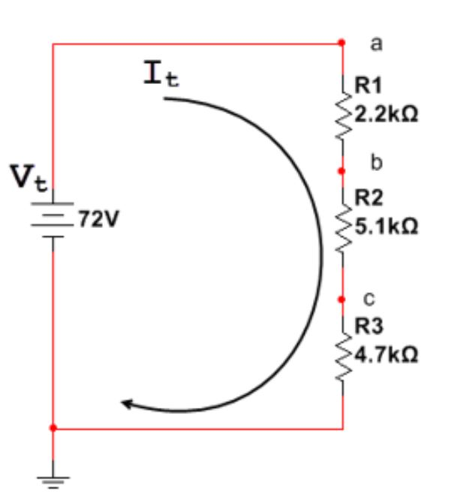
Here is a picture of 3 resistors in series. We refer to each individual resistor by a numeric subscript ($R_{1}$, $R_{2}$, and $R_{3}$). We also see points a, b, and c. These are simply points that the circuit designer has labeled so that we can describe measurements across components easier. A couple other things to note are that current is travelling from the positive lead/terminal of the power supply (denoted by the longer line at the top of the battery symbol on the left) clockwise to the negative lead/terminal. We usually represent current as flowing from positive to negative but in actuality, we will soon learn that current can flow in either direction (this is called electrical bias), and can even alternate direction in AC circuits. Something extremely important to understand is that current is always constant in series circuits, whereas voltage will drop across components. The sum of all voltage drops gives you $V_{t}$. The last thing that I would like to point out is the component at the base of the circuit. This is the ground for the circuit. Usually, a circuit like this would not need a ground, however this picture is taken from an application called multisim, and a ground component is always necessary in multisim in order to compute the values. Alright, here are some questions to help familiarize yourself with series circuits:
1. Calculate $R_{t}$
Here the question is asking to find the total resistance of the circuit. Since all resistors are in parallel, $R_{t}= R_{1}+ R_{2}+ R_{3}$ = 2.2k + 5.1k + 4.7k = 12k ohms. Since all resistors are in killo-ohms, the answer will also be in killo-ohms.
2. Calculate $I_{t}$
For this question we can use Ohm’s law ($\frac{V}{IR}$). To solve for $I_{t}$, we ought to use $V_{t}$ and $R_{t}$. We know $R_{t}$ is 12k, and from the diagram we can see that $V_{t}$ is 72V, therefor we will divide V by R (72V/12k) and get 6. We know this will be in amps, but to get the proper prefix, we do 10^0 – 10^3 since volts are a base measurement and killos are to the power of 3, then we subtract them since we divided, and end up with 6mA.
3. Calculate $V_{ab}$
When the unit symbol has two letters as a subscript, it means that we are looking for the voltage drop between point a and point b ie. across $R_{1}$. Since voltage will drop across components in a series circuit, the voltage will drop after the first resistor. This voltage should be lower than $V_{t}$. To calculate this, we do not want to consider $R_{t}$ because we are not measuring voltage after all resistances, only the voltage after $R_{1}$. According to ohm’s law, V = IR, and in this case, we write the equation as: $V_{ab}$ = $I_{t}$ * $R_{1}$ --> $V_{ab}$ = 6mA * 2.2k ohms. The answer will be 13.2V. It will be in base units because we multiply, meaning we add the exponents of mA (-3) and killo ohms (3), to get 0. This shows us that voltage has dropped after resistor 1, meaning that we dropped 13.2V from our original 72V, meaning we have 58.8V left to use in the rest of the circuit.
4. Calculate $V_{ac}$
This question is similar to the previous one, except now, we are measuring the voltage from point a to point c, meaning that the voltage drop will have increased since we are adding the summation of two separate voltage drops ($V_{ab} and V_{ac}$). There are two ways in which we can do this. Either measure like we did in the previous question, or we can take our previous answer, only calculate $V_{bc}$ and then add $V_{bc}$ and $V_{ab}$ to get $V_{ac}$. In order to do it the first way, we did what we did last time, where we take $I_{t}$ and multiply by R, but this time R will be $R_{1}$+$R_{2}$. Here is the formula: $V_{ac}$ = $I_{t}$ * ($R_{1}$ + $R_{2}$) --> $V_{ac}$ = 6mA * (2.2k(ohms) + 5.1k(ohms)) = 6mA * 7.3k(ohms) = 43.8V.
The second way we can do this as I said would be to take $V_{ab}$ and add it to $V_{bc}$.
$V_{bc}$ = $I_{t}$ * $R_{2}$ --> $V_{bc}$ = 6mA * 5.1k(ohms) = 30.6V + 13.2V = 43.8V
5. Calculate $V_{b}$
When only one letter is posted as a subscript, the implicit second letter is g for ground. In other words, we can read this as “calculate voltage from point b to ground”. Ground as we know is represented by the ground symbol, but for circuits where no components come after the ground, it may be easier to just think of the voltage between point b and the negative terminal of the battery. Once again, there are two ways of solving questions with grounds. The first obvious solution is to calculate voltage from point b to what I will refer to as point g (ground) which will be any point after our last component ($R_{3}$). The alternative method is to subtract the voltage at point b from total voltage and I will try to explain why that works. Using the first method, the equation would go as follows: $V_{b}$ = $I_{t}$ * ($R_{2}+ R_{3}$) --> $V_{b}$ = 6mA * (5.1k(ohms) + 4.7k(ohms)) = 6mA * 9.8k(ohms) = 58.8V. The other method of getting this value is, as I mentioned, to subtract voltage at b from $V_{t}$. This works because we are getting the amount of voltage available after point b. This means that if we remove the first voltage drop from the total voltage, we will get the remaining voltage ($V_{b}$). Here is that formula: $V_{b}$ = $V_{t}- (I_{t}$ * $R_{1})$ --> $V_{b}$ = 72V – (6mA * 2.2k(ohms)) = 72V – 13.2V = 58.8V.

Power
Power is another unit by which we can measure electrical components. It’s measurement is in Watts and is a much less informative measurement than voltage, current, or resistance. There are three ways in which we can measure power (represented by P). Unlike ohm’s law, these are much harder to memorize so I suggest you write them down and keep them handy when you need them. The first equation for power is P = VI. This is the most simple and easy to remember. The second equation is P = $\frac{V^{2}}{R}$ and the third equation is $P= I^{2}R$. We use power when we are not concerned about how much voltage or current will be drawn, but rather what our electrical bill may be, or how much energy an outlet can handle. For example, your computer has a power supply measured in Watts. It can draw as much current or voltage as it needs from the outlet, however it cannot exceed it’s power rating. Similarily, Hydro cannot measure and calculate how much current your appliances have used and how much voltage. Instead they multiply them and charge by Watt-hours. Something that we need to be careful of is when we are trying to calculate power using one of the latter 2 equations. When we have exponents in our equation, we need to remember to also apply that exponent to our measurement unit. For example, if I do $P= I^{2}R$ and I is 4mA, and R is 3.3k(ohms), then when I square I to get 16, I also square mA. mA is 10^-3 x 10^2 = 10^-6. Keeping this in mind, when we multiply 16 by 3.3 (16*3.3 = 52.8), R will be in killo-ohms, and current will be in micro amps. since we are multiplying, we add 10^3 killo to 10^-6 micro and get 10^-3 milli. Therefor the answer would be 52.8 mW

Parallel Circuits
As I mentioned, parallel circuits function differently than series circuits, and while they may take a little bit to fully grasp, it shouldn’t take too long to get the hang of them with practice. Some differences between are series circuits and parallel circuits as follows:
1. Current: In series circuits, total current ($I_{t}$) is the sum of I at each component. In other words, current is forced down one path, meaning that $I_{t}= I_{1}+ I_{2}+ I_{3}+$... An even better way of explaining this is that the circuit will always draw the current it needs to satisfy all components. As a result of this, the current after every component will be the same, thus ${I_{t}= I}_{a}= I_{b}= I_{c}…$ In a parallel circuit, the circuit branches, thus current will flow down every path. Depending on resistance, certain paths may have more current that others.
2. Voltage: In a series circuit, $V_{t}$ is equal to the voltage drop across each component. In parallel, multiple components can be connected to the source voltage, meaning that voltage will be the same down each path connected to the source. The voltage source does not necesarily mean the power source, but rather the voltage at the point where are parallel components connect to. In other words, the equation for voltage in parallel circuits is: $V_{t}= V_{1}= V_{2}= V_{3}=$...
3. Resistance: Resistance is probably the biggest difference between series circuits and parallel circuits. In series, the total resistance is the summation of all resistors, therefor $R_{t}= R_{1}+ R_{2}+ R_{3}+$... In parallel, we calculate total resistance much differently. If n amount of resistors are in parallel and they have the same resistance, the formula will be $R_{t}$ = $\frac{R}{n}$ where R is the resistance of any of the resistors (since they will all have the same resistance) and n is the number of resistors. If there are 2 resistors in parallel which have 2 different resistances, then we use the formula $R_{t}$ = $\frac{R_{1}R_{2}}{R_{1}+R_{2}}$ and finally, if we have more than 2 resistors and they are all different resistances, we always use the equation $\frac{1}{\left(\frac{1}{R_{1}}\right)+ \left(\frac{1}{R_{2}}\right)+ \left(\frac{1}{R_{3}}\right)…+ \left(\frac{1}{R_{n}}\right)}$ Essentially we take the inverse of the summation of the inverse of each individual resistor.

In summary, series circuits, total resistance is the sum of all resistors, $V_{t}$ is the sum of all voltage drops, and current is static. In parallel circuits, total resistance is calculated using the formulas above if placed in parallel, and/or the resistors are added if they are in series, voltage is static for each path connected to the power source, but may drop within a branch, and current is split down each path depending on resistance. Now we have seen the basic differences between the two types of circuits, but that wont be helpful unless we practice and see for ourselves how this stuff actually works.

1. Calculate $R_{t}$ of the circuit
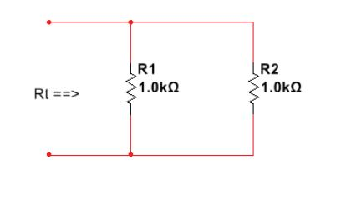
Here we have two resistors in parallel. We can tell they are in parallel since the wires intersect at the base of R1 after they split. Whenever you see a wire branch, you immediately know that it is in parallel. We start at the top left, and see that the wire branches, so we can write // to represent that branch. Therefor, the equation of $R_{t}$ = $R_{1}$ // $R_{2}$ We can then replace the values of $R_{1}$ and $R_{2}$ with 1.0k(ohms), and rewrite this as: $R_{t}$ = 1.0k(ohms) // 1.0k(ohms). Since both resistors have the same resistance, we will be using the first equation $R_{t}$ = $\frac{R}{n}$ Plugging the values in looks like this $R_{t}$ = $\frac{1.0k(ohms)}{2}$ and therefor $R_{t}$ = 0.5k(ohms) or 500 ohms if you prefer.

2. Calculate $R_{t}$ of the circuit
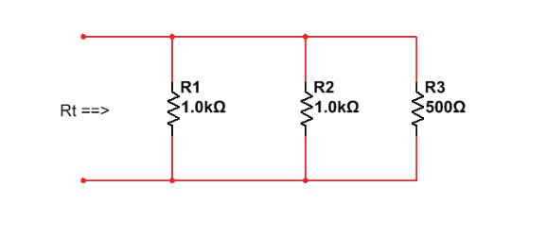
Here we have 3 resistors in parallel, and while 2 of them are the same resistance, $R_{3}$ is 500 ohms which means that we will need to use the inverse formula. If you recall, the formula is $\frac{1}{\left(\frac{1}{R_{1}}\right)+ \left(\frac{1}{R_{2}}\right)+ \left(\frac{1}{R_{3}}\right)…+ \left(\frac{1}{R_{n}}\right)}$ so by substituting the values it looks like $\frac{1}{\left(\frac{1}{1.0k}\right)+ \left(\frac{1}{1.0k}\right)+ \left(\frac{1}{500}\right)}$ = $\frac{1}{1k + 1k +2k}$ = $\frac{1}{4k}$ = 0.25k(ohms) or 250 ohms.

3. Calculate $R_{t}$ of the circuit
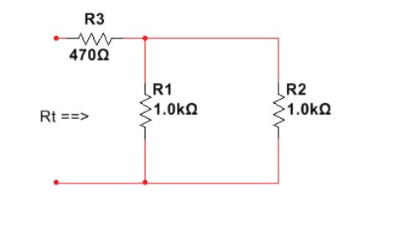
Now we introduce another resistor $R_{3}$, but notice that the split in the circuit has not occured yet. This means that $R_{3}$ is in series with two other resistors in parallel. In circuit one, we described the relationship of $R_{1}$ and $R_{2}$ through the equation $R_{t}$ = $R_{1}$ // $R_{2}$. When two resistors are in series, we know to add their values. This means that our new relationship will be the addition of $R_{3}$ and $R_{1}$ // $R_{2}$. This looks like $R_{t}$ = $R_{3}+ R_{1}$ // $R_{2}$. Resistors in parallel take precedence over addition so it is best to envision brackets surrounding components that are in parallel since those should be calculated first. We can now plug in our values to our equation: $R_{t}$ = $470(ohms)+(1.0k$ // 1.0k) We’ve already calculated the resistance of the two 1.0k resistors in parallel, which we said was 500(ohms) so all that’s left is to add 470 and 500 to get a total resistance of 970(ohms).

4. Calculate $R_{t}$ of the circuit
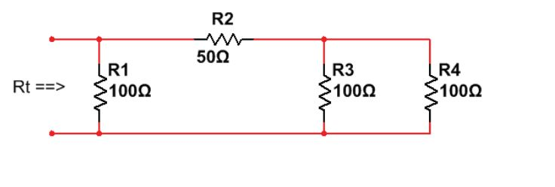
Continuing the trend of adding resistors, we now have another 100 ohm resistor. I find it helpful to sometimes redraw the circuit from top to bottom or read it from right to left. Looking at this we see that a split occurs at the very beginning of the circuit, before $R_{1}$. This means that we know $R_{1}$ is in parallel, because it has deviated from the main branch. $R_{2}$ on the other hand, is in series as we know. The equation describing this relationship is $R_{t}$ = $R_{1}$ // $R_{2}$ + $R_{3}$ // $R_{4}$ Adding braces makes this much clearer: $R_{t}$ = $R_{1}$ // [$R_{2}$ + $(R_{3}$ // $R_{4}$)] Filling in the values: $R_{t}$ = 100 // [50 + $(100$ // 100)] $R_{3}$ is in parallel with $R_{4}$ and they have the same resistances, so we can use $R_{t}$ = $\frac{R}{n}$ --> $R_{t}$ = $\frac{100}{2}$ = 50 Subbing that back in our equation is now $R_{t}$ = 100 // [50 + $5$0] = 100 // 100 = 50. The total resistance of this circuit will be 50(ohms).

5.
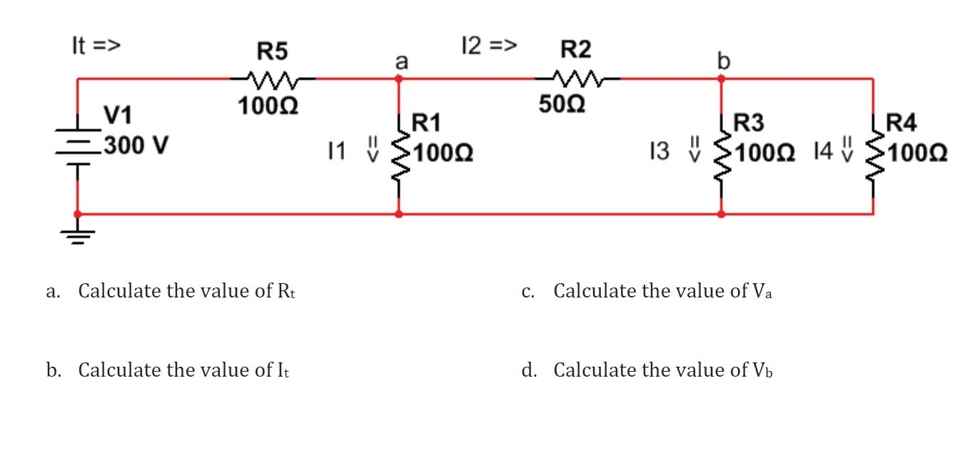
a.
$R_{t}$ = $R_{5}$ + [$R_{1}$ // $R_{2}$ + $(R_{3}$ // $R_{4}$)]
$R_{t}$ = 100 + [100 // 50 + $(50$ // 50)]
$R_{t}$ = 100 + [100 // 50 + $50$]
$R_{t}$ = 100 + [100 // 100]
$R_{t}$ = 100 + 50
$R_{t}$ = 150(ohms)

b. $I_{t}$ = $\frac{V_{t}}{R_{t}}$
$I_{t}$ = $\frac{300V}{150(ohms)}$ $I_{t}$ = 2A

c. In order to get $V_{a}$ we must remember that there is an implicit g for ground, meaning that we need to find the difference of $V_{t}$ - $V_{1}$ where $V_{1}$ is the voltage drop after the first resistor ($R_{5}$) because that should give us the remaining resistance. In other words, keep in mind that the branches in the circuit with $R_{1}$ and $R_{2}$ will theoretically have 300V each of potential energy since they are both drawing from the 300V source. The reason that they won’t actually be drawing 300V is because the resistors in series will create voltage drops along the way to each branch, meaning that our actual voltage source for our first branch will be the voltage after $R_{5}$. Total voltage - $R_{5}$ will give us the difference between $V_{a}$ and $V_{g}$
$V_{a}$ = $V_{t}$ - $V_{1}$ $V_{1}$ = $I_{t}R_{5}$
$V_{1}$ = $2A* 100(ohms)$ = 200V
$V_{a}$ = $V_{t}$ – 200V
$V_{a}$ = 300V – 200V = 100V

d. To calculate $V_{b}$ will be more difficult because we have not only lost voltage from $R_{5}$ due to voltage dropping across components, but we have also lost current, since some of the current has gone down the first branch, and some has continued right along the top branch. We will need to measure $V_{2}$ which will be voltage after resistor $R_{2}$ and we will also need to measure current $I_{2}$ which will be current after the first branch.

$V_{b}$ = $V_{a}$ - $V_{2}$
$V_{2}$ = $I_{2}R_{2}$
$I_{2}$ = $I_{t}{- I}_{1}$ Take total resistance, and subtract the resistance that went down the first branch to get $I_{2}$
$I_{2}$ = $2A-\left(\frac{V_{1}}{R_{1}}\right)$
$I_{2}$ = $2A-\left(\frac{100V}{100(ohms)}\right)$
= 1A
In this case, it appears that 1A of current went down each path. This is because the total resistance of the right side of the circuit was equal to 100 ohms if you recall. Since $R_{1}$ if 100 ohms and the right side of the circuit is 100 ohms, we should expect the current to split in half at the first branch. At this point, we have found the amount of current travelling down $I_{2}$. We must now find $V_{2}$.
$V_{2}$ = $1A* 50 \left(ohms\right)$
$V_{2}$ = 50V
$V_{b}$ = $100V-50V$ $V_{b}$ = 50V

6. We will do one last exercise to really push this stuff into your mind and hopefully help grasp any loose straws.
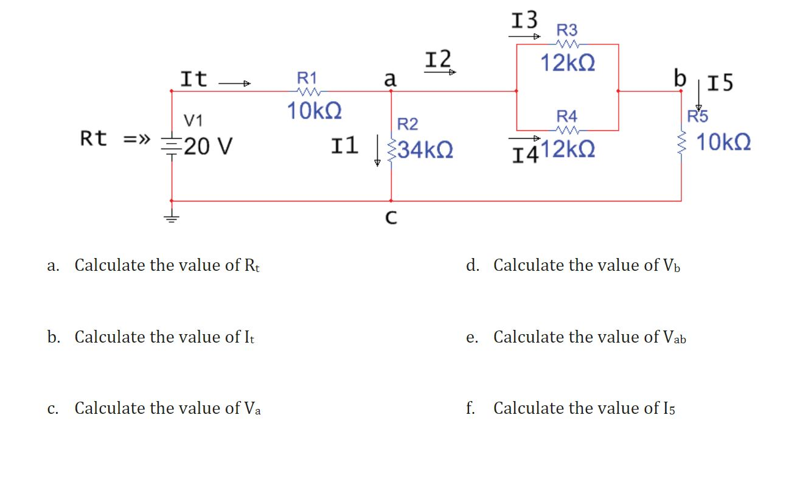

a. $R_{t}$ = $R_{1}$ + [$R_{2}$ // [($R_{3}$ // $R_{4}$) + $R_{5}$]]
$R_{t}$ = 10k + [34k // [(12k // 12k) + 10k]]
$R_{t}$ = 10k + [34k // [6k + 10k]]
$R_{t}$ = 10k + [34k // 16k]
$R_{t}$ = 10k + 10.88k
$R_{t}$ = 20.88k

b. $I_{t}$ = $\frac{V_{t}}{R_{t}}$
$I_{t}$ = $\frac{20V}{20.88k(ohms)}$
$I_{t}$ = 958µA

c.
$V_{a}$ = $V_{t}-$ $V_{1}$ where $V_{1}$ is voltage after $R_{1}$
$V_{1}$ = $I_{t}R_{1}$
$V_{1}$ = 958µA * 10k (10^-6 + 10^3 = 10^3)
$V_{1}$ = 9580kV or 9.58V
$V_{a}$ = $20V-$ 9.58V
$V_{a}$ = $10.42V$

d.
$V_{b}$ = $V_{a}-$ ($V_{3}$ // $V_{4}$) where $V_{3}$ and $V_{4}$ are the voltages after resistors $R_{3}$ and $R_{4}$
In order to solve for $V_{b}$, as was the case for the last question, we need to have current $I_{2}$ after the initial branch which, as we also know, requires subtracting $I_{1}$ from $I_{t}$. We will also need the voltage after both resistor $R_{3}$ and $R_{4}$ and subtract that from $V_{a}$. Something that bothered me for a while, was trying to understand how voltage $V_{a}$ could be different from the voltage after resistor $R_{3}$ and $R_{4}$ since the formula we looked at earlier ($V_{t}= V_{1}= V_{2}= V_{3}=$... ) led me to believe that voltage should always be the same for circuits in parallel. I finally understood what was happening when I measured voltage across $R_{2}$, and noticed how it was the same voltage as $V_{a}$. You see, that equation is only true for voltages across components that are in parallel. If you study our equation that we wrote at the beginning ($R_{t}$ = $R_{1}$ + [$R_{2}$ // [($R_{3}$ // $R_{4}$) + $R_{5}$]]), you will notice that $R_{1}$, $R_{5}$ and ($R_{3}$ // $R_{4}$) are actually in series since they have addition symbols next to them. $R_{2}$ is the only component on its own which is in parallel, therefor, its voltage ($V_{2}$) should equal $V_{a}$, and the voltage across the right side of the circuit. I have tried to illustrate this better with some pictures from multisim. Here are the comparisons:
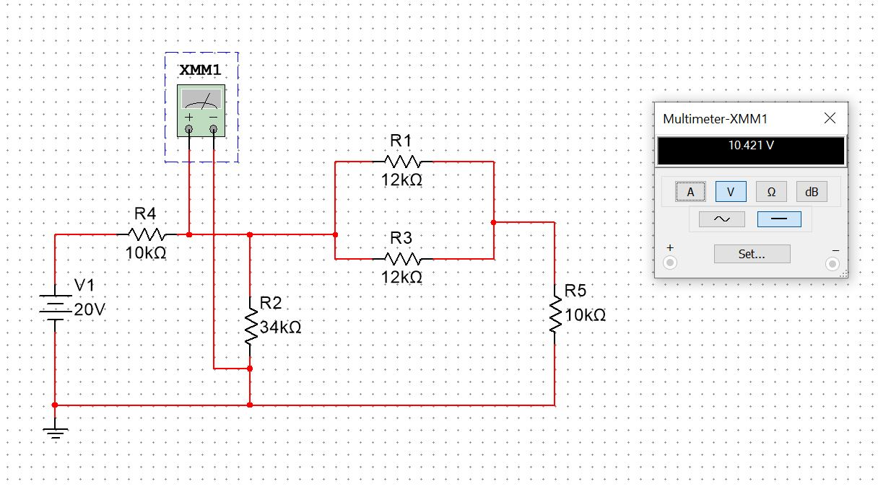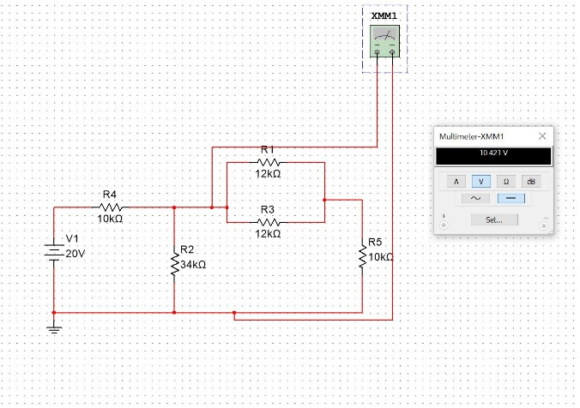
Please note that what we are measuring now ($V_{b}$), would resemble the second image, except that the positive lead of the multimeter would be on the right side of ($R_{3}$ // $R_{4}$) at point b. Maybe now you can see clearer as to why $V_{b}$ = $V_{a}-$ ($V_{3}$ // $V_{4}$). Continuing on...
$V_{b}$ = $V_{a}$ - $I_{2}$($R_{3}$ // $R_{4}$)
$I_{2}$ = $I_{t}$ - $I_{1}$
$I_{1}$ = $V_{a}$/$R_{2}$
$I_{1}$ = 10.42V / 34k(ohms)
$I_{1}$ = 10.42V / 34k(ohms)
$I_{1}$ = 306µA
$I_{2}$ = 958µA - 306µA
$I_{2}$ = 652µA
($R_{3}$ // $R_{4}$) = (12k // 12k) = 6k
$V_{b}$ = 10.42V – (652µA * 6k)
$V_{b}$ = 10.42V – (652µA * 6k)
$V_{b}$ = 10.42V – 3.91V
$V_{b}$ = 6.51V
And we can reaffirm this number by adding $V_{a}$, $V_{b}$, and ($V_{3}$ // $V_{4}$) together: 10.42V + 6.51V + 3.91V = 20V
Hopefully that was enough to make you think, and experiment. Now that we understand the very basics of how electricity works, we can move on to more fun stuff like all of the electrical components available to us, and how we can begin to make them work in unison to create some cool stuff.

Diodes
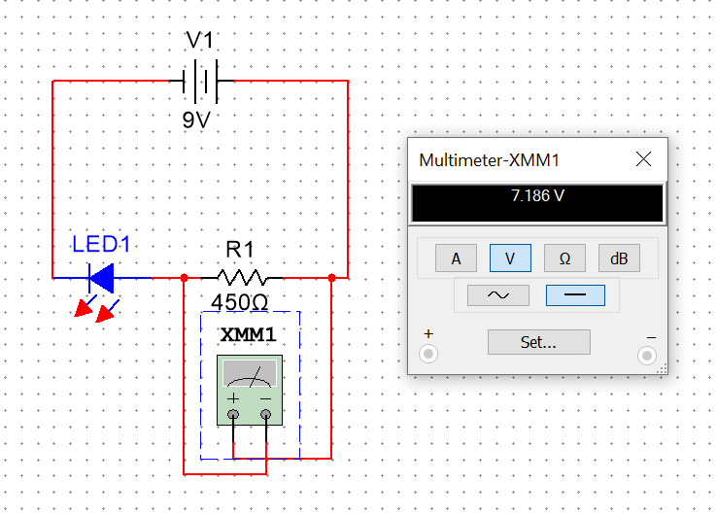
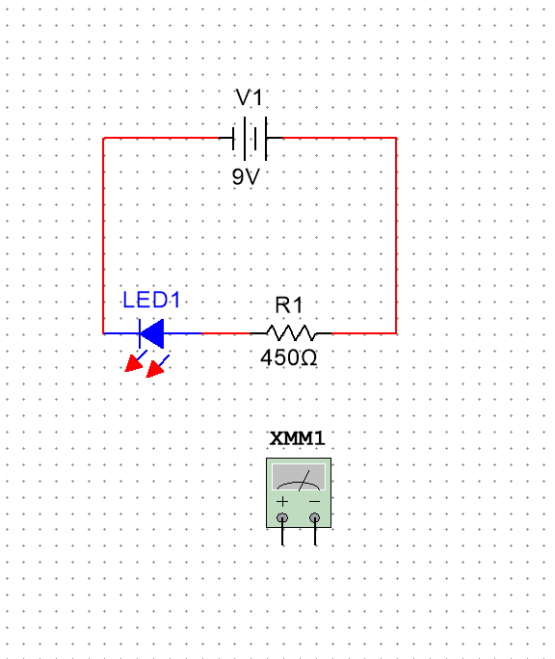
A diode is what we call a semi-conductor. Semi conductors are a really important concept in the world of electronics. In fact, they are the basis of transistors, another component which we will look at shortly that CPUs are made of. Back to my point though, a semi-conductor is any material which conducts electricity to some degree, but typically not very well. A chemical process called doping is performed, in which, electrons are added or removed, causing the atoms to become unstable and pass electrons to each other. Often, you will hear the terms n-type and p-type doping. n-type means adding excess electrons, meaning the material will give away electrons easily, whereas p-type doping means removing electrons to make a material that is more positively charged, and will more easily accept electrons. In diodes, we put an n-type material next to a p-type material, sometimes called the anode (positive) and cathode (negative) leads. It is for this reason that diodes are always biased, meaning they have a specific orientation whereas certain components can be placed in any orientation. Diodes are a family of components, including most notably, the LED (light emitting diode). The LED light is a staple in electronics and come in very handy. I will show you how to create a series circuit that will illuminate an LED. As you can see in the picture below, the LED is illuminating. I began with a 9V battery. Typically, LEDs such as this one are rated to draw 20mA of current, although it is always good to check with the data sheet. Using Ohm’s law, we can calculate that our resistance should be 9V/0.02A which gives us 450 Ohms. Without the resistor in the circuit, the LED would have access to way too much voltage and burn out. This LED is recommended to take 2V. Since voltage is directly proportional to current (ie. a change in either voltage or current will affect resistance), we don’t have to worry about how much voltage is dropped across the resistor, since we already calculated resistance, which means that both voltage and current will be appropriate for the LED. To show you what I mean, we can look on the multimeter and see that the resistor drops the voltage by 7.186V, leaving 1.814V for the LED. Conveniently close to what the LEDs rated for..... This is what I meant by saying that we don’t need to account for voltage drops across loads.

Transistors
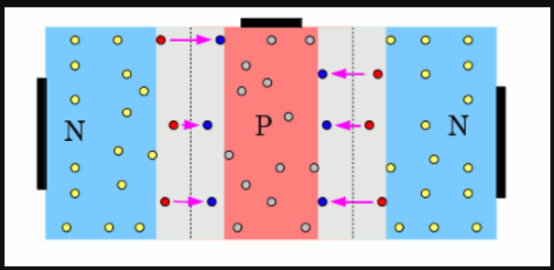
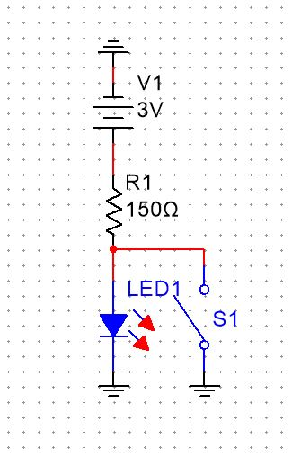
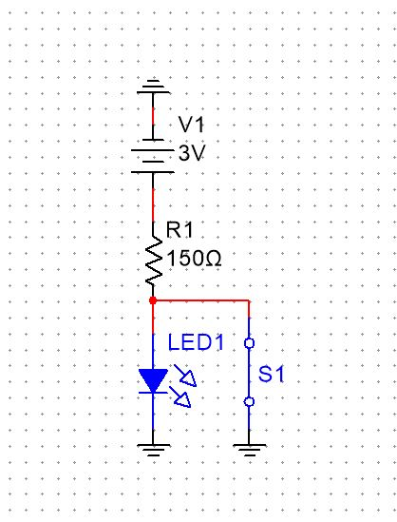
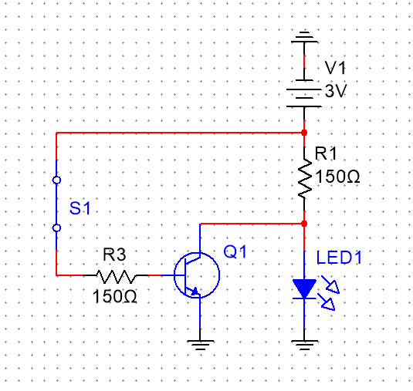
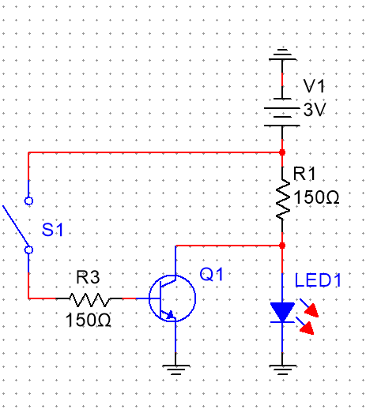
Earlier, I mentioned transistors. Turns out your CPU has literally billions of them! Within small components that are machined by factories, transistors are on the atomic level of tininess. Within hobbyist projects like what we are doing, they are more like the size of a thumb tack. Functionally, they work the same. While diodes have an n-type material next to a p-type material, transistors have a p-type material sandwiched between two n-type materials. Transistors have 3 leads. The middle lead is called the base, and the outer leads consist of the collector and emitter. The collector, as you may guess, is the input lead for the current, while the emitter is the output. So how does it work? When current is applied to the base, it polarizes the p-type material, and essentially allows current to flow from the collector to the emitter. Transistors can be used as switches, or for amplification. Microphones, for example, use transistors to amplify the electrical frequency, thus making the output louder than the input. This is done by manipulating the bias of the current ie. changing its direction of flow. We won’t be looking into amplification in this guide, as it is a pretty advanced topic. Instead, I wanted to show you how we can create a NOT gate using a transistor. As you know, NOT gates reverse the binary input. The idea is that you have a switch or button that, when pressed, applies current to the base of the transistor, and because the resistance of the transistor is less than that of the LED, the current flows through the transistor and ignores the LED. Firstly though, it should be noted that there is an easier way of making a NOT gate than using resistors. You can simply place a switch before your component that is connected to ground so that when the switch is pressed, current is forced to go through the switch. That would look like the pictures on the right. As you can see, the current normally flows through the LED, however, when the switch is pressed, it is forced to go back to ground. You have to be very careful here because any circuit without a load will quickly dissipate heat and can start a fire or burn you. This is why the resistor is placed before both the switch and the LED. If the switch was connected above the LED and you closed the switch, you would have a short circuit and it would quickly overheat. The resistor ensures that the energy is being used and therefor does not overheat. Now lets look at the transistor version of the NOT gate. As you can see below, the switch is closed and current travels to the base of the transistor. This allows the current that was flowing through the LED to take the path of least resistance and go through the collector instead. Notice once again that there is a resistor after the switch, which is to prevent overheating once again. Something critical to note here is that the type of transistor actually matters. There are two types of transistor: NPN and PNP. What these essentially boil down to is the polarization. One will have the p-type material for the base and n-type material for the collector and emitter, and the other will have n-type for the base and p-type for collector and emitter. We can test which is which with a multimeter in a really sneaky way. On your multimeter you should have a mode called diode mode, denoted by the LED symbol. If you place the negative lead on the base of the transistor, and the positive lead on either the collector or emitter and get a reading, it is a PNP transistor which we don’t want for this NOT gate. Otherwise, if you place the positive lead on the base, and the negative lead on either the collector or emitter and get a reading, it is an NPN resistor which is what we want. This is best memorized by NPN: negative positive negative, PNP: Positive, negative, positive.

