C Programming

This guide will cover the C programming language written by Dennis Ritchie. It assumes you are already familiar with a programming language or two and will not go into detail on basics like functions or data types. That is not to say this guide won't explain these things at all, but it assumes you are familiar with the core concepts. You should also have an intermediate understanding of UNIX or GNU/Linux as Unix was written entirely in C and shares a lot in common with it. Without further ado, allow us to delve into arguably the most significant programming language of all time.

The C programming language was inspired by the B programming language but fixes a lot of issues with that language. There are different variants of C (C99 released in 1999, C11 in 2011 and C18 in 2018, as of 2020). We will be using C99 as it is the most commonly used and least buggy. You may think of C as the intermediate step between assembly language and higher-level languages like Java or Python (but closer to assembly than to those higher-level languages). C often requires more out-of-the-box thinking since it is a much lower-level language than something like Python that has plenty of libraries/APIs/frameworks. This is the blessing and curse of C, as it is fantastic for writing very low-level applications like program engines or operating systems since it is so easy to interface between C and the hardware of the computer. C begins to become less ideal when you are working with high level applications like GUIs or web apps. By far the most difficult aspect of C is the fact that you must manage memory which is not second nature to most programmers. There are key words built in which can tell the system to store variables in the CPU registers for fast access or create our own variable types. We must create our own garbage collection, that is to say, remove stale or unused data and variables to free up space. We must carefully consider the length of arrays and so-forth.

Intro

As you should know if you are familiar with Unix utilities, to compile and run a C program, we compile it using the GCC (the GNU C compiler) from the GNU compiler collection. The file must have a .c extension (referred to as source files). Run the command gcc <file.c> [-o <output_name>] where -o is an option for a new output filename instead of the default which is ‘a.out’. When a c file is compiled, what’s called an object file (a file ending with .o) is generated. We will discuss this more in the Makefile section. Almost every C file will require the stdio.h header file (standard input/output) which contains basic functions like printf() for outputting text. Header files are C/C++ files used for function, macro, and extern variable definitions. Notice I say definitions/declarations and not initialization. This is because functions need to be defined before they are initialized (ie. populated with code as a block), which often creates unnecessary clutter in our .c files, thus the need for .h files. The stdio.h file belongs to the C standard library, also called libc or glibc if you are using the GNU variant that comes with all Linux distros. In C, a code library is simply a collection of header files and object files containing functions, structs, and global variables.
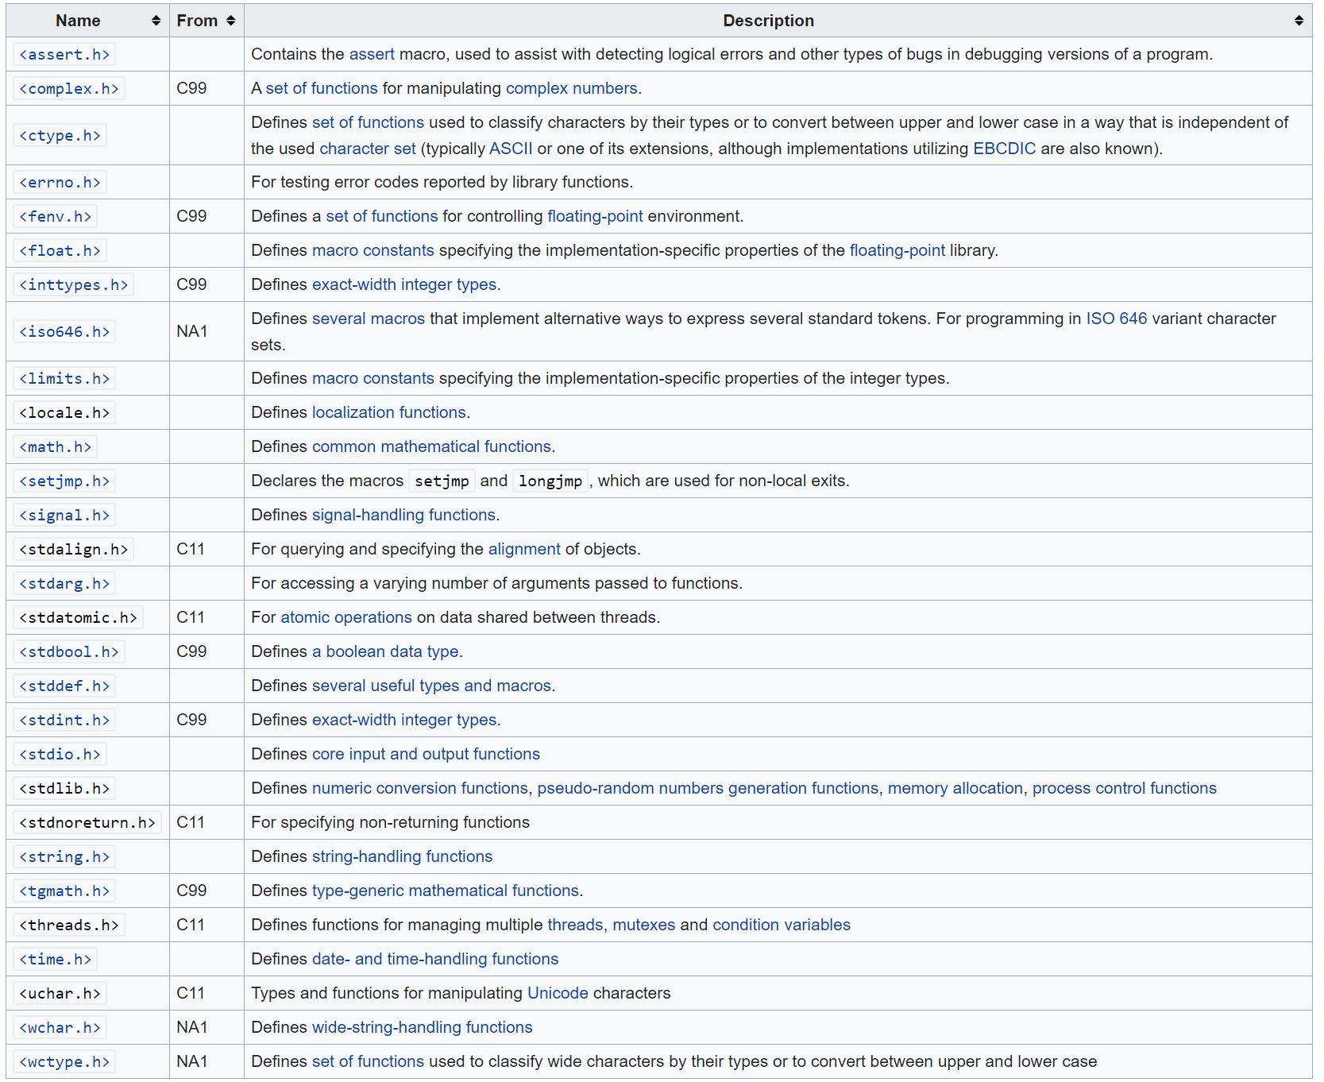
Figure 1 All libc .h files
In other words, for us to be able to use the stdio.h file in our code, we must have the libc/glibc library installed on our pc. Virtually all computers will have this library by default, but for libraries which are not installed, you may install them with your package manager (on Linux) or online as an archive, and then copy them to /usr/lib/ in order for the library to be visible for all users on the system. To “include” (essentially import if you are familiar with Java or python) a .h file in our code, the keyword ‘include’ is used in conjunction with the special symbol # which we’ll go into more detail on later. For example: #include <stdio.h> where the <> braces signify that the library either exists in /usr/lib or /lib. The main function in C is aptly named ‘main’ and the compiler expects this function to exist. Similar to Java, we must declare the return type of each function. main() should return an int indicating the exit status of the program. It is good practice to return 0 at the end of main, as it should never throw any errors.

Datatypes

Data types in C are sort of strange, but you must understand that a primitive programming language will have primitive datatypes. For example, Strings do exist as their own unique data type (since you should know it is an object/reference type ie. non-primitive), char is part of the integer family since C reads chars by their decimal ASCII value, Boolean doesn't exist since 1 and 0 are sufficient for true and false respectively (though enums exist for assigning a continuous set of integers to multiple variables), arrays are viewed as a collection of variables of the same type residing next to each other in memory (contiguously), void exists, pointers are something nearly all languages use under the hood but they are most prominent in C, function return types exist, structure types exist (sort of like an object but not identical) and union types exist. We will look at all of these in time. C places a large emphasis on integer types and pointers since they are capable of accomplishing most tasks. By default, integer types (aside from char) are signed but also have unsigned counterparts. Here is a table describing the storage size and value range of each integer type.

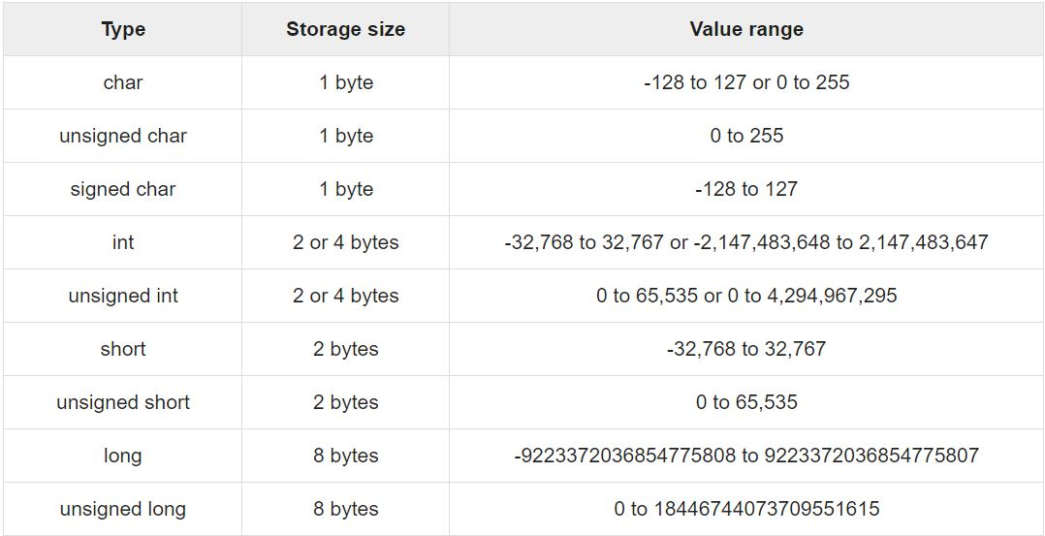

In professional C code, you will often see explicit declarations for signed and unsigned, and this is because a lot of these values are platform dependant. When no keyword is given, the variable is always implicitly signed. On the other hand, unsigned variables should always be declared as unsigned (please note that certain floating-point integers must be signed, such as float or double, but not long). Another side note about C that we will look into later is that char variables are really just unsigned integer values (0 - 255) which have corresponding ascii symbols. For this reason, a char can be represented with the int type and vice versa. Typically, it is recommended to use char to refer to a character literal and int to refer to an integer literal, however, casting between the two is a common occurrence in C when we deal with character manipulation so keep that in mind.

Functions

There is not much to discuss about functions but there are a few things to note. First of all, functions should be declared before their bodies are “initialized” ie. populated with code, or called ex. int returnNum(int i); This is sometimes called a function ‘prototype’ and consists of the functions signature (return type, name, and parameters). If the function prototype is not included before the function body, the compiler will give a warning. Although not an error, omitting the prototype can lead to unexpected behaviour so it is recommended to practice writing prototypes prior to creating the actual function. If a function does not accept parameters, it should use void as a parameter ex. char acceptNothing(void); This is not the same as char acceptNothing() because the former will under no circumstance accept arguments, whereas the second prototype takes an unspecified amount of arguments. This means that the compiler will successfully compile without any warnings if you pass an argument to a function that does not have void as it’s parameter. Functions that do use parameters should have their parameter's datatype defined in the braces, as you would in Java. One last note is that function overriding is not something that exits in C, as it is not an OOP language and polymorphism was not a consideration. In other words, every function must have a unique name (although there are ways of mimicking function overloading which we will discuss later).

Integer Literals

Decimal: a simple number ex. 54
Octal: Begins with 0 and must be a valid octal digit
Hexadecimal: begin with 0x or 0X
Unsigned int: Ends in u

Note that unfortunately there are no binary literals. There are ways of mimicking binary values in C, but because there are varying methods, and because they are not real data types in C, I will let you look those up if you require their use.

Floating-point Literals

Double: Any number with a decimal 45.6
Float: Floats must end in f, otherwise double is assumed ex. 12.56f
Long: Ends in l
Unsigned long: Ends in ul

#define and const

In C we can create what are called macros using #define. Keywords that begin with a hashtag ‘#’ are known as preprocessor directives. Preprocessors are part of the compilation process but are ran before the program is actually compiled. #define is one such preprocessor directive which are used for defining macros, as I already stated. Macros can be thought of as a general purpose name given to either a value (akin to a variable), or to a lambda function (a tiny throw away function). This is useful for say, booleans. Macros should be written in capital letters by convension, the assignment operator is heavily discouraged (=), and you should not use a semi-colon to end the statement since macros are normally limited to one line ex. #define TRUE 1. In order to have multi-line macros, we use a backslash ‘\’ at the end of the line before going to the next. Multiline macros would apply to the lambda functions which I discussed earlier. There are user-defined macros and system macros, and this sort of the case for all operating systems (for example, Windows has environment variables which serve the same purpose as macros). The most commonly used system macro in Linux is NULL, which represents 0. Because NULL is a macro, it is always capitalized, and writing it as ‘null’ is an error (unlike Java where null is not a macro and can thus is case-insensitive). If you are familiar with languages like JavaScript or Python, you probably know that const refers to a variable which is unable to be altered. This is also similar to the final keyword in Java. You may also use the word const in C, however this raises much confusion for new C programmers, as they tend to question what the difference between macros and const variables is. There are 3 primary differences between a macro and const: Firstly, the constant variable will have a datatype, whereas macros are interpreted during recompilation, and are therefor dynamically typed. Secondly, constants reserve a location in memory, whereas macros are local literals ie. they don’t take any memory space as they are expanded during runtime. Finally, executing code libraries can potentially change the value of a constant at runtime even though they should not be updated. This is why, for example, you cannot define an array with a constant int as it’s length. const is generally preferred over macros though macros exist for a reason, so don’t completely disregard them. When it comes to using macros as functions, things get extremely messy, which is why they can only practically serve as lambda functions, and not full-blown functions with complex logic. Since all variables passed through a macro function are expanded at runtime, this leads to arithmetic errors. To prevent this we enclose everything in brackets, however, the more variables and logic that you introduce, the more brackets you bring in, hence the messiness. I will not provide examples here, as if you really need to use macros as functions, there are much better explanations elsewhere; but I did feel that it was important to bring them up as you will see them whilst reading other people’s code.

Scope

There are 5 different keywords we can use to define the scope of a variable. These 5 words are: auto, global, register, static, and extern. Don’t take these for granted, it is important that you understand when it is appropriate to use these keywords and why.
auto: If you happen to have learned C++ prior to C, you may be familiar with the keyword auto, however, the auto keyword in C++ and auto in C have completely different meanings and ought not be confused! auto in C is the default scope given to a variable declared in stack space, that is to say, variables which are local to a function. Since auto is assumed for all variables declared within a function, there is really no practicality to explicitly declaring a variable to be auto. I’ve never seen it done personally at least...
global: Hopefully you have a better idea of what global is used for. If not, it’s used for variables declared on the heap, ie. outside of functions. These are accessible by any function at any time. However, keep in mind that scope exists to avoid bugs in your code, so we really want to avoid using global whenever we can. Plus they take up heap space which can be costly, whereas macros are also accessible anywhere at anytime and don’t take up space in memory which is why macros are a good alternative. I only like to use global for variables which are constants and need to be accessible by almost every function.
register: This is an interesting one. Register denotes a variable which should be stored in one of the CPUs registers for fast access as opposed to RAM. This should be used for variables which need quick access such as counters (though people rarely use register in practice unless you need the absolute most speed out of your program). Variables declared with register do not have a memory address, and this is important because it means that register cannot be used on pointers. Also, a very important thing to note is that assigning register to a variable does NOT mean that the variable will indefinitely go to the register, only that your system will try its hardest to place it in a register if possible. This is limited to how many registers the system has, and what is currently in use/taking priority.
static: Once again, static does not really mean the same thing that it does in OOP languages. Whereas in OOP static means that the variable belongs to the class and is not considered an attribute/instance variable, in C, static is used for variables that should be kept in heap space. Despite the keyword global existing, static is actually the default keyword used implicitly for global variables. Unlike global however, static can be explicitly used on local variables so that they don’t get destroyed after the stack pointer returns from a function. In other words, a local variable using the static keyword remains intact for the program’s lifetime. We tend to use pointers over static, making it and global somewhat obsolete.
extern: Arguably the most important one out of the list of 5 is extern. This keyword is used for variables that should be accessible to all object modules. An object module is essentially the object files we discussed earlier (.o). Since the compiler is able to combine object files into one executable file, we can in fact have variables that can be accessible to any file in our program. extern variables are unique in that they cannot have a definition, only a declaration. They only point to an already existing variable with the same name and reside in header files. For example, if in my main.c file i declare and define a variable: int number = 6; then in my header file main.h, I can declare extern int number; and now number is accessible to any other files that I create. Generally, it is best to pass arguments to functions to avoid bad code so use extern with caution.

Operators

Operators are the same as you would expect and should be familiar with so I will not be covering those here. There are two operators which we will use commonly in C that we have not used in Java and these are the address operator (&) and the dereference operator (*). Variables do not exist as a unique entity. Instead, a variable is really a fancy way of describing some data such as the number 5 and it’s location in memory. In other words, the variable name that you write in your code is really just a label interpreted by the compiler as an address which contains some data. The address operator is used to return the address of a given variable ie. &someVariable. You may have heard of the term ‘reference’ such as a ‘reference variable’. In object oriented languages, this term is interchangeable with objects ie. an object is a reference and vice versa. In C, it is better to think of the word reference interchangeably with the word “address”. The dereference operator is then the means to reverse the effects of the address operator. In other words, there is a 1:1 key->value pair between addresses and variables. ‘&’ returns the address/reference of a variable, and * returns the value associated with an address. If you were to use both of these together ie. *&someVariable; their effects would cancel out.

Pointers

Now we reach the real meat and potatoes of C: pointers! Tying in with what I just discussed in the operator section, a pointer, as was briefly mentioned will be declared using the * symbol, so int* means pointer to an int and char* means pointer to a char, etc. Pointers must have a datatype and must point to a valid address (ie. one that contains a value of the same datatype). You can think of pointers as a form of transportation. While they are technically variables, they always contain addresses and act as a passage towards another variable. It is good practice to declare pointers as NULL if an address is not assigned right away. This will prevent accidental pointer exceptions. As you know, the & symbol returns the address of a variable, and this is primarily used for pointers. A regular variable cannot store the address of another variable since addresses are represented as hexadecimal literals (not the same as an integer). In other words, in order to access the address of a variable, we can either use the & sign to reference the original variable’s address, or we can output the value stored in our pointer variable (the address of the variable the pointer is pointing to). The dereference operator (*) acts as a sort of key:value return feature. By dereferencing a pointer using the dereference operator ‘*’ before it’s name, we return the value associated with the address stored in the pointer variable. In other words, the pointer variable borrows the address of another variable of the same datatype, and the dereference operator returns the value stored in sed address. Here is a script which will print the address of a variable var, the address held in a pointer ip (which points to var), the value associated with the pointer ip's address and the address of the ip pointer. Ex.

int main () {

int var = 20; /* actual variable declaration */
int *ip = &var; /* store address of var in pointer variable*/

printf("Address of var variable: %p\n", &var);

/* address stored in pointer variable */
printf("Address stored in ip variable: %p\n", ip);

/* address of the pointer variable itself */
printf("Address of ip pointer: %p\n", &ip);

/* access the value using the pointer */
printf("Value of *ip variable: %d\n", *ip);

return 0;
}

Output:
Address of var variable: 0x7ffcf2676b1c
Address stored in ip variable: 0x7ffcf2676b1c
Address of ip pointer: 0x7ffcf2676b20
Value of *ip variable: 20

Notice that in printf we use %p for the address of &var since & points to the address of the variable. %p is the format specifier for a pointer address. In the last printf, we enter *ip since we want the value that ip is pointing to as opposed to the address it is storing (which would just be ip without the asterisk).

If you thought that was confusing, please make sure you understand the basic concept and write out the code above for yourself because I am going to be addressing even more about pointers now. To start, it may already be a question in your mind, whether or not we can have pointers to other pointers; and the answer is yes, we can have an infinite number of pointers pointing to other pointers. It is very important when looking at pointers to take their syntax one step at a time and remind yourself of what a pointer is actually doing. If we declare a pointer: int *p1 which is set to the address of variable x: int *p1 = &x; we know that p now stores the address of x, and by dereferencing p1, we return the value associated with the address of x. We also know that p1 has its own address (it is a variable after all, and all variables are stored somewhere in memory). Therefore, we may declare pointer int **p2 which stores the address of p1: int *p2 = &p1; and so by dereferencing p2, we get the value associated with p1’s address, which happens to be x’s address. Notice that we declare int **p2 with the appropriate number of asterisks so that we know it is a double pointer. This number increases as we continue to add pointers to pointers. We can now return the value of x by dereferencing p2 twice ie. printf(“The value of x is: %d”, **p2); In other words, you can think of pointers to pointers as layers of an onion, and as we dereference them, we get closer and closer to the center. While double pointers have certain use-cases, it is unlikely that you would ever need/see a triple pointer or beyond, though it is not impossible, and I have had to use a triple pointer once, personally.

Arrays

An array in C is defined as follows: int arr[10]; with 10 being the size of the array (normally required). If the initial data is known to us, we can omit the size field and simply fill in the values within curly braces. ex. double arr[] = {21.3, 2.7, 99.65, 1.6754}; The size of an array initialized like this will be set to the number of variables within the curly braces and ignore whatever number is placed in the square brackets if you do so choose to include a number for clarity. Additionally, in most versions of C, we are unable to set size via a variable ex. int arr[size]; This also applies even if the variable is declared as constant. Whilst the const keyword prevents a variable from updating during runtime, at compile time the const variable’s value is still unknown, thus we cannot use it to initialize the size of an array. This is an extremely frustrating aspect of C, and therefor you should get it in your head early on that you cannot use a variable to set the size of an array. The best way to get around this is to use macros, otherwise you will be forced to create a pointer array. In C it is important to think about arrays differently than we would in Java. arr, &arr and &arr[0] all refer to the first index of the array aka the same address in memory, though there is a huge caveat, and this is likely one of the most confusing aspects of C that I am not looking forward to explaining as I don’t want to get this wrong. arr, &arr, and &arr[0] are treated differently depending on the circumstance even though they all technically refer to the same base address. Typically, however, arr on its own refers to the array itself, ie. the entire contiguous chunk of memory reserved for each element. For example, to get the length of an array, since there is no .length attribute, we typically do: int len = sizeof(arr)/sizeof(arr[0]). Since sizeof() treats arr as the entire chunk of contiguous memory, it will be equal to the number of indexes times the size of the array’s datatype eg. 10 * sizeof(int). sizeof(arr[0]) will just be the size of the element at index 0 which just = sizeof(int). Therefor, dividing 10 * sizeof(int) / sizeof(int) we get 10. On the other hand, if we add an offset to arr by itself, such as 3, C interprets this as taking the base address of the array and adding 3 * sizeof(int) to it, even though you might think it’d add 3 * 10 * sizeof(int). This is essentially how the index operator ([]) works. When we place an index in the index operator, we are actually just telling C to add that offset to the base address of the array and then dereference that address to return the value of that element. eg. int arr[] = {1, 2, 3, 4}; printf(“The third element is %d\n”, *(arr+2)); will print 3 since we take the base address of arr, add 2 * sizeof(int), then dereference that address. The same would work for *(&arr[0]+2), but would not work for *(&arr+2). The later would actually do what I mentioned earlier and add 2 * nElements * sizeof(int) You will need to simply keep a reference on you as you first start coding, or write an example program or two to see all the nuances of arrays. As you practice coding in C, you will realize the major similarities between pointers and arrays, and that’s because they are essentially the same thing, and this is crucial to remember. In fact, it is not required to ever use arrays in C, as you can always allocate a block of memory, point to that block’s start address, store variables in it, and offset the pointer by the correct amount to reach the data you want. THIS IS WHAT ARRAYS ARE!! Arrays only exist for convenience, so keep that in mind as you use them.

Pointers to Arrays

Now what about pointers to arrays? Yes, those are a thing too. I explained in the array section before this that by using the array’s name by itself, we get the address of the first index of the array, which also happens to represent the array itself, as a whole. By setting a pointer of the same datatype of an array equal to the address that the array starts at, we can simply use pointer arithmetic to jump to the appropriate address and dereference it.

ex:
int main(void) {
int arr[] = {2, 4, 6, 8}; /*Let’s say arr begins at address $1000*/
int *ptr = arr; /*ptr now holds the address $1000*/
printf(“Value at index 2 is: %d\n”, *(ptr + 2)); /*prints 6 since we jump 2 addresses and then deref
return 0;
}

Notice that in the printf statement when we add 2 to pointer, the compiler recognises we are performing arithmetic on a pointer, and thus we add 2 * sizeof(int) to the address, making it $1002, and then dereference the address to get the value (6). The last thing that I should mention about pointers is what are called function pointers. This is probably the weirdest part about pointers, but as we’ll come to discuss, functions also have addresses in memory (specifically in a portion of memory called to stack) and the cpu jumps to these function addresses when a function is called. Since we know that pointers are all about storing addresses, we can naturally point to functions. This is neat because we can pass functions as parameters using function pointers. The syntax for this is strange though, because we must cast each and every parameter to the pointer as well. The type of the pointer must match the return type of the function. Please also note that the brackets surrounded the pointer matter. Here is some sample code to examine:

#include <stdio.h>

void fun(int a, char b, long c);
void fun(int a, char b, long c) {
printf("Value of a is %d value of b is: %c value of c is %ld\n", a, b, c);
}

int main(void) {

void (*fun_ptr)(int, char, long) = &fun; //pointer to function
//void (*fun_ptr)(int, char, long); These two lines are equivalent to the above statement
//fun_ptr = &fun;
(*fun_ptr)(10, ‘b’, 234456476); // call the function via the pointer with matching arguments
return 0;
}

2D-Arrays

You should be aware of how 2D arrays function under normal circumstances, which is why I will be talking about 2D arrays in regard to pointers specifically. As we now know, we can look at arrays as a set of contiguous blocks of memory (based on datatype), containing some value. We also know that by adding to the base address of the array, we add the entire length of the array to itself because of how C adds according to the datatype of the variable in question. By adding 1 to the array, we end up at the beginning of the memory address proceeding the end of the array since we’re really adding 1 * nElements * sizeof(datatype). Now think of an array of arrays, not as a 2D grid, but rather a 1D line and how that would really just look like a contiguous set of arrays smooshed together. In order to “go down a row” (fancy talk for accessing the next array), we add 1 to the array like I mentioned. Then, in order to advance in the columns, we add the offset to the address of the array we jumped to. This might sound confusing but study the code I have provided here:

main()
{
int i, arr[3][4] = {{10, 11, 12, 13}, {20,21,22,23}, {30,31,32,33}};
int (*ptr)[4] = arr;

printf("%u %u %u", ptr, ptr+1, ptr+2); //Output (if ptr = address 5000): 5000 5008 5016
printf("%u %u %u", *ptr, *(ptr+1), *(ptr+2)); //Output (if ptr = address 5000): 5000 5008 5016
printf("%d %d %d", **ptr, *(*(ptr+1)+2), *(*(ptr+2)+3); //Output: 10 22 33
printf("%d %d %d", ptr[0][0], ptr[1][2], ptr[2][3]); //Output: 10 22 33
}

In the second last printf() call we output *(*(ptr+1)+2); Think long and hard about what is happening here. ptr is a pointer array, that is to say, an array filled with pointers of type int. If it were simply an int pointer, the datatypes would be incompatible, but by creating a pointer array which has the same number of indexes as columns in the array, we set each pointer contained in the pointer array equal to the address of the corresponding value in arr. ptr itself is set to be the address of arr. Effectively, we have created a duplicate array. Now by adding 1 to the ptr, we are really adding 1 to the address of ptr, which happens to be the address of the array as a whole ie. we are advancing in row count towards the second set array. We then dereference this, and this is because again, the pointer contains only the array address which is a reference type ie. it’s value is an address (hence why to get index arr[0][0] we use a double pointer, to dereference the address of the array which returns the address of its first index, which when dereferenced gets our first element. This is also equivalent to typing *(*(ptr+0)+0)). We get the address, add 2 to it (which is our offset in columns), and then dereference that. Keep in mind that the same applies for normal 2D arrays, not just pointers. Notice that in the code, when we declare ptr, we must surround the pointer part in brackets. This is because the index specifier takes precedence over the dereference operator. In other words *int[5] = *(int[5]) which would dereference the value of a regular array at index 5 rather than creating an array containing int pointers. The brackets are not a cast to an int pointer, but rather, are simply there for precedence reasons.

It should also be quickly noted that an array of strings is considered a 2D array because a string is an array of characters. If you wanted a 2D array of strings, it is easier to simply have a 1D array of strings and pass the appropriate offset through your function to jump to the “next row” which would only exist as an imaginary boundary. Otherwise, you begin to deal with 3D arrays and that is not ideal.

Pointer Precedence

I mentioned before that certain actions take precedence when operating on pointers. For example, pre- and post-increment/decrement operators have varying relationships with the dereference operator. You may know that postfix operators have precedence over unary operators and so, something such as *x++ would be parsed as *(x++). In the case that two unary operators such as the pre-increment/decrement operator and the dereference operator were put together; the compiler would read them left to right. For example, *++x would be read as *(++x) and ++*x would increment the value of the dereferenced pointer x, or in other words, ++*x = ++(*x).

Strings

A string in C, while not a real data type, can be created in a variety of ways. The classic example of creating a string in c is by using an array of characters ie. char greeting[6] = {'h','e','l','l','o','\0'}; The null character ‘\0’ or simply ‘\’ indicates the end of a string and is required by the compiler (although this method is not at all practical). A simpler alternative to this is to create an array and have the compiler interpret a given string as a ‘String literal’. A string literal is perhaps an odd concept to grasp, but in essence it is as it sounds: A literal representation of a string. They are surrounded in double quotes “”, are appended with our null terminator (‘\0’) automatically ex. greeting[] = “hello”; The difference between an array of chars and a string literal is simply in how they are interpreted. An array of type char should be used as such, and a string literal should be used as if it was one unit (a string). As I mentioned, arrays and pointers are practically identical, thus you will often see pointers to string literals as well. For example: char *s = "I am considered a string"; The first method of declaring strings is almost never used, whereas the second method is common in structs and buffers, and the third method is commonly used for print statements or string comparisons (these are just conventions however, and the latter two methods can pretty much be used interchangeably depending on whether you want dynamic sizing and sacrificing memory, or a static size that only occupies the length given to the array). Pointers always occupy more space than the datatype of the value they point to. In the case of strings, the first two methods of declaration occupy 6 bytes on modern hardware, whereas the pointer occupies 8. The format specifier “%s” in printf expects a string literal value and thus, does the dereferencing for us for both the array version and pointer version (no dereferencing required). In order to modify the content of a char pointer to a string literal, we can simply use ‘=’ as you would do in Java ie. alterme = “newstring”;. Arrays cannot be altered like this, however, therefor we must use a function from the string.h file called strcpy in order to modify an array of string literal. Ex. strcpy(arr_alterme, “newstring”); strcpy copies the string literal provided as the right-hand argument into the array in the left-hand argument. If you wanted to get a specific character from a string you can index both the array version or const char pointer version. You can dereference either and then add the offset value to get the character at that position ie. printf(“%c”, *(alterme+2)); output: t, or printf(“%c”, *(arr_alterme+2)); output: t. As I mentioned Strings have their own header file, <string.h> (also from libc) which includes methods such as strcpy() for copying one string into another, strcat() to concatenate two strings, strlen() to return the length of a string in bytes - 1, strcmp() to compare the equiveillance of two strings, strchr() to return a pointer to the first instance of a given character within a string, and strstr() to return a pointer to the first occurrence of a string within a string.

Structures

Here is an interesting portion of the C language! A structure is a collection of related data. It is often compared to an object in OOP, but just keep in mind that C is not object oriented and therefor, shouldn’t always be compared to OOP languages (hypocritical coming from the guy comparing Java to C at every opportunity). It is really a list of variables that may have differing datatypes. In fact, structs are very similar to arrays in C, in that each field is stored sequentially. We can perform arithmetic on pointers to structs to get the structs next or previous field(s). Here is an example of a struct ‘Books’:
struct Books {
char title[50];
char author[50];
char subject[100];
int book_id;
};

And then create an object of type struct Book:

struct Books HarryPotter;
strcpy(HarryPotter.title, "The Chamber of Secrets");
strcpy(HarryPotter.author, "JK. Rowling");
strcpy(HarryPotter.subject, "Fiction");
HarryPotter.book_id = 23423455;

To access the value of a structures element, we can simply use the dot operator ex. printf("Author: %s\n", HarryPotter.author); Things get stranger with pointers however. To create a pointer to our Books structure we would naturally declare it as: struct Books *struct_pointer; We can then store the address of a child structure in this pointer ex. struct_pointer = &HarryPotter; To access the members of a structure using a pointer, we use an arrow operator ex. struct_pointer->title; which would be the equivalent of typing (*struct_pointer).title; In other words, the arrow operator is like the dot operator, only if dereferences the reference before applying the dot. Here is some example code:

#include <stdio.h>
#include <string.h>

struct Books {
char title[50];
char author[50];
char subject[100];
int book_id;
};

/* function declaration */
void printBook( struct Books *book );
int main( ) {

struct Books Book1; /* Declare Book1 of type Book */
struct Books Book2; /* Declare Book2 of type Book */

/* book 1 specification */
strcpy( Book1.title, "C Programming");
strcpy( Book1.author, "Nuha Ali");
strcpy( Book1.subject, "C Programming Tutorial");
Book1.book_id = 6495407;

/* book 2 specification */
strcpy( Book2.title, "Telecom Billing");
strcpy( Book2.author, "Zara Ali");
strcpy( Book2.subject, "Telecom Billing Tutorial");
Book2.book_id = 6495700;

/* print Book1 info by passing address of Book1 */
printBook( &Book1 );

/* print Book2 info by passing address of Book2 */
printBook( &Book2 );

return 0;
}

void printBook( struct Books *book ) {

printf( "Book title : %s\n", book->title);
printf( "Book author : %s\n", book->author);
printf( "Book subject : %s\n", book->subject);
printf( "Book book_id : %d\n", book->book_id);
}

Output:

Book title : C Programming
Book author : Nuha Ali
Book subject : C Programming Tutorial
Book book_id : 6495407
Book title : Telecom Billing
Book author : Zara Ali
Book subject : Telecom Billing Tutorial
Book book_id : 6495700

Additionally, we can declare a new struct using curly braces, similar to how we are able to declare arrays with curly braces, assuming we know the data that we want for each field in the struct. Ex:
struct Book Book3 = {“Newtonian Physics – 1st Edition”, “Isaac Newton”, “Physics and Math”, 12345};
If you had an array of structs, you could simply surround a collection of declarations similar to the one above in curly braces, and comma separated, as you would with a 2D array ie. {{}, {}, {}} This logic even applies to the return statement. If the return type of a function func was a struct, we can return our curly brace notation and then when we call our function, set a pre-declared struct equal to the return value/output of func.

A struct containing a struct as one of it’s fields/members is called ‘nesting structs’. If you nest a struct of type ‘x’ within itself, this is called a self-referential struct, similar to a self-referential class in Java. For example:

struct Student {
int id;
};

struct Course {
char *courseCode;
struct Student student; /*Nested struct*/
};

Here we have a Student struct declared within a Course struct. If we were trying to access the student id within a Course struct, we would use the dot operator twice. For example:
struct Course cst8123;
cst8123.student.id = 1245;

Now let’s say that the student field was a pointer to a Student struct:

struct Student {
int id;
};
struct Course {
char *courseCode;
struct Student *student; /*Self-reference*/
};

struct Course cst8123;
In this case, you would retrieve the id field using a combination of dot and arrow eg. cst8123.student->id = 1245;

Namespaces and typedef

I am going to now try and explain what namespaces are and how they are relevant. As of writing this, I am still a student and can’t say this with 100% certainty, but as far as I know, most programming languages if not all use namespaces. In essence, namespaces are a way for the compiler to keep track of scope. It is like a list of all the variable labels, function labels, and struct labels that exist in the program (keep in mind, labels are the names we give define in our code that the compiler reads as addresses). If we write the same function name twice, the compiler detects a duplicate label in the namespace and thus gives us an error since we cannot store two things in the same address. Java and C++ get around this when we ‘overload’ methods because the labels in those languages include the parameters as part of the label ie. the method/function signature, whereas C only takes the name as the label. Anyways, in C, namespaces are pretty much relevant for 2 reasons: typedef and struct instances. typedef is a keyword in C used to define “new” datatypes. I put parentheses around “new”, because really, typedef is used to create aliases that are then stored in the namespace. For example: typedef unsigned char byte; In this example, unsigned char is the input datatype, and byte is the alias that we have added to the namespace. Now, something I have yet to mention about namespaces is that in C, there is one namespace for program data (function, variables, types, keywords), and one namespace for structs, and they are completely independent of one another (therefor we can define a function func, and a struct func and have no issues). Things get infinitely more confusing when it comes to structs and namespaces. The syntax for a struct as I have shown is: struct <struct_label> { <members> }; However, I saved a detail for this section which is that you may have an optional ‘instance’ of a struct which gets added to the struct namespace: struct <struct_label> { <members> } [instance]; So the way that I look at this to make sense of it is that the first part: struct <struct_label> are dependant on each other and cannot be separated, thus you can think of them as the datatype. The members are similar to how an array functions in that you have members within a block of memory, only with structs, they can be of differing datatypes. The instance is like the variable name, and you may define multiple instances exactly as you would define multiple variables of the same datatype eg. int a,b,c; or struct mystruct {data} a,b,c; The most important thing is just to remember to think of ‘struct mystruct’ as the datatype. Following me? Cool, because now we introduce typedef again. By placing typedef in front of the struct keyword, we really do one thing: instances now become aliases for the struct. This means that we can omit the struct keyword each time we define a new struct of type mystruct, and simply use a, b, or c as the datatype instead ie. a newstruct = {<members>}; Here is some code that will show you every valid way of declaring struct:

/*******Using only struct keyword******/
//Example 1: struct with label but no instance
struct mystruct {
int item1;
char item2;
};

//Example 2: struct with instance but no label
struct {
int item1;
char item2;
} instance;

//Example 3: struct with both label and instance
struct mystruct {
int item1;
char item2;
} instance;

/******Using typedef and struct******/
//Example 4: typedef with instance but no label
typedef struct {
int item1;
char item2;
} instance;

//Example 5: typedef with both instance and label
typedef struct mystruct {
int item1;
char item2;
} instance;

Try to bear with me as I attempt to explain these 5 examples:
- In example 1, we declare a struct with a label/name but no instance. A struct declared like this is added to the program namespace, but not the struct namespace. This means that the struct is accessible anywhere in our program including within the struct itself. All we need to do to create an instance of it is say: struct instance = malloc()/{members};

- In example 2, we declare a struct with no label but with one instance. The instance is added to the struct namespace, but the program has no knowledge of it’s existence. We cannot make a self-referential struct using this method, and there may only be one instance of it. The only way to use it is by using it’s singular instance eg. struct instance_name newstruct = malloc()/{members};

- In example 3, we declare a struct with both label and instance. This is identical to the first method only now we have predefined instances/variables which are ready to be operated on

- In example 4, we create a struct with an instance but no label and additionally adding typedef. This means that the label is used as an alias for the datatype rather than as a variable. The only way to create an instance of this struct is by using the alias as the datatype eg. alias_name newstruct = malloc()/{members}; where the struct keyword may now be omitted. You cannot create a self-referential struct in this manner.

- In the final example, we create a struct with the typedef keyword as well as both label and instance. In this manner, the struct can be created in any way you wish with every benefit. It may be created by using the label name ie. struct label_name newstruct; or it can be created using the typedef alias: alias_name newstruct; and on top of that it is able to be self-referenced.

Unions

Unions are the same principle as structures. The difference between the two is that a struct allocates memory for each field that it contains, whereas a union can store multiple variables of varying types into one memory location. This causes issues however so it must be used properly. The size of a union will be the size of it's largest member. This means that if I define a union:
union Data {
int i;
float f;
char str[20];
}

then the size of Data will be 20 bytes since the array is the largest item in our union and is 20 bytes long. Another issue with unions is that their values may overlap if the programmer is not careful. For instance, using printf after the union is declared will overlap data and output incorrect values. Here is an example:

/*How not to use union*/
#include <stdio.h>
#include <string.h>

union Data {
int i;
float f;
char str[20];
};

int main( ) {

union Data data;

data.i = 10;
data.f = 220.5;
strcpy( data.str, "C Programming");

printf( "data.i : %d\n", data.i);
printf( "data.f : %f\n", data.f);
printf( "data.str : %s\n", data.str);

return 0;
}

Output:

data.i : 1917853763 /*wrong*/
data.f : 4122360580327794860452759994368.000000 /*wrong*/
data.str : C Programming

/* How to properly use union*/
#include <stdio.h>
#include <string.h>

union Data {
int i;
float f;
char str[20];
};

int main( ) {

union Data data;

data.i = 10;
printf( "data.i : %d\n", data.i);

data.f = 220.5;
printf( "data.f : %f\n", data.f);

strcpy( data.str, "C Programming");
printf( "data.str : %s\n", data.str);

return 0;
}

Output:

data.i : 10
data.f : 220.500000
data.str : C Programming

Unions are typically used when we want to represent two structs of differing types as one generalized union. Sort of how in object-oriented languages, the parent class of two children is a generalization of those classes, unions are often used to store 2 structs and reference the appropriate one depending on the circumstance.

Bit Fields

Suppose we declare a small variable like a Boolean for example where we don't need the entire length of the data structure. We can tell C to only use the required amount of memory space necessary using bit fields. For example:
struct {
unsigned int widthValidated:1;
unsigned int heightValidated:1;
} status;

This structure would normally require 8 bytes of memory space since an unsigned int takes 4 bytes of space on modern hardware. Only 2 bits will actually be used since each variable will store either a 0 or 1. You may then declare a struct containing 32 1-bit values but once this limit reaches an overflow, the 33rd variable is allocated to the next slot in memory and the structure will consume 8 bytes of memory so be careful.

#include <stdio.h>
#include <string.h>

/* define simple structure */
struct {
unsigned int widthValidated;
unsigned int heightValidated;
} status1;

/* define a structure using bit fields */
struct {
unsigned int widthValidated : 1;
unsigned int heightValidated : 1;
} status2;

int main( ) {
printf( "Memory size occupied by status1 : %d\n", sizeof(status1));
printf( "Memory size occupied by status2 : %d\n", sizeof(status2));
return 0;
}

Output:

Memory size occupied by status1 : 8
Memory size occupied by status2 : 4

Enums

You may have heard of the term enum before but not actually known what it meant. Well at the crux, enums are very simple to understand. They are a list of key:value pairs where the value is always an integer value, and will be p+1 where p is the previous value in the set. 0 is assumed to be the first value unless otherwise stated, so as an example, I could declare an enum as follows: enum colors{red, orange, yellow, green, blue, purp, magenta}; and this would assign red with 0, orange with 1, yellow with 2, and so on. If at any point I disrupt this by setting a value to something that would not be part of the natural ordering, then the following values will resume from there eg. enum days{mon=10,tues,wed,fri=14,sat,sun}; then mon will be 10, tues = 11, wed = 12, fri = 14, sat = 15, and sun = 16. This might not seem all that useful but using enums can set you apart from an average programmer to a professional one. Enums are useful for correlated items that require some sort of basic ID system to differentiate them. They obviously work fantastic in things like case statements.

Function Parameters

I figured that it would be helpful to dedicate a section towards explaining how we pass parameters in C, because this can get really messy and confusing if you don’t understand what’s going on. In C, we either pass arguments to functions using call by value, or call by reference, and this will depend on what you are trying to accomplish. We know that addresses are references to variables, and that they can be dereferenced using pointers. We also know that variables which are local to functions (at least ones declared with an automatic or register scope) are only temporarily in existence while the function is active. What I am getting at is that, if we pass a variable to a function using pass by value ie. passing the variable itself through the function, then when the function receives it’s value, it can only be stored temporarily, and thus does not affect the variable outside of the function. In other words, if I passed the variable x as an argument int a function foo(int x), and then added 5 to x inside foo(), x would not actually increment by 5. Rather, it’s local copy within foo() would. In order to actually increment x, we would be required to use pass by reference, in which we pass x’s address to foo, and have a pointer dereference it for us. That way, the value associated with the memory address stored in the pointer is incremented, ensuring that the original version of x is incremented. In order to do this, we make our parameters pointers, and we pass addresses as our arguments for sed parameters. Ex.

/* declare function with pointer parameters */
void addTwo (int *a, int *b);

void addTwo(int *a, int *b) {
*a += 2;
*b += 2;
}

int main(void) {
int a = 3;
int b = 8;
addTwoNumbers(&a, &b);
printf(“Value of a after func: %d | Value of b after func: %d”, a, b);
return 0;
}

printf will be 5 as the value of a and 10 as the value of b. When it comes to passing reference type variables as arguments such as strings or arrays, the logic is the same, but we must be careful to remember that reference types act differently than normal variables. I think it will be better to simply provide an example rather than explain the logic.

Ex.
#include <stdio.h>

void pass(char **s2, int arr[]);
void pass(char **s2, int arr[]) {
*s2 = "new and improved";
arr[0] = 4;
arr[1] = 5;
arr[2] = 6;
}

int main(void) {
char *s1 = "original";
int arr[] = {1, 2, 3};

printf("%s: %d, %d, %d\n", s1, arr[0], arr[1], arr[2]);
pass(&s1, arr);
printf("%s: %d, %d, %d\n", s1, arr[0], arr[1], arr[2]);
return 0;
}

Output: 0riginal: 1, 2, 3
new and improved: 4, 5, 6

Here we see that the array does not need to have the address symbol when passed by reference because we know that calling an array by name refers to the address of its first element. Strings on the other hand, need the address specifier when using pass by reference, but note that the parameter must be a pointer to a pointer since s1 is already a pointer to a string literal (recall what I mentioned in the String section). Just keep in mind that when we pass anything as an argument, we are setting the parameter equal to sed argument. With that in mind here is what is happening with our string:
1. s1 is a char pointer pointing to the address of the string literal “original”
2. its address is passed on to the pass function which is the same as saying char **s2 = &s1;
3. we dereference s2 and set its value = to “new and improved”.

Something that is not clear however, is that when we pass arrays as arguments to a function, they actually “decay” into a pointer. This means that it loses it’s type and size. This is not at all obvious, and is a very strange nuance of C. Here is a better description of what I’m talking about:
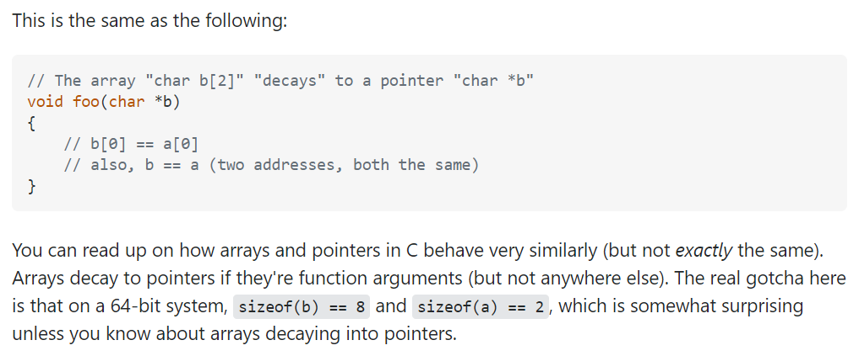
In other words, the parameter was originally (char b[2]), but when we pass the array as an argument, this really turns into (char *b) and thus if we take sizeof(b) we will get 2 rather than 8! For this reason, as well as many others, we try to avoid passing arrays as parameters in C, preferring pointers most of the time.

Passing 2D arrays as arguments to a function is in my opinion, a nightmare. There are a few ways of doing this. The first is if your compiler supports Variable Length Arrays (VLAs). This is a special case where your compiler is actually able to assign your array with a variable length at compile time, despite this normally being invalid. This is accomplished by entering the rows and cols as separate parameters. Function declaration eg. func(int rows, int cols, int arr[rows][cols]) { ... }. In my opinion this is just plain sketchy and breaks functionality because it’s so specific to the version of C you’re using as well as your compiler/system. The second way is with the dimensions pre-defined in the prototype. For 2D arrays, the first dimension is optional, thus the function could be written as func(int arr[4][5]) { ... } or as func(int arr[][5]) { ... } The array that you pass as an argument must match the rightmost dimension. Similar to how 1D arrays decay into pointers when passed as parameters, we can explicitly decay our 2D array into a pointer as well. eg. func(int (*arr)[3]) { ... } and then pass the 2D array in as normal.

Another example may be that we need to pass an array of structs by reference so that each element in the struct array that we passed is updated. In order to do this, we simply pass the array, since arrays are already reference types ie. the value they contain is an address, therefor we don’t need to use the address operator. The parameter for the function will be a pointer of the same struct type that the array is, and we use pointer arithmetic to advance our offsets in some loop. Here is the code:

struct Frog {
char color[10];
int lilypads_hopped;
};

struct Frog frogs[5];
initializeFrogData(frogs, 5)

/*Function declaration*/
void initializeFrogData(struct Frog *frogptr, int len);
void initializeFrogData(struct Frog *frogptr, int len) {
int i;
for(i = 0; i < len; i++) {
strcpy((frogptr + i)->color, “green”);
(frogptr + i)->lilypads_hopped = rand() %10;
}
}

So, in this example, we create a frog struct with two data fields: color and lilypads_hopped. We then create an array of type Frog and pass the array, and it’s length to the function initializeFrogData(). The function sets a pointer of type Frog, called frogptr equal to the first address of the array. We offset this address using i in the for loop, and then use the arrow operator to dereference the pointer and set it’s fields. Each frog will have green as its color and the line: (frogptr + i)->lilypads_hopped = rand() % 10; will set the number of lilypads_hopped = to a random number between 0 and 9. Two things to note with the way I’ve written this are that, while you will get random numbers, I never got into seeding which I won’t get into here, but basically, your random numbers will be the same every time you run the program unless you compile again (research srand() and rand() for more info). Secondly, the struct Frog should probably be placed in a header file and included in whichever file your functions are in. Other wise, it will need to be global which we generally like to avoid if possible.

Standard IO

As with most systems, standard IO is composed of stdin stdout and stderr. In C, there are many, many functions for IO streams. To summarize IO streams if you are unaware, you can think of a stream as a one-way tunnel through which we can either send data to the system or receive data. A stream must be opened to let data in or out and should always be closed after use to prevent data/memory leaks. In Linux/Unix systems, when the user enters some command into the terminal, the kernel stores the input into a buffer (a temporary array). This buffer can then be parsed accordingly (usually whitespace separates the command from additional arguments and the newline character when the user presses enter signifies the end of that command). There is also a system macro called EOF (end of file) which is a macro representing the value -1. EOF is used when characters are read in one at a time (this is called serial reading as opposed to parallel). Since characters are essentially an unsigned int, that means they do not normally have negative values, hence why EOF is -1. It should be noted that, frankly, C is pretty awful at interpreting user input (like really awful). Remember that keypresses on your keyboard are sending ascii codes to the OS which only interprets these as characters. Therefor, entering a number and having the compiler interpret it as such as typically a difficult process to perfect. As I stated, there are many, many functions for user IO in C and I will be discussing the most relevant ones. They all follow similar naming conventions: f typically means file or format, and s usually means string. Here is a list of the ones that we’ll be discussing and a brief summary of each one:

- getchar(void) – get the first character from the input buffer
- putchar(int c) – outputs character to stdout
- gets(char *s) – reads a line from input stream into buffer pointed to by s
- puts(const char *s) – outputs string s + ‘\n’
- scanf(const char *format, ...) – interprets all characters in buffer before ‘\n’ according to the conversion specifier
- printf(const char *format, ...) – prints to stdout according to how it interprets data
- fgets(char *s, int size, FILE *fp) – technically for file usage, though happens to be the best function for user IO in most cases. Reads size-1 characters from input buffer into ‘s’
getchar(void)
getchar will return the first character input to the buffer. As with the majority of functions that read from stdio, if this function is used in a loop, and the user enters a string, the string will enter the buffer and getchar will continue to read characters until the buffer is empty. This function sort of sucks because there is really no way to force the user to enter a single character. If you are okay with this function only reading the first character of the users input then it it is okay to use, although keep in mind that you will still have to check whether or not the value is an integer if you’re expecting a character.

putchar(int c)
putchar accepts a character as an argument and will print this character exclusively to stdout. This function is much easier to manage than the previous one since the programmer decides what gets passed when the function is called.

gets(char *s)
I didn’t actually want to talk about gets, just mention that it is deprecated in C99 and removed from C11 afterwards so don’t use it. I felt this was relevant because many programming tutorials out there will tell you to use gets, since they are not maintained. Luckily, most compilers will warn you about this.

puts(char *s)
Unlike gets(), puts() is not deprecated. puts() will send the given string to stdout, although this function is pretty much entirely overshadowed by printf() as printf can do this + more, however this option is specific to strings making it good if you want to print a title or something like that.

scanf(const char *format, ...)
scanf() is quite the hot topic in the C programming community if that’s what you want to call it. It accepts conversion/format specifiers denoted by the percentile sign following the appropriate character within a string literal as it’s first parameter. The second parameter is what’s called a variadic parameter which we will go over soon. Just know that it allows us to pass as many variables to the function as necessary. scanf reads from the input buffer until a white space character ‘ ‘ or newline ‘\n’ is encountered. It does this for each conversion specifier in the first argument, interpreting each string it reads by that datatype. An important thing to keep in mind is that scanf leaves any trailing newline or white space character in the buffer. This is an issue because the user must always press enter to submit the string they type in the terminal; thus the buffer almost always ends with a newline feed. If you were to use getchar() after scanf, it would return the stale newline feed that was left by scanf(). It is the common consensus that you should avoid scanf at all costs even though it is very convenient. It is deemed unsafe because you have no control over how many bytes it actually reads, it is simply left for interpretation. The best alternative seems to be fgets which we will get to shortly.

printf(const char *format, ...)
printf() is the classic method of printing text in C, and it is much better than scanf (there seems to be a trend with output functioning much better than input...) printf() functions relatively the same as scanf, although the conversion specifier letters vary in functionality mildly. %d is for integers, %c for characters, %s for strings, %f for float, %l for long, %ld for double, %p for address, %u for unsigned, etc. variables are given as arguments for each specifier, and they are interpreted accordingly. Use the man pages for differentiating the conversion specifiers of printf and scanf.

fgets(char *s, int size, FILE *fp)
We now arrive at fgets which is meant to be like gets() (deprecated) but for files. Fortunately, it works much better than gets(), which now grants a warning if used mentioning that it can be used for all sorts of malicious attacks. The difference? Simply that fgets will only read size amount of bytes. As this function is meant to read from a file, it’s last parameter is a pointer of type FILE which is a typedef of a system struct called _IO_FILE. As everything in Linux is a file, the 3 io streams are also files. We can pass stdin as an argument for this parameter and have it read from the user. It will read n-1 bytes from the stream and store them in a local buffer ‘s’ which we supply. This is great because we can read characters from the input buffer to an array that we create, and then parse this array before passing it to our string! As I mentioned, this should be used over scanf() wherever possible and while it is frustrating to use at times, it is your best tool for user input in almost all cases.

Files and I/O

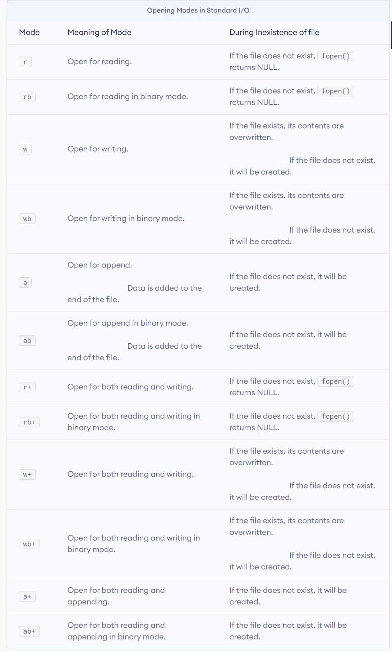
We just spent some time looking into user input/output in the previous section and now I’d like to discuss file IO. I previously stated that C does not handle user input very elegantly, however, it handles file IO much better. In fact fgets, the final function that we discussed in the previous section, is arguably the best function for user IO, and it is ironically meant for files. An important and interesting thing to note about files in C is that they can be read or written as two types of files: Binary or text. This should be rather straightforward; binary files are stored as binary data and are unreadable to humans (they also occupy less space), whereas text files are human readable files that translate bytes to ascii characters. Text is always assumed as the default for the functions we will look at. Each function requires a mode. These modes are either read, write, or append. A plus sign ‘+’ will indicate that an additional mode will be used later. This additional mode depends on the original mode. Here is a list of each combination of mode and what it means. Anytime you see ‘b’ it means interpret the file as binary.
You may have noticed that there is mention of a function called fopen(). This is of course how we open the stream for file operations. The true prototype for fopen is FILE *fopen(const char *filename, const char *mode); As you can see, it returns a pointer to a struct of type ‘FILE’ and it takes two strings as parameters: filename is the path to the file being operated on and mode is the mode as we discussed earlier. fopen will check the directory that your .c file is in for the argument given for filename. This means that you do not have to give the full path to the file if it is in the same directory as the .c file calling fopen. Let’s discuss the FILE struct, as this will most likely come up a fair amount. FILE is a typedef for a struct that our OS can understand. It contains the following fields:

char* _IO_read_ptr; /* Current read pointer */
char* _IO_read_end; /* End of get area. */
char* _IO_read_base; /* Start of putback+get area. */
char* _IO_write_base; /* Start of put area. */
char* _IO_write_ptr; /* Current put pointer. */
char* _IO_write_end; /* End of put area. */
char* _IO_buf_base; /* Start of reserve area. */
char* _IO_buf_end; /* End of reserve area. */

/* The following fields are used to support backing up and undo. */

char *_IO_save_base; /* Pointer to start of non-current get area. */
char *_IO_backup_base; /* Pointer to first valid character of backup area */
char *_IO_save_end; /* Pointer to end of non-current get area. */

Luckily, we do not need to remember these because our functions will handle updating fields internally. The process then for operating on a file is as follows:
1. Create a pointer of type FILE and set it equal to the return value of fopen.
2. fopen should accept the full path or relative path (if in the same directory level) for the file being operated on, as well as the mode string
3. You may optionally check if there was an error in opening the file by seeing if the FILE pointer is NULL eg. if(fp == NULL) {return 1;}
4. use fclose() to close the file stream once finished

This process is very similar to the Scanner object in Java, only we pass our FILE pointer as a parameter for each function that we use rather than using it to call methods. This should make a lot more sense in a second when we actually go over the functions for file IO similar to what we did for user IO.

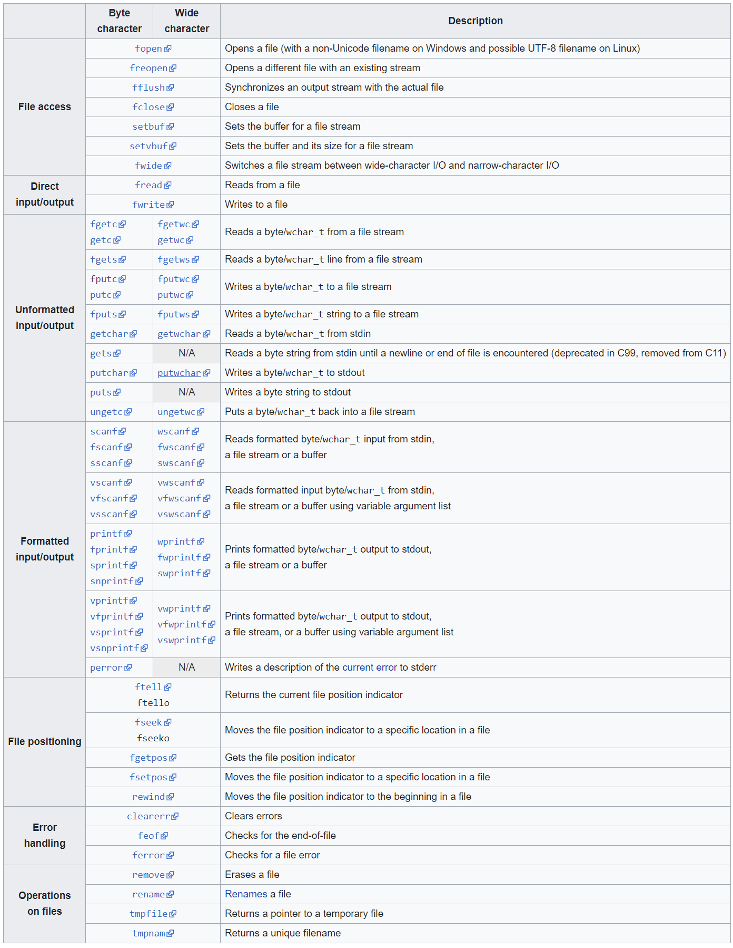

fopen(const char *filename, const char *mode)
We already discussed fopen but perhaps you are skimming through this document, so I have made it easier to find. fopen opens the file stream for reading/writing/appending to the specified file. The filename parameter is the full path of the file (or simply the name of the file if it exists in the same directory level as the .c file). The mode parameter should be a string specifying the mode of operation. By default, each mode will be interpreted as operating on a text file unless explicitly told to interpret the file as binary using the letter ‘b’ in the mode string. The function returns pointer to a struct of type FILE so you should always set a pointer of type file equal to the output of this function eg. FILE *fp = fopen(...).

fclose(FILE *stream)
fclose will close the specified file stream. By passing the FILE pointer returned by fopen, the file that was associated it with it will no longer be accessible unless re-opened. Generally, fclose should only be used when you are certain that you no longer need access to the file eg. reading data in through a file at the start of a program and never again throughout the programs lifetime.

fread(void *ptr, size_t size, size_t nmemb, FILE *stream)
fread is meant for direct reading from a file. It stores the data it reads into a buffer “ptr”. size_t, in case you wern’t aware, is simply a typedef for int defined in stdio.h, and simply adds clarity to the code. In this case we have two arguments of type size_t: size and nmemb. size is the size in bytes, and nmemb is the number of chunks of data to be read (each “size” bytes long). Finally, “stream” is the file pointer.

fwrite(const void *ptr, size_t size, size_t nmemb, FILE *stream)
fwrite is naturally the counterpart for fread. All of the parameters are the same for fwrite , only this time the function will write to the file rather than read from it. Unfortunately, there is no way with this function to specify where in the file you want to write to (same goes for fread), however there is a function we will look at in a while that will allow us to do this.

fgetc(FILE *stream)
fgetc means file get character ie. get a character from a file. This is essentially the file equivalent to getchar()). Instead of only taking input from stdin, fgetc expects a file pointer. Once again, positioning for reading will be handled by another function. The function simply returns an ascii decimal number or -1 if at EOF. Note that reading files one character at a time is often very efficient, despite the natural tendency to assume that this would not be efficient.

fputc(int char, FILE *stream)
Naturally, we need a way to output characters to a file so fputc is the obvious choice. The first parameter is the character to output and the second parameter will be the file pointer as always.

fscanf(FILE *stream, const char *format, ...)
The fscanf function is the file equivalent to scanf. This function can be used to read and interpret sets of characters as a specific data type. If you do not grasp this, it is very possible that you skipped over or forgot how scanf works and I’d recommend that you refer to that to understand fscanf (also the parameters should be pretty self-explanatory).

fprintf(FILE *stream, const char *format, ...)
fprintf is of course the same as printf, only now we are formatting the output that gets written to the file. The parameters work the same as they do with the File stream, format string, and parameters for the format specifiers.

perror(const char *str)
A function which is a bit more interesting is perror, which is actually really weird and I’m not super sure why it needs to exist. Essentially, it just lets you print a message before stderr is flushed so it will precede error messages created by the compiler.

ftell(FILE *stream)
At this point we’ve moved past file input/output and are now looking at file positioning. As I discussed, a FILE struct contains information about which byte it is currently on so it knows which character to read next. It is often used to get the size of a file in bytes so that we have a reference when using the next function: fseek.

fseek(FILE *stream, long offset, int whence)
The fseek function is a very useful function if you know how to use it. While ftell can tell us the position of the FILE pointer within the file, fseek can move the FILE pointer to a specified offset in order to begin reading or writing from that position. Another interesting part about fseek is that there are 3 macros included in stdio.h that can be useful for this particular function. These three macros are SEEK_SET, SEEK_CUR, and SEEK_END. In the order which I described them, these macros essentially mean: from the beginning of the file, from the current position being pointed to, from the end of the file. The offset parameter is the offset of bytes that we want to move the FILE pointer by from whence. This can be a negative value if you want to move the pointer backwards. whence is the reference position for offset. In other words, it is the starting point for the pointer before it moves ‘offset’ number of bytes. This is where you would use the 3 macros I defined: SEEK_SET, SEEK_CUR, and SEEK_END.
rewind(FILE *stream)
Another interesting and useful function is rewind. This sets the file pointer back to the beginning of the file specified. Imagine a scenario where a file needs to be continuously updated as the program changes. You will eventually need to start over from the beginning of the file so you can overwrite relevant information. This function is essentially identical to fseek(file, 0, SEEK_SET);

feof(FILE *stream)
The final function that I feel might be useful to you is feof. This function is typically used for error handling. It essentially just checks for EOF, the same as comparing the current character to the macro. It is really a matter of preference whether you think the syntax is cleaner or not.

Preprocessors

The C preprocessor (CPP) is not a part of the compiler, but rather a separate step in the compilation process. In simple terms, a C preprocessor is a text substitution tool which instructs the compiler to do required pre-processing before actual compilation. Preprocessor commands begin with # such as #define. Here is a list of each command:

#define: Substitutes a preprocessor macro
#include: Inserts a particular header from another file (a library).
#undef: Undefine a preprocessor macro.
#ifdef: Returns true if macro is defined.
#ifndef: Returns true if macro is undefined.
#if: Tests is a compile condition is true.
#else: The alternative for #if.
#elif: #else and #if in one statement.
#endif: Ends preprocessor conditional.
#error: Prints error message on stderr.
#pragma: Issues special commands to the compiler, using a standardized method.

Pragma Once and Header Guards

When it comes to the #include directive, we need to be careful. Including external header files in your source file may lead to an unoptimized compiling phase. Due to the fact that external header files can include other header files, it is very possible; almost innevitable, that we may end up accidentally including a header file that is already being included within another header file that we’re including. In this scenario, the linker will actually include (copy) the header file into our source file multiple times. In this case, we can use a concept known as a header guard. It is really quite simple:

#ifndef <header.h>
#define <header.h>

The code above checks if header.h is already included. If not, we define the header. The next time that header.h tries to get included, it will skip over the guard since it is already defined. This can be effectively replaced by #pragma once in later iterations of C. They are the exact same thing. The only thing is that older versions of C may not understand #pragma once, so it is usually a good idea to include both one after the other. Eg.

/* Understood by modern C */
#pragma once
/* For older versions of C */
#ifndef <header.h>
#define <header.h>

Predefined Macros and Macro Operators

_DATE_: MM DD YYYY
_TIME_: HH:MM:SS
_FILE_: Contains the current filename as a string literal.
_LINE_: Contains the current line number as a decimal constant.
_STDC_: Defined as 1 when the compiler complies with the ANSI standard.

PS. These are amazing for data logging!!!
Macros are normally confined to one line. The macro continuation operator \ is used to continue a macro that is too long for a single line.
Ex.
#define message_for(a, b) \
printf(#a " and " #b ": We love you!\n)

int main(void) {
message_for(Carole, Debra);
return 0;
}

The token pasting operator ##, when included in a macro definition combines two arguments. It permits two separate tokens in the macro definition to be joined into a single token. Eg:

#include <stdio.h>

#define tokenpaster(n) printf ("token" #n " = %d", token##n)

int main(void) {
int token34 = 40;
tokenpaster(34);
return 0;
}

When compiled it will produce the output: token34 = 40. We first define a function tokenpaster() with parameter n. It prints token(n) = followed by a decimal value from the variable token##n. Here, we've used the pasting operator to append the value of #n to "token". Therefor, when we call tokenpaster(34), it returns token34's value (40).

The defined() operator is a function which checks if an identifier has been defined using #define. This is the same as using #ifdef and #ifndef. Ex.

#include <stdio.h>

#if !defined (MESSAGE)
#define MESSAGE "You wish!"
#endif

int main(void) {
printf("Here is the message: %s\n", MESSAGE);
return 0;
}

Macros with arguments must be defined using #define before they can be used. This essentially means that we can not operate on an argument passed to a Macro function. If we want to do this, we must enclose the parameter in brackets as opposed to using the # symbol. Ex.

#include <stdio.h>

#define MAX(x,y) ((x) > (y) ? (x) : (y))

int main(void) {
printf("Max between 20 and 10 is %d\n", MAX(10, 20));
return 0;
}

Rather than

#include <stdio.h>

#define MAX(x,y) (#x > #y ? #x : #y)

int main(void) {
printf("Max between 20 and 10 is %d\n", MAX(10, 20));
return 0;
}

In general, if you have a function, it is best to simply declare the function rather than storing it as a macro.

C Header Files

As you know, .h or header files are like libraries with functions and defined variables for us to use. We can actually easily write our own header files. We typically like to keep all of our constants, macros, global variables and function prototypes in a header file which we can then access from our source code. If we define a header file "header.h" which contains the line: char *test (void); and then a main program called program.c, we can use #define to "import" our function. In reality, while “importing” a file might seem like some voodoo magic to you, #include literally just pastes all the code in the header file at the bottom of your .c file. That’s it. For local headers (which exist in the same directory as our .c program, we use "" rather than <> since <> will search in /lib and /usr/lib, whereas “” will search starting at the relative path of the main .c file. It is possible to accidentally include the header file twice which will result in the compiler processing its contents twice. We can prevent this as follows:

#ifndef HEADER_FILE
#define HEADER_FILE

/*The entire header file*/

#endif

Computed Includes

Sometimes it is necessary to select one of the several different header files to be included into your program. For instance, they might specify configuration parameters to be used on different sorts of operating systems. You could do this with a series of conditionals as follows −

#if SYSTEM_1
# include "system_1.h"
#elif SYSTEM_2
# include "system_2.h"
#elif SYSTEM_3
...
#endif

But as it grows, it becomes tedious, instead the preprocessor offers the ability to use a macro for the header name. This is called a computed include. Instead of writing a header name as the direct argument of #include, you simply put a macro name there. Ex.

#define SYSTEM_H "system_1.h"
...
#include SYSTEM_H

SYSTEM_H will be expanded, and the preprocessor will look for system_1.h as if the #include had been written that way originally. SYSTEM_H could be defined by your Makefile with a -D option.

Type Casting

Converting a datatype into another is known as typecasting or type-conversion. You have most likely seen this at some point when doing integer division. In order to retrieve an accurate value, we can cast the return value of an int division to a double as follows:

int sum = 17, count = 5;
double mean;
mean = (double) sum/count;
printf("Value of mean: %f\n", mean);

As you can tell, the cast operator has precedence over the division, so the value of sum is first converted to double and gets divided by count yielding a double. Similarly, we can cast a char to int since char is an int type. By simply storing a char value as an int variable, we can retrieve its ascii value. Ex.

int c = 'z'
printf("Value of z is: %d", c);

The most important implication of typecasting in C is for casting pointers of type ‘void’ to be other datatypes. Since void can be cast to any datatype in C, sometimes we create a pointer of type void if we don’t know what datatype it will end up assuming. We can always cast this void pointer to any other datatype. An important note to make is that you cannot perform arithmetic on void pointers and you cannot assign the dereferenced value of a void pointer without a cast. Here’s an example:

#include<stdlib.h>
int main() {
int a = 7;
float b = 7.6;
void *p;
p = &a;
printf("Integer variable is = %d", *( (int*) p) ); //casting void* to int*, then dereferencing
p = &b;
printf("\nFloat variable is = %f", *( (float*) p) );
return 0;
}

Error Handling

There are not many libraries or frameworks for error handling in C since it is a low level language. Instead, we use the standard posix streams (POSIX is just a standard written by the IEEE for compliance between Unix and Linux). You are familiar with the standard io streams, but there are others we will be using such as errno, perror(), and strerror(). errno produces the exit status value of the error, perror() is a function which allows us to input our own cause of error and returns an error message from stderr, and strerror() is a function which will allow us to return the stderror message of a given errno. Here is an example:

#include <stdio.h>
#include <errno.h>
#include <string.h>

extern int errno ;

int main () {

FILE *pf;
pf = fopen("unexist.txt", "rb");
int errnum;

if (pf == NULL) {

errnum = errno;
fprintf(stderr, "Value of errno: %d\n", errno);
perror("Error printed by perror");
fprintf(stderr, "Error opening file: %s\n", strerror(errnum));
}

else {
fclose(pf);
}

return 0;
}

Output:

Value of errno: 2
Error printed by perror: No such file or directory
Error opening file: No such file or directory

Variable/Variadic Arguments

We've gone over var args before, but they are handled very differently in C than they are in Java. The first parameter is always an int representing the amount of arguments passed to the function, and ellipses represent the arguments passed. This ends up looking something like: double foo(int num,...) {} Varargs are not actually something included in stdio.h so we have to include stdarg.h. Things get more complicated inside of our vararg function. First, we declare va_list which is a structure defined in stdarg.h. Then we initialize va_list with va_start() by giving it our list and our num parameter. We can use va_arg within a for loop to read out each argument and finally use va_end to clean memory reserved for valist. Here is an example code:

#include <stdio.h>
#include <stdarg.h>

double average(int num,...) {

va_list valist;
double sum = 0.0;
int i;

/* initialize valist for num number of arguments */
va_start(valist, num);

/* access all the arguments assigned to valist */
for (i = 0; i < num; i++) {
sum += va_arg(valist, int);
}

/* clean memory reserved for valist */
va_end(valist);

return sum/num;
}

int main() {
printf("Average of 2, 3, 4, 5 = %f\n", average(4, 2, 3, 4, 5));
printf("Average of 5, 10, 15 = %f\n", average(3, 5, 10, 15));
}

Output:

Average of 2, 3, 4, 5 = 3.500000
Average of 5, 10, 15 = 10.000000

Memory Management

stdlib.h is an important header which also contains functions for memory management. Here are the main ones:

void *calloc(int num, int size) : allocates an array of 'num' elements which are each 'size' bytes big.
void free(void *address) : Releases a block of memory specified by the address.
void *malloc(int num) : Allocates an array of num bytes and leaves them uninitialized.
void *realloc(void *address, int newsize) : Re-allocates memory extending it up to newsize (makes more room).

In the case that we don't know how large an array should be (which is common), we can dynamically create enough space using malloc which stands for memory allocate. Here is an example:

#include <stdio.h>
#include <stdlib.h>
#include <string.h>

int main() {

char name[100];
char *description;

strcpy(name, "Zara Ali");

/* allocate memory dynamically */
description = malloc(200 * sizeof(char));

if(description == NULL) {
fprintf(stderr, "Error - unable to allocate required memory\n");
} else {
strcpy(description, "Zara ali a DPS student in class 10th");
}

printf("Memory address allocated by malloc: %p\n", description);
printf("Name = %s\n", name);
printf("Description: %s\n", description);
}

In this example, we create a static array called name which is 100 characters long, and enough to fit the name we copy to it using strcpy(). After that, we dynamically put aside memory using malloc without having to declare an array. *description is a pointer of type char ie. a string. The relevance of this is explained in the next section. We set the value associated with it's addresses equal to the return value of malloc. If description is NULL, we know that malloc failed to allocate enough memory, otherwise we copy our sentence to the address of description.

The Call Stack

If you are at all familiar with assembly code you are probably familiar with the call stack. A stack is a concept in programming which conforms to the FIFO (first in last out) structure. This means that we push an item onto the stack (like putting a plate on top of a stack of plates), which is the ‘first in’ portion of FIFO, and then we pop off the first item (like taking the top plate off the stack of plates), which is the ‘first out’ part. A stack is allocated for each thread of a program and stored in memory (RAM). Local variables, parameters, and functions (called subroutines in assembly) are all stored in the call stack. The CPU contains special system registers such as the stack pointer (SP) which points to the beginning of the stack. Another register called the program counter(PC) or more commonly, the instruction pointer (IP) points to the next instruction to be executed. It will start at SP and then decrement itself by 1 after each instruction is executed (since the stack goes down not up). By decrementing by the size of the instruction, IP always contains the next address it needs to go to. For every stack, there are ‘stack frames’ which are segments of the stack that are created every time a function is called. Every frame contains 3 things: An array of variables, the location in memory from which the function was called, and the function parameters. When the compiler compiles the program, it searches for main and creates a frame for it. When a function is called these are the steps that are taken:

- Parameters are pushed onto the stack (right to left)
- The return address ie. the address from where the function was called is pushed onto the stack
- Local variables are created
- The function is called
- The function returns after execution
- Return address is popped from the stack so IP can jump back to where it came from
- The frame is destroyed along with all frame data including local variables
This will all make much more sense to you once you practice writing assembly language code. My main goal here is to demonstrate how scope works and why we cannot modify local/register variables, as well as the underlying process behind what you are typing into your computer.

The Heap

malloc() is a function which utilizes nmap and brk which are Linux sys-calls (ie. they communicate with the system through the kernel directly). Any reference-type data is stored in heap, thus malloc can be used for pointers, arrays, structs, or strings (useful for dynamic allocation). nmap will request that the kernel gives us a new memory segment of ‘size’ bytes as specified in malloc’s size parameter, whether it be through virtual memory like swap memory or virtual memory, whereas brk can resize memory segments for programs (the function resize() can resize memory allocated by malloc via the brk sys-call). malloc is able to use these sys-calls to create new memory for our own program called the heap or heap space (basically free-floating memory that isn’t being used as stack space). The programmer has no control over where the computer decides to create this space, and the space that it allocates will be of datatype void* (calloc is another version of malloc which will initialize the space to be all 0s, but this is rarely used, and realloc is used to resize a portion of memory already occupied by malloc). malloc() then returns a void pointer, which points to the first newly allocated address of the heap. If there is not enough available memory to be used as heap speace, malloc returns NULL. While the call stack may contain pointers to global variables, heap space is where the actual global variables are kept. Thus, if we initialize a global variable within a function, the global variable calls malloc under the hood and is stored in heap space. This is problematic because once the functions exits, the local pointer to our global variable is destroyed, and since we do not know where the global variable is stored in heap space, it will occupy that space until the program is finished running and we will have no access to it. This is called a memory leak. The method free() should always be used to dereference the space occupied in the heap once it is no longer required (typically at the end of a function). This is known as garbage collection; something that higher level languages like java do for us, but that is ultimately the programmer’s problem in C. Alternatively, it is acceptable to return a pointer to the location occupied by malloc. As an additional note, you may hear people say that you must cast the void pointer returned by malloc to the user-defined pointer’s datatype. This is a very controversial point in the C community. Many will say that casing the return of malloc is only necessary in C++. I am of the opinion that you should cast, but just be warry either way. ex. int *p = malloc(sizeof(int)*2); VS int *p = (int *)malloc(sizeof(int)*2);

Command Line Arguments

As in Linux, we can pass arguments when we execute the program. This is done similarly to varargs but we use a pointer array instead of ellipses in main to store pointers to our arguments. For example ./a.out arg1 arg2

#include <stdio.h>

int main( int argc, char *argv[]) {

if(argc == 2) {
printf("The argument supplied is %s\n", argv[1]);
}
else if(argc > 2) {
printf("Too many arguments supplied.\n");
}
else {
printf("One argument expected.\n");
}
}

Extra Facts on Compiling

//Future referrence: This section is mal-informed. Needs to be revised.
Of course, we’ve already briefly gone over the compilation process, and I’m sure you are familiar with the GCC, GDB, and creation of basic object files. That being said, compilers are extremely complex, and have a lot more happening under the hood than you might presume. As I will have an entire guide on compilers, I simply want to explain the basic process and purpose of a compiler. The first thing that I suppose you should be aware of is that compilers typically go through a phase known as optimization. If you were to reverse engineer some code, a game let’s say, you would find that it is not 1:1 with the original code. The compiler is smart enough to spot areas that can be simplified. The compilation process as a whole consists of pre-processing, compiling, assembly, and linking. We discussed pre-processing; this is where macros and #include files are processed. The compilation phase takes the output of the preprocessor, along with the source code and generates assembler source code ie. assembly language code. Assembly is the third stage, and you should be familiar with it if you have ever assembled assembly language code. Once assembled, we now have our object file. Object files actually have various formats that can be used. Here is a list:
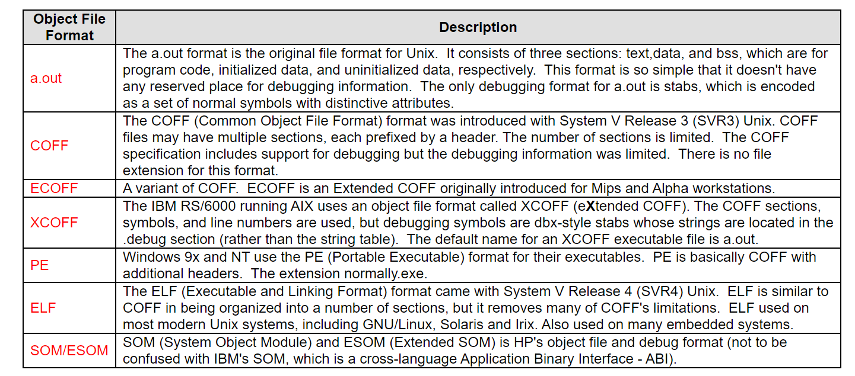
The final and most notable step is the linking process. We use a program called a linker (often built into the compiler) to link libraries. If you have been practicing some C code, you may have came across a header file that you had to include which wasn’t part of glibc/libc such as math.h. Not only do you have to use the #include directive to include it the header in the preprocessor phase, the GCC also requires that you link the library with the -l option eg. gcc file.c -o file -lm so that it knows where to locate math.h. But have you ever wondered why we don’t need to link functions within glibc/libc? Well, I’m sure if you took a few seconds to think about it, you’d come to the conclusion that the compiler links them by default. And you would be correct in assuming this. Because GCC knows that essentially all computers have libc installed, and that the programmer will need access to it’s basic functions, it is linked by default. This is not the case for other libraries however, meaning we have to link them so that the compiler is able to find the actual functions. There is an option to run your program without libc too, if you are writing a program where every last byte is crucial. The option flags for this are -nostdlib -m32. Just note that linking is sometimes done differently on an OS like Windows, as Windows tends to use dynamically linked libraries (.dll files) often, which have a unique process.

Makefile

Perhaps you have attempted to create and compile a program in C that uses multiple files or external header files not included in libc. If so, it certainly failed. In order to compile C programs with multiple dependencies and source files we use the Linux command ‘make’. If you have ever used the pacman package manager on distros such as Arch Linux or Manjaro, you might be familiar with the Arch User Repository (AUR) which uses a variant of the make command ‘makepkg’ which is essentially a fork of make that is capable of compiling more languages than just C. For our purposes, we will be using make because it is less complex. The make command looks for a file called makefile/Makefile in the present working directory for rules on how to compile and link the program.

As mentioned, make uses the principle of rules. A rule has a specific syntax. The template is as follows:

target: prerequisites
recipe

Note that the indent for the recipe does matter. As you can see, each rule has 3 sections if you will. The target is usually the name of the file generated by a program. A primary example are object files and executables which we discussed in the compilation process section of this document. Note that the target might also simply be the name of an optional command that the user might add. A common example of this is ‘clean’ which will typically remove any unused object files and sometimes the executable file as well. If the user wanted to execute this command, they could enter “make clean” (this will begin to make more sense as I explain prerequisites and recipes). Prerequisites are files that the target relies upon for it’s inception. As you are aware by now, object files rely on a mixture of source files (.c files) and header files (.h files). Similarly, executables rely on object files to be created. Finally, we have recipes, which are the actual command that we are entering into the Linux/Unix command line.

The first rule in a makefile is called the “default goal” and will be the default rule that is run if the user only enters “make” into the command line. Typically, we create variables in our makefiles which take the same syntax as bash scripts eg. VAR=value. There are conventions to variables which you will see come up a lot. For example CC which stands for “c compiler” and is usually set to gcc. Many times, we have a variable called DEPS which are the dependencies for the default goal. Other conventional variables are CFLAGS, OBJ, LIBS, etc. I think with these core concepts explained, I can walk you through an article titled “A Simple Makefile Tutorial” found here: https://cs.colby.edu/maxwell/courses/tutorials/maketutor/
Whilst they do a good job of explaining makefiles, I would simply like to elaborate on what’s already been said. The example scenario that they start with is that you are trying to compile a program with two .c files: hellomake.c and hellofunc.c. A very simple example is given for compiling these two files using a makefile:

hellomake: hellomake.c hellofunc.c
gcc -o hellomake hellomake.c hellofunc.c -I.

In this case, the target is called hellomake. The target relies on both source files to be created. Finally, the recipe for how to create it is given: gcc -o hellomake hellomake.c hellofunc.c -I. The -o option is the output name for the executable as you know and the -I option essentially means “look in the current directory for the header files”.

The next example they give showcases the use of variables within the makefile.

CC=gcc
CFLAGS=-I.

hellomake: hellomake.o hellofunc.o
$(CC) -o hellomake hellomake.o hellofunc.o

This example works because by putting the object files in the dependency list and the recipe, make is smart enough to know that it needs to compile the .c files first, so it will do this for us automatically. Note that $(CC) is simply how we obtain the value associated with the CC variable ie. gcc. This example still poses problems, however, because if a header file were to be changed after running make for the first time, the .c files would not be recompiled.

CC=gcc
CFLAGS=-I.
DEPS=hellomake.h

%.o: %.c $(DEPS)
$(CC) -c -o $@ $< $(CFLAGS)

hellomake: hellomake.o hellofunc.o
$(CC) -o $@ hellomake.o hellofunc.o

In this example, some new concepts are introduced. $@, $<, and $^ are essentially pre-defined variables by make. $@ refers to the target, $< refers the leftmost item in the dependency list, and $^ refers to all items in the dependency list. We have now expanded to 2 rules. The first rule (or default goal if you will) creates our object files, whereas the second rule is for the executable itself. It is more common to see makefiles split up object and executable files for flexibility purposes (trust me: you will want your makefiles to be as flexible as possible). Let’s look at the default goal first. The percentile symbol is equivalent to the wildcard operator (*). Essentially, any file that ends in .o will depend on a sibling .c file with a matching name, as well as hellomake.h. The recipe for this rule might look messy, but after realizing what the special variables mean, it is pretty simple. The -c option means compile a source file into and object file (omitting it would result in the rule creating an executable which we don’t want). The output name is set to be the name of the target. The $< variable states that we are running gcc on the current .c file associated with the target. Finally, the CFLAGS variable tells gcc to look in the current directory for hellomake.h. The second rule is more straightforward. Our target executable relies on both object files which should have been produced by the previous rule. The output file will be named after the target once again.

CC=gcc
CFLAGS=-I.
DEPS=hellomake.h
OBJ=hellomake.o hellofunc.o

%.o: %.c $(DEPS)
$(CC) -c -o $@ $< $(CFLAGS)

hellomake: $(OBJ)
$(CC) -o $@ $^ $(CFLAGS)

Now we really begin to get more robust. Not much is changed in this example from the previous example, although there are a few things to note. First is that we create a new variable OBJ which simply removes the need to type both object files twice as we did in the second rule of the previous example. We could have entered $(OBJ) in the recipe as well but the author thought that the $^ variable was sexier I suppose. Remember, $^ refers to the entire dependency list of the target.

IDIR=../include
CC=gcc
CFLAGS=-I$(IDIR)

ODIR=obj
LDIR=../lib

LIBS=-lm

_DEPS=hellomake.h
DEPS=$(patsubst %,$(IDIR)/%,$(_DEPS))

_OBJ=hellomake.o hellofunc.o
OBJ=$(patsubst %,$(ODIR)/%,$(_OBJ))

$(ODIR)/%.o: %.c $(DEPS)
$(CC) -c -o $@ $< $(CFLAGS)

hellomake: $(OBJ)
$(CC) -o $@ $^ $(CFLAGS) $(LIBS)

.PHONY: clean

clean:
rm -f $(ODIR)/*.o *~ core $(INCDIR)/*~

The final example given to us only becomes necessary for larger projects that have their files split into a proper file structure. This makefile would be overkill for a project that only requires something like 3 .c files (although it is never bad to have good project structure even if the project is small). We begin with a variable called IDIR which means “include directory” and is the folder containing all of our header files. CFLAGS has been modified to accomodate this new IDIR variable. ODIR is our object directory which contains all object files. LDIR is our library directory which contains local libraries. Not all PCs will have the same libraries, and so if you include things that are not part of libc, sometimes it is a good idea to copy them locally into your project to make it more portable. The cost of this is obviously space. Now we get to DEPS which has changed drastically. patsubst is a function provided by make that means “pattern substitute”. Here is its definition: $(patsubst PATTERN,REPLACEMENT,TEXT) . It will replace any words in TEXT that match PATTERN with REPLACEMENT. In our case, if you substituted the variables with their values, it would look like: $(patsubst %, ../lib/%, hellomake.h). Here we say, any file titled hellomake.h that matches with % (anything) will get replaced by ../lib/%. In otherwords, hellomake.h becomes ../lib/hellomake.h, and if there were more .h files in _DEPS, they would all be altered to start with ../lib/ as well. I will be skipping the first two rules as I feel they haven’t changed enough to require explanation. The final note of interest is .PHONY and clean. .PHONY is a special target that specifies keywords that should not follow their default interpretation. Normally, clean is a keyword that is pre-defined by make. Since we want to define it to fit our makefile, we add clean to .PHONY and redefine it below. This recipe will simply force the removal of all object files in ODIR. The core command is not really important to you since it is disabled in Linux by default but I will explain it if you are truly interested. If you’ve ever got a segmentation fault by going out of bounds in stack memory you will receive the error “Segmentation fault (core dumped)”. If core dumps are enabled, a file will be created called core that essentially logs key information about the programs state when it crashed. This actually is very useful if you’re using a debugger like gdb.

