The GNU/Linux Operating System

Preface:
GNU/Linux is an operating system, primarily used by developers and large enterprises, including myself. This document will be covering the Linux OS primarily from a developers standpoint. I do aim to lightly cover some of the desktop features of Linux as well. Most institutionalized education systems only cover Linux from the point of view of a system admin (likely because Linux is most commonly used by server administrators), but as someone who uses Linux as their daily driver, I hope to give a bit of insight into what that’s like as well. Understanding the fundamentals is the most important thing though, so developer tools and desktop features are secondary.

Introduction:
Although niche to most people, Linux is an extremely significant achievement in the world of computing, with a rich history to boot. It was created in 1991 by a man named Linus Torvalds, who was a computer science graduate from the university of Helsinki. We will come back to Linus momentarily, but first, it’s important to understand the history of Unix. What’s Unix you ask? Unix was invented in 1969, with team leads Ken Thompson and Dennis Richie. Unix was invented for use within the Bell System at Bell Labratories, and is commonly well respected for its design philosophies, often refered to as “The Unix Philosophy”. It was a modular and portable operating system that was ported to many systems in the early 1970s under various vendors. You may know Dennis Richie as the author of the C programming language. Originally, Unix was written in assembly language, but was eventually rewritten in C, after it was created by Richie. In the late 1980s, an open operating system standardization effort known as POSIX was released, which attempted to unify the various distributions of Unix released under various vendors. POSIX was very successful, and we still have operating systems being built to comply with its standards to this day. Cut forward to 1983. A man named Richard Stallman, a programmer and freedom activist, launched a campaign called the GNU project. GNU stands for “GNU, not Unix”. In essence, he wanted to write an operating system composed entirely of free software that would be based off of Unix. Most people think of “free” to mean $0.00, but by “free” we mean free as in freedom. Stallman defines his idea of “The Four Freedoms”:
1. The freedom to run any program as you wish, for any purpose
2. The freedom to study how the program works, and make modifications to you it as you wish. Open source code is a pre-requisite for this.
3. The freedom to redistribute software
4. The freedom to redistribute modified copies of the software
Along with starting the GNU Project, Stallman is also noted for starting the Free Software Foundation (FSF), developing the GNU Compiler Collection (a toolchain for compiling C code), developing the famous text editor, EMACS, and for creating the GNU Public License (GPL). Cut back to Linus Torvalds. Linus attended one of Stallman’s lectures and was compelled to take on the task of developing a kernel that would satisfy the GNU Project. Thus Linux (often called GNU/Linux) was written, heavily based of off Unix. The Linux kernel remains open source to this very day and accepts contributors on Github.

The Linux Kernel:
If you aren’t familiar with kernels, that is okay – they are not something that every developer will work on in their lifetime. A kernel is essentially the heart of the operating system. Its primary purpose is to be the bridge between the hardware of a device and the operating system. To be a bit more specific though, the kernel often deals with hardware interrupts, device drivers, process management, resource management, etc. Linux’s kernel is known as a monolithic kernel, as opposed to a micro kernel. This means that it is in charge of extra functionalities which aren’t necessarily essential for the kernel to operate. The kernel can be modified by vendors and can have extra applications packaged alongside it to create a unique copy of Linux. These distributed copies of Linux are known as “distros” for short. There are hundreds, possibly thousands of Linux distros for you too choose from; each of which is different, but unified through the core functionality of the Linux kernel, and their compliance to the POSIX standard.

Some Linux Distros:
As I stated earlier, there are many distributions of Linux. Since Linux falls under the GPL license, people are free to copy and modify distros as they see fit, not just the kernel. A few primary distros gave rise to many child distros: Slackware, Debian, RedHat, and Arch. If you look at the Linux timeline Wikipidia: https://en.wikipedia.org/wiki/List_of_Linux_distributions you can get a better visual. The only popular child distro that came from Slackware (in my opinion) is OpenSuse. Popular children of Debian include: Ubuntu, Raspbian (for Raspberry Pi), Kubuntu, Linux Mint, Pop OS, Elementary OS, Zorin, etc. Popular RedHat-based distros include: CentOS, Fedora, Qubes OS, etc. And finally, popular Arch-based distros include: Porabola, Manjaro, Black Arch, and Artix.

The Linux community can get very concerned over so-called “bloat-ware” ie. software that is either monolithic (like systemd), packed with extra features, or that has poorly written, and unoptimized code. You may hear certain distros refered to as “minimalist distros”. Generally, minimalist distros such as Arch Linux, Void Linux, and Gentoo come packaged with next to no applications, and expect the user to install and configure most applications by themselves. Stay away from these distributions if you are a beginner, but don’t disregard them as “too difficult” either. Installing a minimalist distro may not be as hard as some people might assume, and it’s a really good learning experience, if nothing else.
Components of a Linux Distro:
I’ve been sort of vague about the key differences of various distributions up until now, but I aim to cover what you can reasonably expect to find in a Linux distribution. Of course, the heart of every distribution is the Linux kernel. The kernel may have minor changes from distro to distro, but for the most part, it usually remains unchanged. Most Linux distributions come packaged with a boot loader, which is launched by the BIOS/UEFI, or whatever initial program loader is on the system. The boot loader is responsible for booting the OS. By far the most common boot loader is called GRUB which stands for “Grand Unified Bootloader”. The distro will also come packaged with various services known as “daemons”. A daemon is essentially an application process that runs in the background. Daemons often provide some low-level functionality. For example, sshd is the Secure Shell (SSH) Daemon, which provides ssh functionality. All Linux distros must come with basic utilities. When we talk about utilities, we’re referring to the commands that you can type into the command line to have your shell execute. Some basic utilities include cd, ls, cat, etc. Depending on the distro, you may have more or less utilties when you first install it. Speaking of shells, every distro comes with some shell, which is a command line interpreter. It reads in shell code, and executes it. Common shells are the Bourne Shell (sh), the Bourne Again Shell (bash), the Korn Shell (ksh), the C Shell (csh), and the Z Shell (zsh). Finally, a lot of distros come with a package manager. Packages in Linux refer to utilities + extras eg. documentation, config files, etc. A package manager is in charge of downloading applications from some centralized repository and then installing and configuring them. It is also responsible for updating packages on your system and for uninstalling packages.

Installation Process:
Installing a Linux distribution varies from distro to distro, but generally, they share a lot of similarities. Because of the history of Linux, and of operating systems in general, Linux distros are often distributed as ISO files which represent optical disks of the past (CDs and DVDs) in a digital format. ISO is not actually an acronym for anything, it just refers to the ISO 9660 standard used for CD-ROM media. Anyways, these can often be torrented using qtorrent (which is not illegal unless the distribution costs money), or downloaded from an official website or mirror server. It is recommended that you compare the checksum that is often provided on the website with the checksum of the ISO file to make sure that it hasn’t been tampered with. You may want to use a tool such as Rufus to “burn” the ISO onto your thumbdrive. This will optionally format the drive at the same time, which is ideal. Once the ISO is on the thumbdrive, entering your PCs BIOS/UEFI will allow you to select the thumbdrive as your primary boot device. Upon saving the settings and rebooting your computer, the boot loader will launch the Linux image. This is often refered to as a “live CD”. The operating system is not yet installed on your computers hard drive, it’s just a live image that you can mess around in, sort of like a VM. This is good for testing that all your devices connect and that you enjoy the UI. Changes made to a live CD are volatile, meaning on reboot, they will no longer be saved. The live CD will sometimes come with a document that will explain the process of actually installing the OS, or sometimes, the installer is launched as soon as you boot the live CD, and other times, you just need to read the documentation online. It is possible to dual-boot both Linux and Windows if you have enough hard drive space, but I will not cover how to do that here.

A Fresh Install:
Once Linux is installed to your hard drive, you will no longer require the live CD. There are some things to note about the environment that is executed on boot. First and foremost, you will almost always start in some login screen. The login screen is the basic authentication method for most operating systems. The authentication on Linux is usually controlled by a daemon known as PAM (Pluggable Authentication Modules). Presumably, the installation wizard for the OS requested a username and password, so this is where you’d enter that. Upon entry, you will most likely be greeted by a GUI (not always, but usually). The OS’s GUI is known as the Desktop Environment, or DE for short. Popular DEs include KDE Plasma, XFCE, Cinammon, GNOME, MATE, etc. You will probably have some sort of application launcher, some sort of file explorer/manager, a terminal emulator, and a system info bar at the top of the screen. These all depend on the distro, as well as the DE. For example, Ubuntu uses GNOME as its DE. Nautilus is the GNOME file manager, Applications Menu is the GNOME application launcher, and GNOME Terminal is the GNOME terminal emulator. Speaking of the terminal emulator, Ctrl + Alt + t is usually the shortcut to open up a terminal session. It’s always good to update your packages and your system on a fresh install. This is because your ISO could come with outdated packages. Assuming that you are using a Debian-based distribution, you package manager will be called “apt”. If you open a terminal, we can enter our first commands. The first command to run is “sudo apt update”, followed by “sudo apt upgrade”. The former command will download any updates to packages installed on your system, and upgrade will actually install those updates. This includes updates to the kernel. If you want to see what packages are installed on your system, you can run “apt list --installed”. Apt has other features as well, such as searching the repositories for packages. These are summarized in the manual for apt. On nearly all distros, packages must come with documentation. These docs can be found with the “man” utility. For example, to learn more about apt, you can run “man apt” which will bring up the documentation for apt. The man command is one of the most useful and essential commands for being self-sufficient in Linux, otherwise you will be doing google searches all the time.

The Linux Filesystem:
Linux has a very intuitive filesystem with a tree-like structure. On Windows, each hard drive is its own filesystem, but on Linux, there is only one filesystem which can be shared with external devices. Here is an example of what your filesystem might look like (give or take a few directories).
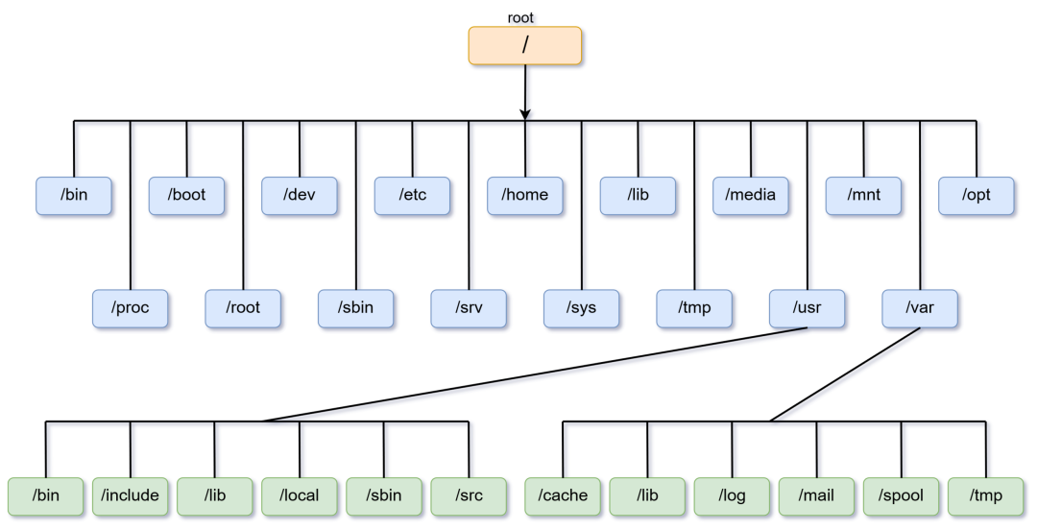

The star player here is the root directory. Root is just a regular folder from which all of our other directories stem. It is denoted by the forward slash symbol (/). Within root we have multiple directories which are each designed for some unique purpose. I will cover each in depth (not including the green ones).
/bin: The bin directory stands for “binaries”. User utilities are stored here, such as ls, cat, mv, grep, etc. A binary is just a compiled executable that can be run on your system. Note that bin also contains your shell (usually set to bash by default), since it too is a binary.
/proc: Proc stands for process. It contains the Process IDs (PIDs) of all running processes on your system. This directory is not all that interesting for the most part.

/boot: The boot directory contains configuration files for the boot loader, as well as the Linux kernel. The kernel will be called vmlinuz-linux. If you are using GRUB as your boot loader (likely), then grub.conf may be useful for configuring how your system boots.

/root: The root directory is the home directory for the root user. It is often empty since the root user usually doesn’t need to have any files in their home directory.

/dev: The dev folder is quite special and possibly difficult to grasp at first. Essentially, dev contains device files. These devices can range from hard drives to peripherals such as your mouse and keyboard, to even virtual devices such as a random number generator. It’s worth noting that hard drives (including SSDs) often start with the prefix sda, whereas NVMe drives often start with the nvme prefix. We will cover this more later.

/sbin: The sbin directory likely exists on your system.

