Linear Algebra and Polynomials

Introduction:

This will be the first of many poor attempts to explain mathematics in a manner that is friendly towards people who suck at Mathematics. Admittedly, I am quite awful at math, but it is a topic that I genuinely **want** to understand and learn. I hope to learn with you as I write this document. This guide will be going all the way back to basic highschool math with linear Algebra and Polynomials. I feel like this is where the school system that I grew up failed us. This “guide” assumes that you are familiar with basic algebra, what variables are, constants, etc. It will be heavily biased towards programmers since programming is my profession. I will likely use language akin to how programmers would speak, and many examples will be related to common programming problems. Moreover, the topics I cover will be biased as well. Expect to eventually get around to learning physics and a lot of manipulation within the 3rd Dimension. You can likely expect that things like statistics will only briefly be covered. While topics like stats do come up in programming, it is often not that frequently, nor am I very interested in that area of math. Without further ado, we will begin way back with the Cartesian Plane, x, y, functions, and the line.

The Cartesian Plane:

The Cartesian Plane is the grid that we use to define many mathematical equations. It was invented by a French philosopher and mathmetician, Rene Descartes. To us, the cartesian plane might not be that fascinating or intricate invension, but I would argue it’s actually more complex than most people might give it credit for. The Cartesian plane is limited to 2 axes, obviously because drawings are limited to 2 dimensions. Most of us would think of the Cartesian Plane as a series of lines that are perfectly vertical, and a series of lines that are perfectly horizontal, all a fixed distance apart from each other. I would argue that this mentality is not accurate. The Cartesian Plane is really a sequence of points, not lines, however, the intersections of lines represent these points which is why we typically draw the lines. Notice that the fixed distance between the rows of lines, and the fixed distance between the columns of lines must be equal. Additionally, this fixed distance can scale infinitely large or infinitely small. We tend to space this fixed distance at a unit of 1. This number 1 is one of many, many examples of normalization in mathematics. You will see as we get into topics like vector maths, that the process of scaling things down to a factor of 1 is extremely useful. I could go on, but I don’t want to confuse you more than necesarry. Just understand that the Cartesian Plane is a useful tool for representing 2 dimensional functions in a visual and artistic way.

Functions:

One thing within math that never actually clicked with me was the idea of functions. The name itself always confused me. Functions and equations are related but are not technically the same thing. A function is described by an equation. Functions are usually represented by a letter, although in programming, we describe functions as words usually, which can also be the case in math (it’s just very rare). The most common function is f(x). The function f(x) is made up of two components: The function name – f, and the parameter (x). The parameter can accept anything, whether it be a constant like 5 or another variable like u. The brackets represent an input ( ) and we are inputting something into the function f. As I mentioned, functions are described by equations. This means that we could say f(x) = x. When we say “= x”, we mean the function f(x) is described by the equation on the right of the equals sign. In programming, functions tend to “return” some value, and you can think about mathematical functions in the same way if it’s helpful. Essentially, we evaluate the equation on the right, and whatever that equation gives us is the “returning value”. Let’s take f(x) = 5 for example. In this case, 5 is the equation, and since there are no operations to perform, 5 would be the return value. Another example, f(x) = x + 5 would return whatever x + 5 equals. Now, another confusing thing about functions is how our input value relates to the equation. If we were to say that f(2) = x + 5, what we are really saying, is that everywhere we find an x, x will be replaced with 2. This is because we always assume that x is an independent variable ie. Some number belonging to the x axis of our Cartesian Plane. We also assume that f(x) = y. In other words, f(x) and y are synonymous and can be used interchangeably. In my opinion, you should always get in the habit of reading y whenever you see any function, whether it be f(x), g(x), p(x), etc. I would like to go over one more example to give a better demonstration of everything we’ve covered. Let’s say we have the function f(x) and the equation that describes f(x) is 2x + 6 (f(x) = 2x + 6). In this scenario, whatever input value we give f(x), the x in the equation will change to match the input. So if we now called f(x) with an argument of 7, it would look like this: f(7) = 2 * 7 + 6 which evaluates to 20. Therefore, f(7) = 20, or we could say y = 20 when x = 7.

Constants, Variables, and Scalars:

With that overly complex explanation out of the way, I’d like to cover some terms within mathematics that are very important to be able to differentiate between.

**Constants:** A constant is any number that is unchanging. More importantly, constants do not affect variables in any way. Constants can be represented as numbers eg. 5, 3.7, -1, etc. Or sometimes as letters. The most common letters for describing constants are k and c (although be careful because c is more oftentimes a variable, not a constant). Numbers such as pi, Euler’s number, and the force of gravity are called universal constants because they appear in nature and do not ever change.

**Variables:** Variables are the opposite of constants. The word variable means “changing”. Variables cannot change whenever they feel like it, but rather, they are dependent on other variables or external forces to be altered. For example, x as we seen, will change depending on the input of the function f(x).

**Scalars:** The term scalar is more often used in vector maths, but is applicable in any field of mathematics. A scalar is simply a constant which multiplies a variable. For example, the 2 in 2x is a scalar, because even though 2 would normally be a constant, it is multiplying the variable x by a factor of 2. In contrast, the 2 in x + 2 is still a constant because it does not affect the value of x directly.

Lines:

Most functions in math can be described by lines. The easiest line to create in all of math is the line x = k, where k is any constant number. For example, x = 5 creates an infinitely tall line at the point x = 5.

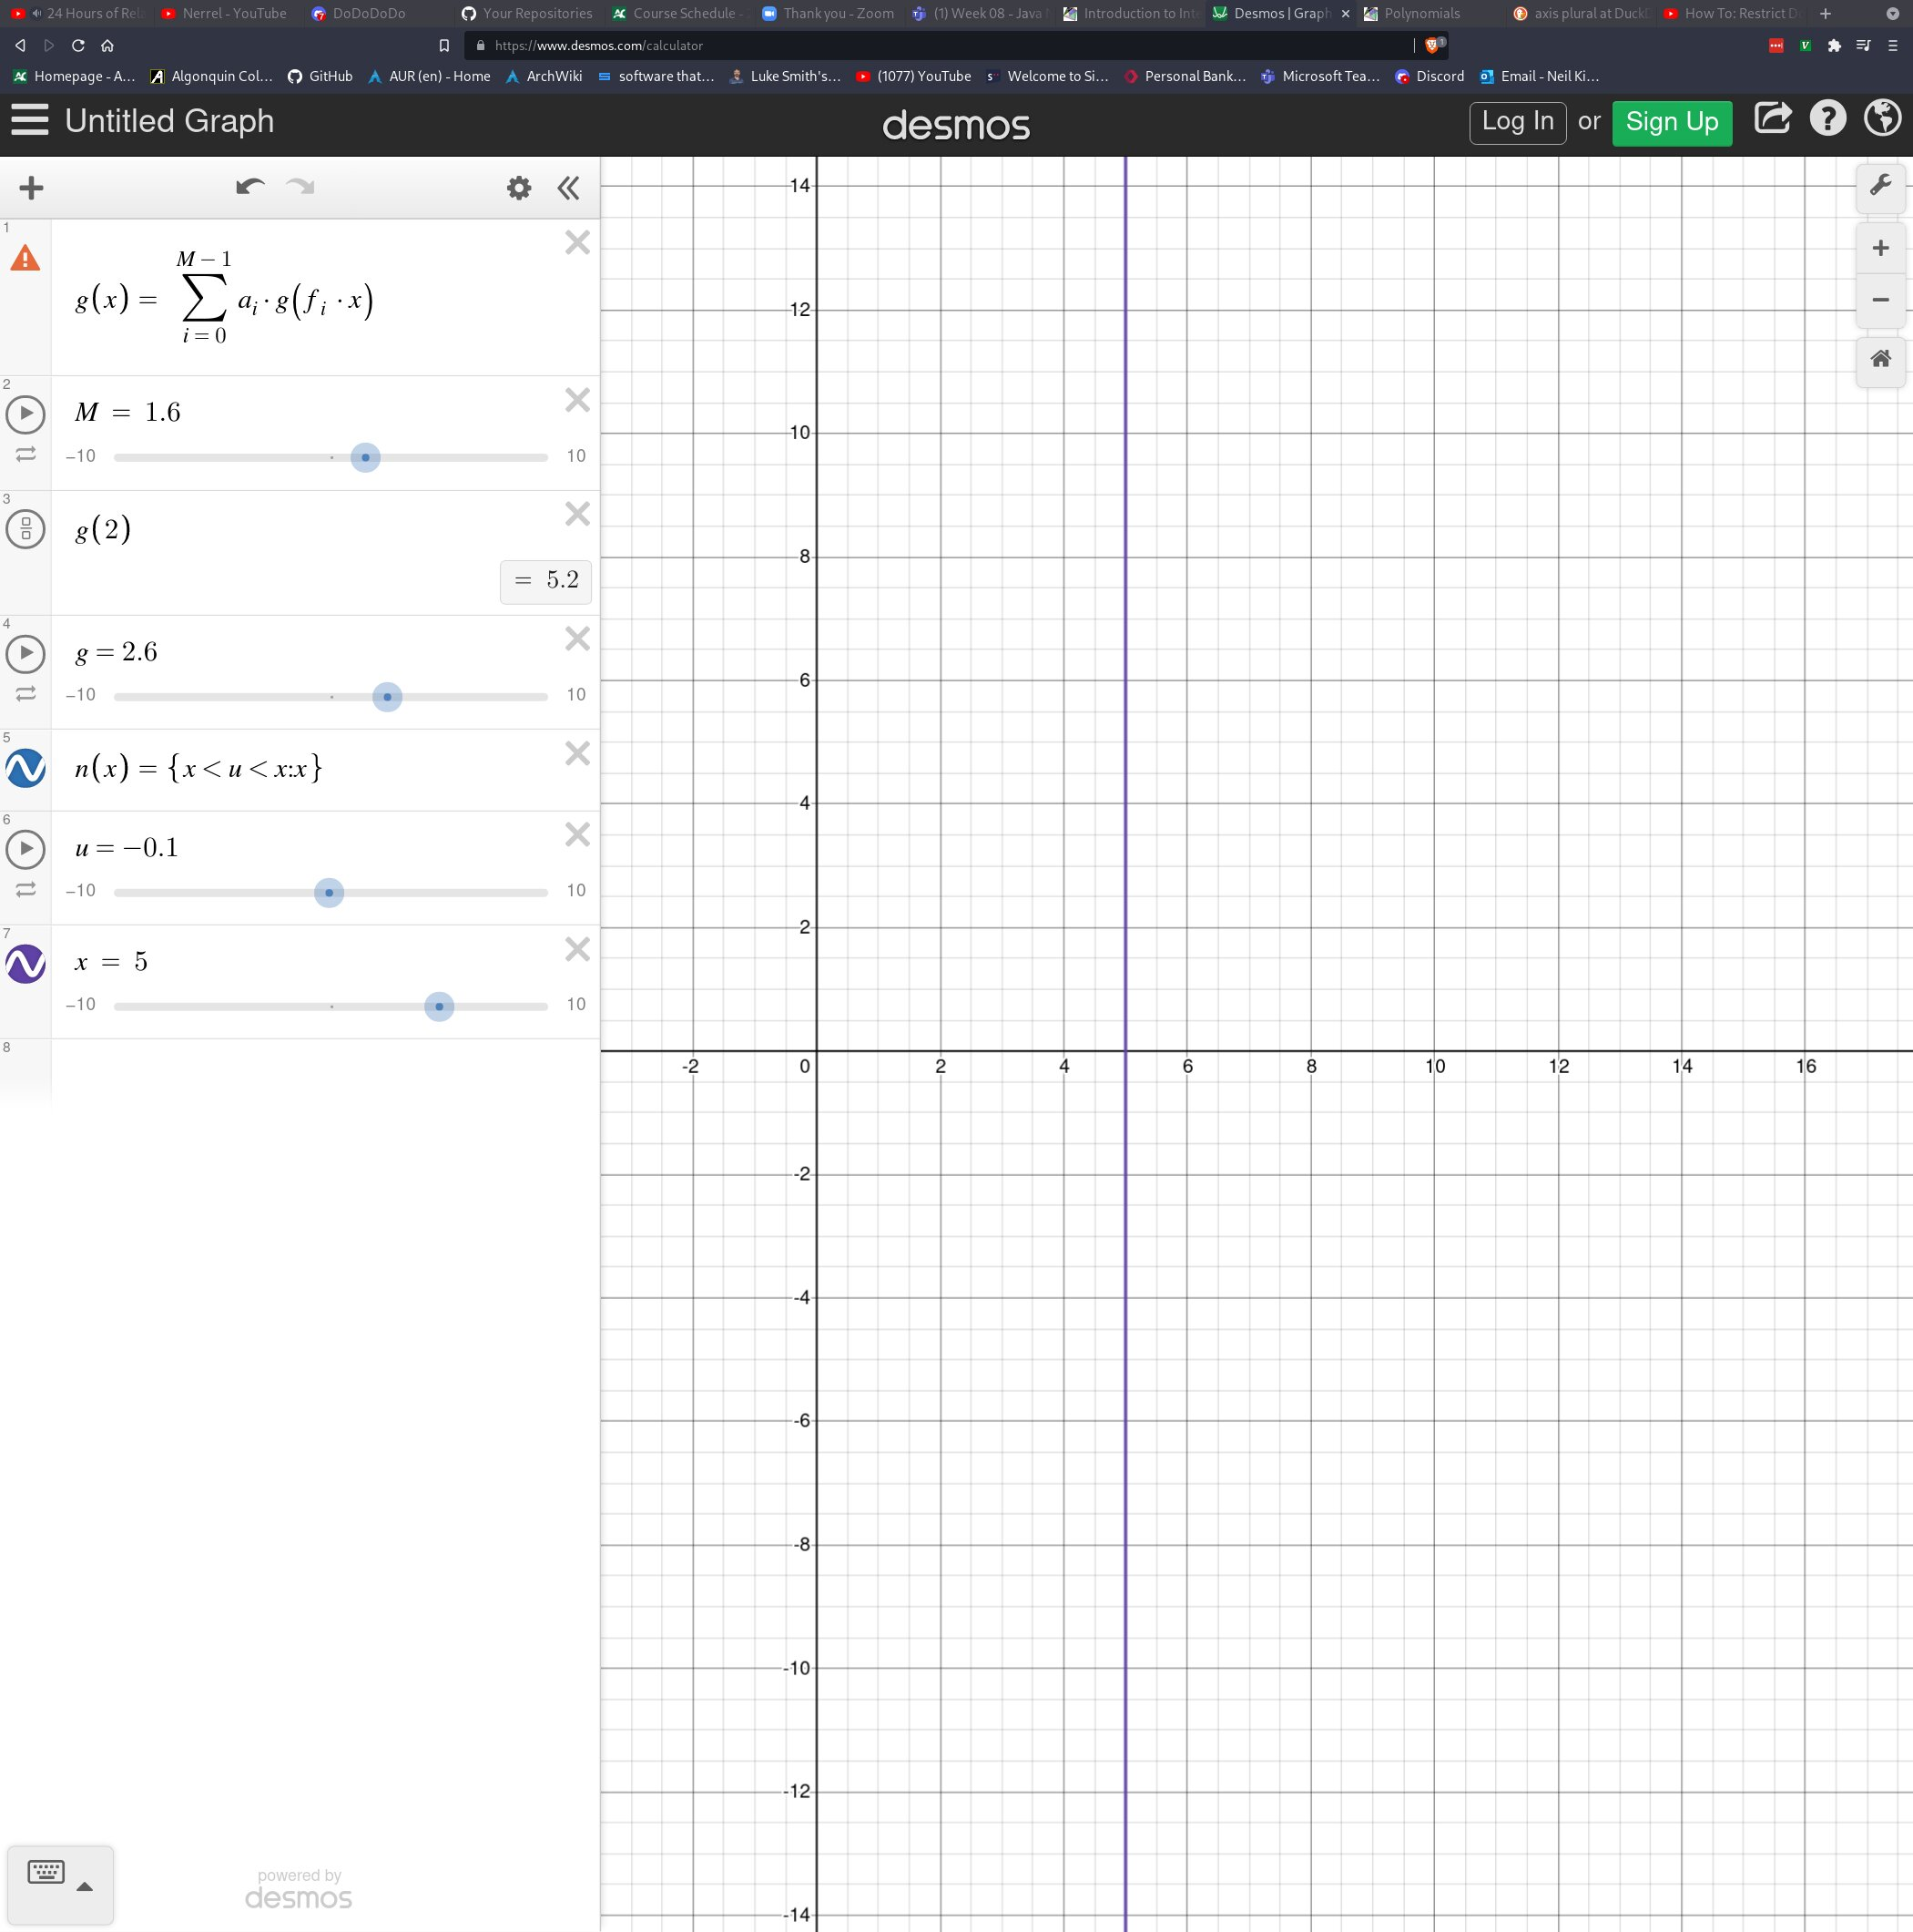

The line in blue is the line described by x = 5. If we were to create a horizontal line where y = 5, we would describe that as f(x) = 5. Recall that f(x) and y are synonymous.

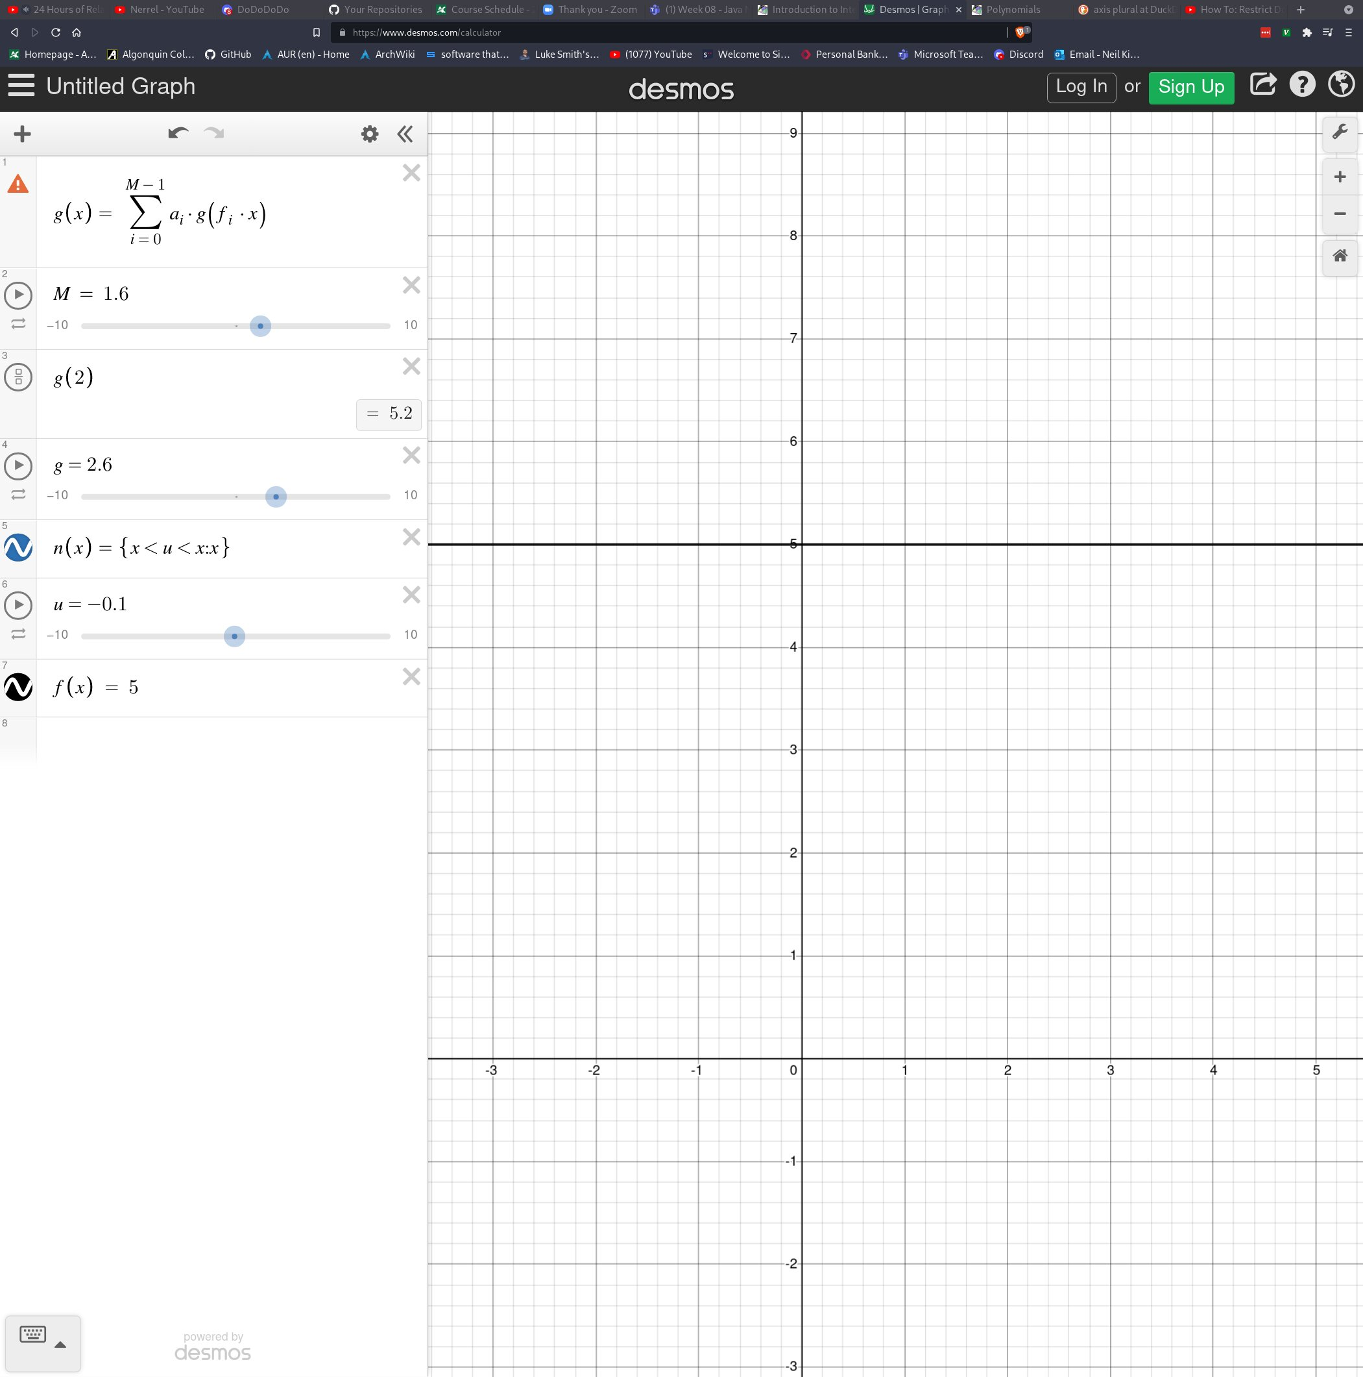

Next on the list is creating a diagonal line. As we’ll come to see, diagonal lines are very interesting because they have the power to describe the steepness of slopes (A.K.A the rate of change) which is very useful in mathematics. Perhaps, it would be best to describe a few more terms before continuing.

Integers, Decimals, Whole/Natural Numbers:

In case you weren’t familiar yet, whole numbers (sometimes also called the set of natural numbers, represented by ℕ) are all numbers ranging from 0 to infinity that do not include partial numbers/fractions. This means 0, 1, 2, 3 ... are all acceptable, however, numbers like -1, 1.1, 1/2 are not whole numbers. The set of integers (represented by ℤ) are also whole numbers, but integers also contain negative numbers. This means ... -3, -2, -1, 0, 1, 2, 3 ... are all integers, but we still dont accept partial numbers. Decimals include negatives and partial numbers/factions. -5.4, 6.7, 99.1, -1000, are all decimals.

Slope:

The reason I wanted to cover those terms first is because we will be looking at negative integers when we deal with slope. By slope, I’m still referring to diagonal lines. The simplest diagonal line is represented by the function f(x) = x. This function will create an infinite line that has a slope of exactly 45 degrees.

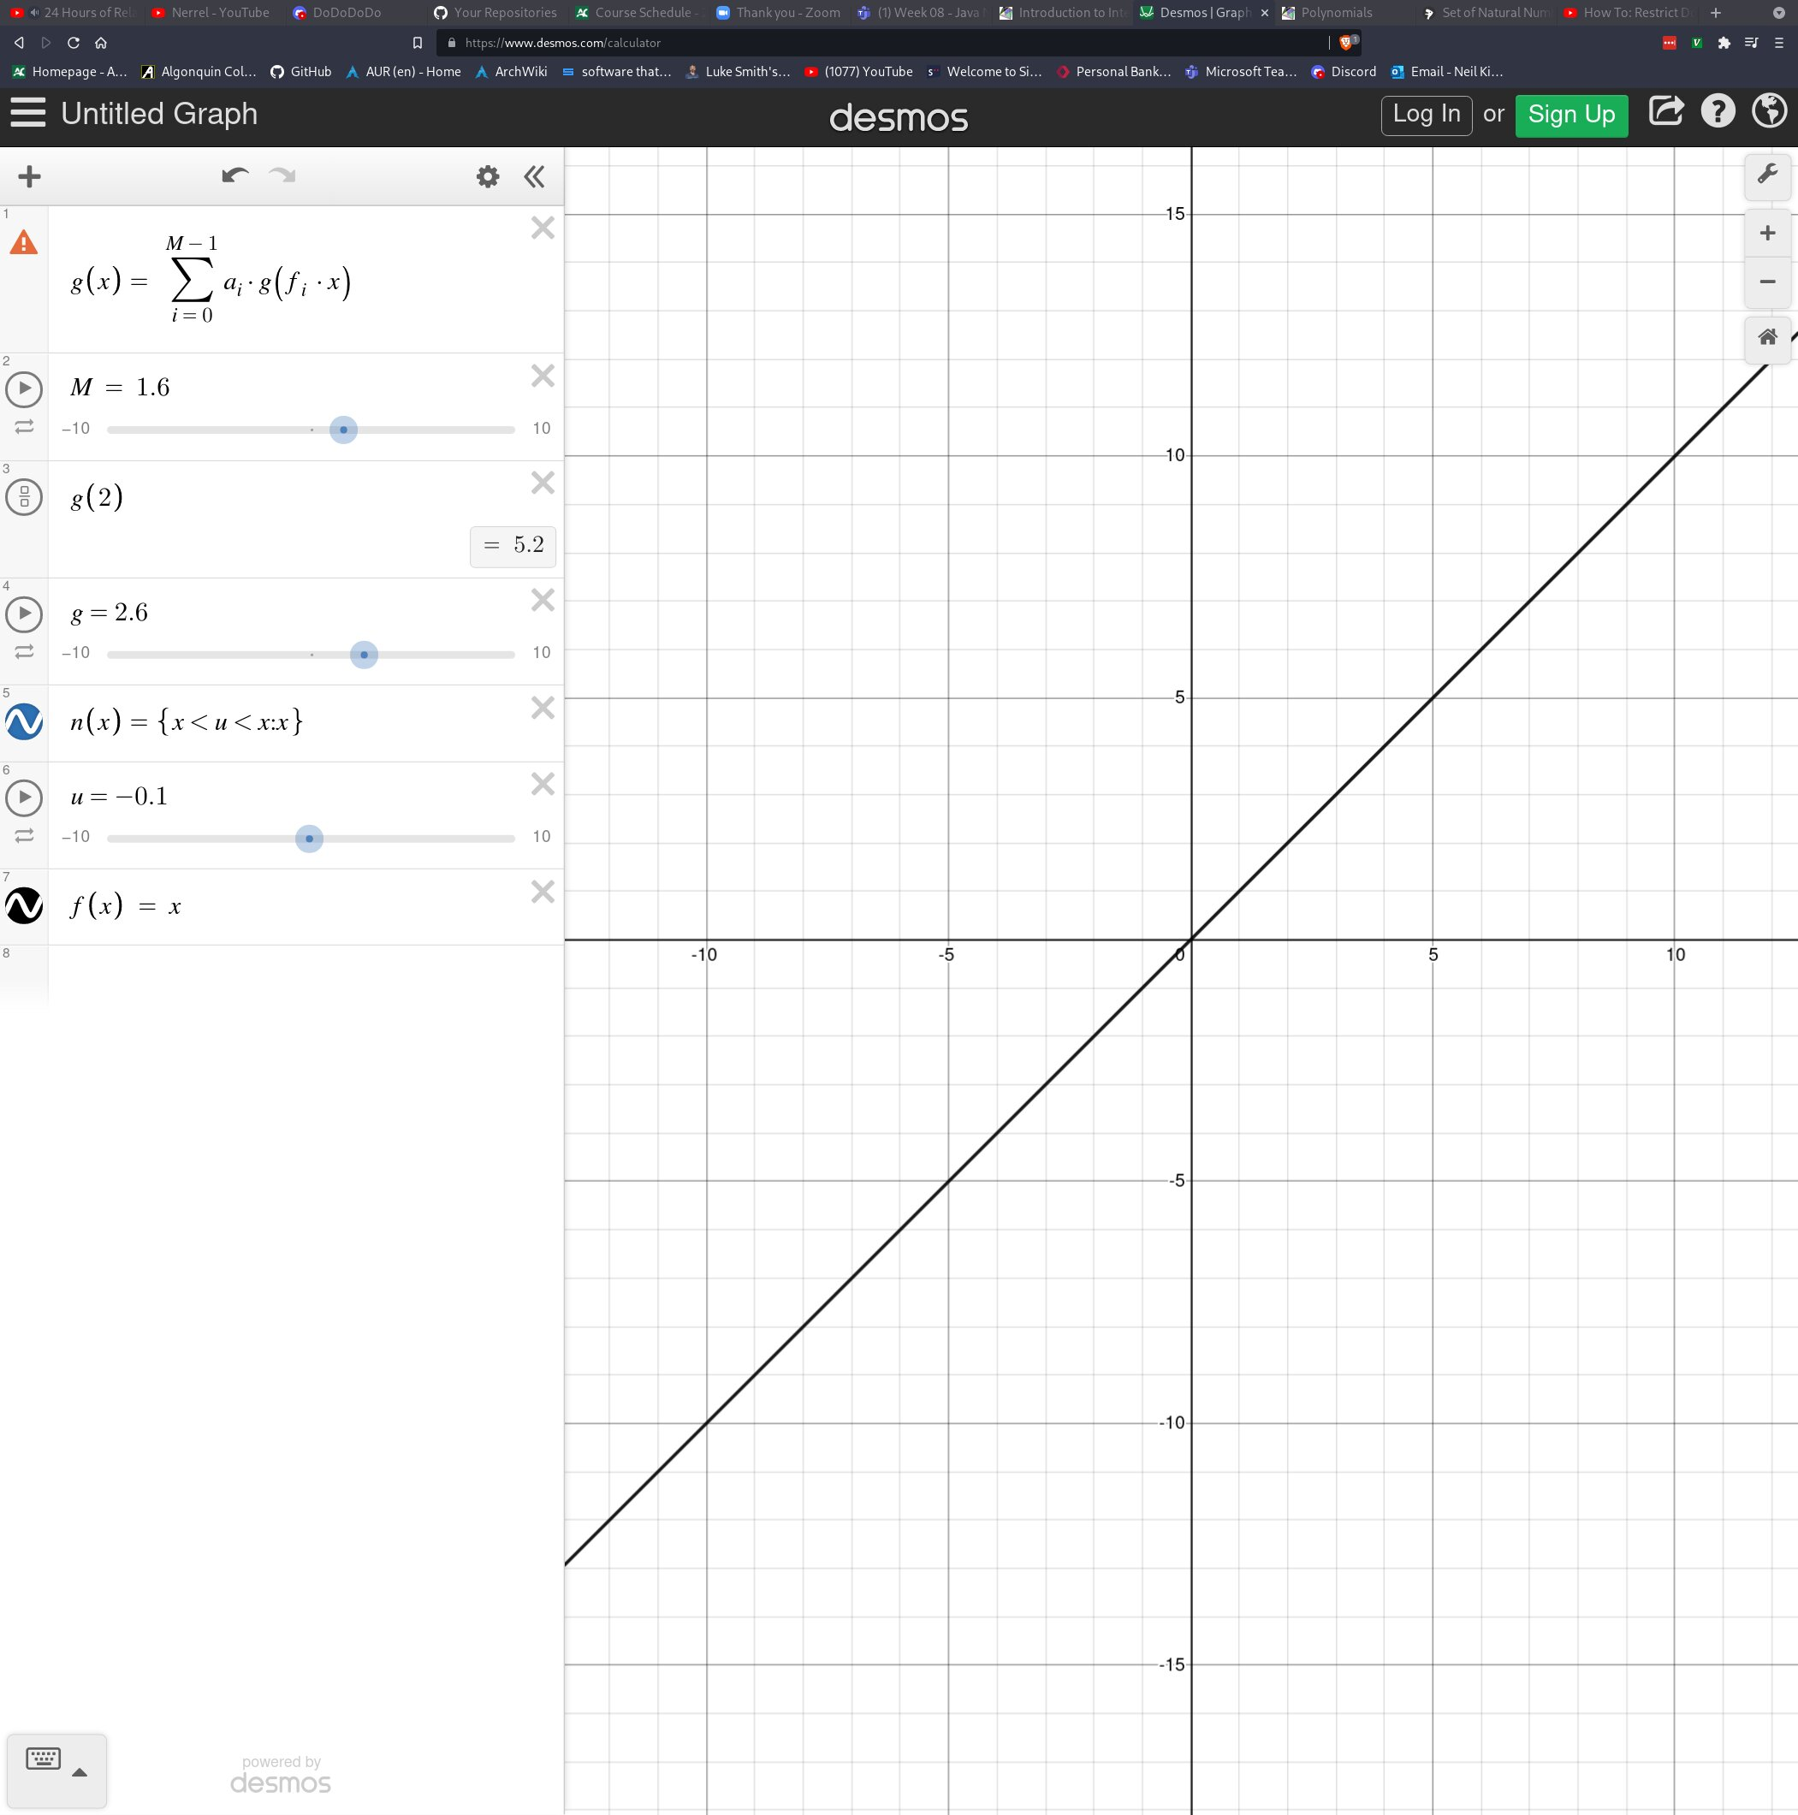

The way to verify this is to plug in multiple values of x into f(x) and realize that the return value for y corresponds to what we see on the graph. For example, f(1) = 1. We can verify that y = 1 when x = 1 on the graph visually. Notice that whenever x is equal to an integer (a whole number, whether it be negative or positive) y is also an integer. This logically checks out since we are really just saying y = x, so no matter what x is at a given point on the graph, y will share the same value. This also explains why we get a perfect 45 degree slope.

In linear algebra, we don’t actually describe slope by degrees. We would not say that this line is 45 degrees, even though it is. We would actually say that the slope of this line is 1. This is because we have a special formula to describe slope in linear algebra. The equation for slope is m = y/x where m = slope. Therefore, once we calculate y for any x point on the graph, we are able to get the slope of our line. For example, let’s find y at x = 5. To do this, we call our function f(x) = x with 5 as our argument. f(5) = 5, therefore y = 5 when x = 5. Now we plug these values into our slope equation:

m = y/x

m = 5/5

m = 1

As I mentioned, the slope for this line is 1 because the rate of change of y is the same as the rate of change of x ie. They grow at the same rate. Let’s try another example:

f(x) = 2x

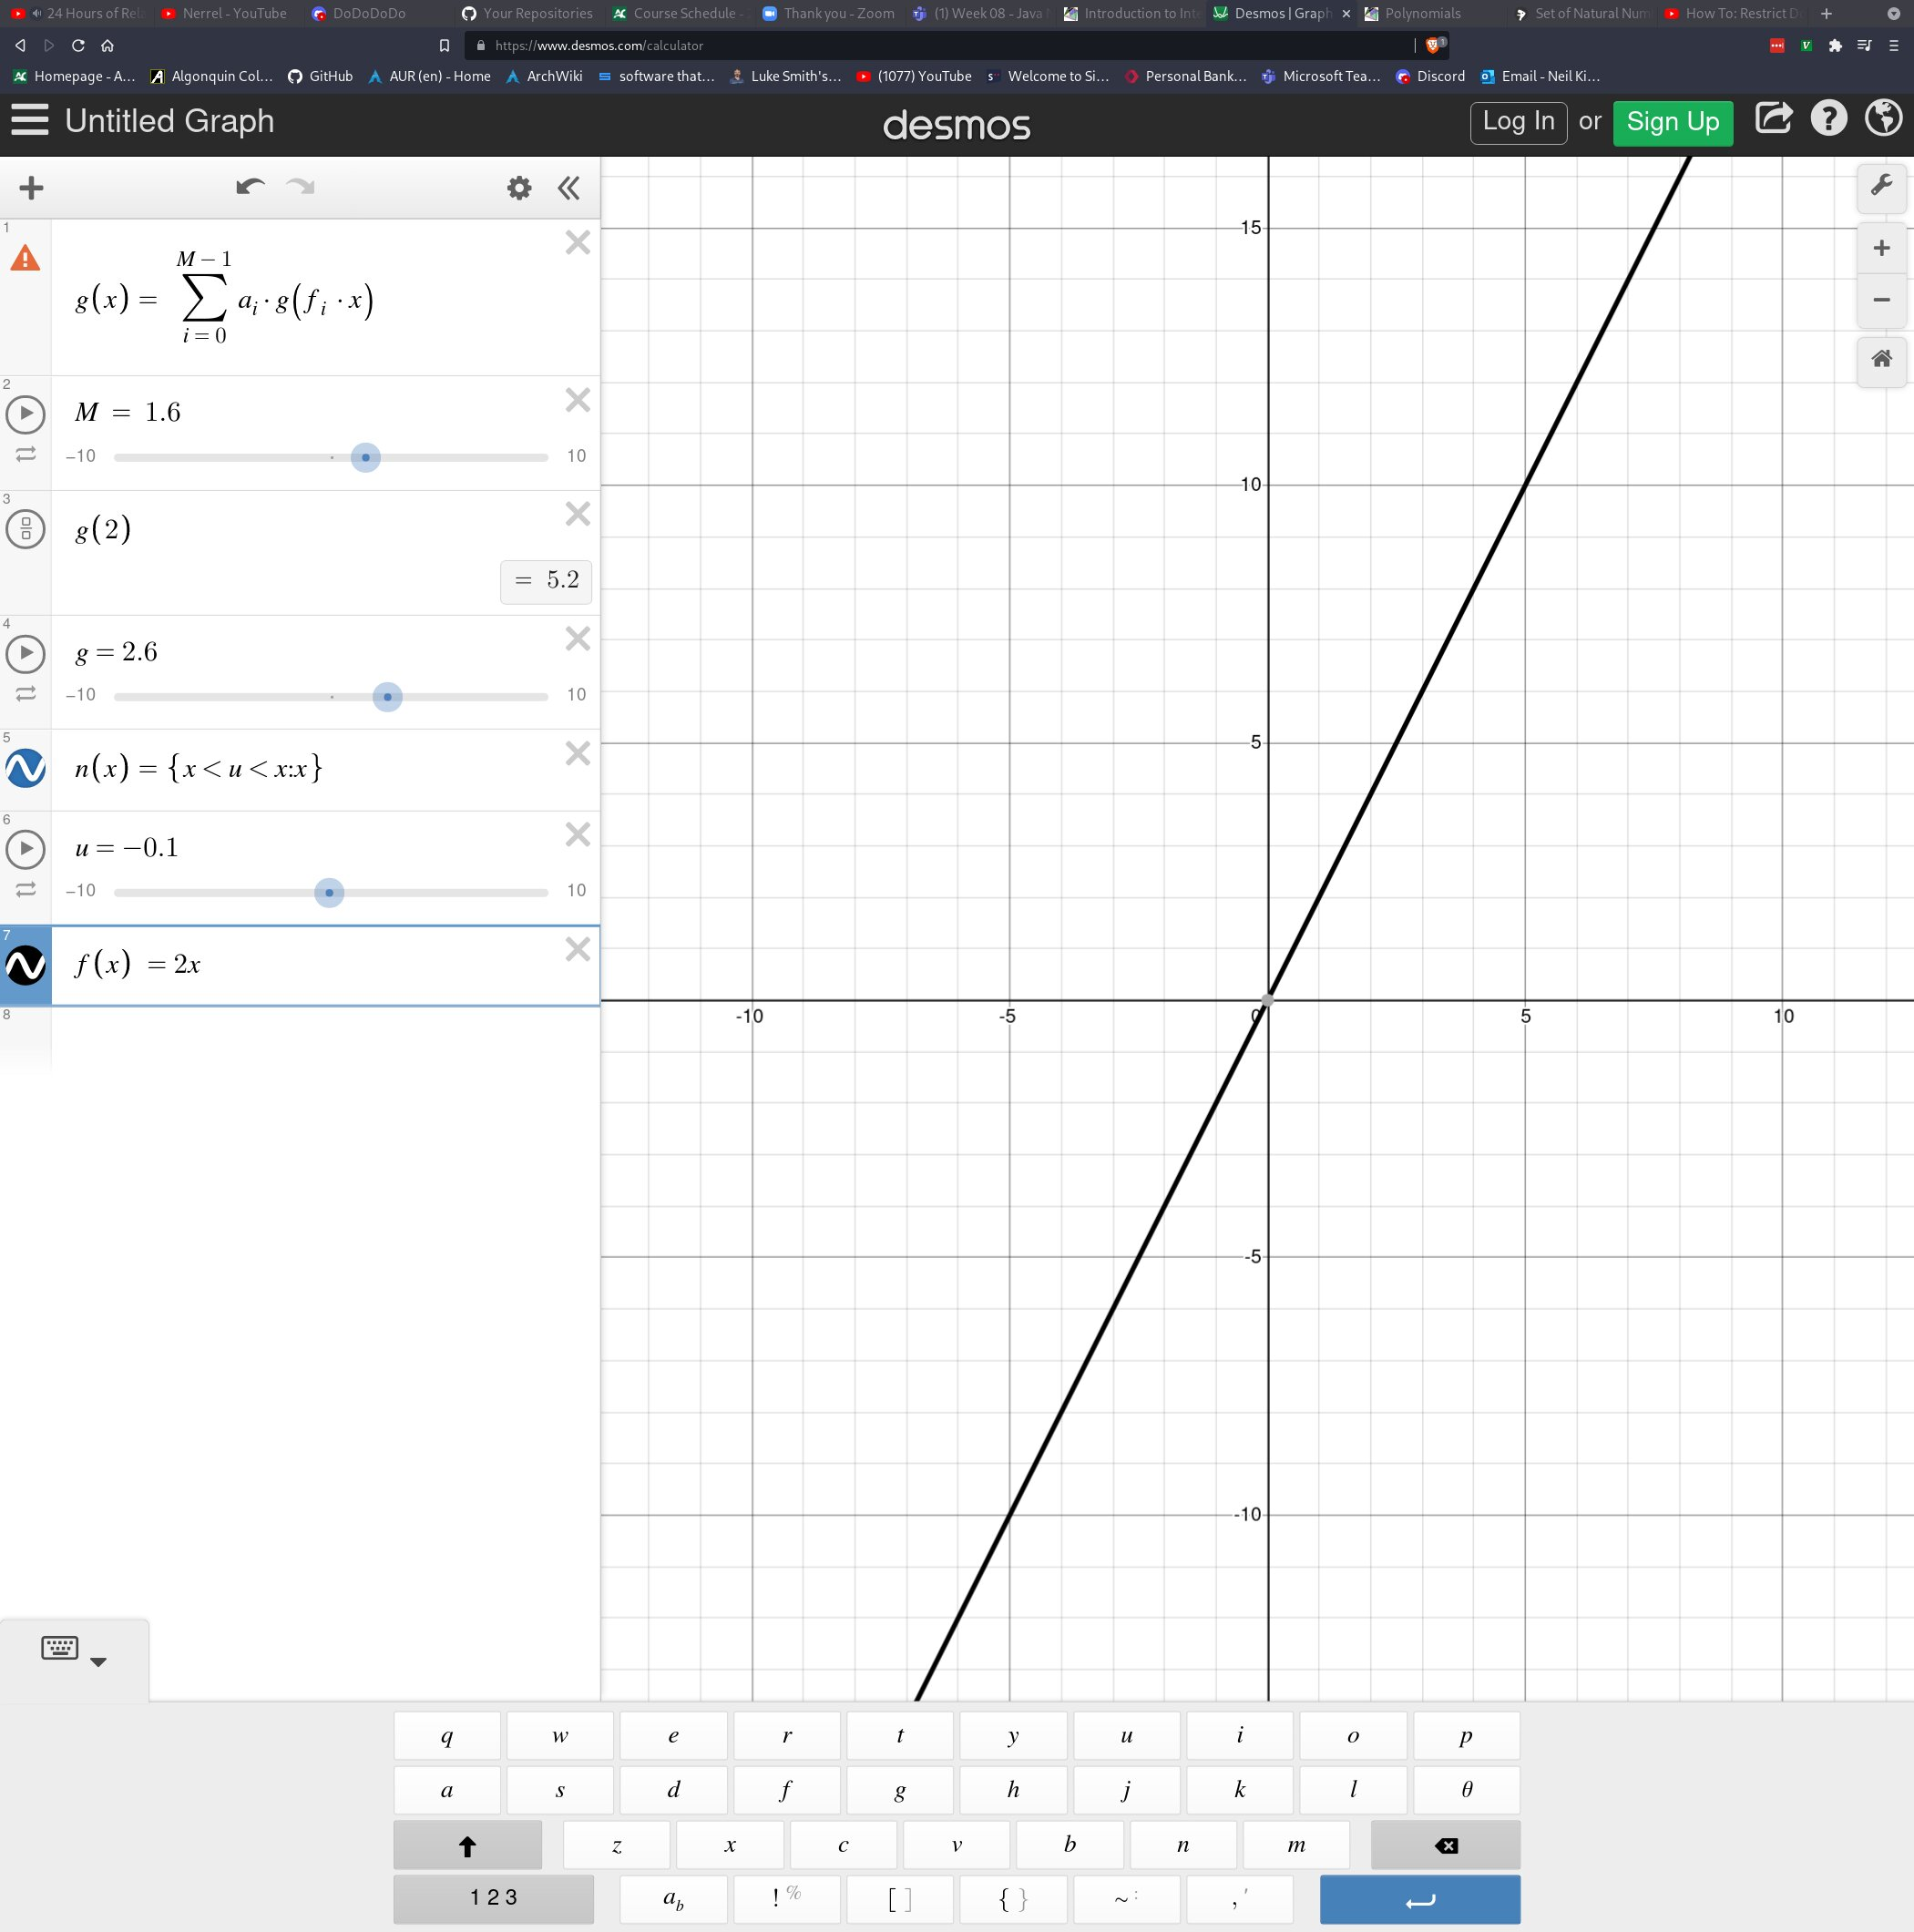

Here you can see that the slope is a bit steeper. This is because we have a scalar in front of x that is causing it to grow twice as fast. In other words, for every value of x, y will be 2 times greater than x. To calculate the slope for this, we plug in any arbitrary value of x and find y.

f(x) = 2x

f(7) = 2(7)

y = 14

When x = 7, y = 14 which makes intuitive sense since 2x is 2 times x and 14 is twice as much as x. To find the slope, we simply use the formula m = y/x:

m = y/x

m = 14/7

m = 2

As you may have expected, our slope is 2 in this case. There’s actually a good reason for this. You see, we can describe all properties of a sloped line using the equation f(x) = mx + b. Our equation for the line above was f(x) = 2x + 0 which is in the form f(x) = mx + b. If you notice, 2 is in the place of m in the equation of a sloped line so we actually didn’t even need to calculate the slope at all; it was already given to us. You may wonder what b represents. b is the offset of what we call the y-intercept. The y-intercept is the value of y when x = 0. By changing b, we can shift the entire line up or down in the y axis. This won’t affect the slope at all since b is a constant (it doesn’t multiply x), but it will affect our line. For example, using our previous equation but adding a value for b:

f(x) = 2x + 3

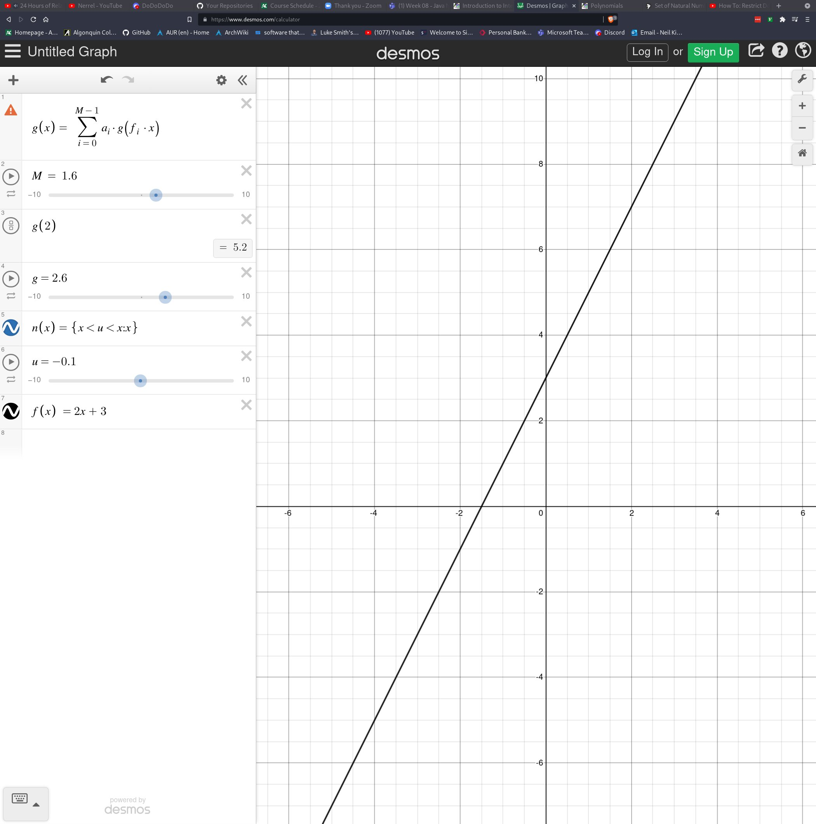

What you can note here, is that if we look at the point where x is 0, we see that the line no longer goes through the center. This is because the y-intercept (represented by b), adds 3 to every output of y given an input x. This is most easily demonstrated by plugging in 0 for x into our equation:

f(x) = 2x + 3

f(0) = 2(0) + 3

f(0) = 3

And this matches what we visualize on the graph as well.

Average Slope/Rate of Change:

Okay, so now we know how to find the slope of a line, but what if we wanted to find the slope of a line that was not straight. Well, there is actually no way to calculate the slope of a line that isn’t straight without approximating. Within mathematics there are various ways of approximating slope, and this will come up during calculus, however given the knowledge we have right now, we will take a very poor approximation of the slope. In order to do this, we still use our equation y = mx + b, however, the way we calculate the m portion (the slope) will differ a bit.

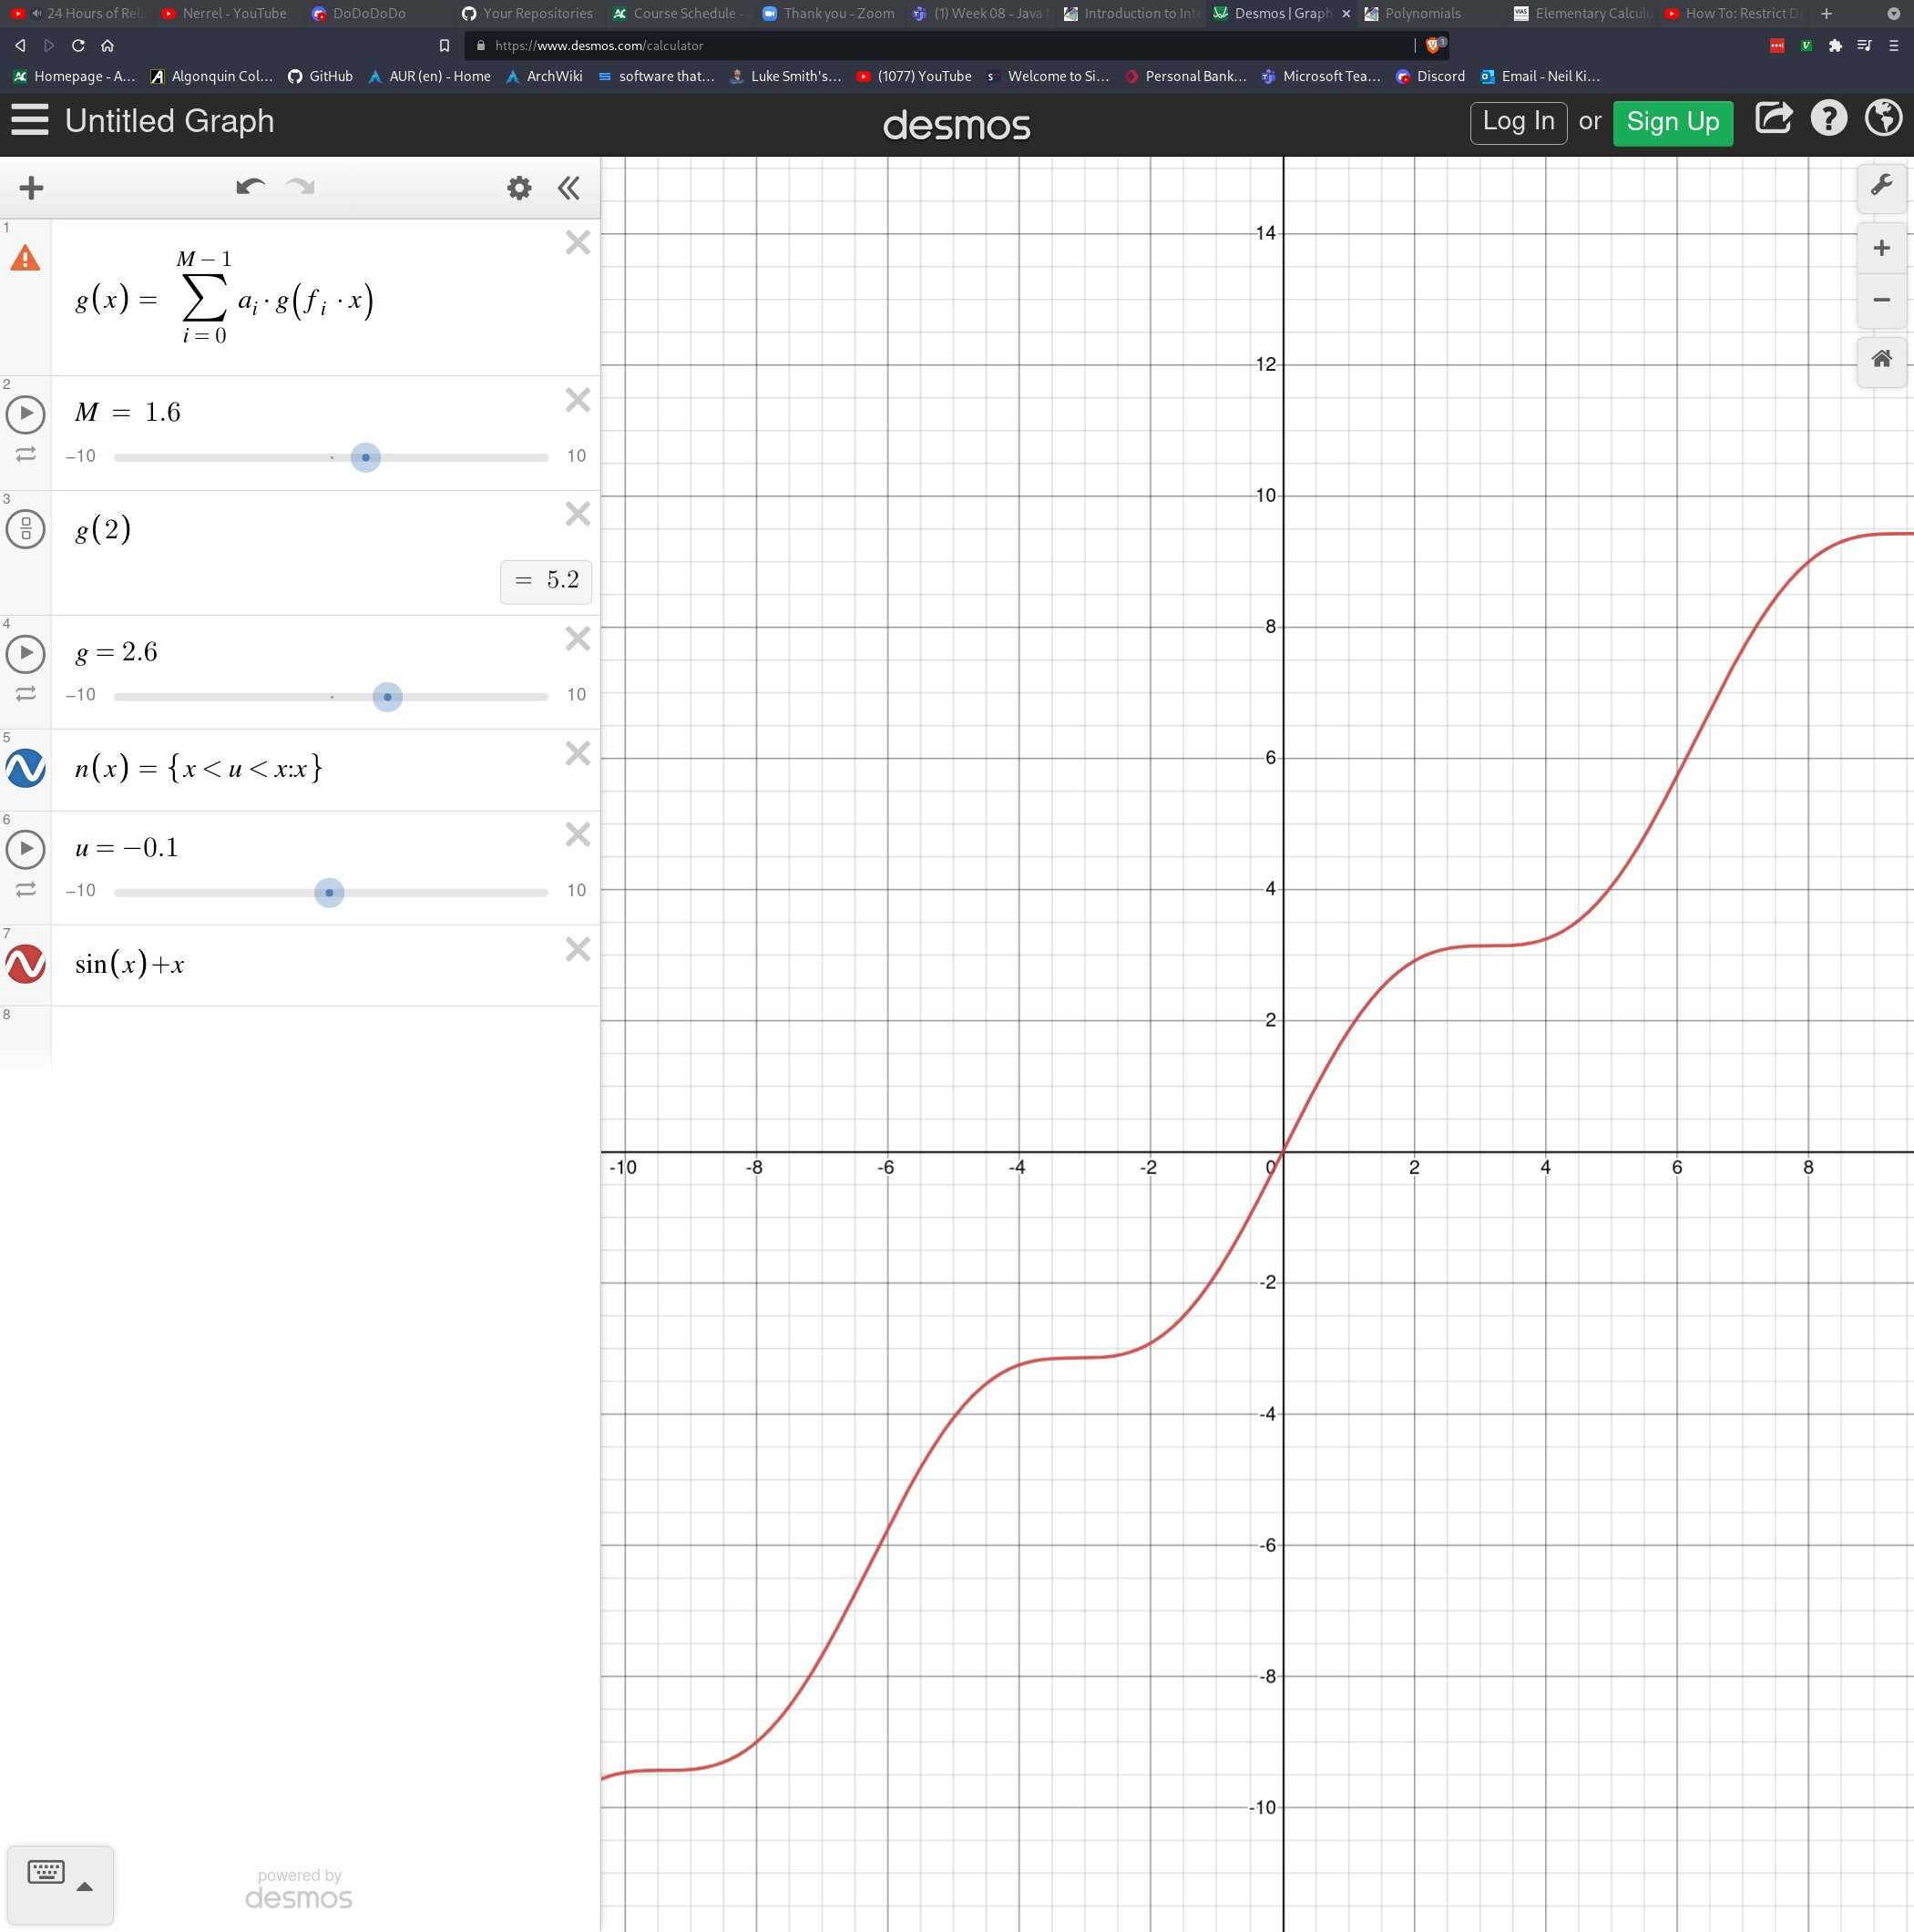

The equation described above is sin(x) + x, however, the logistics of this are not important. We simply want to find the average slope between two points. Not just any two points though, these should be 2 points that belong to the line described above. In most highschool classes, they might just tell you to look for two points where it appears as though x and y are integers, however, this is a bit silly in real life. What i will demonstrate is perhaps slightly more complicated, but necesarry for your understanding. In order to get two points on the line above, we want to pick two x coordinates that appear as though they will give us an accurate measurement, and then find the y values for them. In the example above, I am going to use the x coordinates 0 and 2 because they are easy to demonstrate with. Now recall that I said we need to find coordinates that appear on the line that we’re finding the average slope for. This will require calculating y using the equation of that line given the 2 x values we’ve chosen. Our equation was sin(x) + x as I mentioned.

f(x) = Sin(x) + x

f(0) = sin(0) + 0

x = 0, y = 0

f(x) = sin(x) + x

f(2) = sin(2) + 2

x = 2, y = 2.909

So now we got the two points p1(0, 0) and p2(2, 2.909) which can be shown on the graph here by the green dots:

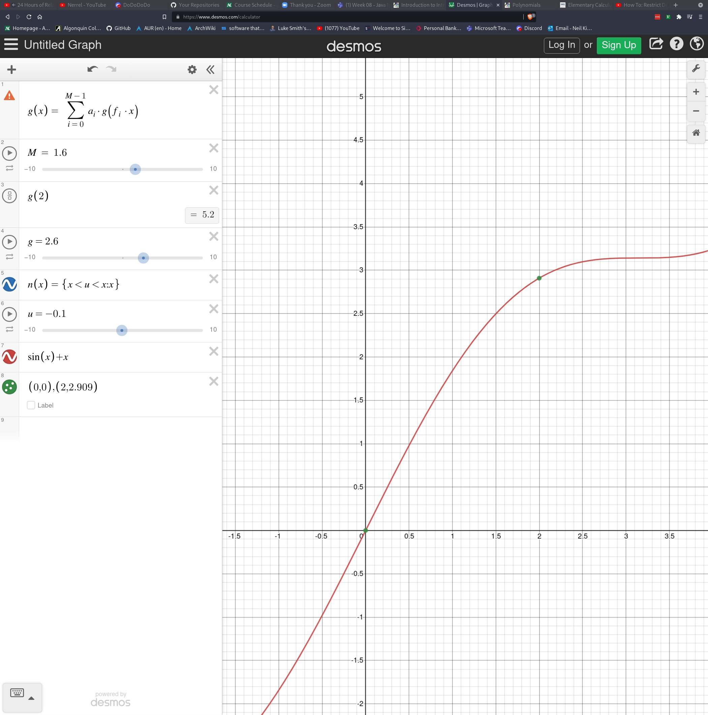

Now we want to find the average slope. To do this, we draw a straight line between our two coordinates. We are going to alter our formula for slope to something slightly more complicated. We will still be using m = y/x, however we are going to describe y and x as the distance between our two y coordinates, and the distance between our two x coordinates. This can be done by subtracting the y value that is lower down from the y that is higher up, or for x by subtracting the x further to the left from the x further to the right. The distance between the 2 ys is called “delta y” and the distance between the 2 xs is called “delta x”. Sometimes people like to show these distances by drawing a box with the 2 coordinates as corners.

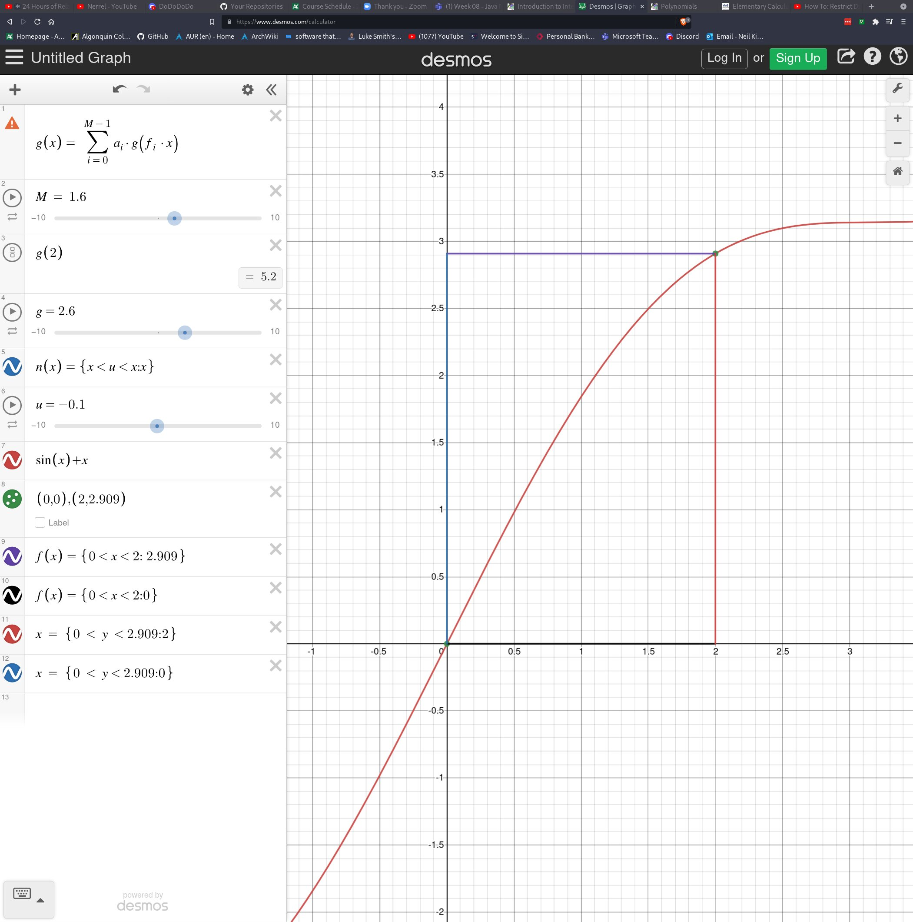

In order to describe delta y and delta x we say m = (-)/(-). Keep in mind, by taking the difference between the two ys and the two xs, we’re getting the lengths shown visually by the box above. Then we divide the height by the width which is exactly the same as what we were doing before with m = y/x. In this example, if we substitute our numbers, we get:

m = (2.909 – 0)/(2 – 0)

m = 2.909/2

m = 1.4545

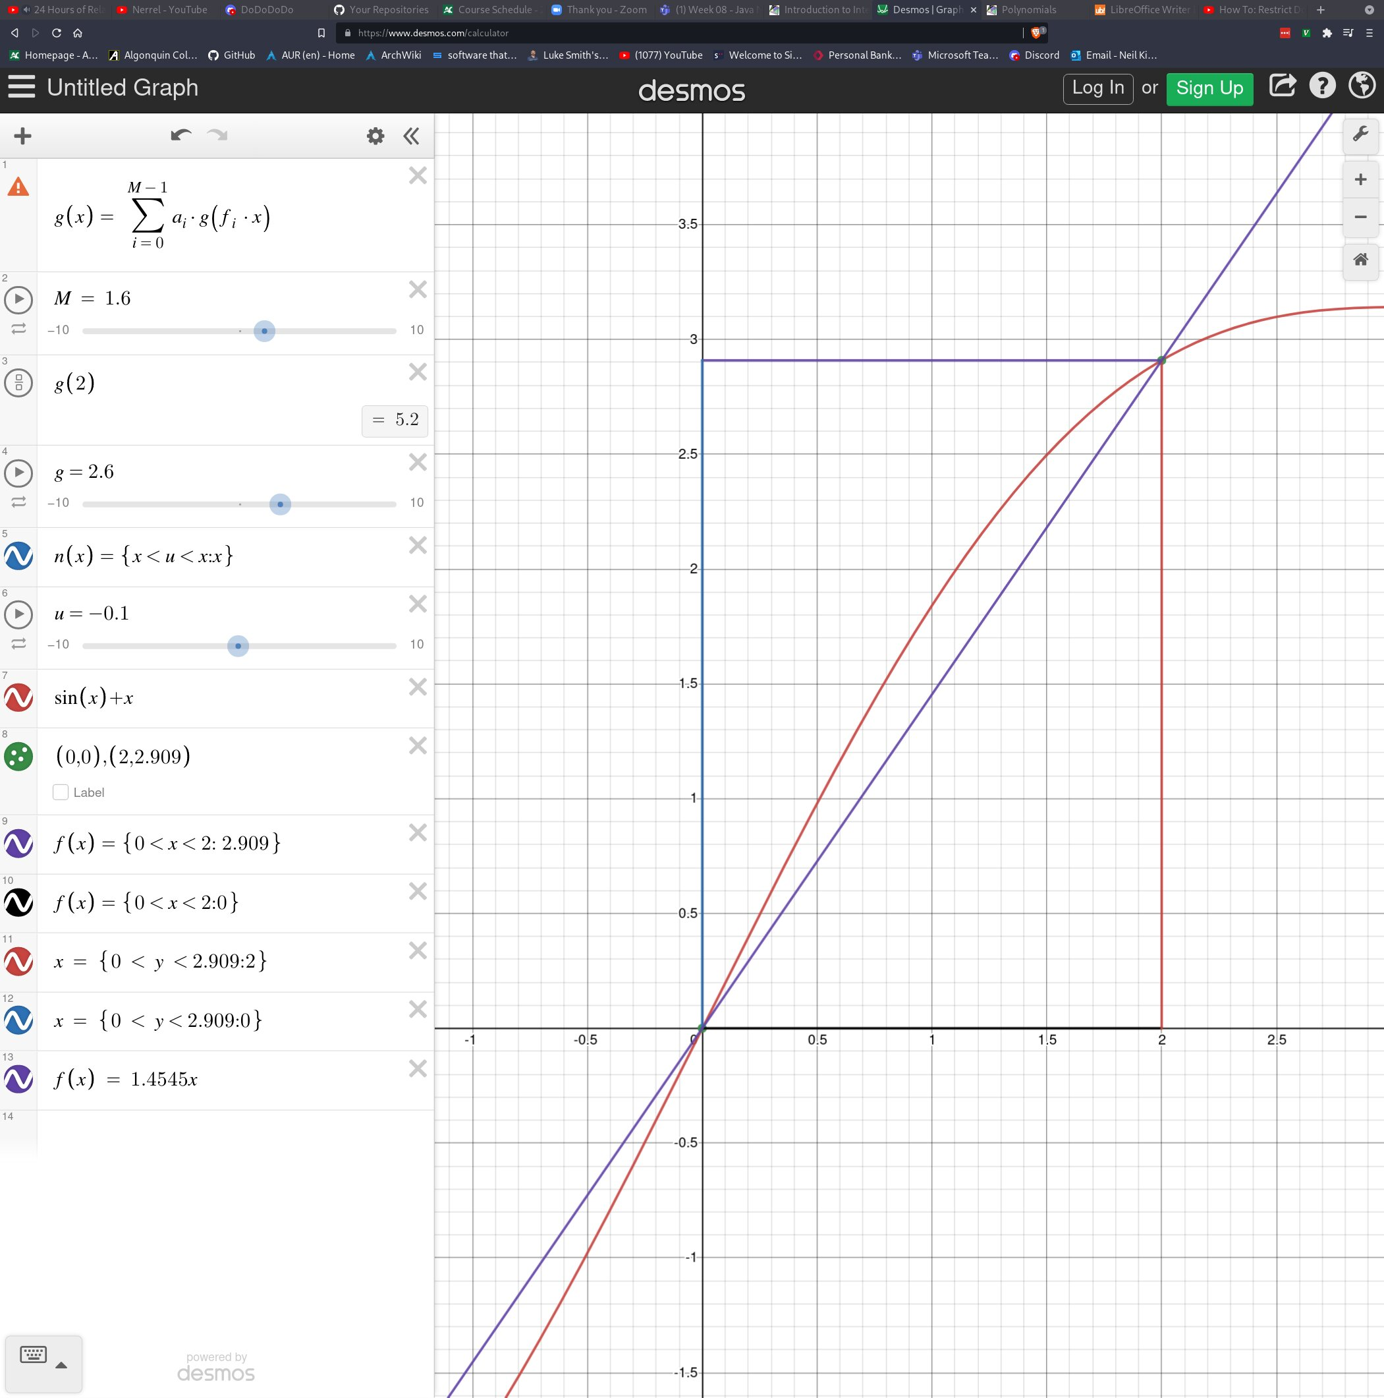

As you can see, things are looking a bit messy perhaps, but the purple line is described by our new equation f(x) + 1.4545x. The wider apart the x values, the more general and likely more accurate the average slope will be. Since our x values don’t give a good scope of the entire line, this is probably not an accurate slope, unless we only cared about sampling the data within that particular region.

Finding the Roots:

Many times in math, you will be told to find the roots of the equation. This was also something that confused me throughout most of highschool math. Really, what we mean by “roots” is find the value of x when y = 0. Or in other words, find where the line passes through the x axis ie. Begins transitioning to the negatives. Finding the roots is a common and useful thing to be able to know how to do. Straight lines can only ever have 1 root, however, when we take a look at polynomials such as quadratics we can find 2 roots, and even more than that with higher degree polynomials. For lines though, only 1 root, which makes things very simple for us. Usually in math, we are solving for y, however when you are asked to find the roots of an equation, you are solving for x. Since the roots are = x when y = 0, we simply substitute f(x) with 0, and then solve for x. This requires knowledge of algebra to accomplish. Take the equation of a line: f(x) = 19x + 4. In order to solve for x, we set y = 0 and then rearrange the equation to get x:

0 = 19x + 4

4 = 19x

4/19 = x

0.21 = x

If we plot this, we can indeed see that at y = 0, x will be 0.21

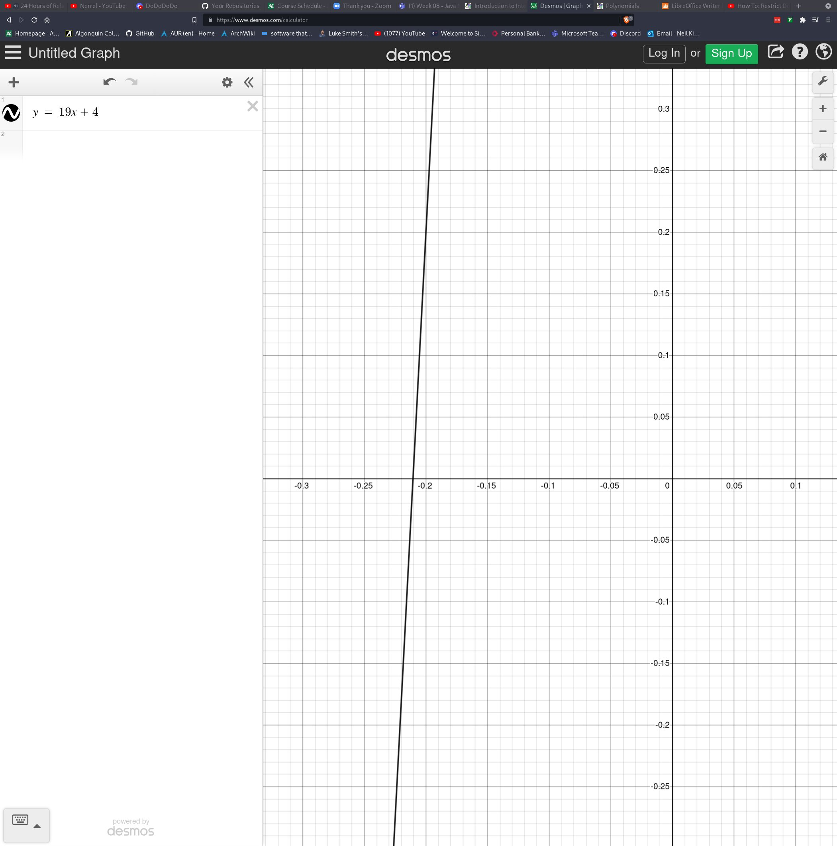

The Intersection between 2 Lines:

When dealing with more than 1 line, it is often useful to be able to find the point of intersection between them. This is relatively easy to do, however, people like myself tend to think too hard about it. The coordinate at which two lines intersect will be shared by both lines. In other words, both lines share the same value for x and the same value for y at the point where they meet. This should just make logical sense. Therefore, what we can do is set the two equations equal to each other which will give us a new function that can be used to find x. Take the following two equations: f(x) = 3x – 3 and g(x) = 2.3x + 4 represented on the following graph:

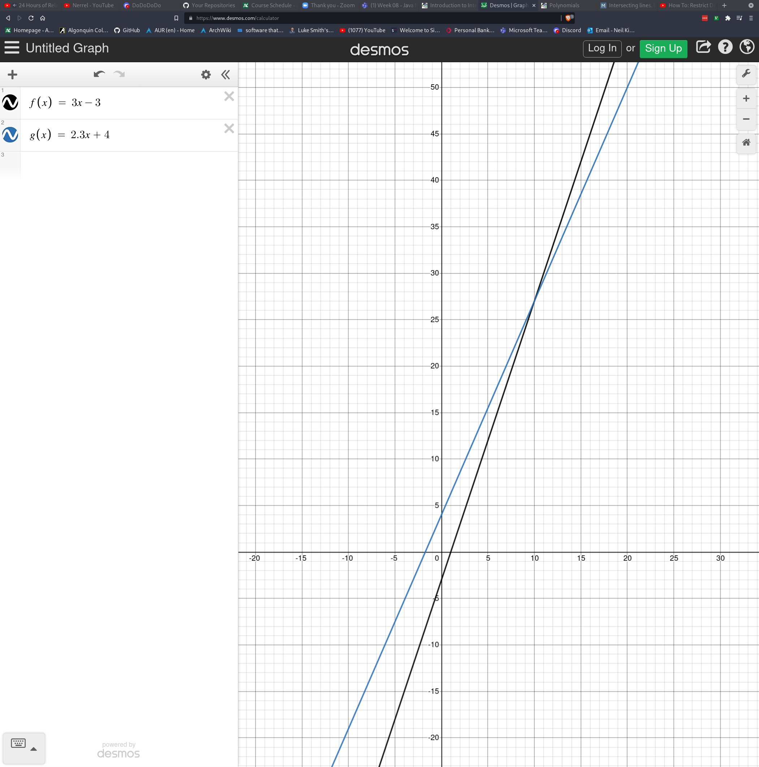

We want to find the point of intersection so we set the two equations equal to each other to find the common point that they both share:

3x – 3 = 2.3x + 4

3x – 2.3x = 4 + 3

0.7x = 7

x = 10

Now we found x, but we need to find y. Since both equations share the same y at x = 10, we can simply substitute x = 10 into either function. I’ll choose g(x) for the fun of it.

g(x) = 2.3x + 4

g(10) = 2.3(10) + 4

g(10) = 23 + 4

y = 27

And now we see that our coordinate of intersection is (10, 27) which we can confirm in Desmos:

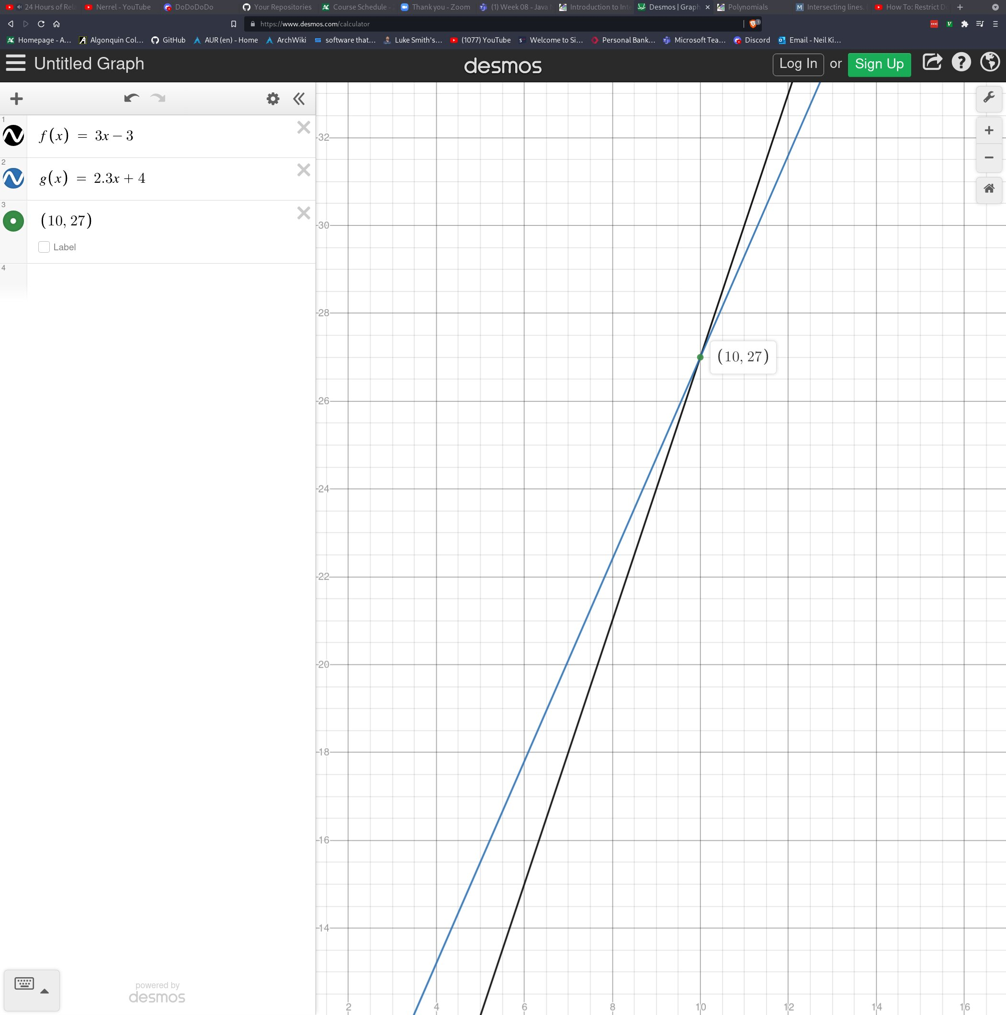

Polynomials:

With the basic knowledge about lines and the equation y = mx + b, it’s time to quickly move on to polynomials. Polynomials are a very strange concept in mathematics, but they are where high school seems to be most focused on. The word polynomial means “many terms”. A “term” in mathematics is any chunk of values in an equation separated by an operator. That sounds very strange perhaps, and I’m sure there is a much better definition than that, but it is pretty easy to visualize. Take the following polynomial:

This polynomial can be split into 3 terms based on the operators +, and -. Therefore, the three terms would be:

a)

b)

c)