Linear Algebra

Introduction:

Linear algebra is my personal favorite area of mathematics. Linear algebra is technically a large field of mathematics that consists of multiple subsets of maths, including vectors (the study of geometry), trigonometry (the study of angles), and kinematics/physics (the study of motion). Typically, when you hear linear algebra, most people are referring to vector maths, but linear algebra is more than that. We wont be focusing so much on physics in this document since I’ll have a dedicated document for physics, but we may look at fundamentals such as gravity, velocity, and acceleration.  
  
Vectors:

Fundamental to linear algebra are vectors. Vectors confuse people such as myself who learned nothing but algebra during highschool and learned that lines could be represented by equations like y = mx + c, or $y={\left(x−h\right)}^{2}+{\left(y−k\right)}^{2}$. The difference between these algebraic functions and vectors is that algebraic functions are used to represent a set of data, whereas vectors are specifically concerned with representing some spacial location in R2 (two-dimensional) and R3 (three-dimensional) space. Vectors do not use equations to represent positions, but rather, matrices. Matrices have multiple definitions depending on the field of study that you look at. In computer science, a matrix is a list of items (the actual type of data is irrelevant). In physics, a matrix is an arrow pointing in some direction in space, and that has some length. Mathematicians attempt to generalize these two things.

As I mentioned, vectors can exist in R2 or R3 space. We will begin by only considering R2 space. Similar to algebra, we can draw our vectors on a cartesian plane. The cartesian plane, if you weren’t aware, was created by French mathmetician Rene Descartes. The fact that it’s referred to as a “plane” is very appropriate. In mathematics, a plane is a two-dimensional surface that extends infinitely. Think of it as a sheet of paper with an orientation. So a cartesian plane can be thought of as an infinite sheet which can be segmented into evenly spaced cross sections in both the x-axis and y-axis. This is important because vectors are used to describe the orientation of planes. A vector in R2 has two components: The x component, which represents the direction that the vector points to along the x-axis, and the y-component, which represents the direction that the vector points to along the y-axis. Keep in mind that vectors are composed of two things: their direction (which are our x and y components), and a magnitude, which is the length of the arrow. To get a better visual, consider the vector below:

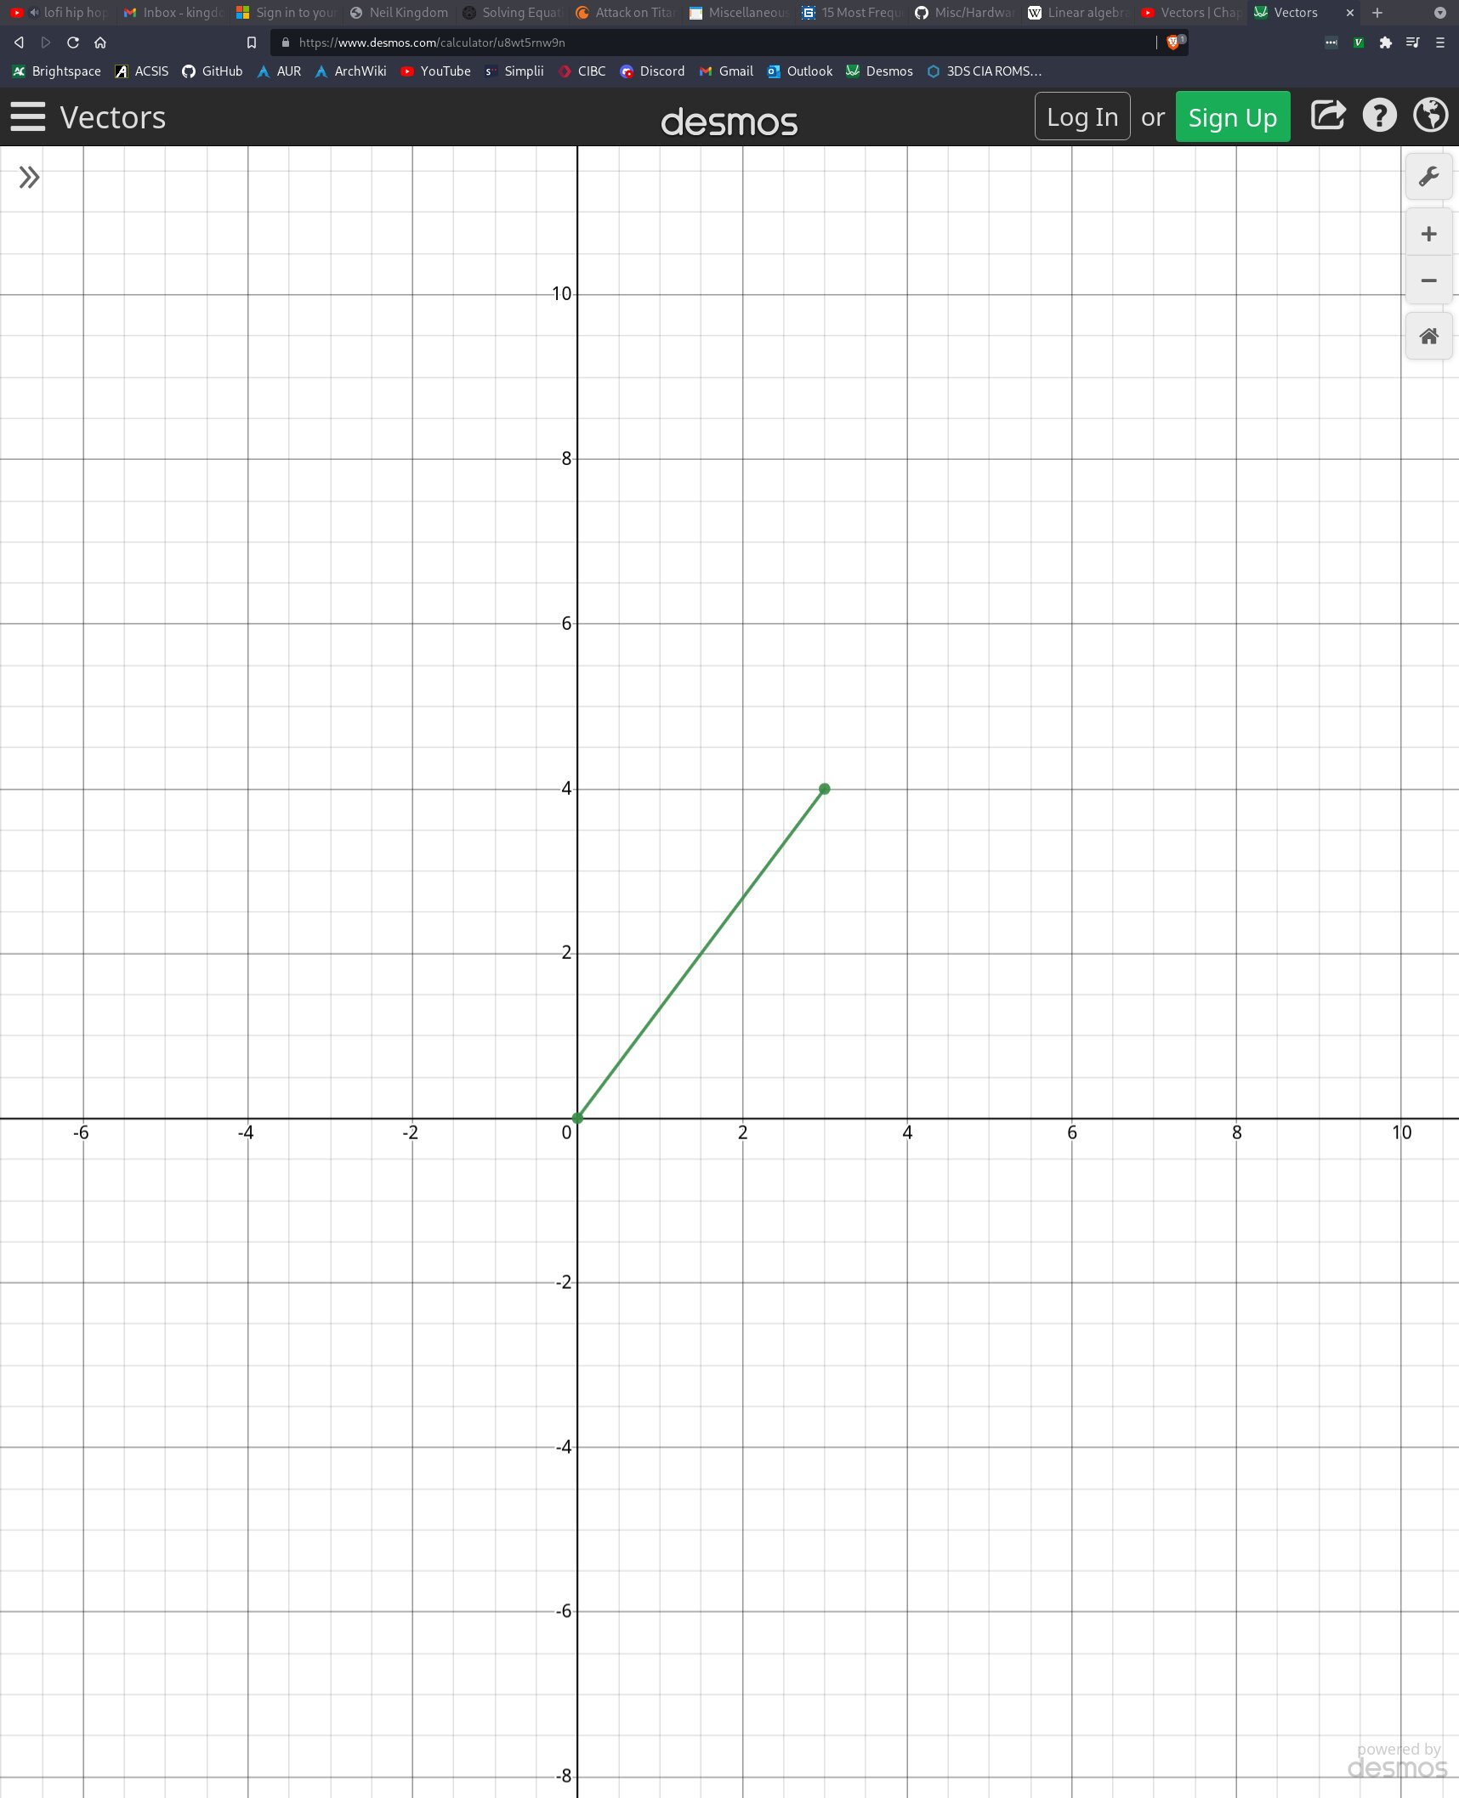The origin of this vector is (0, 0). The vector “points” North-East. It’s x-component is 3, and its y-component is 4. The mathematical notation for writing this vector would be $⃑v=\left[\begin{matrix}3 \\ 4\end{matrix}\right]$. Note that the ordering of the vector list is always x, then y, then z. The above vector could just as easily be written as $⃑v=\left[3,4\right]$, but it is often easier to represent vectors vertically for when we start to multiply them with other vectors or matrices. The arrow-like symbol above the variable v indicates that v is a vector. In order to calculate the length of this vector, we simply use pythegoras’ theorum. You can picture an imaginary line along the y axis at x = 3 which forms a right angle triangle with the vector as the hypotenuse. In order to calculate the length then, it’s

$c^{2}=a^{2}+b^{2}$

$$c^{2}={\left(x_{2}−x_{1}\right)}^{2}+{\left(y_{2}−y_{1}\right)}^{2}$$

$$c^{2}={\left(3−0\right)}^{2}+{\left(4−0\right)}^{2}$$

$$c^{2}=3^{2}+4^{2}$$

$$c^{2}=9+16$$

$$c^{2}=25$$

$$c=\sqrt{25}$$

$$c=5$$

The length of this vector then, is 5. When discussing vectors, we refer to the “length” as the “magnitude” of the vector. We could express this as $\left\|⃑v\right\|=5$. The double lines surrounding the $⃑v$ mean “magnitude”. In other words, the expression above is saying that the magnitude of v is 5, ie. the length of vector v is 5.

To summarize, a vector has a direction (represented by an x-component and y-component), and a magnitude (calculated with pythegoreas’ theorum).   
  
Adding Vectors:

A common operation to perform between 2 vectors is vector addition. But what does it mean to “add” two vectors. Let’s use an example. Let’s say that Google maps is telling you how to get from your house to some location. Technically, Google maps could just draw a straight line between your house and your destination, but that would be impractical if you were driving, because you are only permitted to follow the direction of the roads. Instead of giving one direction, Google maps can give you a set of directions that “sum” up to the straight line between your house and the destionation. In other words, the length of the sum of vectors might be greater than if you had travelled in a straight line ie. you may end up travelling more distance, but the directions are equivallent, since the destination is the same. Let’s see how adding two vectors creates a resultant vector. In the image below we have two vectors that we will call $⃑V_{a}$ and $⃑V_{b}$

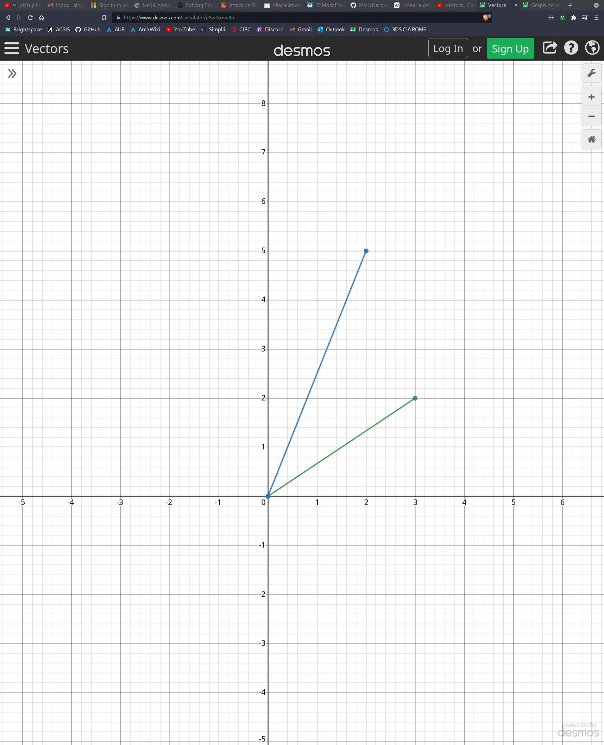In order to add these two vectors, we essentially add the two x-components together, and the two y-components together which will yield a resultant x-component and resultant y-component of the new vector, $⃑V_{c}$.

$$⃑V_{c}=⃑V_{a}+⃑V_{b}$$

$$⃑V_{c}=\left[\begin{matrix}2 \\ 5\end{matrix}\right]+\left[\begin{matrix}3 \\ 2\end{matrix}\right]$$

$$⃑V_{c}=\left[\begin{matrix}5 \\ 7\end{matrix}\right]$$

Below is a visual of how adding these two directions looks:

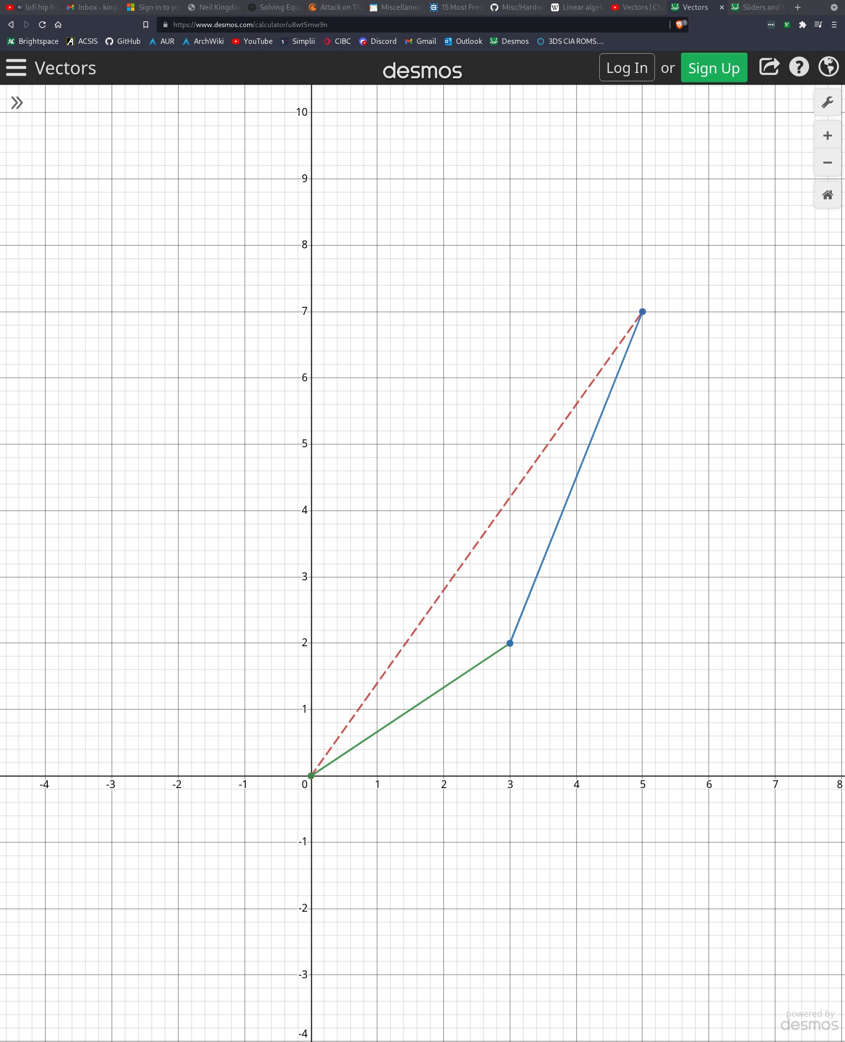  
  
  
  
  
  
  
  
  
  
  
  
  
  
  
  
  
  
  
  
  
  
  
As you can see, moving along $⃑V_{c}$ has the same effect as moving vector $⃑V_{a}$’s origin point to the tail of $⃑V_{b}$. You can picture $⃑V_{a}$’s origin point moving in the direction and magnitude of $⃑V_{b}$ or vice versa. $⃑V_{c}$ summarizes the movement that we took as the shortest path.