

Titanic Dataset

CST8390_23W Assignment 2



February 13, 2023

Algonquin College

Computer Engineering Technology

Business Intelligence and Data Analytics

Hoang, John – 040896360

Kingdom, Neil – 040967309

Prepared for:

Dr. Anu Thomas

Table of Contents

Introduction 3

Data Understanding 3

Starting Dataset 3

Dataset Breakdown 4

Classes Train Set 4

Attributes Train Set (Age Updated) 5

Classes Test Set 5

Attributes Test Set (Updated Age) 5

Data Preparation 6

Preprocessing – Classification 6

Updated Training Dataset on Classification 6

Updated Test Dataset on Classification 7

Cleaning Up 7

Removing Data 7

Updating Missing Values 8

Modeling and Evaluation 8

Discussion of Results 9

Conclusion 9

References 10

Appendix 1 11

Training Set Male (Mr.) 11

Training Set Female (Miss) 12

Training Set Female (Mrs.) 13

Training Set Unique 13

Appendix 2 14

Test Set All Missing Age Instances 14

Test Set Male (Mr.) 15

Test Set Female (Ms.) 16

Test Set Female (Mrs.) 16

Test Set Unique 16

Test Set Fare Missing 16

# Introduction

The Titanic dataset consists of the data collected from the passengers of the sinking of the largest ship built in the 1900’sand is useful in discovering the connections of the features to the survivors [1]. Titanic had about 2224 passengers and more than 1500 died and with the data collected from the tragic event the information on survivors and non-survivors can be analyzed to understand the lost. The objective is to use the dataset to make a prediction on the survivors and non-survivors on the Titanic based on the features. In analyzing each of the features it is possible to rationalize the inclusion of the features in the predictive model. On building the learning model the train set is used and is verified on the test set. The approach is to apply a supervised learning algorithm for classification using decision tree. Decision tree can be summarized as a learning model that categorize features proportionately and respectively to the feature’s identity and applying a recursion. The ID3 (iterative dichotomiser) algorithm is used to divide the features into groups and select the determinant group with the best features by the highest Information Gain. On completing the goal, Weka J48 feature is used to produce the underlying decision tree algorithm [2]. Once the predictive model is built the next step is to supply the training set with the test set and run the classifier. Our objective is to obtain a prediction made based of the constructed predictive model and match the result with the actual facts on the tragic event [3].

# Data Understanding

The Titanic train dataset consist of a total of 889 instances and the test set contains 413 data without a survivor class. The train set has 1 class, survived or non-survivor, and 11 features including:

* Passenger Id (#1-889), that is, the identification number of the passenger,
* Passenger Class (1,2,3) is the social status of the passenger being 1 for First Class, 2 for Standard Class and 3 for Third Class passengers,
* Name that also include the title of the passenger (Mr. ,Ms. , Miss., Mlle., Mme., Mrs., Master, Capt., Major, Col., Lady, Rev.),
* Gender (Male or Female) shows the passenger’s biological identity,
* Age is the passenger’s lifetime as of the time of boarding the Titanic,
* Siblings and Spouse is the count of the passenger’s siblings and spouse aboard the Titanic,
* Parent and Child is the count of the passenger’s children and parent aboard the Titanic,
* Ticket is the fare ticket number,
* Fare is the cost of the ticket,
* Cabin is the room number where the passenger is staying,
* Embarked is the port that the passenger boarded the Titanic [1].

## Starting Dataset

|  |  |
| --- | --- |
| **Attribute** | **Datatype** |
| Passenger Id | Distinct Numeric |
| PClass | Nominal |
| Sex | Nominal Binary |
| Age | Continuous |
| Sibsp | Distinct Numeric |
| Parch | Distinct Numeric |
| Fare | Continuous |
| Embarked | Nominal |
| Cabin | Distinct Numeric |
| Ticket | Distinct Numeric |
|  |  |
| Survived | Nominal Binary |

## Dataset Breakdown

A list of the classes in the dataset is as follows:

* There are 549 instances of non-survivors and 340 survivors,
* 214 First class passengers, 184 Standard class passengers and 491 Third class passengers,
* 312 female passengers and 577 male passengers,
* 167 passengers embarked at port C, 644 passengers embarked at port S and 78 passengers embarked at port Q.
* 606 passengers boarded without a spouse or siblings, 237 boarded with 2 siblings or a spouse, 16 boarded with 3 siblings or a spouse, 18 boarded with 4 siblings or a spouse, 5 boarded with 5 siblings or a spouse and 7 boarded with 8 siblings or a spouse,
* 676 passengers boarded without parents or children, 118 boarded with a parent or a child, 80 boarded with both parent or 2 children, 5 boarded with 3 children or parent, 4 boarded with 4 children or parent, 5 boarded with 5 children or parent and 1 boarded with 6 children or their parent.

In the training set there are 177 instances that are missing data on age or 20% of the dataset and 687 missing data on Cabin or 77.3% of the dataset. In the test set, there are 86 instances that are missing age value or about 20.8% and 1 instance missing value for fare feature of the dataset and can be seen in “Appendix 2”.

On analyzing the names of the passengers in the dataset, it provides a title to the passenger that can be extracted and categorized. Otherwise, the names can be safely removed from the learning model.

## Classes Train Set

|  |  |  |
| --- | --- | --- |
| Category | | Count |
| Survivor | Survived (1) | 549 |
| Non-Survivor (0) | 340 |
| Gender | Female (1) | 312 |
| Male (1) | 577 |
| Embarked | C | 167 |
| S | 644 |
| Q | 78 |
| Siblings and or Spouse | 0 | 606 |
| 2 | 237 |
| 3 | 16 |
| 4 | 18 |
| 5 | 5 |
| 8 | 7 |
| Parent and or Children | 0 | 676 |
| 1 | 118 |
| 2 | 80 |
| 3 | 5 |
| 4 | 4 |
| 5 | 5 |
| 6 | 1 |

## Attributes Train Set (Age Updated)

|  |  |  |  |  |
| --- | --- | --- | --- | --- |
| **Attribute** | **Minimum** | **Maximum** | **Means** | **StdDev** |
| Age | 0.42 | 80 | 29.656 | 14.03 |
| SibSp | 0 | 8 | 0.5224 | 1.104 |
| Parch | 0 | 6 | 0.382 | 0.807 |
| Fare | 0 | 512.329 | 32.097 | 49.698 |

## Classes Test Set

|  |  |  |
| --- | --- | --- |
| Category | | Count |
| Gender | Female (1) | 152 |
| Male (0) | 266 |
| Embarked | C | 102 |
| S | 270 |
| Q | 46 |
| Siblings and or Spouse | 0 | 283 |
| 1 | 110 |
| 2 | 14 |
| 3 | 4 |
| 4 | 4 |
| 5 | 1 |
| 8 | 2 |
| Parent and or Children | 0 | 324 |
| 1 | 52 |
| 2 | 33 |
| 3 | 3 |
| 4 | 2 |
| 5 | 1 |
| 6 | 1 |
| 9 | 2 |

## Attributes Test Set (Updated Age)

|  |  |  |  |  |
| --- | --- | --- | --- | --- |
| **Attribute** | **Minimum** | **Maximum** | **Means** | **StdDev** |
| Age | 0.17 | 76 | 29.917 | 13.891 |
| SibSp | 0 | 8 | 0.447 | 0.897 |
| Parch | 0 | 9 | 0.392 | 0.981 |
| Fare | 0 | 512.329 | 35.599 | 55.843 |

# Data Preparation

## Preprocessing – Classification

Since the name of the passengers provides for a title, it is useful in categorizing the passengers into classes of Mr., Ms. (Ms., Miss and Mlle), Mrs. (Mrs. and Mme.), Master, Capt., Major, Col., Lady, Rev can be its own unique class. Although, Masters does appear to be 12 years of age or under.

It is also useful to categorized the age group. Here, passenger age less than 2 classified as baby, age of less than 12 as a child, age of less than 25 as youth, age of less than or equal to 60 as adult and older than 60 as seniors.

For the Siblings and Spouse and Parent and Children fields the sum is categorized as Relative with none for no relatives on board, few for less than 3 relatives on board and 3 or greater as having many relatives on board the Titanic.

Since the Fare is a continuous type it is possible to perform classification by binning using one of two techniques equal width and equal frequency. On equal width binning, the value of Fare is arranged in ascending order which allows for a quick observation on the number of bins required to divide the features into roughly equal classes. It would seem that to utilized equal width binning it is required to have about 50 identifiable classes. Given that the range of the feature is about 500 starting at 0 to 512.33 and 870 instances are under 100 inclusively of 768 instances being under 30 the bins would have to be in bins of 10 instances. This would make the category’s classes thinly distributed and varies widely with many classes in between being empty.

Equal frequency binning makes more sense in categorizing the Fare feature since it would ensure that each classes contain a number of the ranges of the feature. This is done by arranging the feature values in ascending order and then numbering each instances in orders of 10 from the lowest value fields to the highest value fields.

## Updated Training Dataset on Classification

|  |  |  |
| --- | --- | --- |
| Category | | Count |
| Age Group | BABY | 14 |
| CHILD | 68 |
| YOUTH | 250 |
| ADULT | 536 |
| SENIOR | 21 |
| Relative | NONE | 535 |
| FEW | 263 |
| MANY | 91 |
| Title | UNIQUE | 63 |
| Ms. | 184 |
| Mrs. | 125 |
| Mr. | 517 |
| Equal Frequency | 1 | 89 |
| 2 | 89 |
| 3 | 89 |
| 4 | 89 |
| 5 | 89 |
| 6 | 89 |
| 7 | 89 |
| 8 | 89 |
| 9 | 89 |
| 10 | 88 |

## Updated Test Dataset on Classification

|  |  |  |
| --- | --- | --- |
| Category | | Count |
| Age Group | BABY | 8 |
| CHILD | 18 |
| YOUTH | 144 |
| ADULT | 237 |
| SENIOR | 11 |
| Relative | NONE | 253 |
| FEW | 131 |
| MANY | 34 |
| Title | UNIQUE | 27 |
| Ms. | 79 |
| Mrs. | 72 |
| Mr. | 240 |
| Equal Frequency | 1 | 42 |
| 2 | 42 |
| 3 | 42 |
| 4 | 42 |
| 5 | 42 |
| 6 | 42 |
| 7 | 42 |
| 8 | 42 |
| 9 | 41 |
| 10 | 41 |

## Cleaning Up

## Removing Data

The first step is to remove highly correlated data between the features and the survivor class. Since passenger id and name classes has a 1 to 1 correlation to survivor and non-survivor and relevant information from the name has already been extracted, it’s remove from the dataset. Onward, it’s not necessary to remove duplicates because it had already been verified by the passenger Id and names that all instances are different. Although cabin identifier can be useful in identifying the location of the passenger room, it is missing a significant amount of data on about 80% of the records it’s remove for the reason that improvising a method to fill in the values introduces overfitting of the dataset. Ticket id has some relevancy in the dataset that provides for the venue of purchasing the ticket but over 74%, 660 instances, does not have an identifier code attached to it. Attempts to correlate the identifier code to the ticket without identifiers yielded no significant contributions to the method use on issuance of the tickets. Although a pattern exists but it could not be reasonably identified and over 74% of the data is missing the ticket class is removed.

## Updating Missing Values

The age feature has about 20% of the data missing which is manageable on formulating a solution to resolve a value to the passengers that has a missing age field. Here the idea is to use a random number generator on the range of the age of the passengers that have correlating features. The simplest approach is to use excel spreadsheet filtering tools that can separately identify classes in the categories keeping in tack all other data [1].

The method used is to first identify the missing values by the title class that was previously produce. The result is then filtered by relatives, a category that was also previously produced from the total of spouse, siblings, children and parent of each passenger. An additional passenger class feature is applied on narrowing the range of ages on the missing age value. On the gathered results, the age range is established by the range of cost to the passenger’s fare. The excel expression formula “=RandBetween (lower value, higher value)” is used with the range to resolve the missing age value. For example, a title of “Mr” is crossed filtered by relative with “None” then by passenger class of “First Class” then finally observing the range of ages between the cost of the passenger fare the minimum age and the maximum age provides the inputs to the random number generator. A visual example is provided below where the highlighted green cells shows the features used on filtering the data and the red cells rows shows the instances with missing age value. A complete list of the missing age value and the corresponding retrofitted value for the Train set is provided in “Appendix 1” and the test set in “Appendix 2”.

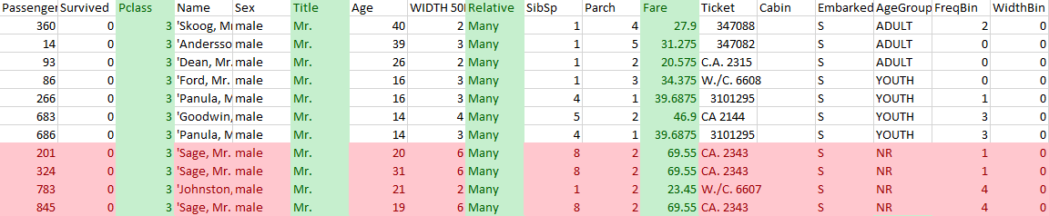

Similar filtering of dataset is done with the test set to resolve the missing age value and the missing fare value.

# Modeling and Evaluation

a. Total instances in the test file: 418  
b. Number of persons predicted to survive (1): 136  
c. Number of persons predicted not to survive (0): 282  
d. Percentage of predicted survival: 32.5%

# Discussion of Results

# Conclusion

# References

|  |  |
| --- | --- |
| [1] | N. Donges, "Predicting the Survival of Titanic Passengers," Towards Data Science, 14 May 2018. [Online]. Available: https://towardsdatascience.com/predicting-the-survival-of-titanic-passengers-30870ccc7e8. [Accessed 13 February 2023]. |
| [2] | I. H. Witten, "The University of Waikato," 2013. [Online]. Available: https://www.cs.waikato.ac.nz/ml/weka/mooc/dataminingwithweka/slides/Class3-DataMiningWithWeka-2013.pdf. [Accessed 13 February 2023]. |
| [3] | T. Facts, D. Fowler and H. i. Numbers, "Titanic Survivor," Titanic Facts, 2023. [Online]. Available: https://titanicfacts.net/titanic-survivors/. [Accessed 13 February 2023]. |

# Appendix 1

### Training Set Male (Mr.)

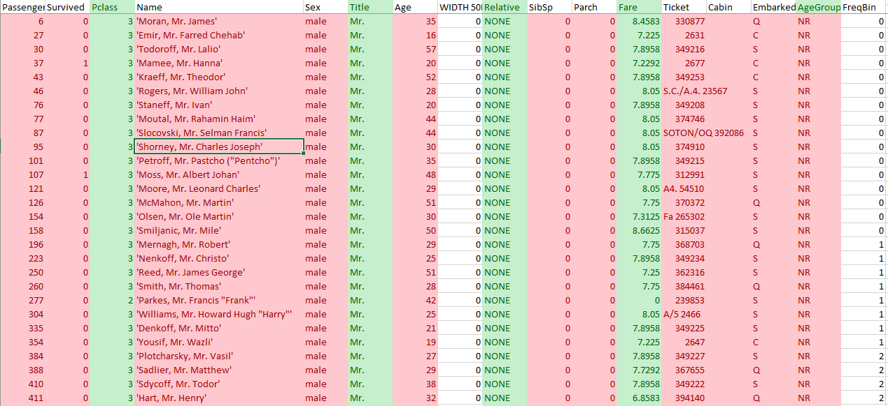

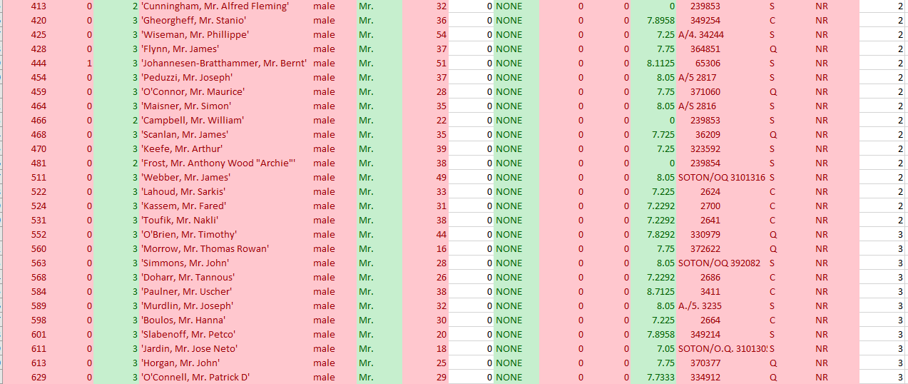

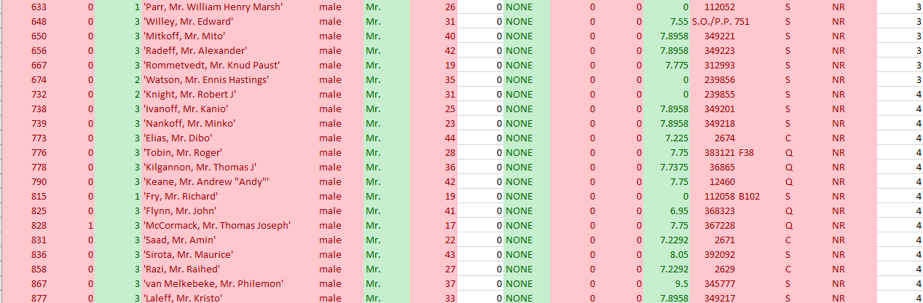

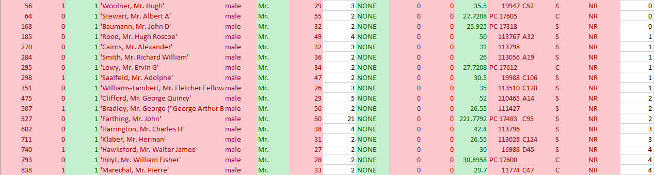

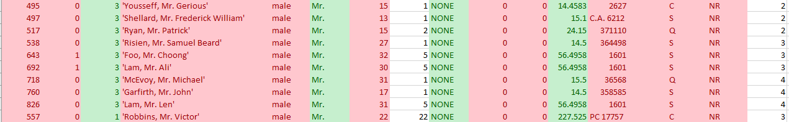

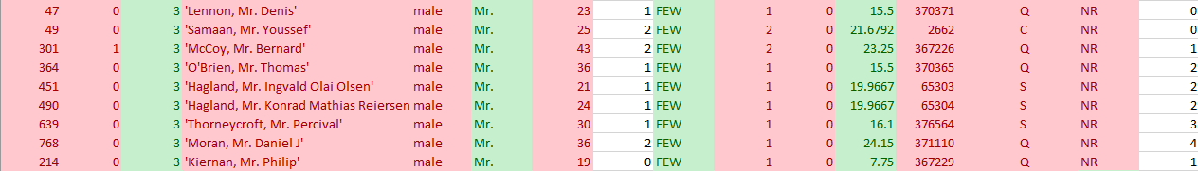



### Training Set Female (Miss)

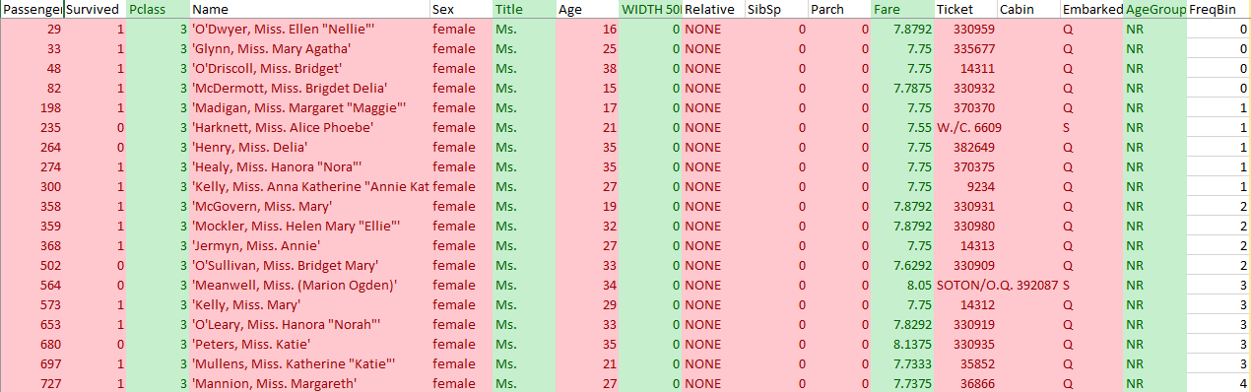



















### Training Set Female (Mrs.)













### Training Set Unique





# Appendix 2

### Test Set All Missing Age Instances

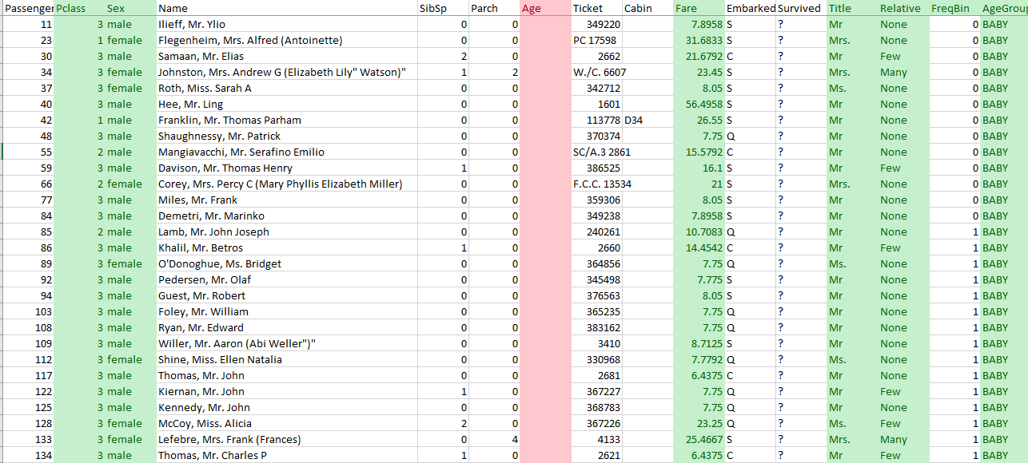

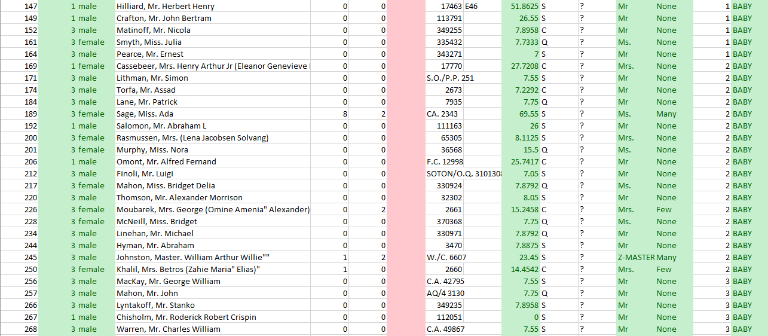

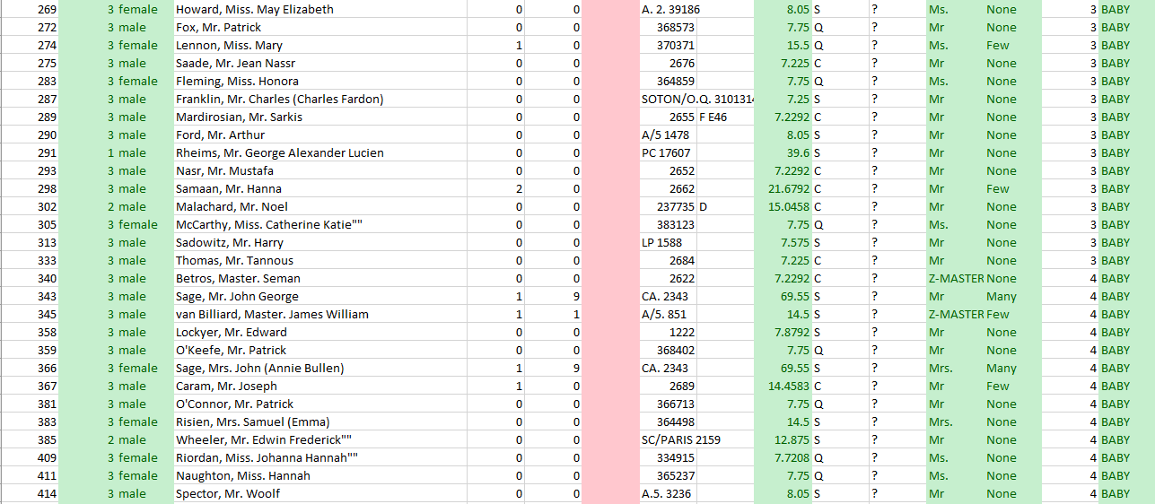



### Test Set Male (Mr.)

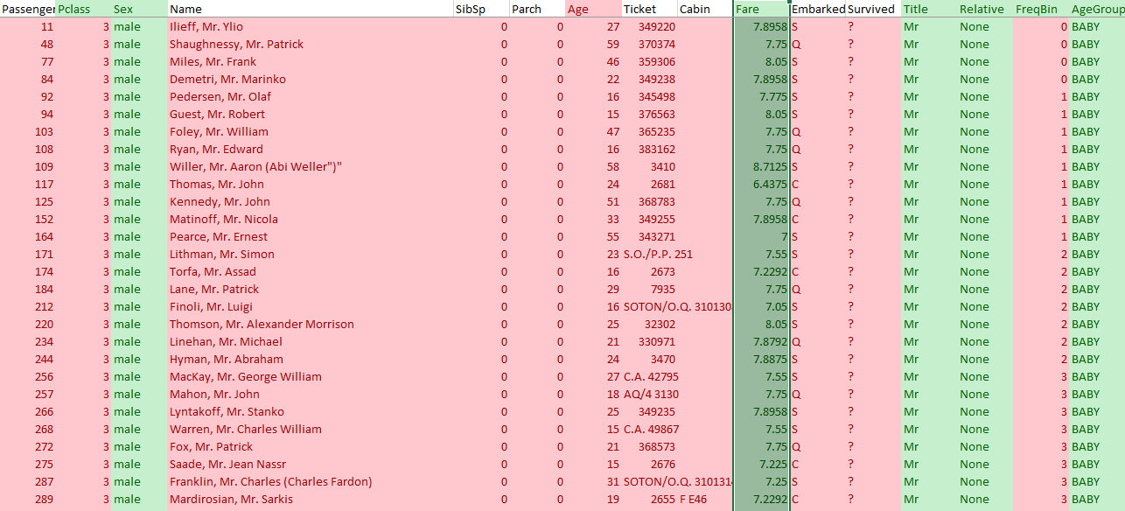

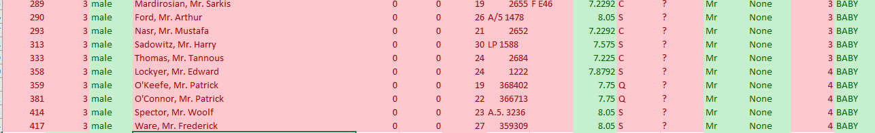























### Test Set Female (Ms.)

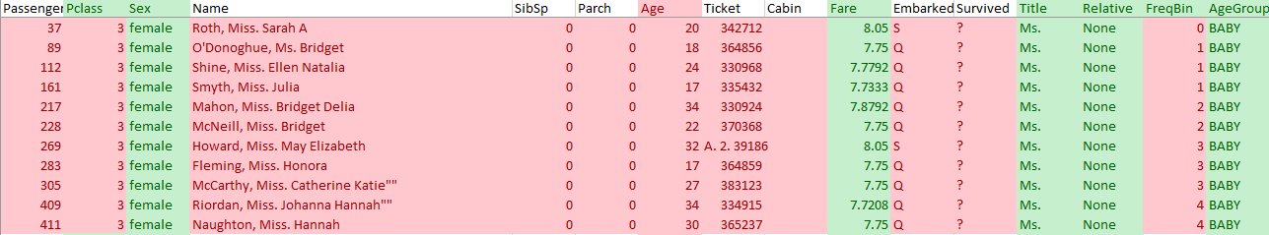









### Test Set Female (Mrs.)















### Test Set Unique





### Test Set Fare Missing

