

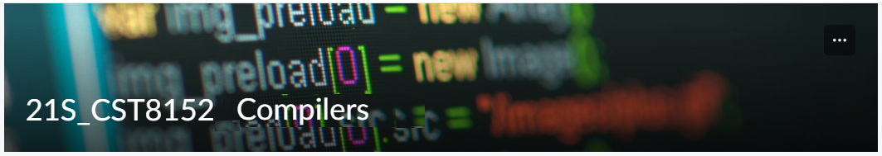

# MODEL TASK**[1]** FOR ASSIGNMENT 2.1 – YOUR LANGUAGE

Team: **Neil Kingdom** - Id: **040967309**

/ **Mohit Nagotra** - Id: **040817484**

* ***Note:*** *This task is part of the Assignment 2 from Compilers Course. Any problem contact your lab professor.*

### PART 1: RE – Regular Expression (1.5 mark)

**Lexeme Classes:** Considering the following syntax:

**Answer:**

**Lexeme Classes (Defined by Alphabets)**

**UL = [A-Z]**

**LL = [a-z]**

**B = {0,1} // Binary digits**

**D = [2-9]**

**DQ = “ //Double quote**

**SQ = ‘ //Single quote**

**P = .**

**LP = $ //Local parameter**

**H = # //Hash**

**EOS = ; // End of statement**

**EOF = EOF //End of file**

**O = [^ULLLBDDQSQPLPHEOSE] //Other**

**//Keywords**

**KEY = {int, float, char, byte, string, bool, void, if, else, while, for, function, return, print, read, true, false, import}**

Here is the RE description of some tokens in SOFIA:

**Answer:**

**Lexemes (Defined by RE)**

**//Literals**

**IL = (B|D)+ //Integer literal**

**FL = (B|D)*P(B|D)+UL? //Optional letter f. Whether or not letter is actually ‘f’ will need to be checked by the parser**

**CL = SQ[^SQ]SQ //Char literal**

**SL = DQ[^EDQ]*DQ //String literal**

**BL = BLB+ //Byte literal**

**//Identifiers**

**LVID = LP(B|D)+ //Local variable identifier eg. $0, $1, $999, etc.**

**VID = UL|LL(UL|LL|B|D)* //General Identifier for methods and/or variable names**

**//Other**

**COM = H[^EHEOSEOF]*EOS //Comment**

*Update: 3rd Oct 2021.*

1. Adapted from resources developed by Prof. Svillen Ranev (Algonquin College, 2019)