**CSYE 7200**

**Big-Data Sys Engr Using Scala**

**Assignment 2**

1. ***from* Method:**

**def** from(start: Int, step: Int): ListLike[Int] =

*LazyList*(start, () => *from*(start+step))

1. **Questions:**

1.(a) what is the chief way by which *LazyList*differs from *Stream*(the built-in Scala class that does the same thing). Don't mention the methods that *LazyList* does or doesn't implement--I want to know what is the *structural*difference.

**LazyList recursively generates the excessive elements.**

(b) Why do you think there is this difference?

**LazyList uses the byname parameters.**

1. Explain what the following code actually does and why is it needed?

def tail = lazyTail()

**Tail is to get the latest generated element in the list.**

**Because there is no real tail for an infinity list.**

1. List all of the recursive calls that you can find in *LazyList* (give line numbers).

**24, 41, 67,80,96,114,129,347,369,385**

1. List all of the mutable variables and mutable collections that you can find in *LazyList* (give line numbers).

**No mutable variables or mutable collections can be found.**

1. What is the purpose of the *zip*method?

**To zip 2 list ListX[x1, x2….] and ListY[y1,y2…] into a new list ListZip[(x1,y1), (x2,y2)…]**

1. Why is there no *length* (or *size*) method for LazyList?

**Because there is no real tail for an infinity list, so the length can be infinity.**

1. **Screenshots:**
2. 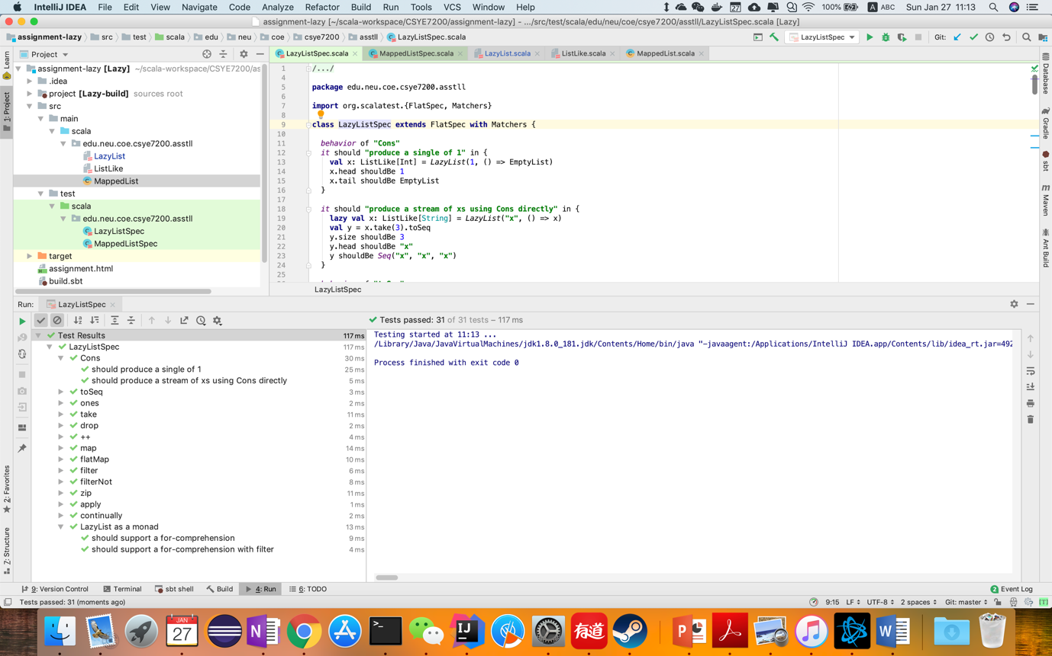**LazyListSpec**
3. **MappedListSpec**

