Drums
This uses piezo-electric buzzers like the ones found in birthday cards. If you apply a changing voltage across them, the buzzer will vibrate and make a sound. If you vibrate the buzzer (by tapping it), it will generate a voltage. This can be detected by the Raspberry Pi.

Before you start
Set up the Raspberry Pi with PyGame and copy the sound files across.

You will need
- Four piezo-electric buzzers
- Four 10kΩ resistors
- A breadboard
- Some jumper leads for connecting things. You'll need mostly male-male, with some female-female to attach to the tilt switches.
- Speakers connected to the Pi's headphone jack to play the sounds.
Use either a Pi Cobbler or a Raspberry Leaf to help identify the pins. If you're using a Pi Cobbler, make sure that the coloured side of the ribbon in in the corner of the Pi. If you're not using a Pi Cobber, you'll need some extra female-female jumper leads to connect the Pi to the breadboard.

Make this circuit

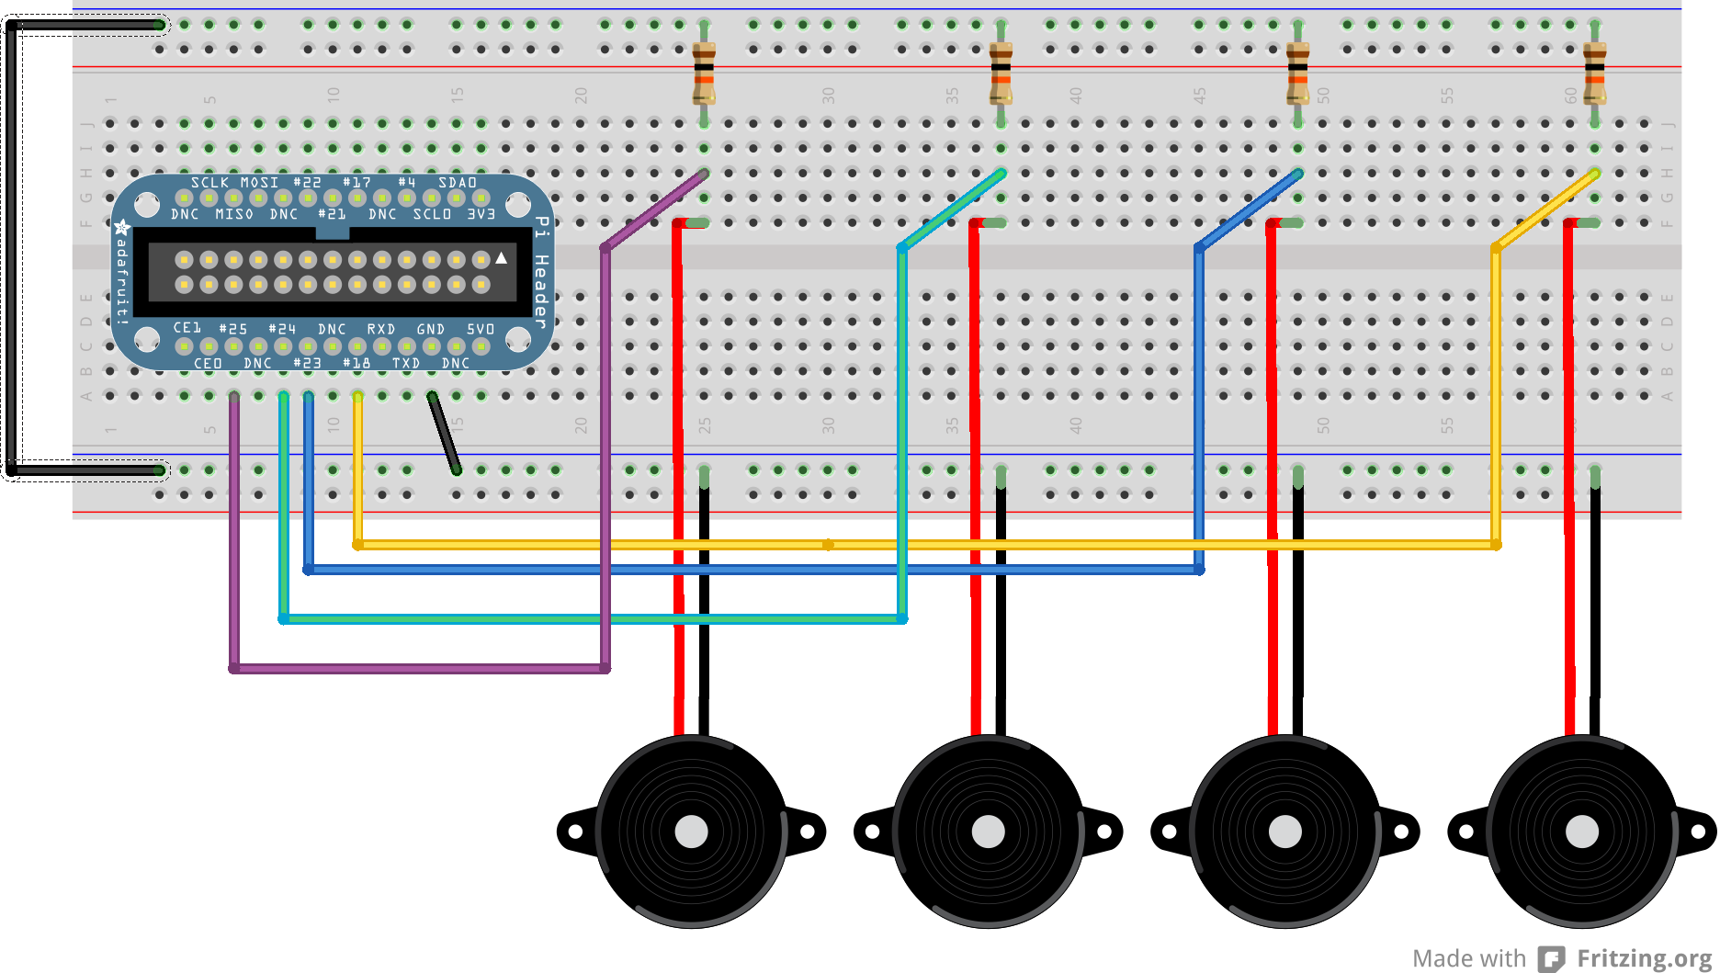
Use pins 25, 24, 23, 18, GND

Enter this program
pi@blackberry:~$ cd pi-music
pi@blackberry:~/pi-music$ nano drums.py
Use nano to enter this code into drums.py

(Layout is important: use four spaces, not tabs, and make sure all the columns line up. Distinguish carefully between () [] {} . , )

import pygame
import RPi.GPIO as gpio

gpio.setmode(gpio.BCM)
pins = [25, 24, 23, 18]

drums = ['sounds/hihat.wav',
'sounds/snare.wav',
'sounds/slowdrum.wav',
'sounds/maracas.wav']

pygame.mixer.init()

sounds = {}
for pin, wav in zip(pins, drums):
sounds[pin] = pygame.mixer.Sound(wav)

def handle_sound(pin):
sounds[pin].play()

for pin in pins:
gpio.setup(pin, gpio.IN)
gpio.add_event_detect(pin, gpio.RISING, callback=handle_sound,
bouncetime=100)

while True:
pass

Play the drums
Run with
pi@blackberry:~/pi-music$ sudo python drums.py

