# Musical Glove

This uses a set of tilt switches to control notes. If you put the tilt switches on long wires, you can strap them to the fingers of a glove. When you wiggle your fingers, you'll trigger the switches and play the different notes.

## Before you start

Set up the Raspberry Piwith PyGame and copy the sound files across.

## You will need

* Four tilt switches
* Four 10kΩ resistors
* A breadboard
* Some jumper leads for connecting things. You'll need mostly male-male, with some female-female to attach to the tilt switches.
* Speakers connected to the Pi's headphone jack to play the sounds.

Use either a Pi Cobbler or a Raspberry Leaf to help identify the pins. If you're using a Pi Cobbler, make sure that the coloured side of the ribbon in in the corner of the Pi. If you're not using a Pi Cobber, you'll need some extra female-female jumper leads to connect the Pi to the breadboard.

## Make this circuit

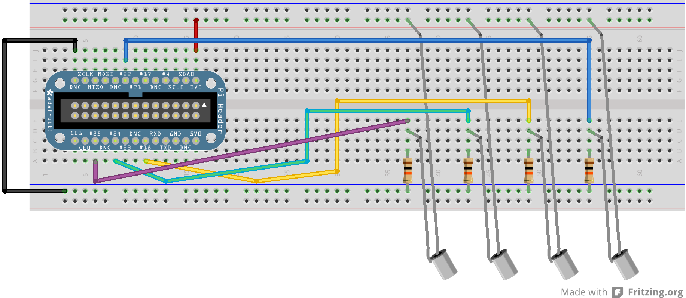

Use pins 25, 24, 18, 22, GND, 3v3

## Enter this program

pi@blackberry:~$ cd pi-music

pi@blackberry:~/pi-music$ nano glove.py

Use nano to enter this code into glove.py

(Layout is important: use four spaces, not tabs, and make sure all the columns line up. Distinguish carefully between () [] {} . , )

import pygame

import RPi.GPIO as gpio

gpio.setmode(gpio.BCM)

pins = [25, 24, 18, 22]

guitars = ['sounds/guitar1.wav',

'sounds/guitar2.wav',

'sounds/guitar3.wav',

'sounds/guitar4.wav']

pygame.mixer.init()

sounds = {}

for pin, wav in zip(pins, guitars):

sounds[pin] = pygame.mixer.Sound(wav)

def handle_sound(pin):

if not gpio.input(pin):

sounds[pin].play()

else:

sounds[pin].stop()

for pin in pins:

gpio.setup(pin, gpio.IN)

gpio.add_event_detect(pin, gpio.BOTH, callback=handle_sound,

bouncetime=200)

while True:

pass

## Play the glove

Run with

pi@blackberry:~/pi-music$ sudo python glove.py