# Keyboard

This uses simple non-latching switches to make a keyboard. When the key is pressed, the note starts. When it's released, the note stops.

## Before you start

Set up the Raspberry Piwith PyGame and copy the sound files across.

## You will need

* Eight non-latching button switches
* Eight 10kΩ resistors
* A breadboard
* Some jumper leads for connecting things. You'll need mostly male-male, with some female-female to attach to the tilt switches.
* Speakers connected to the Pi's headphone jack to play the sounds.

Use either a Pi Cobbler or a Raspberry Leaf to help identify the pins. If you're using a Pi Cobbler, make sure that the coloured side of the ribbon in in the corner of the Pi. If you're not using a Pi Cobber, you'll need some extra female-female jumper leads to connect the Pi to the breadboard.

## Make this circuit

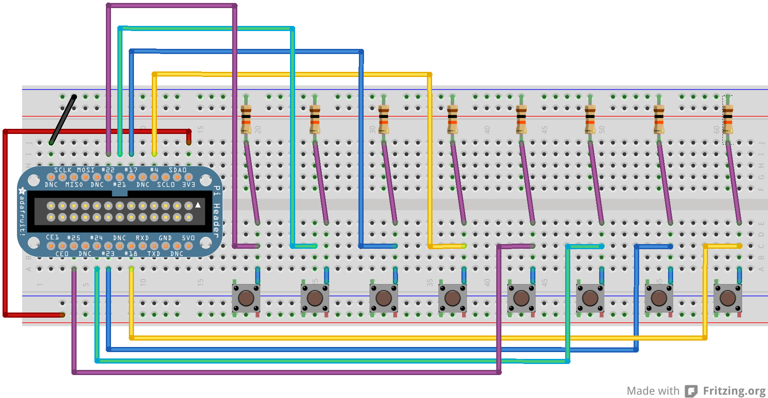

Use pins 22, 21/27, 17, 4, 25, 24, 23, 18, GND, 3v3

## Enter this program

pi@blackberry:~$ cd pi-music

pi@blackberry:~/pi-music$ nano keyboard.py

Use nano to enter this code into keyboard.py

(Layout is important: use four spaces, not tabs, and make sure all the columns line up. Distinguish carefully between () [] {} . , 0 O. Watch the case of letters: i ≠ I and s ≠ S)

import pygame

import RPi.GPIO as gpio

gpio.setmode(gpio.BCM)

if gpio.RPI_REVISION == 1:

pins = [22, 21, 17, 4, 25, 24, 23, 18]

else:

pins = [22, 27, 17, 4, 25, 24, 23, 18]

notes = ['sounds/keyboard-g.wav',

'sounds/keyboard-a.wav',

'sounds/keyboard-b.wav',

'sounds/keyboard-c.wav',

'sounds/keyboard-d.wav',

'sounds/keyboard-e.wav',

'sounds/keyboard-f.wav',

'sounds/keyboard-g-high.wav']

pygame.mixer.init()

sounds = {}

for pin, wav in zip(pins, notes):

sounds[pin] = pygame.mixer.Sound(wav)

def handle_sound(pin):

if gpio.input(pin):

sounds[pin].play()

else:

sounds[pin].stop()

for pin in pins:

gpio.setup(pin, gpio.IN)

gpio.add_event_detect(pin, gpio.BOTH, callback=handle_sound,

bouncetime=50)

while True:

pass

## Play the keyboard

Run with

pi@blackberry:~/pi-music$ sudo python keyboard.py