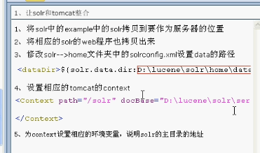

Tomcat



Solr conf



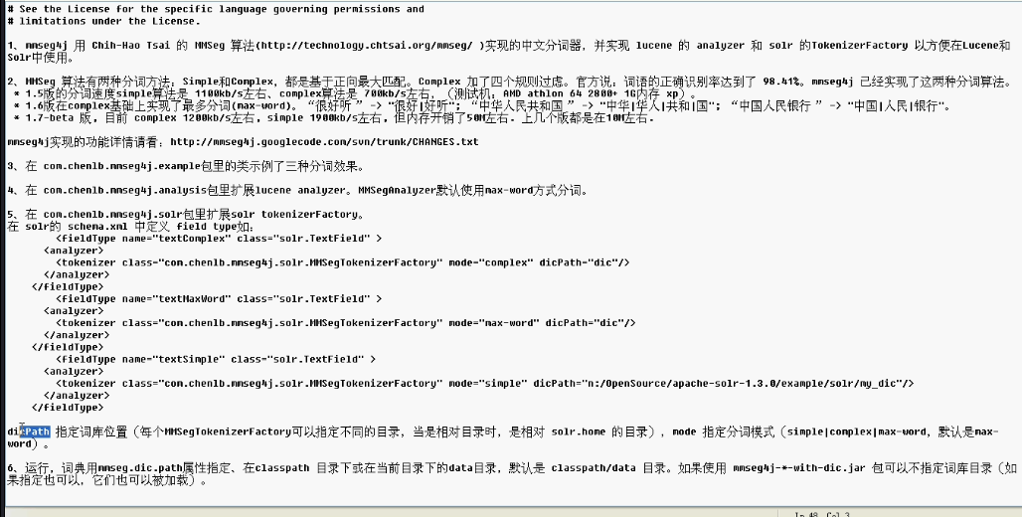

修改Eclipse的编码方式

修改eclipse默认工作空间编码方式，General——Workspace——Text file encoding

[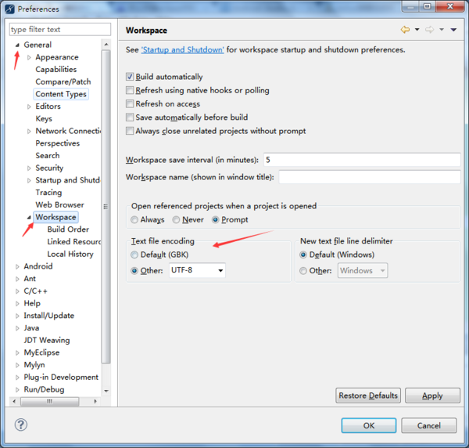](https://gss0.baidu.com/-4o3dSag_xI4khGko9WTAnF6hhy/zhidao/pic/item/b21c8701a18b87d6cbdfbddf010828381e30fd55.jpg)

修改工程编码方式，右击工程——Properties——Resource——Text file encoding

[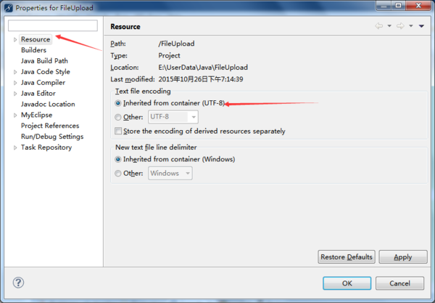](https://gss0.baidu.com/-4o3dSag_xI4khGko9WTAnF6hhy/zhidao/pic/item/96dda144ad345982f6c7f4520af431adcaef84a4.jpg)

修改文件编码方式，和修改工程编码基本一致，右击文件——Properties

[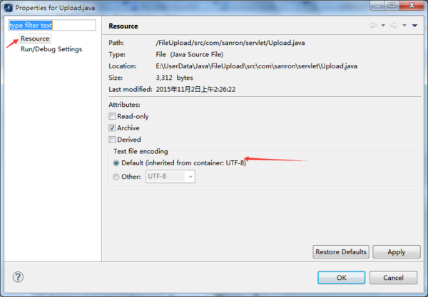](https://gss0.baidu.com/-vo3dSag_xI4khGko9WTAnF6hhy/zhidao/pic/item/3801213fb80e7bec01611221292eb9389a506bb2.jpg)

修改某类文件默认编码方式如.jar，General——Content Types，选择需要修改的[文件类型](https://www.baidu.com/s?wd=%E6%96%87%E4%BB%B6%E7%B1%BB%E5%9E%8B&tn=44039180_cpr&fenlei=mv6quAkxTZn0IZRqIHckPjm4nH00T1YkrHm3nyw9rjc4mWf4P1990ZwV5Hcvrjm3rH6sPfKWUMw85HfYnjn4nH6sgvPsT6KdThsqpZwYTjCEQLGCpyw9Uz4Bmy-bIi4WUvYETgN-TLwGUv3EnHTsn1fzPjD3njczPj6zrHTsn0)，下方的Default Encoding

[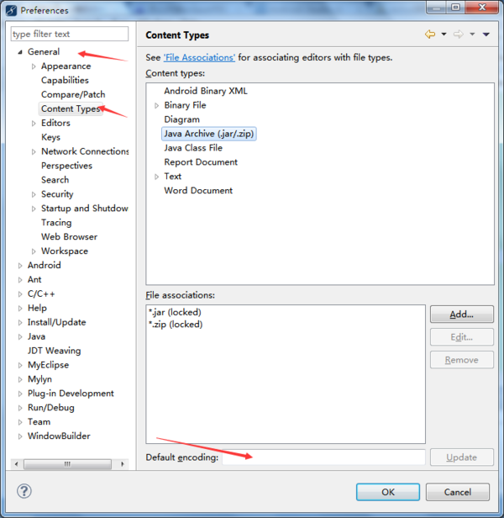](https://gss0.baidu.com/-fo3dSag_xI4khGko9WTAnF6hhy/zhidao/pic/item/b64543a98226cffcc8c5ae72bf014a90f703ea07.jpg)