**ECE 540 FINAL PROJECT PROPOSAL**

Project Name: Extending RojoBot Capabilities and Graphics

Engineer 1: Binata Bhattacharyya

Engineer 2: Neil Roberts

Engineer 3: Brian Dharmanto

Engineer 4: Chad Klingbeil

Project Description [what are you going to build? What component(s) will you use? **Include a block diagram of your design as you envision it**]:

Our team’s goal is to extend the RojoBot capabilities and graphics to provide a unique viewpoint of the RojoBot’s transition through the simulated world. Our goal is to extend the video capability, resolution not yet defined, to show a vantage point from inside the bot as it traverses the map. The screen shot will contain the following:

1) A dynamic view of the simulated world, displayed at the top half of the screen.

2) A topographical view of the map, situated in the lower right quadrant of the screen shot, same as provided in proj2.

3) Bot accessories (steering wheel, directional arrows, etc) will be included in the lower left quadrant to show bot behavior / operations

To accomplish extending project 2, we will incoporate or modify the following modules and conditions:

1) Add long-range sensors to front of bot for detection of obstacles more than 1 cell away. Data used to define obstacle size and depth for displaying proper screen image (what would be seen from the driver’s viewpoint). This will require a new definition beyond ProxL/R as identifying obstacles will require a look ahead approach.

2) Extend VGA graphics to represent an image from the bot cockpit. Must incorporate obstacles from simulated map into view that changes as the bot’s movement/orientation changes.

3) Expand bot control to include push button controls (same as project 1) for user interaction when desired. The bot will follow the black line autonomously until the push buttons are depressed, at which point bot control will reside completely within the push buttons. After a short time (e.g. 1s) autonomous control resumes.

Our block diagram is an extended version of project 2 with two additional bot sensors, expanded video capability (resolution to be determined) to facilitate both the bot icon (topographical map) and imagery of simulated world from inside bot. Since we are still in the discovery phase, we have not yet defined the goal for resolution. Rather, we intend to start with the 512x512 requirement from proj2 and expand resolution as we successfully display the simulated world viewpoint.

To add color and a unique image to our simulated world, we will make use of the reserved map value (‘11’) and implement tree structures as additional obstacles. To do this we will need to modify the map(s) to add these structures.

Design Approach How are you going to build it? how will you demonstrate success on the FPGA Development Board? what are your options if you start running out of time?]:

Our goal is to start small and increase our imagery and capabilities as we meet success. Below is an overview of how we intend to proceed:

Primary Goal

Setup screen view as shown with the following limitations:

1. 3-cell wide view from bot cockpit
2. 5-cell deep view from bot cockpit
3. Simulated world images to increment from cell to cell (non-smooth texturing)
4. Topographical map fully functional (replicate proj2 display capabilities)
5. Bot controls (steering wheel, directional arrows/blinkers, undefined indicators) fully functional
6. Push button control movement for first-pass with the goal to ensure we can display the simulated world imagery in the screnshot successfully

Secondary Goal (Short Stretch)

1. Expand long-range sensors (depth and width)
2. 5-cell wide view from cockpit
3. 10-cell deep view from bot cockpit
4. Push button + autonomous control
5. Additional maps, activated per user request (with switches)

Tertiarty Goal (Super Stretch)

1. Full-width viewpoint from bot cockpit
2. 20-cell deep view from bot cockpit
3. Smooth texturing from cell to cell (obstacles and boundaries); may require texturing module.
4. Autonomous control employs locate black line algorithm (search for black line intelligently).

Milestones/Deliverables [How are you going to demonstrate that you’re making progress]:

Week of 11/15: Screenshot definitions complete, all changes/modifications clearly defined, architect / ownership tasks defined with dated deliverables

Week of 11/22 : Screenshot imagery with majority of capabilities working, long-range sensors working, loop map re-defined with tree obstacles, screenshot image blank

Week of 11/29 : All primary goals reached; team working on stretch goals

Week of 12/6 : Demonstration and Final Report

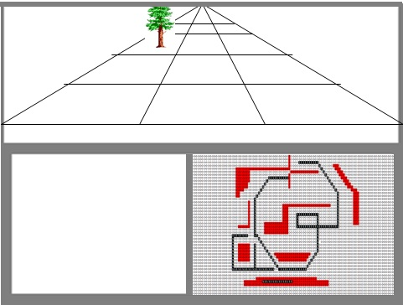

**Figure 1: depiction of screenshot showing bot viewpoint, topographical map view & region for indicators**