SINR Map for a 5G Urban Macro-Cell Test Environment (2020)

Akul Rattan   
*Department of Electronics and Communication Engineering*  
*Manipal Institue of Technology*Manipal, Karnataka  
170907488

Neil Sequeira  
*Department of Electronics and Communication Engineering*  
*Manipal Institue of Technology*Manipal, Karnataka  
170907082

Sushant Lenka  
*Department of Electronics and Communication Engineering*  
*Manipal Institue of Technology*Manipal, Karnataka  
170907474

*Abstract*—We examine how to construct a 5G urban macro-cell test environment consisting of a hexagonal network of 19 cell sites, each containing 3 sectored cells. The signal-to-interference-plus-noise ratio (SINR) is visualized on a map for different antennas. The antennas include single antenna elements, 8x8 rectangular antenna elements and patch antenna elements.

Keywords—Signal to noise ratio, urban cell, antennas, microstrip, patch, transmitter sites

# Introduction

A macro-cell or macro-site is a cell in a mobile phone network that provides radio coverage served by a high-power cell site (tower, antenna or mast). Generally, macro-cells provide coverage larger than microcell. The antennas for macro-cells are mounted on ground-based masts, rooftops and other existing structures, at a height that provides a clear view over the surrounding buildings and terrain. Macro-cell base stations have power outputs of typically tens of watts. Macro-cell performance can be increased by increasing the efficiency of the transceiver. We are constructing a 5G urban macro-cell test environment to visualize the signal-to-interference-plus-noise ratio (SINR) on a map. The test environments are based on the urban environment with high user density and traffic loads focusing on pedestrian and vehicular users. We have taken the 5G core network to include eMBB (enhanced Mobile Broadband). The test environment includes a hexagonal cell network as well as a custom antenna array that is implemented using Phased Array System Toolbox in MATLAB. For the Dense Urban-eMBB test environment, the inter site distance is 200 m. The centre locations are chosen as MathWorks Glasgow, Mumbai and Delhi.

# METHODOLOGY

## Dense urban-eMBB

The Dense Urban-eMBB test environment consists of two layers, a macro layer and a micro layer. The macro-layer base stations are placed in a regular grid, following hexagonal layout with three TRxPs (Transmission Reception Point) each.

## Creating Antenna Elements

Transmitter Parameters:

1. Carrier Freq = 4Ghz for dense urban-eMBB

2. Antenna Height = 25m

3. Total transmit power =44 dB

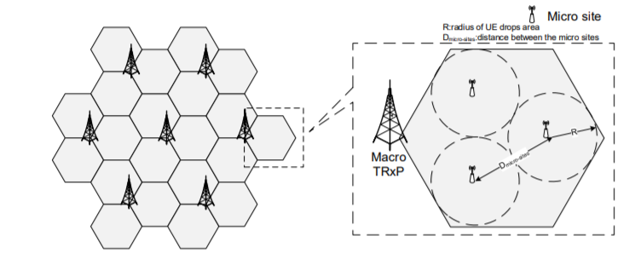

Figure 1: Dense urban-eMBB layout

Antenna Element:

The antenna is modelled as having one or more antenna panels, where each panel has one or more antenna elements.

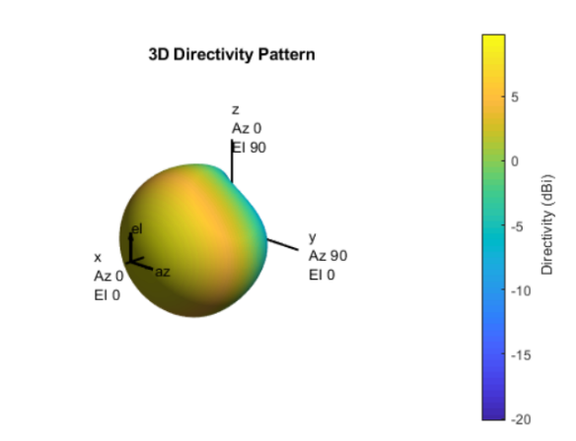

Figure 2: Directivity Pattern of the Antenna Element

## Displaying the SINR Map

SINR is visualized using a single antenna element and the free space propagation model. For each colored location on the map, the signal source is the cell with the greatest signal strength, and all other cells are sources of interference.

Receiver Parameters:

1. Bandwidth = 20Mhz

2. Receiver Noise Figure= 7 dB

3. Antenna Height = 1.5m

# Expected SINR Maps

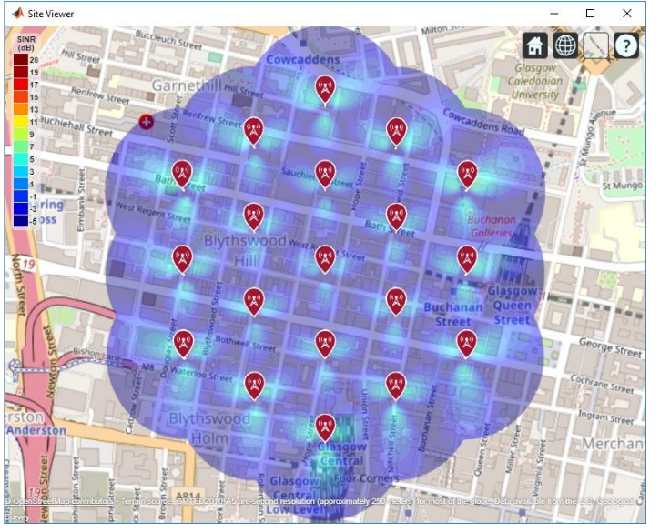

Figure 3: SINR Map for Single Antenna Element

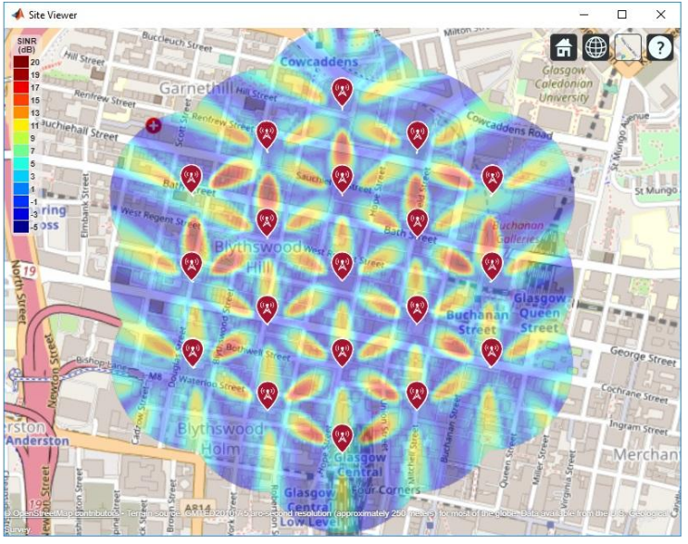

# Project Execution Details

Programming Language: MATLAB

Toolboxes used: a) Phased Array System Toolbox

b) Antenna Toolbox

V. INTRODUCTION TO 5G TECHNOLOGY

5G stands for the 5th Generation of mobile networks. 5G allows for higher data rates, ultra-low latency and lower cost per bit. This allows for widespread integration of not only mobile devices but also a wide range of other devices. As per IMT-20 standards 5G will provide a peak value of 20Gps at larger bandwidths, and a uniform user experience.

VI. 5G VS LTE TECHNOLOGY

The main advantage of 5G over LTE is the higher speeds. This is due to the larger spectrum utilized by 5G and also more advanced radio technology. Also, 5G networks are very efficient in massive MIMO (multiple-input multiple-output) and beamforming. This is due to the use of millimetre wave high frequency bands which has a huge bandwidth and allows a lot of people to be connected simultaneously at high speeds and low latency.

##### References

1. Report ITU-R M.[IMT-2020.EVAL], "Guidelines for evaluation of radio interface technologies for IMT-2020", 2017. https://www.itu.int/md/R15-SG05-C-0057
2. Report ITU-R M.2135-1, "Guidelines for evaluation of radio interface technologies for IMT-Advanced", 2009. https://www.itu.int/dms_pub/itu-r/opb/rep/R-REP-M.2135-1-2009-PDF-E.pdf
3. Sun, S.,Rapport, T.S., Thomas, T., Ghosh, A., Nguyen, H., Kovacs, I., Rodriguez, I., Koymen, O.,and Prartyka, A. "Investigation of prediction accuracy, sensitivity, and parameter stability of large-scale propagation path loss models for 5G wireless communications." IEEE Transactions on Vehicular Technology, Vol 65, No.5, pp.2843-2860, May 2016.

Figure 4: SINR Map for 8-by-8 Antenna Array