Overview of BIT Capital Frontier Lab Intelligence App

The BIT Capital Frontier Lab Intelligence app pulls the latest signals from a series of Frontier AI Labs. The signals are linked with investments currently in the BIT Capital (BitCap) portfolio, indicating how these signals could impact BIT Capital positions as well as the strength of these impacts.

Discussion of the principles of Design

The first design principle for the app was to link announcements to BitCap positions. I did an analysis of BitCap positions across portfolios and settled on the positions within the Technology Leaders portfolio. These positions represent roughly 1.4B € or 47% of BitCap's holdings and announcements by AI Frontier Labs are also most likely to influence these tech-oriented positions, acknowledging that there is overlap in investments across portfolios.

- Aimed to understand how announcements would influence these holdings

- Built the scoring mechanism of the labs with this in mind

Scoring mechanism

The scoring was fit into a series of categories which were linked with BitCap's current holdings.

The event types mechanism answers what kind of event happened. Events have a score ranging from 5 to 0 and include categories like frontier_model_release (5), corporate_finance (4), developer_tooling (2).

The Mechanism category answers how the event transmits to BitCap’s holdings. For the Mechanism category, these were grouped into Compute and Infrastructure Demand, Efficiency and Displacement, Capability and Demand Shape and Structural, with individual categories under each. These were developed collaboratively with Sonnet, with each mechanism linking to a company and with a sign. For example, custom_silicon_substitution is positive for Micron as their product goes into all accelerators, but negative for Nvidia

To get an investment team score we take the event score multiplied the magnitude and confidence of the highest scoring mechanism and normalise.

Practices are specifically for the AI Team and answer what would we do differently, these include integration, evaluation, model_capability, orchestration and serving efficiency. These are also paired with an action score indicating whether the team should adopt, investigate or watch the development.

To get an AI Team score we take the action score and multiply it by the practices score times the confidence and normalise.

The model was asked to grant a confidence score to the rating which it gave. The confidence was based on the evidence found in the document. For every document it scored, the LLM had to support the evidence with a quote. The quotes were then checked by a deterministic process to ensure that the model was not hallucinating a quote.

The confidence scores were multiplied into the overall score, such that low = 0, medium = 0.5, high = 1.0. The multiplier for low was selected empirically based on looking at scored articles where the quoted evidence was weak. Medium was selected as 0.5 to indicate uncertainty and high a 1.0 to indicate certainty.

There are separate scoring prompts for the announcements/articles, papers and posts (GH?). Each prompt is versioned. Prompts were written by Fable 5. In the case of the announcements, the prompts are compared against a gold-test. This serves to test the prompt's agreement, but also to measure variance in the results over time. This second point is discussed further in the

All sources are re-scored when a prompt relevant to that source type changes.

Sources:

- Annoucements - scored how

- Papers - scored how

- GH - filtered and scored

- X (simplified selection, lab leads) - filter (leads), scoring how?

Pipeline

The pipeline is maintained by a yaml file indicating the cadence, cost limits and the relative frequency of certain runs. Additional parameters include retry parameters.

Render.yaml declares the pipeline as a cron service whereby it is run on schedule every morning at 5am. It can also be run manually in the Pipeline tab of the tool. When running manually, the user can select to just run specific parts of the pipeline.

The pipeline runs in eight phases in a fixed order. There’s also a per source failure isolation, so if one of the sources breaks, the others can still be processed. 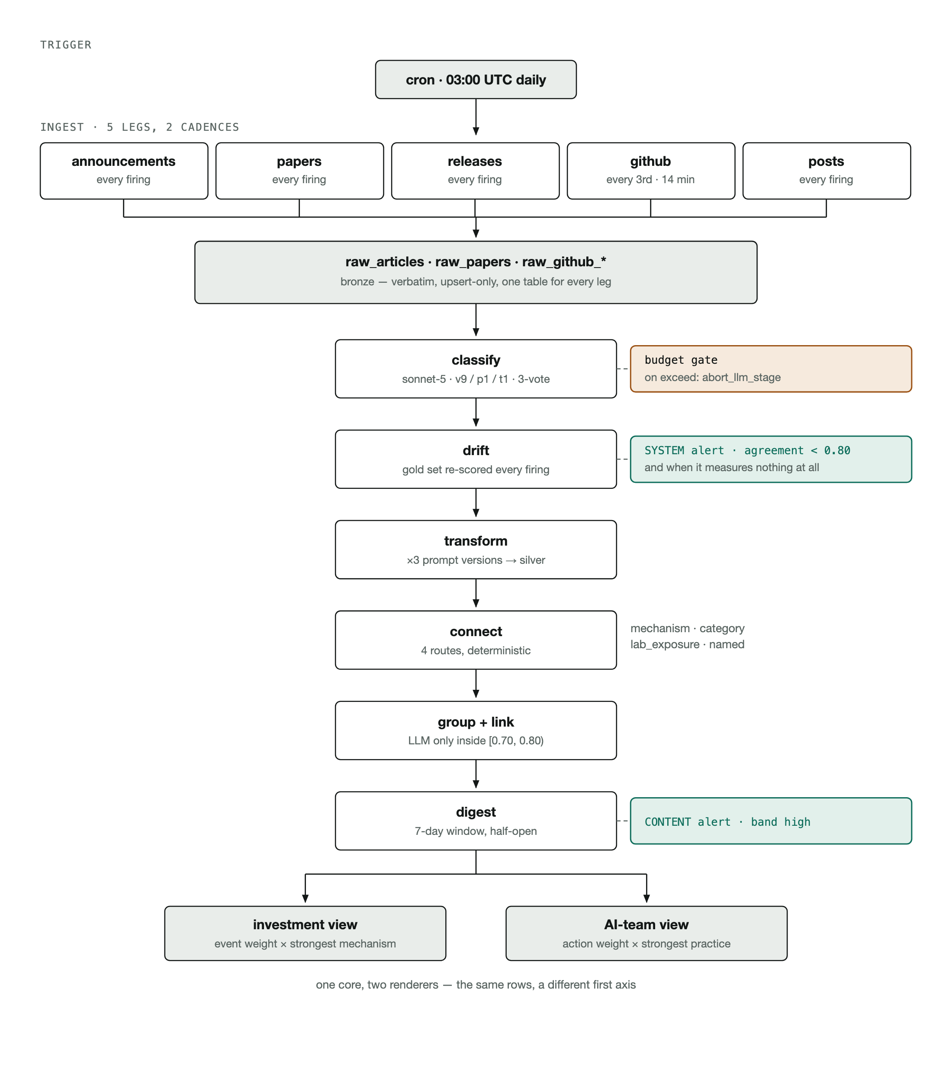
Figure 1The stages of the ETL Ingestion Pipeline

The data is also processed in a medallion archicture
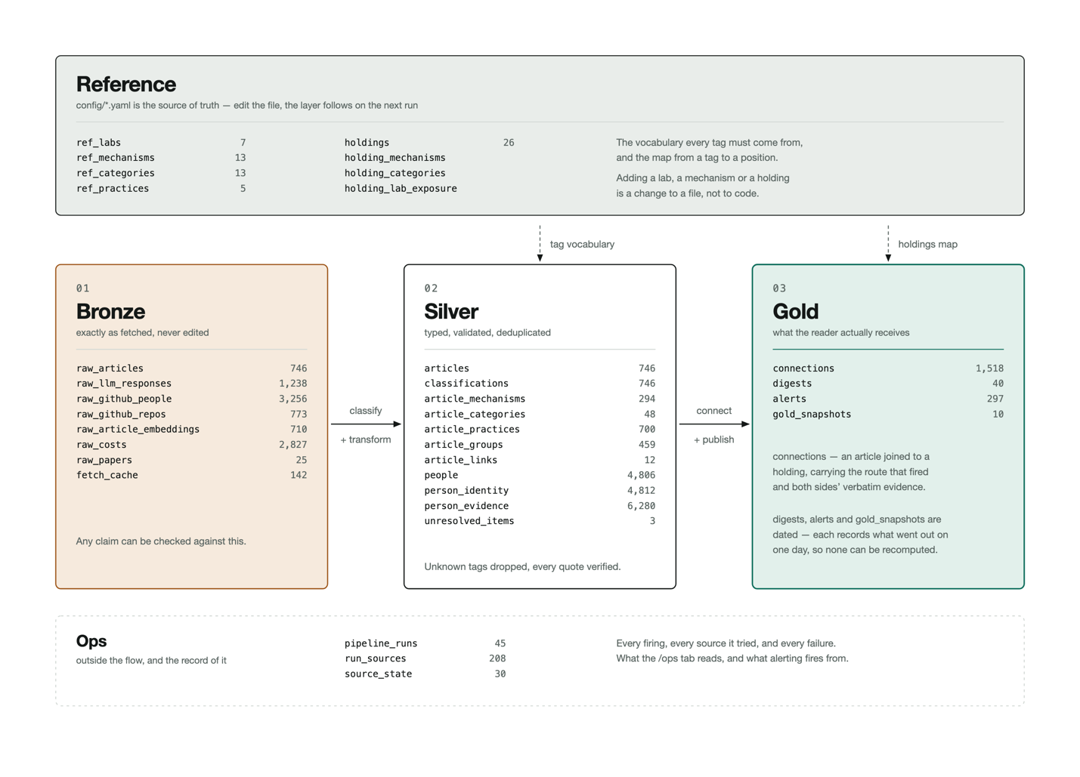
Figure 2 The Medallion architecture
- Cadence

- Costs
- Grouping articles (pipeline)

The pipeline run can be checked in the system health tab in the app. It indicates which parts of the pipeline ran with and without errors. There is also a drift check which compares the model’s output to a gold set of examples. The drift reports the

System Health

The system health tab enabler

- Comparing with the gold set (understand what Micro-F1 is!)

Model selection

To score the sources, namely lab announcements, github releases, X-posts and papers, Sonnet 5 was used. Sonnet 5 was compared against Haiku 4.5 and GPT5-mini on the gold set of announcements over three runs. Haiku was removed because it consistently scored an important article 0. GPT5-mini was removed because of a very high variances with its results across runs.

As noted above, a drift report is run nightly and can be run on command to compare the results from the lab announcement scoring model with the gold set. I acknowledge that there is variance on these results and that the current score, generally around 0.85 Micro-F1 could be improved. I tested a version of the scorer that runs three times on each article and scores based on the majority label with both Sonnet 5 and GPT5-mini. Sonnet 5 performed well, but the variance was still very high with GPT5-mini. This cost of this was however too high in development where I was regularly rescoring the whole 3 months of the corpus. If I had more time, I would have moved over to this scoring method for the sources.

Due to the length of the announcements being scored, I tried to see if it was possible to first summarise them and then score them. I tested summarisation with Sonnet 5, Haiku 4.5 and GPT5-mini, however there was significant degradation of the results on the gold set and the token saving was small – less than 20% per announcement / article on average. This was due partly to the length of the classification prompt. A significant cost saving (~50%) was achieved by applying prompt caching to this prompt first.

For choosing which Frontier AI Lab repos might be relevant to the AI team, the repos are classified using GPT5-mini. GPT5-mini was chosen over Haiku 4.5 for this task based on the results on a set of labelled repos, labelled by Fable 5. The Fable labels were validated by comparing them to a subset of 20 items from this list that I had hand scored where agreement was 95%. Sonnet 5 was not tested for this task. Note this was a filter stage. Once filtered, the repos were then scored by Sonnet 5.

Development cycle

I started off with a planning document based on the case-study and sketched out the high-level steps for the project. I clearly stated in the planning document that every decision needs to be recorded in a decisions document. I also indicated that unit tests must be written for everything the agents do.

Each part of the pipeline started with an interactive research session with a Claude agent. Sources,

I ran different agents in different work-trees simultaneously to work on different features. Along with tracking all key decisions in the decisions document, the agents also wrote short handover documents for other agents once a larger feature was complete. This helped the agents to maintain context throughout the project as it developed.

- Plan, write, code-reviewer, write, code-reviewer, commit and PR
I cycled in a loop of using planning mode to define a feature to be worked on, then having the agent write the code, pass it to a code reviewer agent, make the changes, often call the code reviewer again, make final changes and then submit a PR.

As part of the CI process, a separate suite of unit tests are run that must be passed for every push and PR. The agent runs these tests before pushing and they are run again on GitHub for the push and for any PR.

The app is deployed to Render. Whenever a merge happens on deployment branch (a renaming of main), the app is deployed to Render.

Next steps and improvements

- Incorporating additional sources

- Moving the scoring the most common occurring of three (how to deal with a tie-breaker)

