Halloween Glowstick TRAIL

Red/Orange: ABOUT 1KM
bLUE/gREEN: aBOUT 2KM
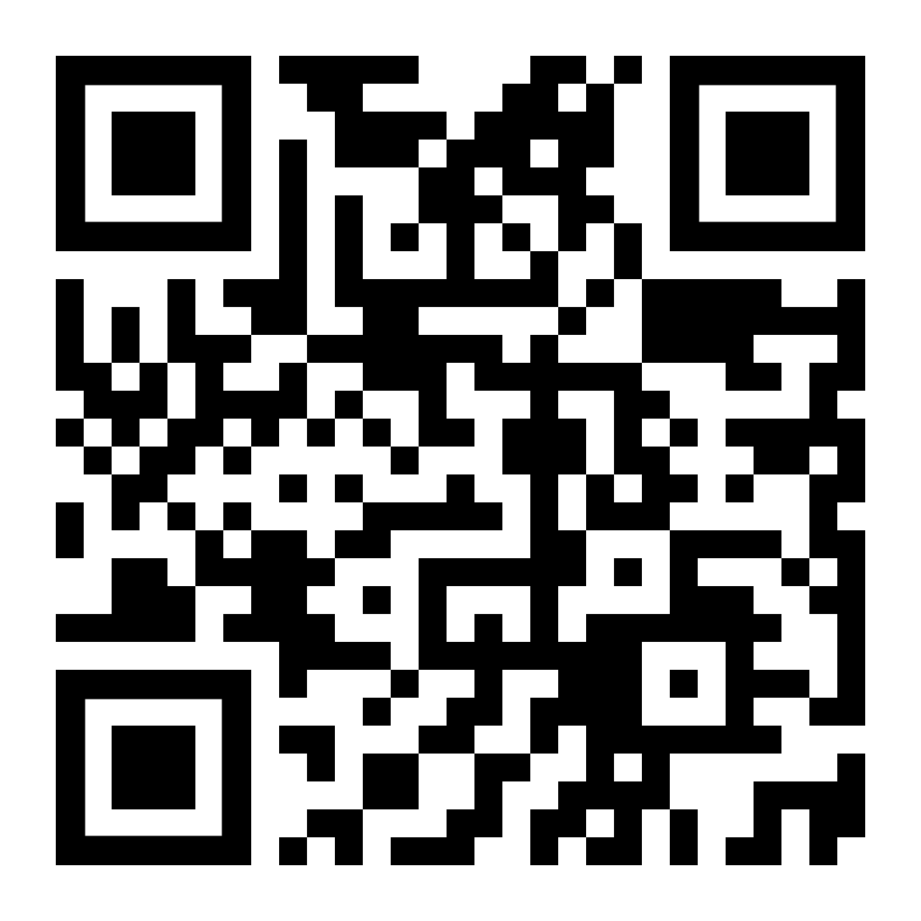

Scan the QR code or visit shorturl.at/abvPT for extra entertainment.

