**Worksheet: Material balances in liquid-liquid extraction**

**Name(s) ______________________________________**

This experiment applies material balances to a liquid-liquid extraction process in which water as a solvent contacts an acetic acid/chloroform mixture in a steady-state counter flow experiment. Because acetic acid is much more soluble in water, it is extracted from the chloroform organic phase into the aqueous phase.

**Student learning objectives**

1. Be able to apply mass balances to a three-component system.
2. Be able to use phase equilibrium data to partially generate the phase envelope on a ternary phase diagram.
3. Be able to explain what happens during liquid-liquid extraction.

**Equipment**

The system consists of three stages where the aqueous phase contacts the organic phase in counter-current flow. The phases leaving each stage are in phase equilibrium.

S = solvent

F= feed

E = Extract

R = Raffinate

The water solvent extracts acetic acid solute from the organic feed (acetic acid, chloroform, and a small concentration of water). The raffinate phase is enriched in chloroform because acetic acid is removed from it.

**Questions to answer before starting the experiment**

How many independent mass balances can you write for each stage of this liquid-liquid extraction? Explain.

The two phases contact each other in a counter-current flow. What might be the advantage of counter-current flow over co-current flow?

Would you expect the feed stream (acetic acid, chloroform, water) to increase or decrease its flow rate as it flows down the extraction system? Why?

Would you expect the water solvent stream system to increase or decrease its flow rate as it flows up through the extraction? Why?

**Before starting**

The solvent only contains water. The mass fractions of the three components in the feed are:

|  |  |
| --- | --- |
| Component | Mass fraction |
| Acetic acid | 0.52 |
| Chloroform | 0.43 |
| Water | 0.05 |

**Procedure:**

1. Turn on the solvent pump and open the solvent valve to start solvent flow into the extraction system. After a time delay the feed pump will start and the feed valve will open.   
The solvent valve is open in this position 

2. Note that the intensity of the color in the flow streams is proportional to the concentration of acetic acid in that stream.

3. Allow time for the system to reach steady state and liquid to accumulate in the extract and raffinate tanks, and then determine the flow rates of the two feed streams and the two exit streams by recording the change in the volumes of each of the four tanks while recording the time elapsed with your phone. Record values in the Table below. You may not be able to measure all four flow rates in one experiment. To increase the accuracy of your volume measurements, zoom with the scroll wheel and drag your mouse to move the image.

4. Determine fluid densities in the four tanks by moving your mouse over the tank with fluid in it.

5. Calculate volumetric and mass flow rates and enter them in the Table.

|  |  |  |  |  |  |
| --- | --- | --- | --- | --- | --- |
| Tank | Elapsed  Time (s) | Volume  Change (mL) | Density  (g/mL) | Volumetric flow rate (mL/s) | Mass flow rate (g/s) |
| Feed |  |  |  |  |  |
| Solvent |  |  |  |  |  |
| Extract |  |  |  |  |  |
| Raffinate |  |  |  |  |  |

6. Repeat these measurements

|  |  |  |  |  |  |
| --- | --- | --- | --- | --- | --- |
| Tank | Elapsed  Time (s) | Volume  Change (mL) | Density  (g/mL) | Volumetric flow rate (mL/s) | Mass flow rate (g/s) |
| Feed |  |  |  |  |  |
| Solvent |  |  |  |  |  |
| Extract |  |  |  |  |  |
| Raffinate |  |  |  |  |  |

7. Calculate average mass flow rates

|  |  |
| --- | --- |
| Tank | Average mass flow rate (g/s) |
| Feed |  |
| Solvent |  |
| Extract |  |
| Raffinate |  |

Measure the compositions of each of the streams by moving your mouse over the stream.

|  |  |  |  |  |
| --- | --- | --- | --- | --- |
|  |  | Mass fractions | | |
| Stream |  | Acetic acid | Chloroform | Water |
| E1 |  |  |  |  |
| E2 |  |  |  |  |
| E3 |  |  |  |  |
| R1 |  |  |  |  |
| R2 |  |  |  |  |
| R3 |  |  |  |  |

**Data Analysis:**

Do an overall mass balance on the system. That is, determine the total mass of the feed tank and the solvent tank at the beginning and determine the total mass in the four tanks after most of the feed tank contents have been fed to the system.

Total mass at beginning: ____________________

Total mass when stopped feed: _______________

Percent difference: _________________

Do an overall mass balance for each species

Total mass of acetic acid at beginning: ____________________

Total mass of acetic when stopped feed: _______________

Percent difference: _________________

Total mass of chloroform at beginning: ____________________

Total mass of chloroform when stopped feed: _______________

Percent difference: _________________

Total mass of water at beginning: ____________________

Total mass of water when stopped feed: _______________

Percent difference: _________________

Carry out component mass balance for each stage to determine the flow rates of R1, R2, E2, and E3

|  |  |
| --- | --- |
| Stream | Mass flow rate (g/s) |
| R1 |  |
| R2 |  |
| E2 |  |
| E3 |  |

Plot the flow rates of the streams in each direction and explain the trends.

Plot the compositions of each component for the feed flow stream and explain the behavior.

Plot the compositions of each component for the solvent flow stream and explain the behavior.

The streams leaving each stage (e.g., E2 and R2) are in equilibrium. This means tie lines connect the two composition points that are in equilibrium on a ternary phase diagram. The two points are on the phase envelope. From the exit compositions from the three stages, locate the six points on the ternary phase diagram below and draw as much of the phase envelope as you can.

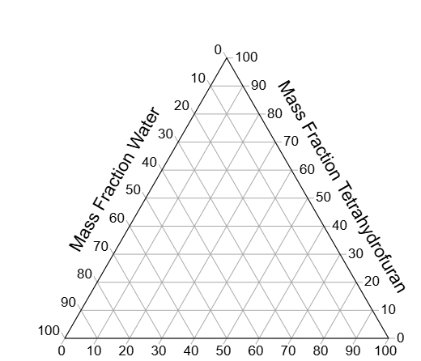

**Questions to answer**

1. Where might these measurement have errors?

2. What safety precautions would you take to conduct this experiment in the laboratory?