Xin Yang

xy213

Report of Homework 4

Q1:

This program using the depth first search to determine if a edge weighted digraph has a cycle in it. If there is no cycle, the program will output “No cycle!”, otherwise it will show “Cycle exists.”. In the given dataset, there is cycle.

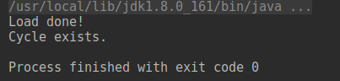

Q2:

This program will by default print the total weight of both Prim’s algorithm and Kruskal’s algorithm. The implementation of Prim’s is based on the eager one.

The performance of Prim’s is better than Kruskal since Prim’s complexity is O(ElogV), which means it will be better for dense graphs, in this dataset, the graph has 250 vertices and 1273 edges, which is a dense graph.

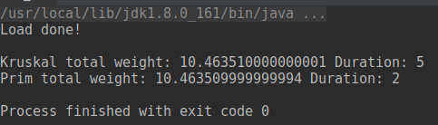

Q3:

I will use topological sort to do the shortest and longest path since it’s a directed graph without directed cycle.

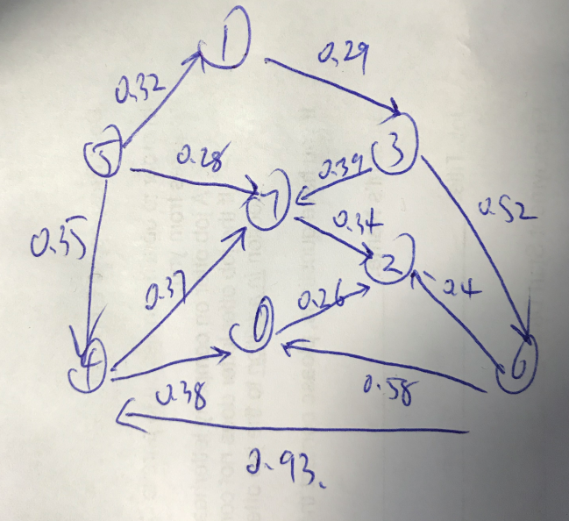

The topological sort is: 5 1 3 6 4 7 0 2.

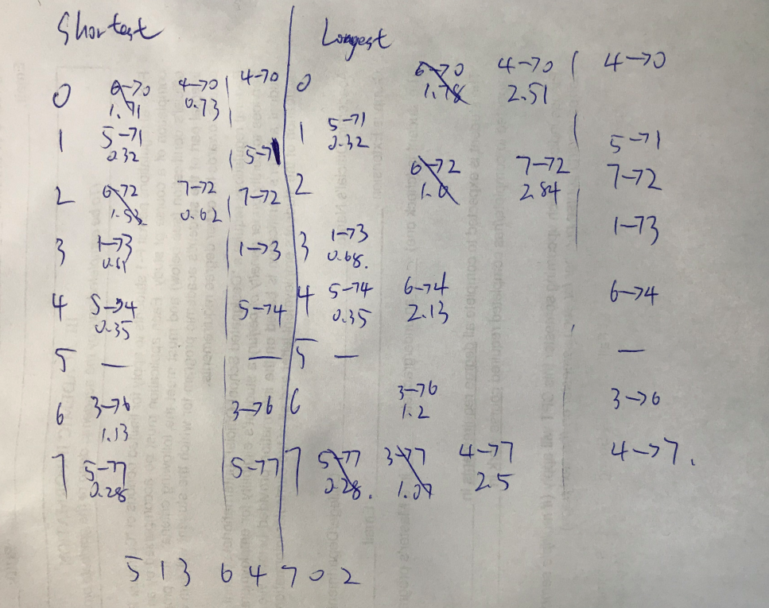

Q4:

(a):

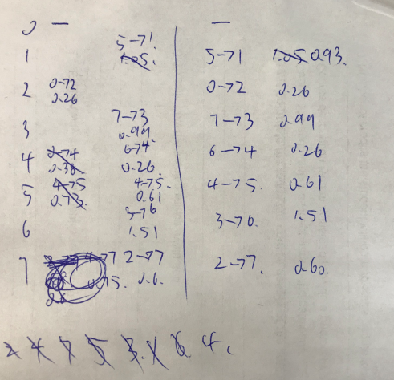

(b):

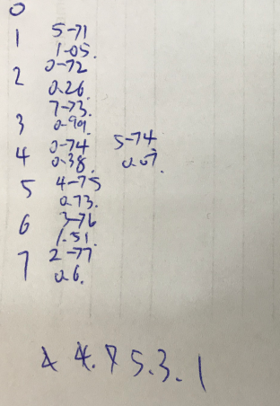

Q5:

This program will print all the steps of both dfs and bfs, and the first number represents the counting number of visited vertices, the last number is the current visited vertex.





Q6:

Running the Djikstra’s algorithm on the datasets from Q4(a) and Q4(b) will both throw an IllegalArgumentException, as there are negative weights in both datasets. If I delete the negative weight detection code, then this program will fall into a dead loop because the negative weight will always decrease the total weights and to the nature of greedy algorithm, the program will keep following the negative weight edge.

