Xin Yang

xy213

HW2

Q1:

For the input of all ones, the results are as below, which is consist with the handwritten part, note that for the handwritten part, all results are kept to two decimal places, but for the programming part, all the calculation are based on Python float number, so there are slight error between the two parts.

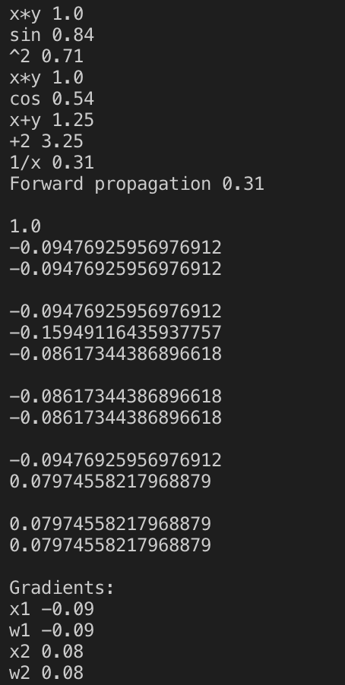

Q2:

For question 2, with all the inputs being ones, the vectorized calculation is based on numpy library, the results are the same as the handwritten part exclude the error caused by different decimal places.

