Xin Yang

xy213

HW4

Result without dropout/batch normalization:

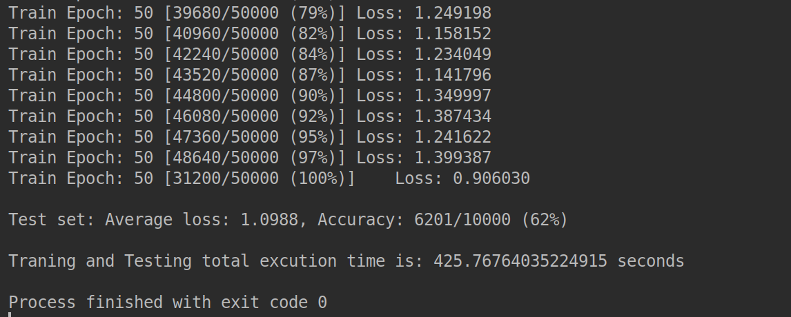

Result with one additional dropout:

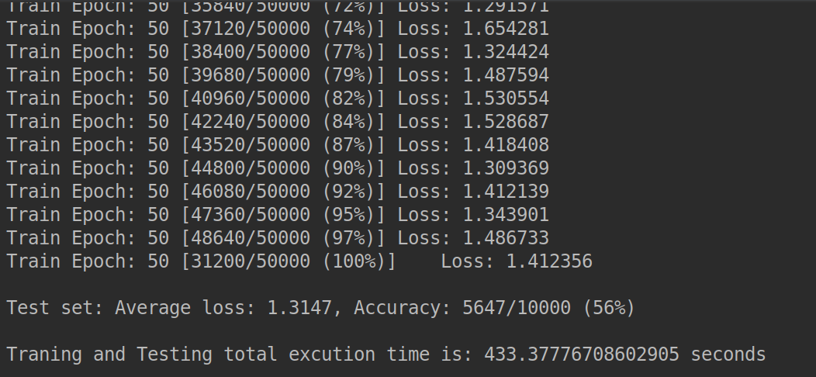

Result with one additional batch normalization:

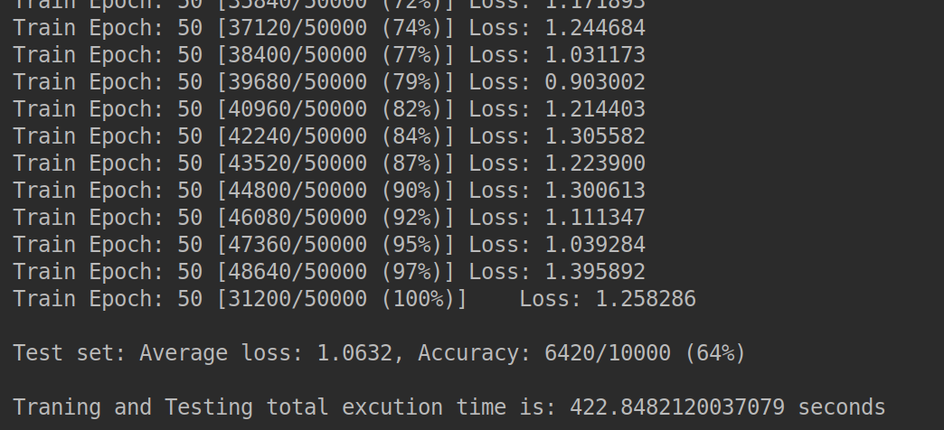

Comparison:

The result of CNN with one dropout layer has the lowest test accuracy of 56%. One possible reason is the dropout layer randomly discards half of the weights, which relieves the overfitting issue, but decreases the accuracy.

The CNN with one batch normalization layer shows a highest accuracy of 64%. The batch normalization is performed before every iteration, which distributes the data in a more uniform way to accelerate the convergence.

The performance without dropout/batch normalization layer shows a 62% accuracy, which is between the one with dropout layer and the one with batch normalization layer.