Factor Name vol_priceSum_rinv factor_type market
Start Date 2007-01-04 End Date 2025-08-26
Universe top75pct Benchmark None
Lag Periods 2 Returns Periods for IC 1
Smoothing Periods None Sector Neutral False
----------------------------------------------------------------------------------
Annualized Return 0.1580 Annualized Net Rerturn -0.0081
Annualized IR 2.3305 Annualized Net IR -0.1190
Maximum Drawdown 0.1222 Maximum Net Drawdown 0.6235
Average Turnover 1.1344
Daily Average IC 0.0243 Annualized ICIR 3.3822
Daily Average Rank IC 0.0194 Annualized Rank ICIR 2.5747
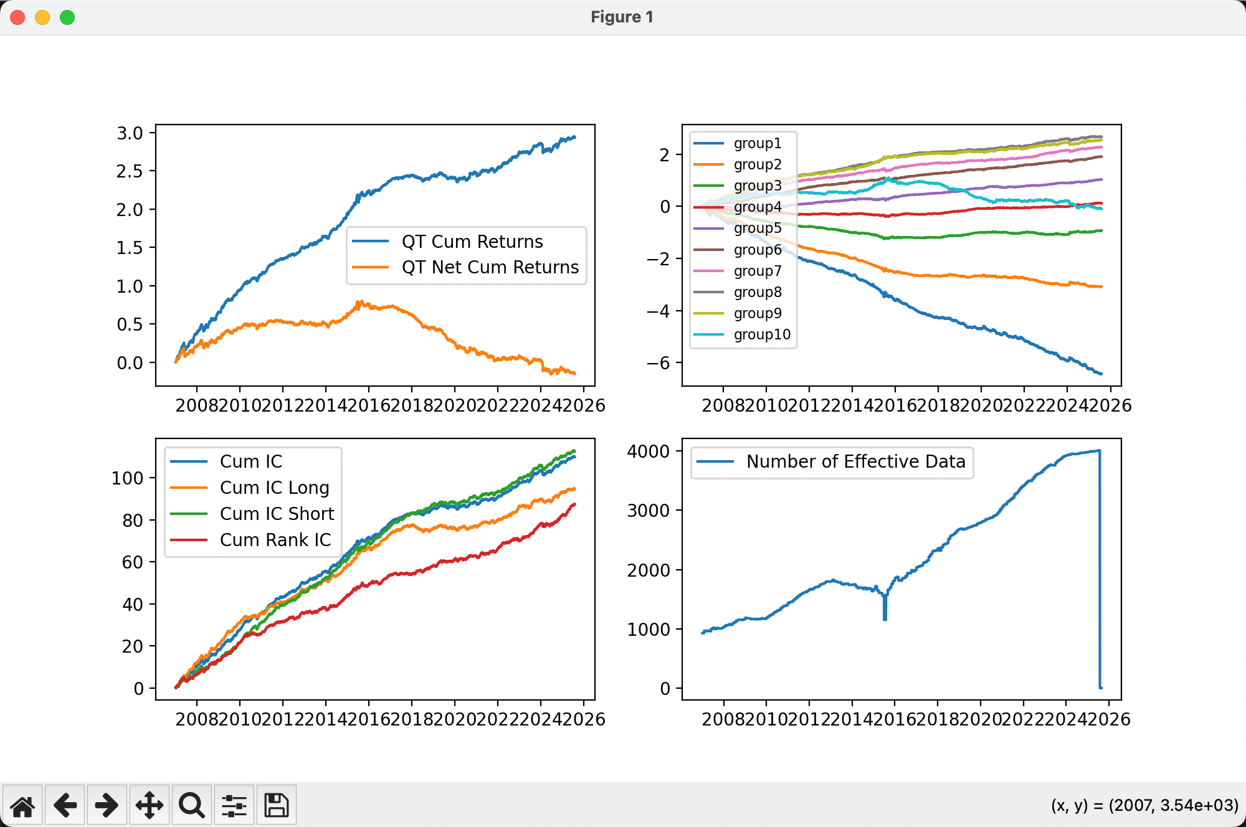
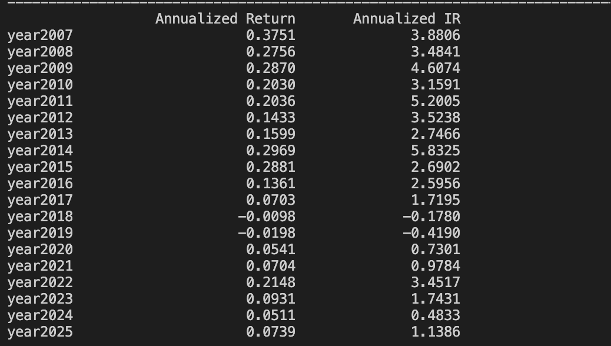

Factor Name vol_std20 factor_type market
Start Date 2007-01-04 End Date 2025-08-26
Universe top75pct Benchmark None
Lag Periods 2 Returns Periods for IC 1
Smoothing Periods None Sector Neutral False
----------------------------------------------------------------------------------
Annualized Return 0.1561 Annualized Net Rerturn 0.1428
Annualized IR 2.4789 Annualized Net IR 2.2675
Maximum Drawdown 0.1510 Maximum Net Drawdown 0.1529
Average Turnover 0.0912
Daily Average IC 0.0149 Annualized ICIR 2.8996
Daily Average Rank IC 0.0250 Annualized Rank ICIR 3.4806

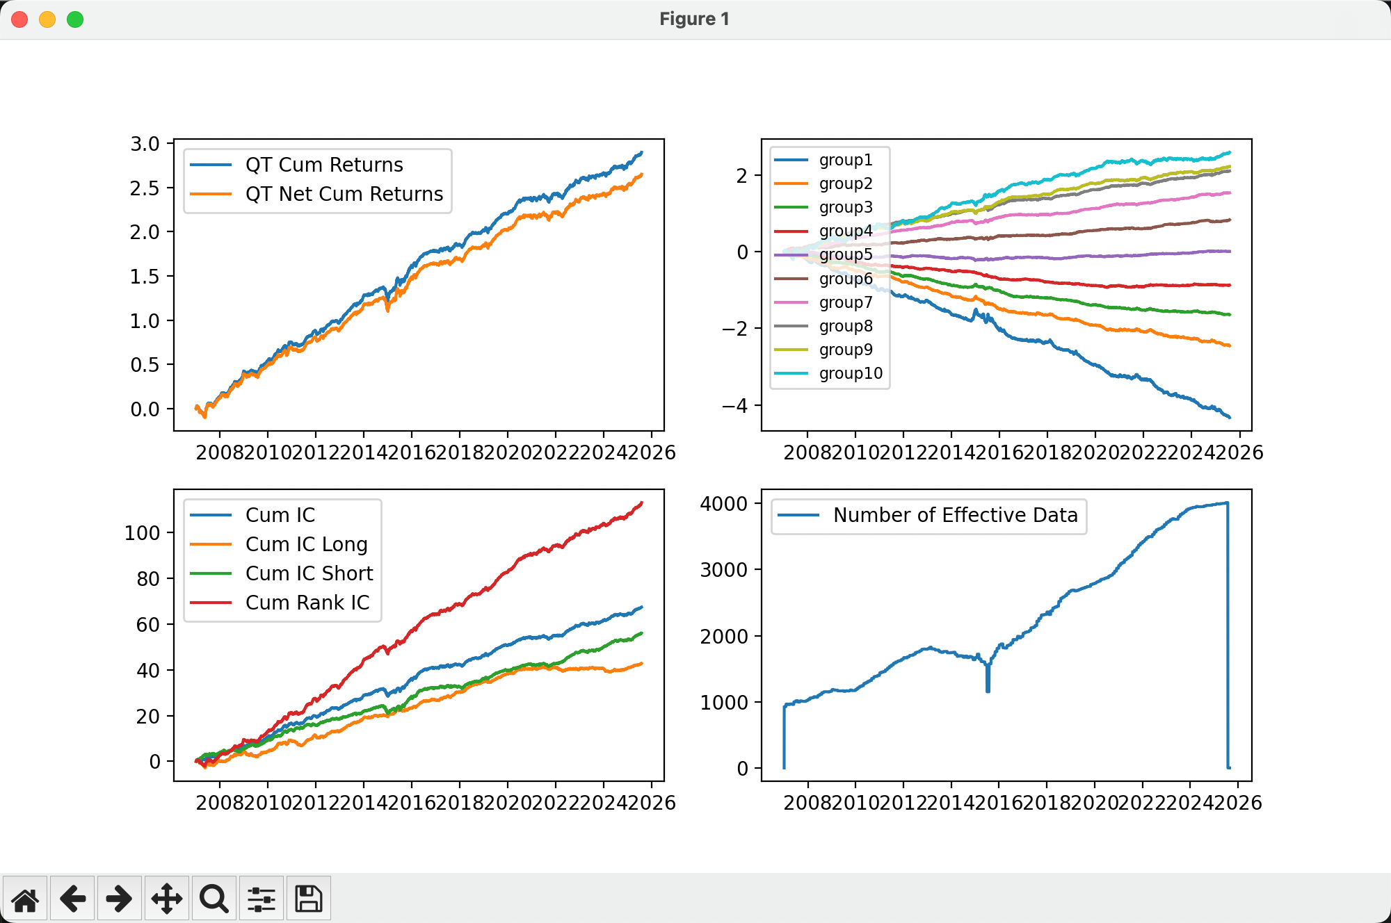
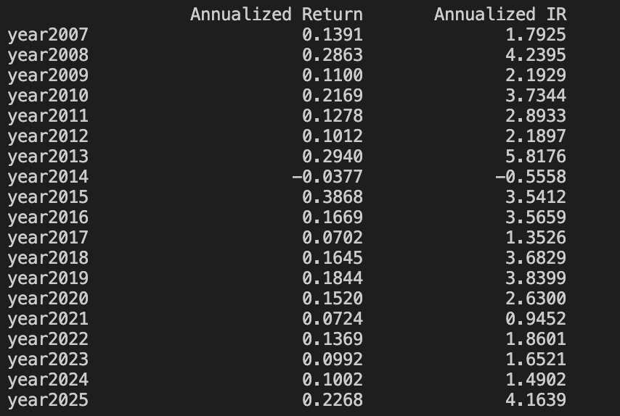
Factor Name ret_sum60_rinv factor_type market
Start Date 2007-01-04 End Date 2025-08-26
Universe top75pct Benchmark None
Lag Periods 2 Returns Periods for IC 1
Smoothing Periods None Sector Neutral False
----------------------------------------------------------------------------------
Annualized Return 0.1355 Annualized Net Rerturn 0.1044
Annualized IR 1.5515 Annualized Net IR 1.1955
Maximum Drawdown 0.1395 Maximum Net Drawdown 0.1480
Average Turnover 0.2112
Daily Average IC 0.0136 Annualized ICIR 1.4845
Daily Average Rank IC 0.0262 Annualized Rank ICIR 2.6397
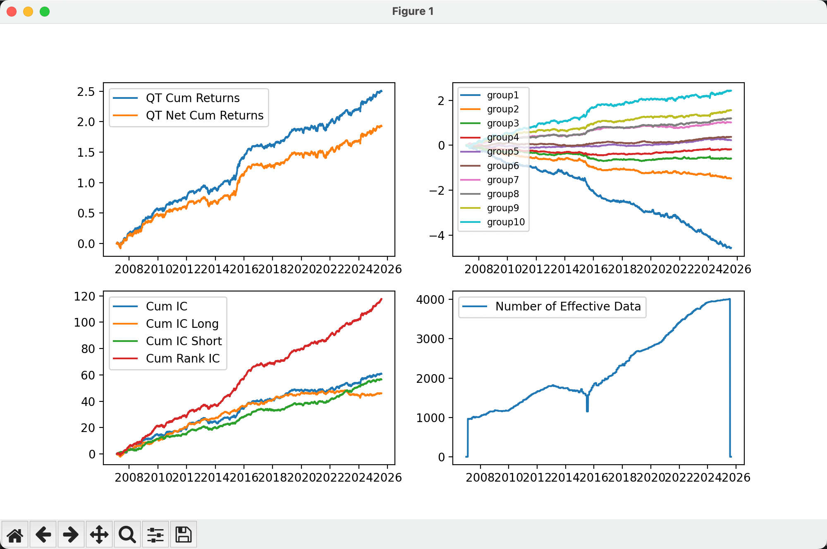

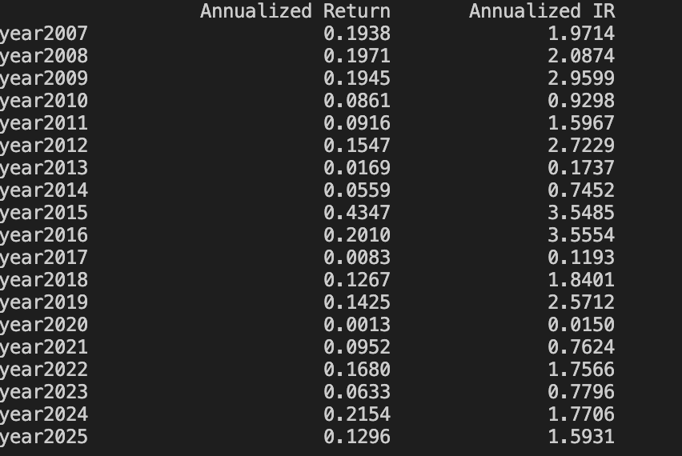
Factor Name ret_20 factor_type market
Start Date 2007-01-04 End Date 2025-08-26
Universe top75pct Benchmark None
Lag Periods 2 Returns Periods for IC 1
Smoothing Periods None Sector Neutral False
----------------------------------------------------------------------------------
Annualized Return 0.1504 Annualized Net Rerturn 0.0990
Annualized IR 1.7380 Annualized Net IR 1.1435
Maximum Drawdown 0.1246 Maximum Net Drawdown 0.1717
Average Turnover 0.3499
Daily Average IC 0.0201 Annualized ICIR 2.2553
Daily Average Rank IC 0.0292 Annualized Rank ICIR 2.9636
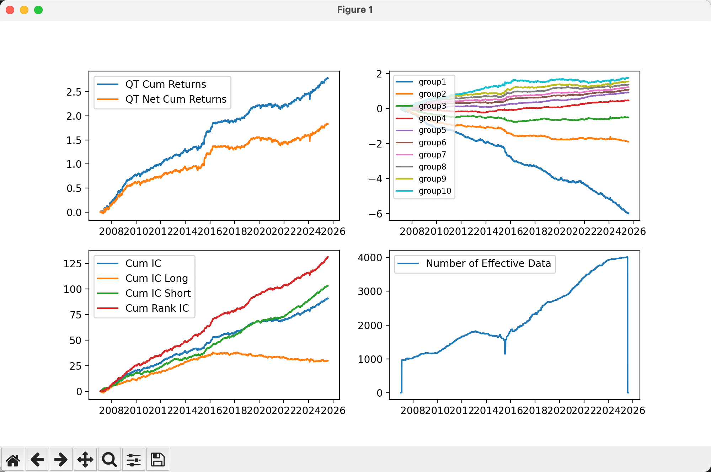

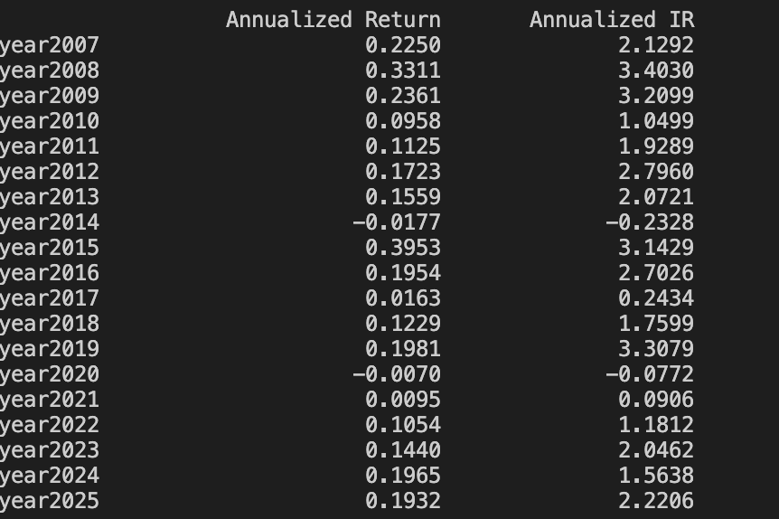

Factor Name std_20 factor_type market
Start Date 2007-01-04 End Date 2025-08-26
Universe top75pct Benchmark None
Lag Periods 2 Returns Periods for IC 1
Smoothing Periods None Sector Neutral False
----------------------------------------------------------------------------------
Annualized Return 0.0537 Annualized Net Rerturn 0.0396
Annualized IR 0.6027 Annualized Net IR 0.4447
Maximum Drawdown 0.2029 Maximum Net Drawdown 0.2143
Average Turnover 0.0960
Daily Average IC 0.0024 Annualized ICIR 0.3330
Daily Average Rank IC 0.0175 Annualized Rank ICIR 1.6115
