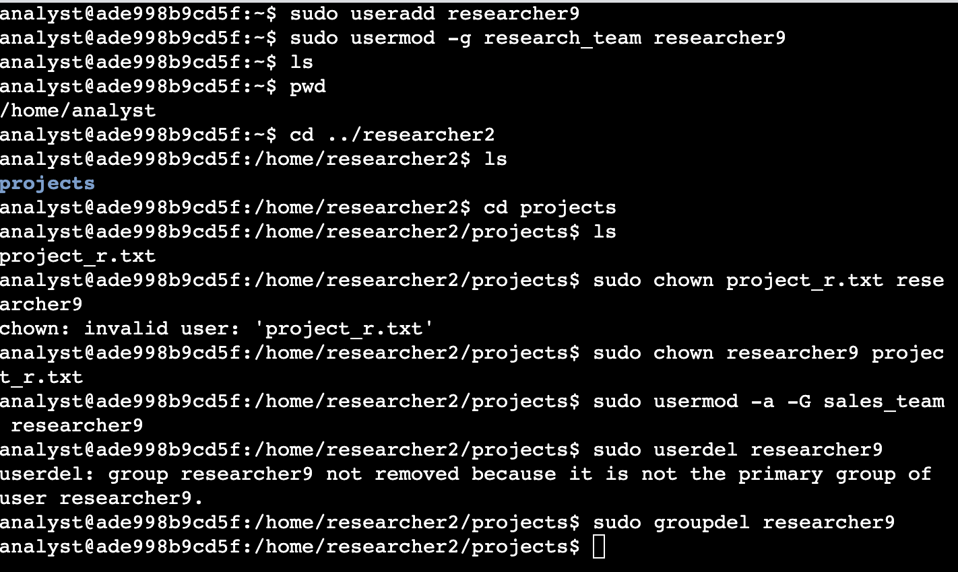

In this file I played around with creating a new user, adding him to a primary group and a secondary group. I then gave this new user ownership of somebody else’s file and finally I deleted the user from the system and the group that was made by default when the user was created.

The main commands of focus here are ‘useradd’ to add a user. ‘usermod’ to change the users participation in the different groups and subgroups. ‘userdel’ to delete and remove a user from the system. ‘chown’ to change ownership of a file to another user within the system. And ‘sudo’ also known as ‘superusers do’ to grant myself the elevated privileges to be able to perform such tasks that normally only the root user would be able to do.

This was very insightful for me and has made me much more comfortable in using the OS.