Developed by:

Name: NEIL MARCEL JERRY J Reg. No.:R211174600046



**PCS CONSULTANCY**

**PCS CONSULTANCY**

Batch Code: S210167

Start Date: 11/11/2020

End Date: 12/12/2020

Name of the Coordinator: Ms. LOPAMUDRA BERA

Names of the Developer: NEIL MARCEL JERRY J

Date of Submission: 12/12/2020



**CERTIFICATE**

This is to certify that this report, titled **PCS CONSULTANCY** embodies the original work

Done by **Neil Marcel Jerry J** , in partial fulfillment of hes course requirement at NIIT.

Coordinator: Lopamudra Bera

**ACKNOWLEDGEMENT**

I’m thankful to our almighty for showering his blessings on me, which was necessary to complete my project successfully. I’d also like to thank my parents for their constant support and encouragement.

I respect and heartily thank my faculty, **Ms. Lopamudra Bera** for providing me with an opportunity to complete the work under her constant care, motivation throughout this project and during the course of this course. Also, I duly acknowledge the help extended by her as my project supervisor. Her keen interest and valuable ideas guided me all along to complete my project successfully.

**ABSTRACT**

PCS Consultancy is planning to provide business and employment oriented service through skill mapping application that operates via recruiting application. This application will mainly be used for professional networking allowing registered employers to post jobs and employees to post their CVs in such a way that their information is organized and easily accessible to all registered users (job seekers, employers and HR consultants). Users will register themselves in the application and fill in their professional details along with their core competencies, certificates, business requirements, current vacancies etc.,

The application should add the competencies to the skill map, and employers should be able to search relevant profiles for their opening using the key words that should match the profiles entered by the users in the engine. Based on the match, relevant profiles should be shown to the employers with their contact details and international business unit name.

Skill mapping feature is a most prominent feature of this website that will reduce time and effort spent on profile screening and mapping the employees profile with the current business requirements. Overall the consultancy is planning on focusing on the following

**CONFIGURATION**

**Hardware:** System Type: x64-based PC

Processor-Intel(R) Core(TM) i7-8550U CPU @ 1.80GHz, 1992 Mhz, 4 Core(s), 8 Logical Processor(s)

**Operating system:** Microsoft Windows 10 Home

**Software:** Eclipse, MySQL

**TABLE OF CONTENTS**

Chapter 1 – Introduction

1. Aim

1.1 Objectives

1.2 Case Study

Chapter 2 - Project Requirement Specification

1. Literature Research

2.1 Statement of Requirements

2.2 Vision Document

2.3 Project Life Cycle Model

Chapter 3 - Project Analysis

1. Project Plan

3.1 Risk Management Plan

3.2 Weekly Status Report

3.3 Storyboard

3.4 System Architecture

3.5 Business process Model

3.6 Software Requirements Specification

3.7 High Level Use Case Diagrams

Chapter 4 – Project Design

1. Low Level Use Case Diagrams

4.1 User Interface Design

4.2 Systems Input and Output Design

4.3 Database Structure

4.4 Entity Relationship Diagram

4.5 Data Model

4.6 Class Diagrams

4.7 Activity Diagrams

4.8 Sequence Diagrams

4.9 User-Centered Interface Designs

4.10 Personas

4.11 Paper Prototypes

4.12 Web Interfaces

4.13 Change Request Form

Chapter 5 –Project Implementation

1. Acceptance Plan

5.1 System Support Plan

Chapter 6 - Project Testing

6.0 Test Plan

6.1 Test Cases

Chapter 7 – Project Deployment

7.0 Training Plan

7.1 Component and Deployment Diagrams

7.2 Deployment Plan

7.3 Maintenance Request

7.4 Service Level Agreement

7.5 Maintenance Plan

Challenges

Observations

References

Appendix

**AIM**

To provide employment and business oriented service through a skill mapping application that operates via recruiting website.

**OBJECTIVES**

Following are the objectives to be achieved through Skill Mapping Application

* User registration
* Skill map
* Job Postings
* Profile Validation
* Recruitment

This objectives are to be automated which were previously done manually.

**CASE STUDY**

Professional Consultancy Services was founded on January 28, 1993 at Chennai. The Founder, Mr. C.V.K.Maithreya is an HR professional who has both managerial and consulting experience.

The Company has, over the, years, serviced the requirements of a number of clients in India, Europe, the Middle East, U.S.A. and Australia. A variety of consultancy projects in the areas of Organization Development and Human Resource Management have been carried out for a wide range of organizations, across industries and sectors.

The Company's HR activities are complemented by a host of other services like advertising for manpower through its sister company, The Phoenix Company, identification of properties for client companies and relocation counselling for expatriate clients.

The Company has a network of associate consultants across the country and resource persons in different parts of the world. Capcon Consultants Private Limited is an independent sister company, based at Delhi. All enquiries should be directed to Ms. Upasika Maithreya, Principal Consultant.

**LITERATURE RESEARCH**

**Introduction**

Utilizing **human resource, project managers and employees** to achieve business requirements and goals is very important for an effective HRM. Organizational **objectives** include workforce handling, staff requirements like hiring and onboarding, payroll **management** and retirement.

**Background Information**

Similar projects are also deployed in areas where recruitment and employee handling procedures are main interest such as Software companies, Multinational companies

**Research Findings**

**Conclusion**

|  |  |
| --- | --- |
| PROJECT OBJECTIVES | |
| Title | PCS Consultancy |
| Subtitle | Professional Management System |
| Author(s): | Neil Marcel Jerry J |
| Author’s e-mail: | neilmarceljerry@gmail.com |
| Author’s phone: | 9445163772 |
| Description: | Automated Recruited System |
| Version | 1.1 |

**About Your Company**

**Professional Consultancy Services** (PCS) is a business consultancy which provides a wide range of business services to clients.

**Need for Process Automation**

* Adds consistency and quality to recruitment
* Improves the productivity of HR team
* Saves time by easing the workload
* Enables organizations to find the right talent

**Software Requirements**:

Eclipse, MySQL

**Benefits**

Improves the Recruitment Qualities

Pre-Screening of Candidates.

**STATEMENT OF REQUIREMENTS**

**Software Development Plan**

* [1. Waterfall](https://plan.io/blog/software-development-process/#1-waterfall)
* [2. Agile and Scrum](https://plan.io/blog/software-development-process/#2-agile-and-scrum)
* [3. Incremental and Iterative](https://plan.io/blog/software-development-process/#3-incremental-and-iterative)
* [4. V-Shaped](https://plan.io/blog/software-development-process/#4-v-shaped)
* [5. Spiral](https://plan.io/blog/software-development-process/#5-spiral)

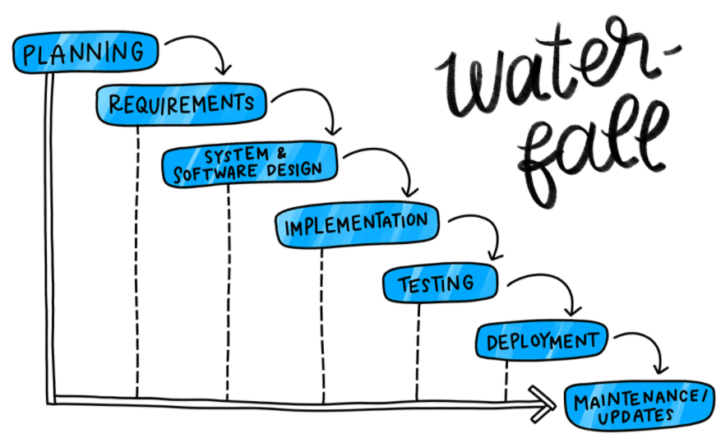

* **Alignment**: How does this project connect to your company’s larger mission and goals?
* **Resource availability and allocation**: Do you have the people and tools you need to take this on?
* **Project scheduling**: How does this project fit within your company’s goals and other tasks?
* **Cost estimation**: How much is it going to cost?

**Risks**

1. Employment-related Lawsuits.
2. Employee Benefits Liability.
3. Theft & Embezzlement
4. Prediction
5. Requirements inflation

**PROJECT LIFE CYCLE MODEL**

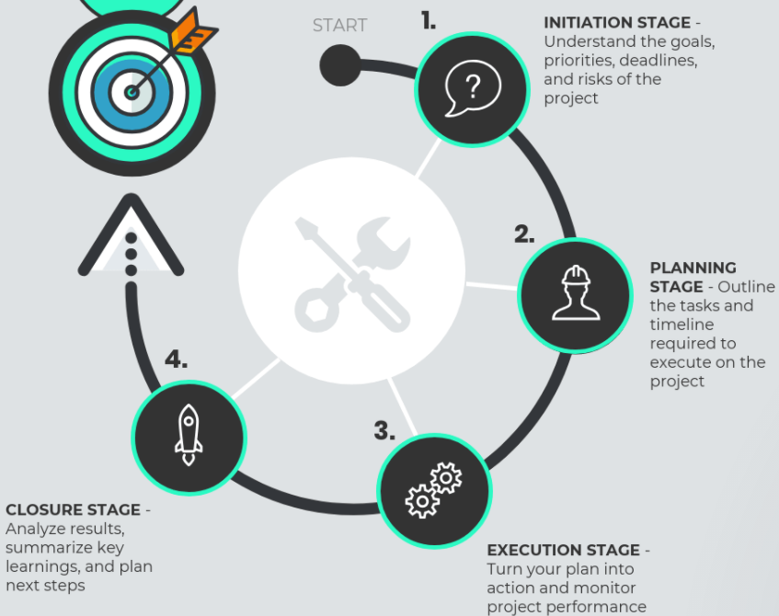

* [**The project initiation stage:**](https://venngage.com/blog/project-life-cycle/#1) understand the goals, priorities, deadlines, and risks of the project
* [**The project planning stage:**](https://venngage.com/blog/project-life-cycle/#2) outline the tasks and timeline required to execute on the project
* [**The project execution stage:**](https://venngage.com/blog/project-life-cycle/#3) turn your plan into action and monitor project performance
* [**The project closure stage:**](https://venngage.com/blog/project-life-cycle/#4) analyze results, summarize key learnings, and plan next steps

**PROJECT PLAN**

