BORROMEO, DANIEL CHRISTIAN R.

BSCS – 2A

ACTIVITY 3 – PERSONAL WEBSITE

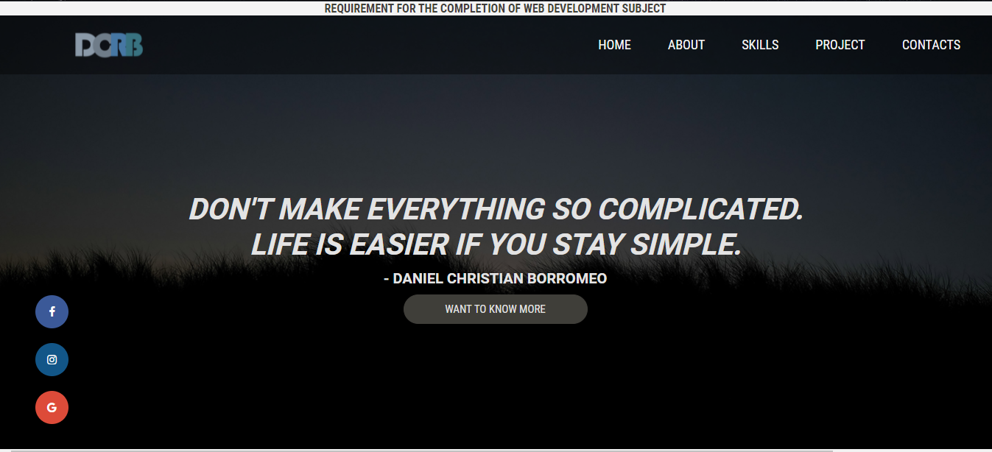HOMEPAGE

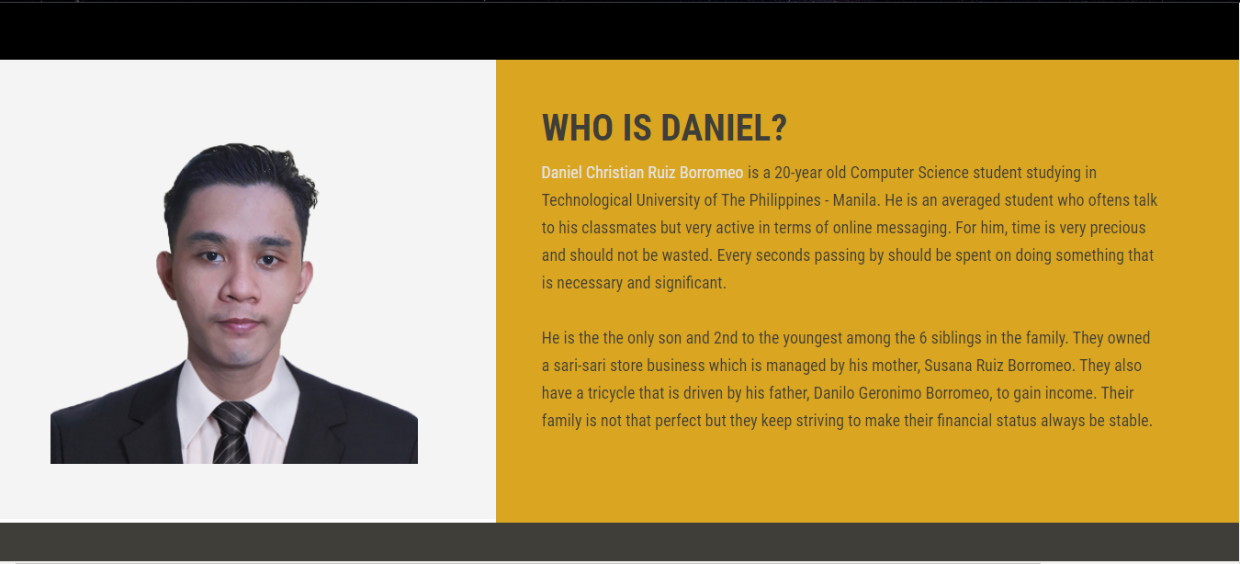ABOUT PAGE

­

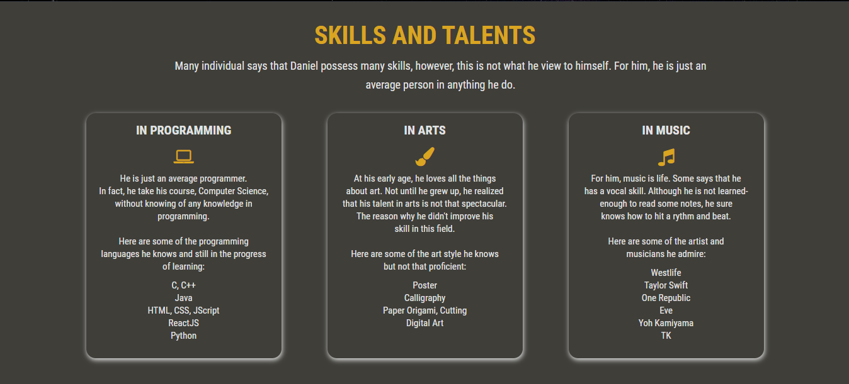SKILLS PAGE

PROJECTS PAGE

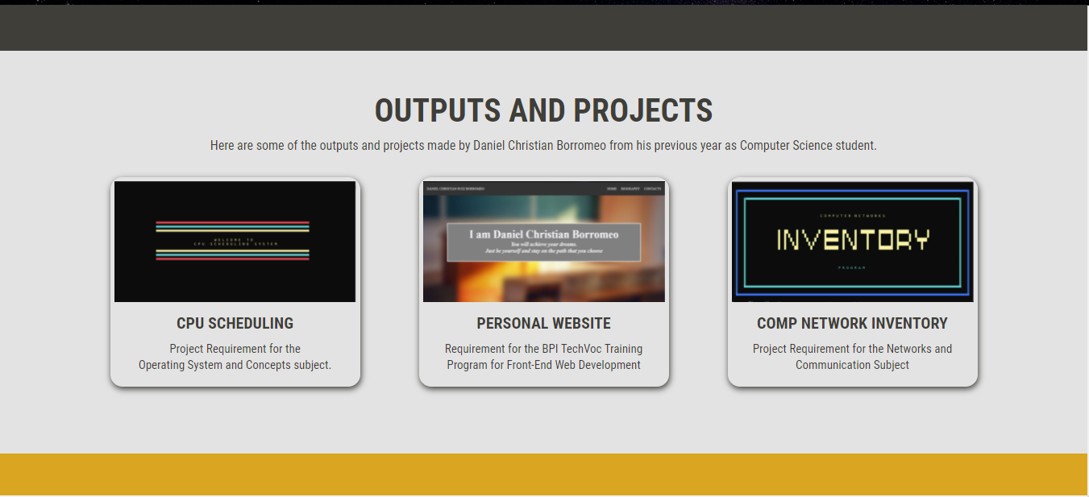

CONTACT PAGE AND FOOTER

