**COMPETENT AUTHORITY IN CATALONIA IN THE FIELD OF ECOLOGICAL PRODUCTION**

Link: <https://www.mapa.gob.es/es/alimentacion/temas/produccion-ecologica/listaautoridadescompetentesccaaeco092019_tcm30-379437.pdf>

Direcció General (DG) Agricultura y Ganadería

Gran Vía de les Corts

Catalanes 612-614, 2ª planta

08007 Barcelona

**ECOLOGICAL AGRICULTURE STATS 2018**

Link: <https://www.mapa.gob.es/es/alimentacion/temas/produccion-ecologica/estadisticaspe2018_tcm30-513741.pdf>

Primary Activities by Region Manufacturing activities by Region

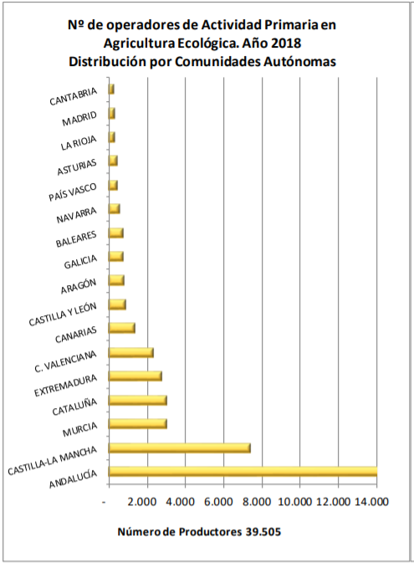 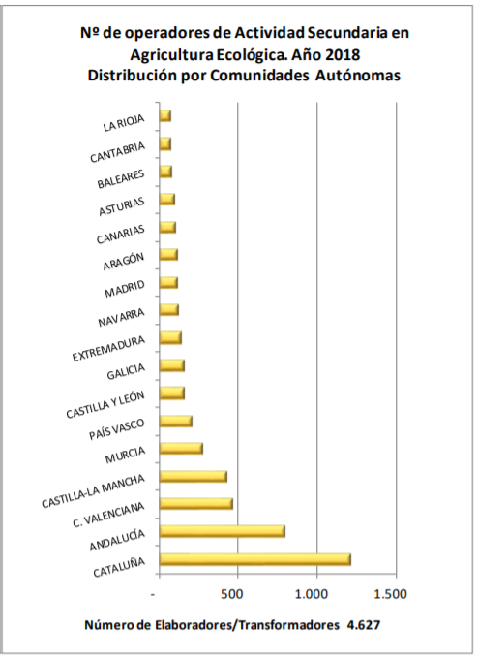

Services Activities by Region Surface of ecological agriculture by Region (2018)

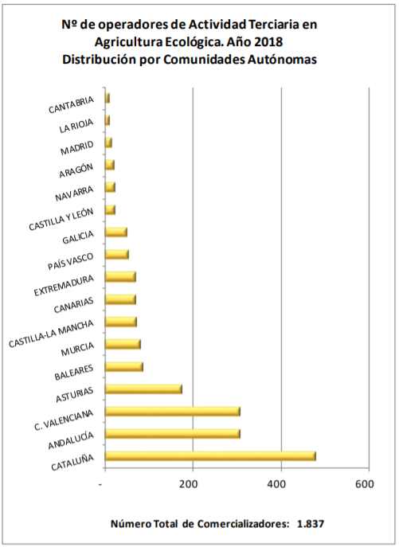 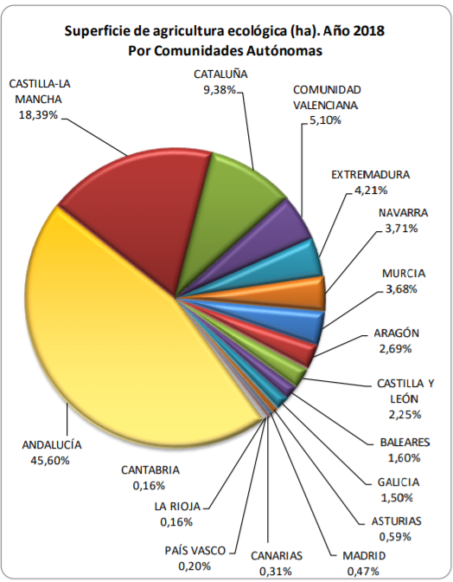

Amount of Operators per Ecological Agriculture Activity 2018



**COMPILATION OF STATISTICS OF THE ECOLOGICAL SECTOR IN CATALONIA**

Link: <http://pae.gencat.cat/web/.content/al_alimentacio/al01_pae/13_observatori_pae/Fitxers/estadistiques_ccpae_recull.pdf>

Surface in organic production for crops 2018

Pastures, meadows and fodder 145,763

Forest, scrub and wild collection 23,821

Vine 16,680

Olive trees 8,395

Cereals and legumes for grain 7,461

Guaret, green fertilizer and wasteland 2,929

A. nuts 2,932

Fruit trees 1,332

Vegetables 814

Another 687

**PRICE COMPARISON WITH COMPETITORS**

**Organic Basket Barcelona**

<https://www.organicbasketbarcelona.com/en#home>

* They deliver baskets with different selection of products.
* The products may vary depending on the customer comments, but they offer seasonal products only.
* Baskets are delivered in a weekly basis.
* Delivery to Barcelona area only
* Taxes, commission, delivery included

TRIAL BASKET 9kg 45€

MEDIUM 12kg 60€

BIG 16kg 80€

OFFICE N/A 80€ *Special fruits & raw veggies selection for offices. Approx. 19 varieties

**El Broquil**

<http://www.elbroquil.cat/cistelles>

* Weekly baskets
* Up to two changes to the content of the regular baskets
* It is also possible to order vegetables per unit
* PENDING: Investigate delivery commission (Need to sign-up)

Small 5-6kg 17€ 6-8 different vegetables

Small (w/Fruits) 5-6kg 19€ 4-6 types of vegetables and 2-3 different fruits

Medium 9-10kg 27€

Medium (w/Fruits) 9-10kg 29€

Vegetable Basics 10kg 20€

Fruit & Vegetable Basics 20kg 40€ 10kg fruits and 10kgs vegetables

**Agroboca**

<https://www.agroboca.com/comprar/frutas-verduras-ecologicas>

* 24hr home delivery service
* Their online store specifies from which supplier you are buying from. Agroboca is just connecting these suppliers with the customers. Minimum amount to buy may vary depending on the suppliers
* They also provide discounts

Examples of baskets by some of Agroboca’s suppliers:

**Basket Name Amount Price Supplier**

Ecologic basket 9kg 27€ Cal Modest

ECO Offer StayAtHome 10kg ~~32€~~ 25€ Cal Modest

ECO Basket 9kg 27€ Planeta ECO

Family Basket 11kg ~~32€~~ 27€ GreenHort