République Algérienne Démocratique et Populaire
الجمهور ية الجزائر ية الديمقراطية الشعبية
Ministère de l’Enseignement Supérieur et de la Recherche Scientifique
وزارة التعليم العالي والبحث العلمي
____________________________________________________________________________________________________

المدرسة الوطنية العليا للإعلام الآلي
(المعهد الوطني للتكوين في الإعلام الآلي سابقا)
École nationale Supérieure d’Informatique
(ex. INI — Institut National de formation en Informatique)

Internship Report
2nd Year Superior Cycle(2SC)
Option: Computer Systems Engineering

____________________________________________________________________________________________________
Design and Implementation of an Interactive Educational Tool for Automata Simulation
____________________________________________________________________________________________________

Realised by: | Supervised by:
- Mekentichi Nejem Eddine | - Dr.  - Dr.

Host Organisation: …….

2025 / 2026

Abstract
This report details the development of a web-based formal automata and Turing machine simulator, completed as part of an academic internship at ESI Algiers under the supervision of <> and <>.
It covers the system’s architecture, state transition parsing logic, and implementation of UI components, providing a comprehensive overview of the project’s design and functionality.

Acknowledgment
I would like to express my sincere gratitude to my supervisors <> and <> for their invaluable guidance and support throughout this internship at ESI Algiers. I am also deeply grateful to my family and friends for their continuous encouragement and understanding during this academic journey.

Table of Contents

Abstract 2
Acknowledgment 2
Table of Contents 3
Table of Figures 4
Introduction 4
Glossary and Terminology 5
Problem Statement 5
State of Art Analysis 6
User Interface and accessibility 6
Offered Functionality 7
Technical Architecture 7
Other Available tools: 8
Proposed Solution 8
Concept and Inspiration 8
Design 9
General architecture 9
M19 Engine Architecture 9
Included Algorithms 10
Parsing and Execution Control 10
Communication between the Engine and the frontend 10
Data representation and performance 10
Ai Chatbot integration 10
Implementation 10
Used Tools and Languages 11
Conclusion 11
Bibliography 11

Table of Figures
Figure 1: system architecture overview 10

Introduction

Glossary and Terminology
- Internal Combustion Engine (ICE): In the context of the M19 engine architecture, the core computational processing unit inspired by Formula One power units, responsible for driving execution loops and state transitions.
- Control Electronics (CE): In the context of the M19 architecture, the supervisory subsystem responsible for managing control flows, signals, and validation rules during simulation execution.
- Imperative Programming Paradigm: A programming style that describes computation in terms of statements that explicitly change a program's state step-by-step (e.g., using loops, mutable variables, and direct assignments).
- Declarative Programming Paradigm: A programming style that expresses the logic of a computation without describing its explicit control flow, focusing instead on what the program should accomplish rather than how to achieve it.
- Structure of Arrays (SoA): A memory layout optimization technique where data attributes are stored in separate parallel arrays rather than an array of structures (AoS), maximizing CPU cache efficiency and vectorization performance.
- Array of Structures (AoS): A traditional memory layout where related data attributes for a single entity are grouped together in memory (e.g., an array of objects where each object holds a state's position, transitions, and flags).
- Data-Oriented Design (DOD): A software design approach that focuses on data layout and CPU cache efficiency, prioritizing how data is accessed and processed by hardware over traditional object-oriented hierarchies.
- DOM (Document Object Model): A programming interface for web documents that represents the page as a structured tree of nodes and objects, allowing programming languages to interact with and modify document structure, style, and content.

Problem Statement
Incoming 3rd year students at the higher national school of computer science ESI Algiers usually face hurdles when it comes to the Theory of Formal languages and Automata, besides the fact that the module is quite theoretical and requires a lot of reflection and rigour, the lack of connection between the theoretical side, and the practical side, makes it even harder for students to grasp the concepts of Computation theory and Automata, in addition to that, the module is taught in a duration of one semester, which makes it more of a sprint for many, then the uniqueness of the formalism used locally makes it impossible to look up and learn visualisation tools available outside.
As an example of the formalism differences, locally, a Turing machine instruction is represented as a 4-tuple, while it is common to be represented as a 5-tuple in outside resources. In addition to that, it is common to pass binary inputs to Turing machines, while locally when using Turing machines for computations, numbers are represented as Bars separated by asterisks. This major difference in formalism adds another constraint and barrier against using outside resources available online. Not to mention that many of the available are fully graphical which makes them quite exhausting when machines scale up, while others use a custom local DSLs to write instructions.

State of Art Analysis
Among existing solutions, JFLAP stands out as the prevailing industry and academic standard for automata simulation. To evaluate its practical suitability for modern academic workflows, this analysis examines the tool across three main dimensions: user interface and accessibility, offered functionality, and technical architecture.

User Interface and accessibility
Before one could start using JFLAP, a download is required, which is not possible unless one is registered as an academic individual which puts the first barrier to the accessibility to the tool. In terms of waiting for validation and then being allowed to download the programme.
JFLAP’s development started in 1990, and then its first release as a java-based application was in 1996, which is quite legacy for the current standards and tech trends. And while its pedagogical content is still there, its interface and design aren’t up to the recent software development standards.
JFLAP relies completely on a graphical representation of all types of automata machines, which is not a problem when a user is building a simple lecture example model, but once the machine scales up, and state transitions start getting tangled, that graphical approach makes it very hard to build and maintain a machine, and could collapse at any moment. Which we consider a major problem, especially if you are limited by one semester to get comfortable with many theoretical concepts.

Offered Functionality
Despite its legacy constraints, JFLAP provides an extensive and robust suite of functionalities that has cemented its position as an educational standard (Rodger & Finely, 2006). Its feature set spans several core computational models and operations, including:
Automata Construction and Simulation: Supports the creation, editing, and step-by-step trace simulation of Finite Automata (DFA and NFA), Pushdown Automata (PDA), and Turing machines.
Grammar and Parsing Tools: Offers utilities for working with regular expressions, context-free grammars, and parsing transformations (such as LL and LR parsing analysis).
Machine Conversions: Automates theoretical conversions between models, including translating regular expressions to NFAs, NFAs to DFAs, and grammars to pushdown automata.
Multi-Tape and Specialised Machines: Accommodates complex variations such as multi-tape Turing machines and systems with unrestricted grammars to support advanced coursework.
Batch Testing and Debugging: Enables users to run multiple input strings simultaneously against a constructed machine to verify acceptance or rejection paths efficiently.

Technical Architecture
JFLAP is a Java-based desktop application built on the legacy Swing framework, which contributes to its heavy memory footprint and complex desktop installation process. Its core was developed in the early years of Java, which lacked the advanced garbage collection and JIT compilation optimizations that were introduced in later versions like Java 8. This introduced many bottlenecks when it comes to performance and stability. Under heavy loads, memory usage spikes as the Java Virtual Machine struggles to manage the massive object graphs created by transition networks, leading to frequent pauses and potential system instability.

Other Available tools:
Beyond JFLAP, the current landscape of automata tools can be categorized into three distinct classes, each presenting unique limitations for academic coursework:
- Programmatic and Headless Libraries (e.g., automata-lib, FAdo): These native Python libraries are designed for writing scripts to evaluate formal languages, but they lack an interactive graphical interface. They rely entirely on command-line execution and can only export static images, making them unsuitable for real-time visual learning.
- Lightweight Web Simulators (e.g., flap.js, Evan Wallace Automata Simulator): These browser-based applications require zero installation and offer a smoother user experience than legacy desktop software. However, they are typically surface-level simulations that rarely support advanced models like Linear Bounded Automata (LBA) or complex non-deterministic behaviours.
- Industrial Frameworks (e.g., OpenFST): Built in C++ by Google and NYU primarily for speech recognition and machine learning, OpenFST is robust and performant. Yet, its extreme complexity and rigid focus on industrial and research applications make it a utility backend rather than an interactive visualization and simulation tool for students (Allauzen, Riley, Schalkwyk, Skut, & Mohri, 2007).

Proposed Solution
To address the learning and performance hurdles students face when trying to use those tools, we introduced a web-based solution that relies on a Domain Specific Language (DSL) to create and manage machines. In the following sections, we will walk you through the architecture and the functionality offered by our proposed solution.

Concept and Inspiration
We wanted a solution capable of visually simulate the different types of automata while remaining as extensible as possible without compromising performance. A simulator that becomes inefficient under heavy computational load would not meet the objectives of the proposed solution.
As a Formula One enthusiast, I drew inspiration from the architecture of modern Formula One power units. A modern F1 power unit is composed of multiple specialized and replaceable components, such as the Internal Combustion Engine, gearbox, and control electronics, each responsible for a specific aspect of the overall system. This led us to consider a similar approach for the simulator: rather than implementing each machine as an entirely separate system, we could design a set of configurable components whose behaviour is defined before the execution and simulation process begins. By configuring these components appropriately, the same underlying architecture can be used to simulate different types of machines.
This approach reduces code duplication while improving maintainability and extensibility. Furthermore, carefully designing the interactions between the components provides opportunities to optimize the execution process and improve the overall performance of the simulator. From this concept emerged the core of our simulator: the M19 engine.
The name M19 itself follows the naming style commonly found in Formula One, with examples such as RB19 and W11. The letter M represents my initial, while 19 refers to the twentieth century, a particularly important period in the development of automata theory and the theoretical foundations upon which the simulator is based. Thus, the name combines the Formula One inspiration behind the architecture with the theoretical domain of the project.

Design

General architecture
At the highest level, the proposed design can be visualized as two main components: the M19 engine, responsible for managing the simulation process, and a frontend layer, responsible for user interaction and visualization. The engine follows an imperative paradigm, explicitly controlling each execution step, state transition, and internal data management operation. In contrast, the frontend follows a declarative approach, describing how the current state of the simulation should be represented visually based on the data received from the engine. This separation allows the execution logic to remain independent of the presentation layer. These components are connected through an API, which exposes the data required by the frontend to represent and interact with the current state of the simulation.
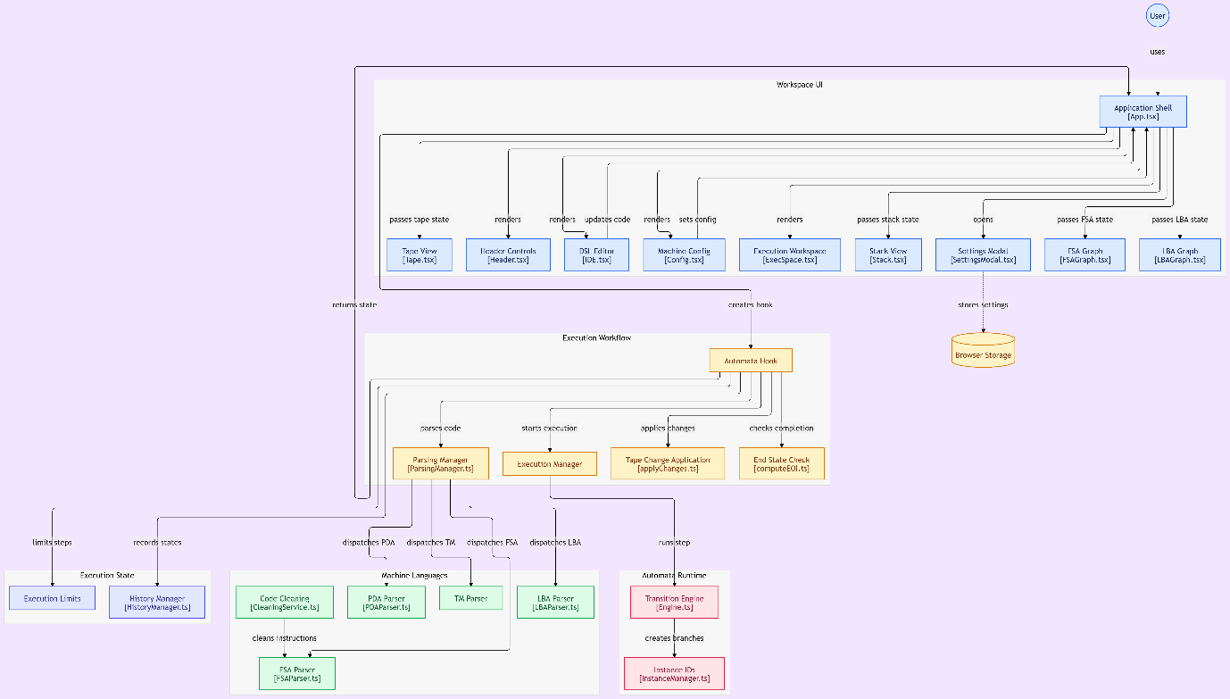
Figure 1: system architecture overview

M19 Engine Architecture
The M19 engine had to be both performant and flexible. To achieve this, we decided to adopt a Structure of Arrays (SoA) approach for data management within the engine. This approach has been shown to provide improved cache locality for certain workloads, reducing the frequency of cache misses and, consequently, the time spent waiting for data to be retrieved from main memory. [Citation]
Beyond its performance characteristics, this representation also supports the management of multiple machine instances simultaneously. This is particularly important for handling nondeterministic machines, where a single execution step may result in multiple possible states that must be processed concurrently.
The execution loop is then configured at instantiation time through the engine's constructor, effectively determining the execution strategy of a given engine instance before the simulation begins. The following class diagram details the internal architecture of the M19 engine and illustrates the relationships between its main components.

Included Algorithms
Mirror Automaton:
Non-Deterministic Automaton to Deterministic Automaton:
Degeneralisation of an automaton:

Parsing and Execution Control
Execution preparation undergoes a predictable pipeline that allows for error detection before stepping into the Execution phase, to ensure a correct and coherent execution by the engine.
Mainly, the presentation layer wraps the machine type, alphabet, instructions and different parameters specific to machines into config objects, then passes it to the “ParsingManager” which detects the machine type and forwards the configuration to the concerned parser. As shown in the figure below.
“ExecutionManager” is the unit responsible for controlling the behaviour of the core engine…

Communication between the Engine and the frontend
The communication between the execution engine and the frontend represents a critical architectural boundary within the simulator. Because the tool handles both deterministic models and complex non-deterministic automata (such as NFAs, PDAs, LBAs, and Turing Machines) with simultaneous execution branches, the bridge between the React UI and the core TypeScript execution loops must strictly govern state observability, request lifecycles, and asynchronous updates.
To achieve this, the system implements a specialized engine API mediated through custom React hooks (Automata Hook) and orchestration managers (Engine.ts, InstanceManager.ts). This API establishes a clear contract:
- Request & Control Flow: The frontend dispatches user-driven intents—such as parsing DSL code via the ParsingManager, initiating execution steps, or applying tape/stack alterations (applyChanges.ts)—down to the orchestration layer.
- Observability & State Dispatch: Conversely, the engine exposes controlled state snapshots to the UI layers (ExecSpace.ts, graph visualizers, and tape/stack views). Rather than allowing arbitrary direct mutations, the engine yields structured execution states and branch results that the frontend uses to render real-time transitions, highlight active states, and track step completion (computeEOI.ts).
- History & Replay Management: The communication layer hooks directly into the HistoryManager, allowing the frontend to request historical snapshots, step backward/forward, or inspect previous execution states without re-running the underlying machine logic.

Data representation and performance
Designing an interactive simulator for formal language models requires high-frequency state updates, particularly when animating graph traversals or handling massive non-deterministic branching trees. To ensure smooth 60fps UI rendering and prevent execution lag during complex state expansions, the data representation strategy prioritizes memory efficiency and CPU cache locality:
- Structure of Arrays (SoA) Layout: To optimize memory access patterns and hardware cache locality during concurrent state execution, core data structures are organized using a Structure of Arrays layout in TypeScript rather than traditional fragmented object graphs. This keeps tightly coupled simulation metrics contiguous in memory, drastically reducing cache misses during heavy batch computations.
- Optimized Graph & State Representations: Automata definitions (nodes, transitions, tape symbols, and stack headers) are stored in lightweight, immutable-friendly schemas that allow the ParsingManager and parsers (FSAParser.ts, PDAParser.ts, LBAParser.ts) to quickly construct and validate formal machine definitions.
- Decoupled Rendering and Runtime: State updates processed by the Engine are decoupled from React’s virtual DOM reconciliation cycle where necessary. State modifications are buffered through optimized hooks, ensuring that high-speed execution loops and step-by-step animations remain fluid without blocking user interaction in the IDE.tsx or settings panels.

Ai Chatbot integration

Implementation
The implementation followed an iterative approach in a way that allowed integrating more functionalities over the time, the overall schedule is illustrated in the following Gantt Diagram.

Used Tools and Languages
The automata simulator is implemented as a client-side single-page application using TypeScript, React, Tailwind CSS, and custom SVG graphics. The codebase is structured around a modular architecture that separates parsing logic, non-deterministic execution runtimes, and the interactive workspace UI.

Parsing Engines and DSL Architecture
- Unified Parsing Manager (ParsingManager.ts): Serves as the primary entry point for user-authored text, routing input code to specialized parsers depending on the selected theoretical computing model.
- Model-Specific Parsers: Specialized parsers (FSAParser.ts, PDAParser.ts, LBAParser.ts, and Turing Machine parsers) tokenize and validate custom Domain-Specific Language (DSL) scripts, converting plain text rules into robust internal formal machine representations.
- Code Cleaning and Error Handling: Auxiliary cleaning services (CleaningService.ts) strip comments, normalize whitespace, and provide syntax validation feedback directly back to the IDE.tsx editor component.

Execution Runtime and Instance Management
- Orchestration Hooks (Automata Hook): Custom React hooks encapsulate the core execution lifecycle, coordinating step-by-step evaluation, branch state changes, and completion checks.
- Non-Deterministic Branching (InstanceManager.ts): Manages concurrent execution paths for non-deterministic machines, assigning unique instance IDs to track parallel evaluation branches without freezing the main thread.
- State Transition Engine (Engine.ts): Evaluates active machine states against current tape heads, stack frames, and transition rules, applying updates via dedicated modifiers (applyChanges.ts, computeEOI.ts).

Frontend Workspace and Visualization
- Application Shell (App.tsx): Coordinates global state distribution, passing tape states, stack frames, and model configurations down to specialized visual components.
- Interactive Visualizers: Real-time graph renderers (FSAGraph.tsx, LBAGraph.tsx) leverage SVG graphics to dynamically display node transitions, active states, and machine configurations.
- Inspection Panels: Dedicated views—including the Tape View, Stack View, and History Manager (HistoryManager.ts)—allow users to step forward and backward through execution history, inspect past states, and export graphical outputs.
- Persistence & Settings: User preferences and workspace configurations are managed via a Settings Modal (SettingsModal.tsx) and persisted using browser storage.

Conclusion

Bibliography
Allauzen, C., Riley, M., Schalkwyk, J., Skut, W., & Mohri, M. (2007). OpenFst: A General and Efficient Weighted Finite-State Transducer Library. Implementation and Application of Automata (CIAA) (pp. 11–23). Prague: Springer.
Rodger, S. H., & Finely, T. W. (2006). JFLAP – An Interactive Formal Languages and Automata Package. In S. H. Rodger, & T. W. Finely, JFLAP – An Interactive Formal Languages and Automata Package (p. 212). Sudbury, MA: Jones and Bartlett (or Jones and Bartlett Publishers).

