# **EXPERIMENT 12 DATE:**

**AIM:**

Write a program to implement the K-mean, Hierarchial Clustering for the given dataset and compute the accuracy of the model and compare.

**REQUIREMENTS:**

1. scikit-learn - used to load the iris dataset.

2. numpy - handling arrays.

3. matplotlib - to create scatter plots and visualizing.

4. seaborn - to set the plot style and color palette.

**PROCEDURE:**

STEP 1: Import the scikit-learn, numpy, matplotlib, and seaborn libraries.

STEP 2: Load the Iris dataset using the ‘load-iris’ function from scikit-learn.

STEP 3: Apply the K-means hierarchial clustering algorithms on the dataset using appropriate functions.

STEP 4: Compute the accuracy of the clustering models using the ‘accuracy_score’ function from scikit-learn.

STEP 5: Visualize the clusters and ploting the axes labels, titles and color palettes.

**CODE:**

import pandas as pd

import numpy as np

import matplotlib.pyplot as plt

from sklearn.datasets import load_iris

from sklearn.cluster import KMeans, AgglomerativeClustering

from sklearn.metrics import accuracy_score

from sklearn.preprocessing import StandardScaler

from sklearn.decomposition import PCA

iris = load_iris()

X = iris.data

y = iris.target

scaler = StandardScaler()

X_scaled = scaler.fit_transform(X)

pca = PCA(n_components=2)

X_pca = pca.fit_transform(X_scaled)

kmeans = KMeans(n_clusters=3, random_state=42)

kmeans.fit(X_scaled)

kmeans_labels = kmeans.labels_

hierarchical = AgglomerativeClustering(n_clusters=3)

hierarchical.fit(X_scaled)

hierarchical_labels = hierarchical.labels_

kmeans_accuracy = accuracy_score(y, kmeans_labels)

hierarchical_accuracy = accuracy_score(y, hierarchical_labels)

plt.figure(figsize=(12, 4))

plt.subplot(1, 2, 1)

plt.scatter(X_pca[:, 0], X_pca[:, 1], c=kmeans_labels, cmap='viridis')

plt.title('K-means Clustering')

plt.xlabel('Principal Component 1')

plt.ylabel('Principal Component 2')

plt.subplot(1, 2, 2)

plt.scatter(X_pca[:, 0], X_pca[:, 1], c=hierarchical_labels, cmap='viridis')

plt.title('Hierarchical Clustering')

plt.xlabel('Principal Component 1')

plt.ylabel('Principal Component 2')

plt.tight_layout()

plt.show()

print("K-means Accuracy:", kmeans_accuracy)

print("Hierarchical Accuracy:", hierarchical_accuracy)

**OUTPUT:**

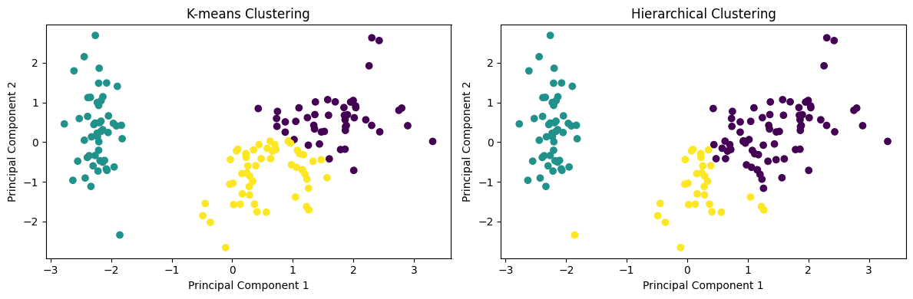

**RESULT:**

Therefore, the code applies K-means and hierarchial clustering on the Iris dataset, computes the accuracy of the models and visualizes the clusters using scatter plots.