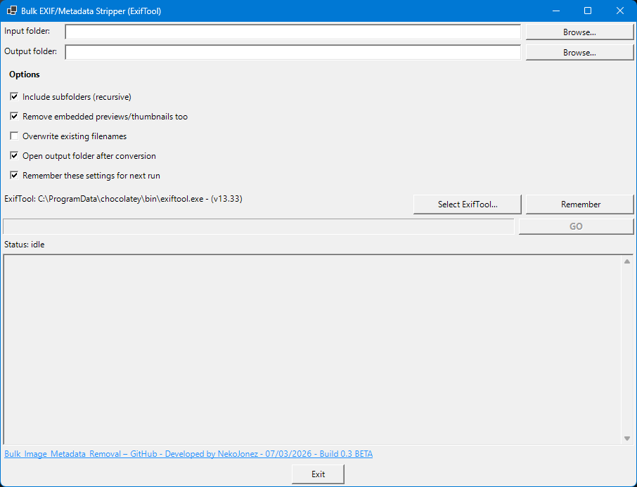
How to Use Bulk Image Metadata Removal
Requirements
This tool uses ExifTool to remove metadata from images.
ExifTool must be installed or available on your computer before you can use this tool.
You can download ExifTool from the official website:
👉 https://exiftool.org
After downloading, you can place the exiftool.exe file anywhere on your computer, such as:
- Downloads
- Documents
- Desktop
- Images
- Or an installation folder created by Chocolatey or Winget
The tool will automatically search for ExifTool in the most common installation locations.
If ExifTool is not found, the tool will notify you and open the official download page.
If ExifTool is installed but not detected, or if you want to use a different version, click “Select ExifTool…” and manually browse to the location of exiftool.exe.
Warning: at the moment, the tool needs the exiftool to be named exactly exiftool.exe or it won’t be found. This will be fixed in a future release.
Removing Metadata from Images
- Place all images you want to clean into a single folder.
Subfolders can be included if the “Include subfolders” option is enabled.
- In the Input folder field:
  - Enter the path to the folder containing your images
or
  - Click “Browse…” and select the folder.
- In the Output folder field:
  - Choose where the cleaned images should be saved.
The original images are not modified — cleaned copies are written to this folder.
- (Optional) Enable or disable:
  - Include subfolders (recursive) – processes images in subfolders as well
  - Remove thumbnails/previews – removes embedded preview images if present
  - Overwrite existing filenames – if the output folder has files with the same name, they will be overwritten.
  - Open output folder after conversion – will open the output folder after conversion.
  - Remember these settings for next run – will remember the input and options for the next run.
- Click “GO” to start the process.
- Progress and status messages will appear in the log window.
When finished, all processed images will be available in the output folder.

Notes
- Original files are never changed.
- Files with the same name in the output folder may be overwritten depending on your settings.
- Large folders may take some time to process.

