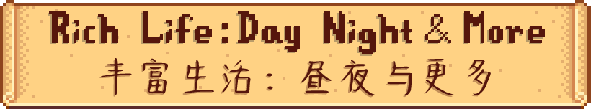

Enhance your game with a dynamic light, all-new Solstice festivals, production machines, and dozens of recipes and items. A complete immersion overhaul!

通过动态光照、全新的至日节日、生产机器以及数十种食谱和物品来增强您的游戏体验。一次完整的沉浸感大修！



**Required Mods:** SMAPI and Content Patcher.

**前置模组：**SMAPI与Content Patcher。

**Compatibility:** In theory, Rich Life: Day Night & More are compatible with most other mods, including popular expansions such as Stardew Valley Expanded, Ridgeside Village, East Scarp, and more. **Completely incompatible Mods:** Any mod that modifies the game's lighting system (such as Dynamic Night Time). If you encounter any mod compatibility issues, feel free to report them to me via mod posts, messages, or other means. Thank you very much!

**兼容性：**理论上，Rich Life: Day Night & More兼容多数其他模组，包括主流拓展模组Stardew Valley Expanded、Ridgeside Village、East Scarp等。**完全不兼容的模组：**任何修改了游戏光照系统的模组（如Dynamic Night Time）。如果你遇到模组兼容性问题，欢迎通过模组帖子、私信等方式反馈给我，非常感谢！

Download the mod file and extract it to the Stardew Valley/Mods folder.

下载模组文件，并解压到Stardew Valley/Mods文件夹。

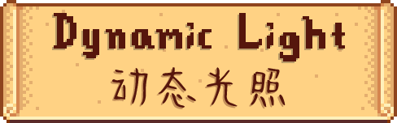

**Simulate the natural lighting changes of the real world.**

**模拟真实世界的光照变化。**

You will experience how sunlight shifts throughout the day and seasons – in summer, sunlight shines through your windows in the early morning, while in winter, daylight is brief and dim, and the night is filled with starlight and artificial light. Every day, every moment, is unique.

你将感受到阳光如何随着季节和时间的变化而变化——夏天的清晨阳光透过窗户照进屋内，冬天的白昼短暂而昏暗，夜晚则被星光和灯光填满。每一天，每个时刻，都是独一无二的。

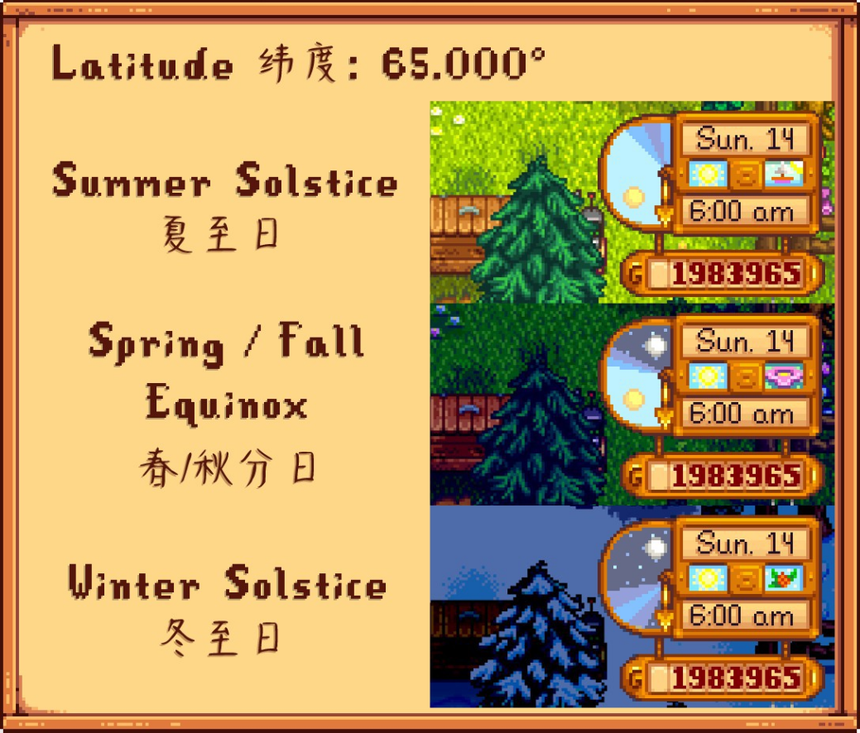

**Detailed lighting configurations, creating your own SDV.**

**详细的光照配置，打造属于你自己的星露谷。**

With simple configuration options, you can fully adjust the lighting and even create a world that is always in "twilight" or "dawn".

通过简单的配置选项， 你可以完全自由地调整光照，甚至打造一个永远在“黄昏”或者“黎明”的世界。

Latitude: Set the geographical location of SDV. Default: 52°, Min: 0°, Max: 90°.

纬度：设定星露谷的地理位置。默认：52°，最小值：0°，最大值：90°。

Ecliptic-Obliquity: Adjust the amplitude of seasonal changes in lighting. Default: 23.436°, Min: 0°, Max: 90°.

黄赤交角：调节光照季节变化的幅度。默认：23.436°，最小值：0°，最大值：90°。

Day Start At Solar Height: Set the minimum solar elevation angle that defines 'daytime' in the game, and adjust the smoothness of the day-night transition. In general, it should be an opposite number to Night Start At Solar Height. Default: 6°, Min: 3°, Max: 9°.

白昼起始太阳高度角：设定游戏界定“白昼”的最小太阳高度角，调整日夜过渡的平滑性。一般与黑夜起始太阳高度角互为相反数。默认：6°，最小值：3°，最大值：9°。

Night Start At Solar Height: Set the maximum solar elevation angle that defines 'nighttime' in the game, and adjust the smoothness of the day-night transition. In general, it should be an opposite number to Day Start At Solar Height. Default: -6°, Min: -9°, Max: -3°.

黑夜起始太阳高度角：设定游戏界定“夜晚”的最大太阳高度角，调整日夜过渡的平滑性。一般与白昼起始太阳高度角互为相反数。默认：-6°，最小值：-9°，最大值：-3°。

Raining Darkness: Set the ambient darkness during the day when it rains, and adjust the visual effects. Default: 0.3, Min: 0.0, Max: 0.3.

雨天暗度：设定下雨时白天的环境暗度，调整视觉效果。默认：0.3，最小值：0.0，最大值：0.3。

Night Darkness: Set the ambient darkness during the night, and adjust the visual effects. Default: 0.93, Min: 0.3, Max: 1.0.

夜晚暗度：设定夜晚的环境暗度，调整视觉效果。默认：0.93，最小值：0.3，最大值：1.0。

Change Clock Texture: Replace the clock texture to make the day's night cycle distribution more intuitive. Default: true.

替换时钟贴图：替换时钟的贴图，让当天日夜分布更加直观。默认：开启。

Extend Early-Day Daylight: Keep day and night evenly divided until the first equinox (Spring 14, Year 1) to make early-game farming easier. Default: true.

延长开局白昼：在第一年春分（春季14日）之前始终昼夜平分，方便玩家前期开荒。默认：开启。



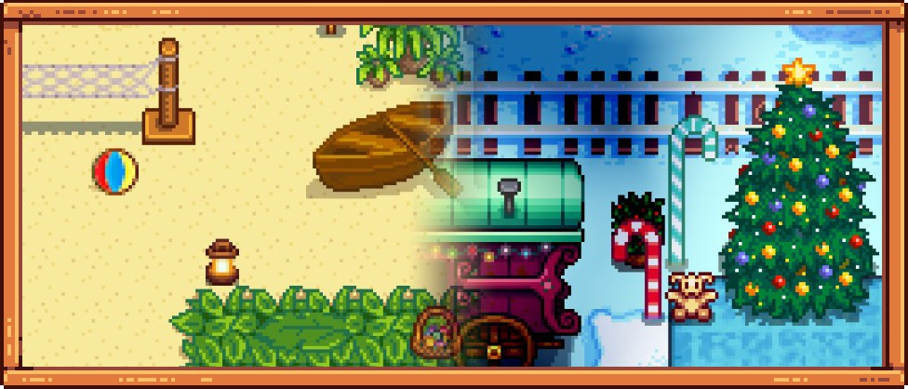

**Celebrate the solstices with unique seasonal festivals.**

**全新的至日节庆，让四季更具仪式感。**

**Summer Solstice Festival:** beach celebration, special stalls.

**夏至节：**沙滩狂欢、特色摊位。

**Winter Solstice Festival:** railroad and hot spring gathering, cozy winter vibes.

**冬至节：**铁路与温泉聚会、温馨氛围。

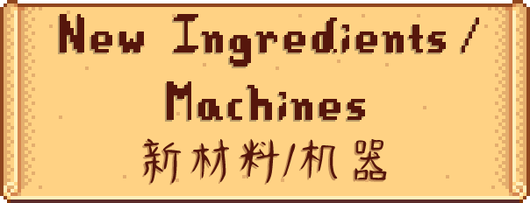

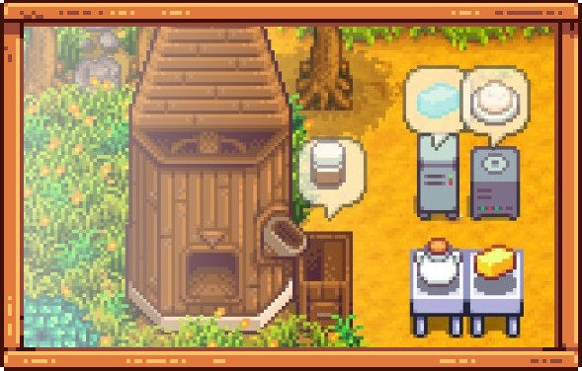

**From harvesting to processing, your farm gains a whole new production chain.**

**采集、 收获、 加工， 你的农场将获得一整套全新的生产链。**

**New Ingredients:** Coconut Milk, Cocoa Powder, Salt, and more, perfect for cooking and crafting.

**新材料：**椰奶、可可粉、盐等，丰富烹饪与打造。

**New Machines:** Ice Machine, Centrifuge, Heliograph, and more, enriching the production chain.

**新机器：**制冰机、离心机、日光计等，丰富产业链。

**New Mechanics:** The Mill can grind Cocoa Beans into Cocoa Powder, and the Fridge can turn stored Water into Ice overnight. And there are more surprises waiting for you to discover!

**新机制：**磨坊可以将可可豆研磨成可可粉，冰箱则会在隔夜后把水转化为冰块。还有更多机制等你发掘。





**Over 30 brand-new dishes to enrich your table and recipe book.**

**超过三十种全新菜肴，丰富你的餐桌与食谱收藏。**

**New Dishes:** From refreshing Coconut Shaved Ice to festive Candy Canes, each dish comes with its own flavor and purpose.

**新菜品：**从清爽的椰奶刨冰到节日氛围浓厚的拐杖糖，每一道菜都有独特的风味和用途。

**Reworked Recipes:** Most classic dishes now have adjusted ingredients, making them more balanced.

**改良配方：**大部分原版菜品的配方经过重新调整，变得更加合理。

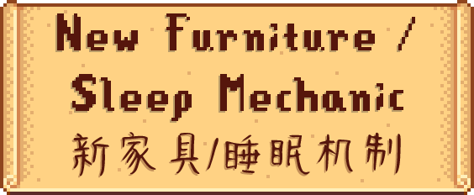

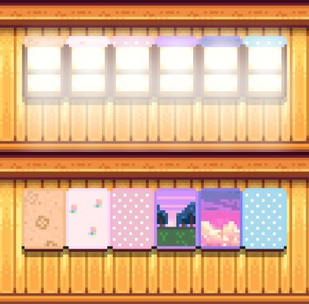

**New blackout windows are here — stylish decorations with real utility.**

**全新登场的遮光帘窗户，不只是装饰，更是实用工具。**

Choose from over 15 blackout curtain styles to suit your aesthetic. They also block out light, ensuring your spouse sleeps soundly during long summer days.

你可以选择超过 15 种不同的遮光帘款式，让房间更符合你的审美。同时，它们还能有效遮挡光线，在夏季昼长时帮助配偶安稳入睡。

**New Mechanic "Poor Sleep":** If there is a regular window next to your bed and the daylight lasts longer than 16 hours, both you and your spouse may experience "poor sleep" due to excessive light. This mechanic will cause a deduction of a certain percentage of your energy (the longer the daylight, the greater the deduction, up to 50%, which is calculated in addition to the exhaustion state and sleeping past midnight). If the calculated energy at the start of the next day is lower than your energy before going to sleep or fainting, your energy will remain unchanged. For your spouse, excessive light will cause them to be angry with you throughout the day, decreasing their friendship toward you (the longer the daylight, the greater the deduction, up to 15 points). Installing blackout windows will prevent this issue from occurring.

**新机制“睡不好”：**如果床边有普通窗户且昼长超过16小时，你和你的配偶可能会因为光线过亮而导致“睡不好”。这一机制会使得你被扣除一定比例的能量（昼长越长，扣除的比例越大，最大可达50%，与精疲力尽状态和0点后睡觉叠加计算）。如果扣除后的次日初始能量低于睡觉或晕倒前的能量，能量将保持不变。对于你的配偶，光线过亮会使他们整天对你生气，并降低好感度（昼长越长，扣除的点数越多，最多扣除15点）。通过安装遮光帘窗户可以避免这一情况的发生。

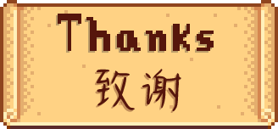

**ConcernedApe**

The creator of Stardew Valley.

星露谷物语的创造者。

**FlashShifter**

The creator of SVE. Grants me permission to create the SVE version of Winter Solstice Festival map.

SVE的创造者。授权我制作SVE版的冬至节地图。

**Jamie Brownhill**

Provides Solaria: Food and Drink Icon Pack. Most of the textures for dishes come from this.

提供了Solaria: Food and Drink Icon Pack。多数菜肴的贴图来源于此。

**lolurio**

Provides First Snow. The BGM of Winter Solstice Festival comes from this.

提供了First Snow。冬至节的背景音乐来源于此。

**madmakingmistery**

Provides pink sky. The texture of Window With Blue Sky Curtain comes from this.

提供了pink sky。蓝色天空遮光帘窗户的贴图来源于此