Project Future

Johny Nguyen, Edgar Elias, Chris Armour

# Game Concept

* A futuristic 2D Platformer shooter.

## Introduction

## Key Features

* Enemies that will track player and attempt to hit them
* Simple Puzzles to advance in the game
* 3 Levels
* Boss fight at the end

## Genre

* 2D Platform Shooter

## Platform

* PC

# Game Mechanics

* The Player will have to move around the levels activating levers, buttons, and other interactable items to advance to the next level. There will be enemies that both attempt to shoot at the player and (mostly) run up and attack in melee range. The puzzles will be simplistic interactions either matching color combinations or other similar easy concepts. There will be a method to upgrade your weapon after finishing each level as well as the ability to increase certain stats. The player will progress through all the levels and then must fight the boss, a giant robot, to beat the game.
* The upgrade menu will allow the player to increase certain stats:
  + Weapon Damage
  + Firing Speed
  + Player Health
  + Unlock utility slot(s)

## Core Game Play

* The player character will advance through the levels to reach the boss. There will be a coin-like collection system from beating enemies, picking up said coin-like object, and from beating a level in a timely fashion. The player after each level will then be met with an upgrade menu that will allow the player to enhance their character’s stats and weapon.

## Player Controls

* Keyboard
* WASD or arrow keys to move
* Space to shoot
* Mouse 1 to shoot
* E interact
* Q and right click (Mouse 2) to use utilities

## Game Flow

* The player character needs to navigate through several platform levels unlocking doors and killing enemies, they will upgrade their character’s stats such as health, damage, and be able to unlock secondary abilities such as throwing grenades and emps. This repeats until they reach the end and must fight a boss to end the game. Dying on normal levels will result in you restarting the level you are on while dying on the boss will give you the option to both restart the game or to revisit the upgrade menu before rechallenging the boss.

## Characters (if appropriate)

* Main character, a guy who really, really hates robots.

## Monsters (if appropriate)

* Various robotic enemies that will primarily attack the player with melee attacks, with one or two that will shoot projectiles.
* Boss robot at the end that will attack by using the environment to try to harm the player in various ways.

## Weapon Properties (if appropriate)

* Player weapon will fire plasma like rounds at a fixed rate.
* The weapon can be upgraded to fire faster, and do more damage.

## Artificial Intelligence

* Enemies lock on at a certain range and then will attempt to rush towards the player or shoot the player. They will not jump and will avoid seeing through walls when navigating towards the player.

# Interface

## Mock-Up Screens

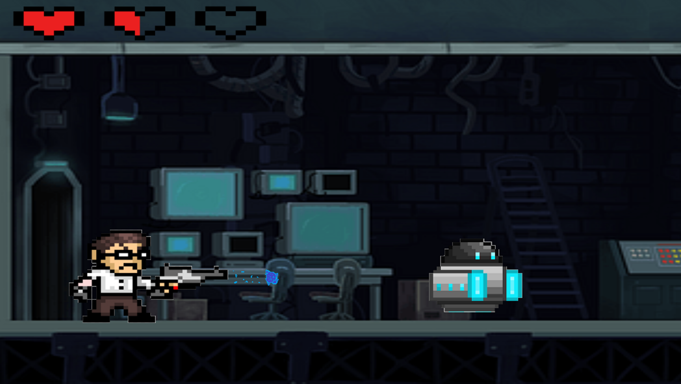

# Art and Video

* Futurist game with the levels set in some type of research lab

## Overall Goals

* To make the game fun
* At least make 1 solid level

# Sound and Music

## Sound Effects & Music

* To be decided

# Story (If Appropriate)

* Artificial intelligent robots have rebelled against their creators and started to destroy the world. The player character will be the one to stop them.

# Level Overview (specific to prototype)

* To be decided

# Project Member Responsibilities (specific to prototype)

Note: Be specific to the prototype submitted at the end of the semester. Each team member should be responsible for entire game objects / prefabs including visuals, sounds, code, interactions, … For example, if there is a door, then 1 person does all the work on the door including the art, sound, code to open/close it, trigger the sound effect, …

## Chris – Level design, collectables

## Edgar – Character Movement, objects for the map

## Johny – Enemies and their AI