VI/ Installation du client Minetest Stable 0.4.16 sur Raspberry Pi 3.

* Matériel : Raspberry Pi 3
* Distribution :
Raspbian Strech with desktop 2017-09-07 = http://vx2-downloads.raspberrypi.org/raspbian/images/raspbian-2017-09-08/2017-09-07-raspbian-stretch.zip

1/ Installation des paquets de développement.

pi@minetest:~ $ sudo apt-get install build-essential git-core cmake libirrlicht-dev cmake libbz2-dev libpng-dev libjpeg-dev libxxf86vm-dev libgl1-mesa-dev libsqlite3-dev libcurl4-gnutls-dev libfreetype6-dev zlib1g-dev libgmp-dev libjsoncpp-dev libluajit-5.1-2 libluajit-5.1-dev libncurses5-dev doxygen gettext-base libgettextpo-dev libopenal-dev libvorbis-dev gettext libleveldb-dev postgresql postgresql-server-dev-9.6

2/ Répertoire de travail.

pi@minetest:~ $ mkdir -p JEUX/MINETEST
pi@minetest:~ $ cd JEUX/MINETEST/
pi@minetest:~/JEUX/MINETEST $

3/ Téléchargement du code source.

pi@minetest:~/JEUX/MINETEST $ git clone https://github.com/minetest/minetest.gitClonage dans 'minetest'...
remote: Counting objects: 51032, done.
remote: Compressing objects: 100% (14/14), done.
remote: Total 51032 (delta 17), reused 9 (delta 9), pack-reused 51009
Réception d'objets: 100% (51032/51032), 50.90 MiB | 162.00 KiB/s, fait.
Résolution des deltas: 100% (36625/36625), fait.
pi@minetest:~/JEUX/MINETEST $

4/ Récupération du tag de la version stable : 0.4.16

pi@minetest:~/JEUX/MINETEST $ cd minetest/
pi@minetest:~/JEUX/MINETEST/minetest $ git checkout tags/0.4.16
Note : extraction de 'tags/0.4.16'.
...
HEAD est maintenant sur 80dc961d... Bump version to 0.4.16
pi@minetest:~/JEUX/MINETEST/minetest $

5/ Création de la branche stable.

pi@minetest:~/JEUX/MINETEST/minetest $ git checkout -b 0.4.16
Basculement sur la nouvelle branche '0.4.16'
pi@minetest:~/JEUX/MINETEST/minetest $

6/ Configuration de la compilation.

pi@minetest:~/JEUX/MINETEST/minetest $ cmake . -DRUN_IN_PLACE=TRUE -DBUILD_SERVER=TRUE -DENABLE_LUAJIT=TRUE -DENABLE_FREETYPE=TRUE -DENABLE_GETTEXT=TRUE -DENABLE_CURL=TRUE -DENABLE_GLES=TRUE -DCMAKE_BUILD_TYPE=Release
-- The C compiler identification is GNU 6.3.0
-- The CXX compiler identification is GNU 6.3.0
-- Check for working C compiler: /usr/bin/cc
...
-- Found Doxygen: /usr/bin/doxygen (found version "1.8.13")
-- Configuring done
-- Generating done
-- Build files have been written to: /home/pi/JEUX/MINETEST/minetest
pi@minetest:~/JEUX/MINETEST/minetest $

7/ Compilation de Minetest.

pi@minetest:~/JEUX/MINETEST/minetest $ make -j2
Scanning dependencies of target GenerateVersion
Scanning dependencies of target jsoncpp
[ 0%] Building CXX object lib/jsoncpp/CMakeFiles/jsoncpp.dir/jsoncpp.cpp.o
[ 0%] Built target GenerateVersion
...
[ 99%] Building CXX object src/CMakeFiles/minetest.dir/voxel.cpp.o
[ 99%] Building CXX object src/CMakeFiles/minetest.dir/voxelalgorithms.cpp.o
[ 99%] Building CXX object src/CMakeFiles/minetest.dir/wieldmesh.cpp.o
[100%] Linking CXX executable ../bin/minetest
[100%] Built target minetest
pi@minetest:~/JEUX/MINETEST/minetest $

8/ Téléchargement du jeu de base.

pi@minetest:~/JEUX/MINETEST/minetest $ cd ..
pi@minetest:~/JEUX/MINETEST $ git clone https://github.com/minetest/minetest_game.git
Clonage dans 'minetest_game'...
remote: Counting objects: 8511, done.
remote: Total 8511 (delta 0), reused 0 (delta 0), pack-reused 8511
Réception d'objets: 100% (8511/8511), 6.52 MiB | 158.00 KiB/s, fait.
Résolution des deltas: 100% (4403/4403), fait.
pi@minetest:~/JEUX/MINETEST $

9/ Installation.

pi@minetest:~/JEUX/MINETEST $ cd minetest/games/
pi@minetest:~/JEUX/MINETEST/minetes/games$ ln -s ../../minetest_game/
pi@minetest:~/JEUX/MINETEST/minetest/games $ cd ../bin/
pi@minetest:~/JEUX/MINETEST/minetest/bin $

10/ Lancement du client.

- Local :

pi@minetest:~/JEUX/MINETEST/minetest/bin $ ./minetest

- Connexion sur un serveur :

pi@minetest:~/JEUX/MINETEST/minetest/bin $ ./minetest --address 213.166.243.99 --name Sam --password Mot2Passe --go

11/ Capture d'écran.

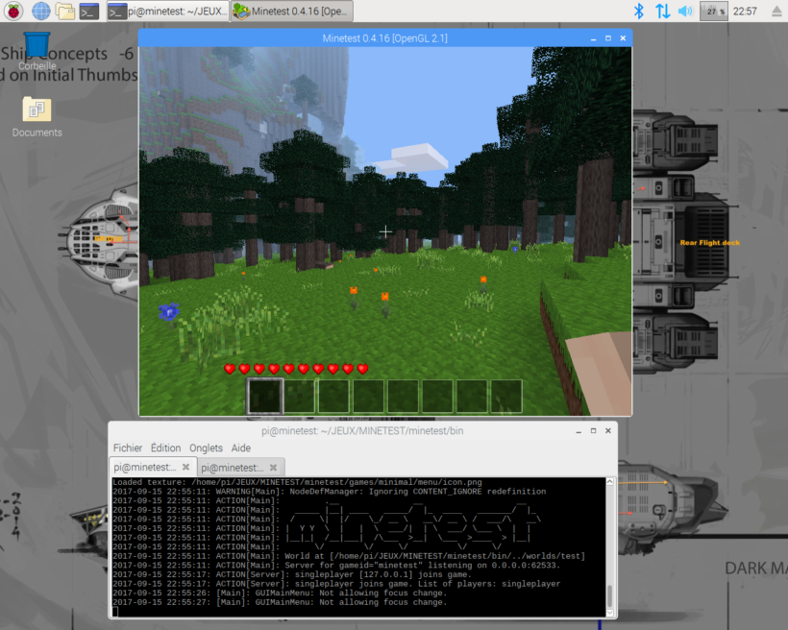

12/ Lien.

https://dev.minetest.net/Compiling_Minetest

