Лабораторна робота №2

Акостакіоає Флоріан 414 КН

Розв’язування мат. рівнянь методом Гауса

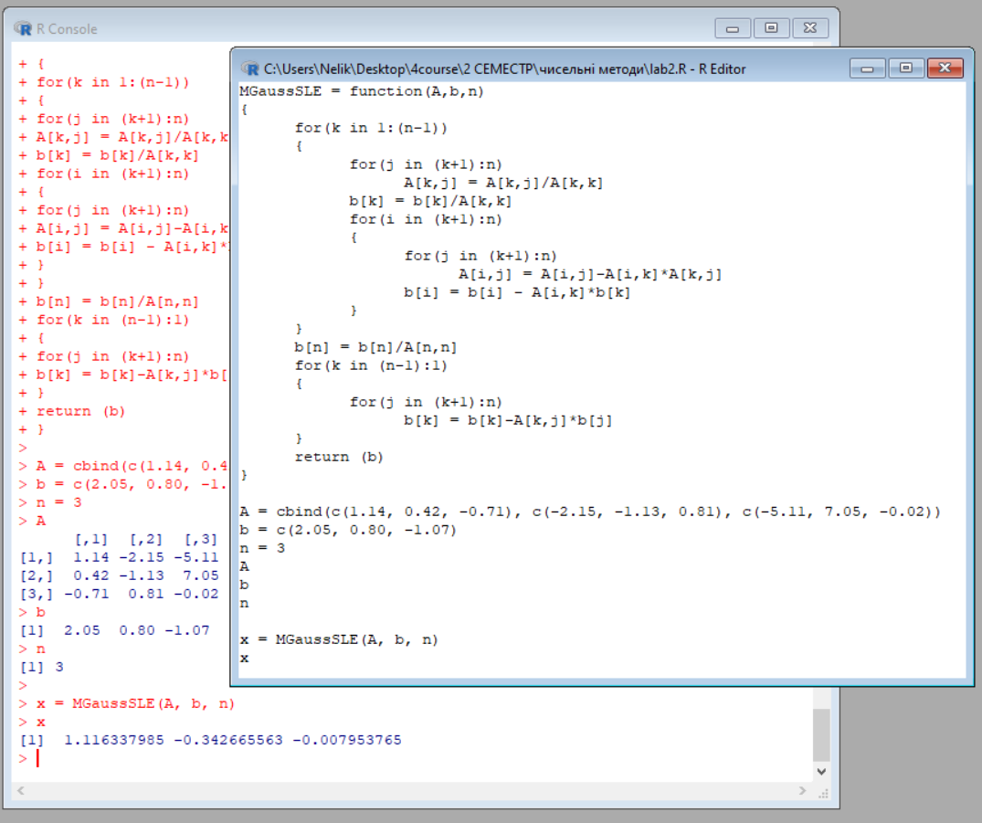

MGaussSLE = function(A,b,n)

{

for(k in 1:(n-1))

{

for(j in (k+1):n)

A[k,j] = A[k,j]/A[k,k]

b[k] = b[k]/A[k,k]

for(i in (k+1):n)

{

for(j in (k+1):n)

A[i,j] = A[i,j]-A[i,k]\*A[k,j]

b[i] = b[i] - A[i,k]\*b[k]

}

}

b[n] = b[n]/A[n,n]

for(k in (n-1):1)

{

for(j in (k+1):n)

b[k] = b[k]-A[k,j]\*b[j]

}

return (b)

}

A = cbind(c(1.14, 0.42, -0.71), c(-2.15, -1.13, 0.81), c(-5.11, 7.05, -0.02))

b = c(2.05, 0.80, -1.07)

n = 3

A

b

n

x = MGaussSLE(A, b, n)

x

Розв’язування мат. рівнянь методом LU-розкладання

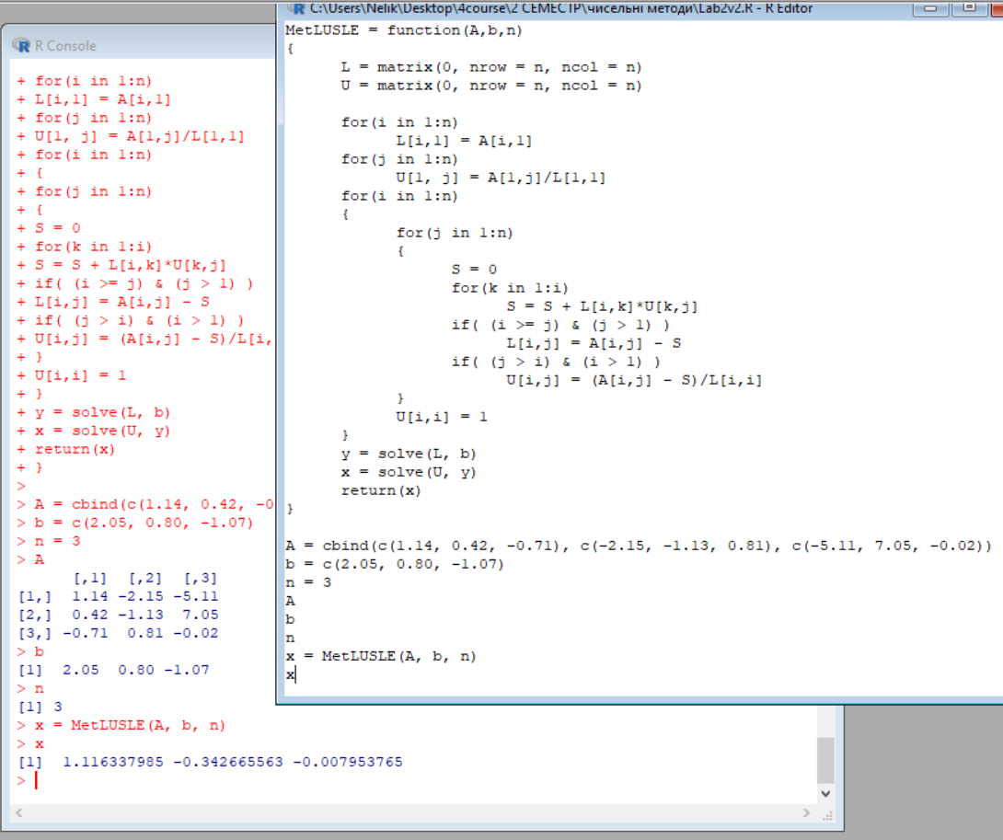

MetLUSLE = function(A,b,n)

{

L = matrix(0, nrow = n, ncol = n)

U = matrix(0, nrow = n, ncol = n)

for(i in 1:n)

L[i,1] = A[i,1]

for(j in 1:n)

U[1, j] = A[1,j]/L[1,1]

for(i in 1:n)

{

for(j in 1:n)

{

S = 0

for(k in 1:i)

S = S + L[i,k]\*U[k,j]

if( (i >= j) & (j > 1) )

L[i,j] = A[i,j] - S

if( (j > i) & (i > 1) )

U[i,j] = (A[i,j] - S)/L[i,i]

}

U[i,i] = 1

}

y = solve(L, b)

x = solve(U, y)

return(x)

}

A = cbind(c(1.14, 0.42, -0.71), c(-2.15, -1.13, 0.81), c(-5.11, 7.05, -0.02))

b = c(2.05, 0.80, -1.07)

n = 3

A

b

n

x = MetLUSLE(A, b, n)

x

Метод Ітерацій

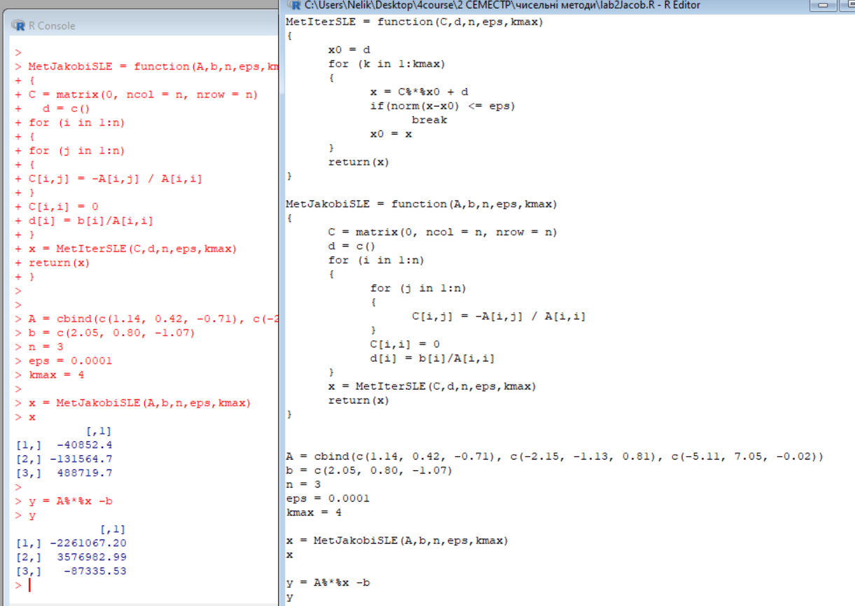

MetIterSLE = function(C,d,n,eps,kmax)

{

x0 = d

for (k in 1:kmax)

{

x = C%\*%x0 + d

if(norm(x-x0) <= eps)

break

x0 = x

}

return(x)

}

MetJakobiSLE = function(A,b,n,eps,kmax)

{

C = matrix(0, ncol = n, nrow = n)

d = c()

for (i in 1:n)

{

for (j in 1:n)

{

C[i,j] = -A[i,j] / A[i,i]

}

C[i,i] = 0

d[i] = b[i]/A[i,i]

}

x = MetIterSLE(C,d,n,eps,kmax)

return(x)

}

A = cbind(c(1.14, 0.42, -0.71), c(-2.15, -1.13, 0.81), c(-5.11, 7.05, -0.02))

b = c(2.05, 0.80, -1.07)

n = 3

eps = 0.0001

kmax = 4

x = MetJakobiSLE(A,b,n,eps,kmax)

x

y = A%\*%x -b

y

Метод Гауса - Жордана

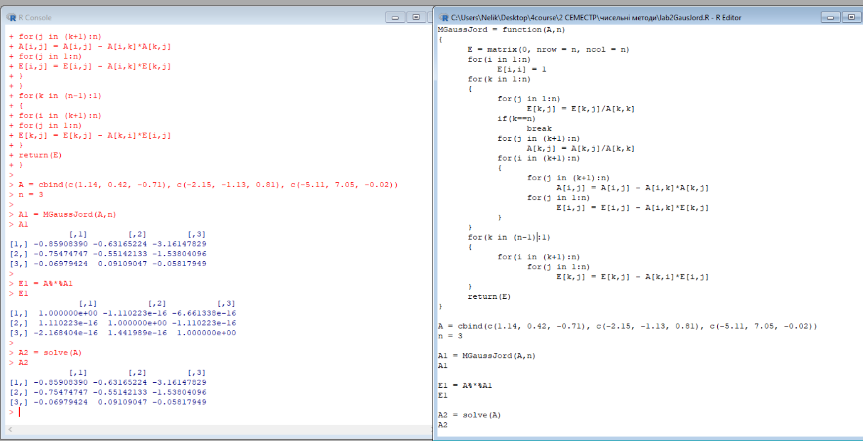

MGaussJord = function(A,n)

{

E = matrix(0, nrow = n, ncol = n)

for(i in 1:n)

E[i,i] = 1

for(k in 1:n)

{

for(j in 1:n)

E[k,j] = E[k,j]/A[k,k]

if(k==n)

break

for(j in (k+1):n)

A[k,j] = A[k,j]/A[k,k]

for(i in (k+1):n)

{

for(j in (k+1):n)

A[i,j] = A[i,j] - A[i,k]\*A[k,j]

for(j in 1:n)

E[i,j] = E[i,j] - A[i,k]\*E[k,j]

}

}

for(k in (n-1):1)

{

for(i in (k+1):n)

for(j in 1:n)

E[k,j] = E[k,j] - A[k,i]\*E[i,j]

}

return(E)

}

A = cbind(c(1.14, 0.42, -0.71), c(-2.15, -1.13, 0.81), c(-5.11, 7.05, -0.02))

n = 3

A1 = MGaussJord(A,n)

A1

E1 = A%\*%A1

E1

A2 = solve(A)

A2