Example

**Laser Rangefinder Range Equation**

1. **Noise Equivalent irradiance**

Calculate the noise bandwidth at the receiver

Kn = 1, Kf = 1, tp= 20ns

NB = $\frac{k_{n}×k_{f}}{tp}$ = $\frac{1×1}{20×{10}^{-9}}$ = 50MHz

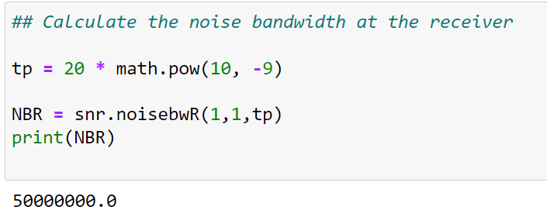

Calculate the receiver filter atmospheric transmittance

$$δ=0.17$$

∝_HT = 1

RT = 2000m = 2km

τa =

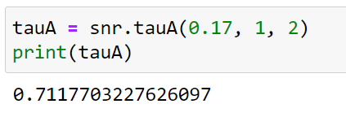

Calculate the detector noise

Given: D*= $3×{10}^{11}$

1. Calculating the noise equivalent irradiance at the receiver

$$A_{r}= \frac{π ×d^{2}}{4}= \frac{π×{0.044}^{2}}{4}= 1.52×{10}^{-3}m^{2}$$

$$NEE= \frac{\sqrt{∆f A_{d}}}{D^{*}A_{T}τ_{a}}= \frac{\sqrt{(50M) (3.5)}}{(3×{10}^{11})(1.52×{10}^{-3})(0.7117)}=4.076×{10}^{-5}$$

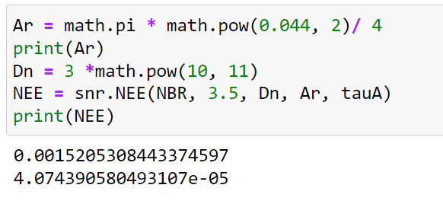

1. **Signal Irradiance**

Laser beam spot diameter and area at the target location.

DT = 1 mm

$$ϑ_{B}=0.8mrad$$

$$LBSD= D_{T}+ ϑ_{B}R_{T}=\left(1 ×{10}^{-3}\right)+ \left(0.8 ×{10}^{-3}\right)\left(2000\right)=1.601 m$$

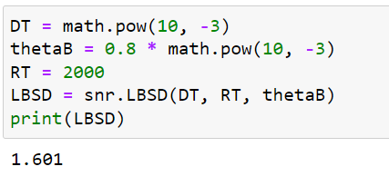

$$LBArea= \frac{π {(D_{T}+ ϑ_{B}R_{T})}^{2}}{4}=\frac{π {(1.601)}^{2}}{4}=2.013 m^{2}$$

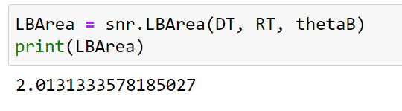

1. Power density at target location without considering the effect of atmospheric attenuation

$$P_{T}= \frac{Transmitted energy of designator }{Pulse Width}= \frac{80×{10}^{-3}}{20 × {10}^{-9}}=4MW$$

$PDtarget= \frac{4 P_{T}}{π {(D_{T}+ ϑ_{B}R_{T})}^{2}}=\frac{\left(4 ×{10}^{6} \right)}{2.013 }=1.987 MW/m$

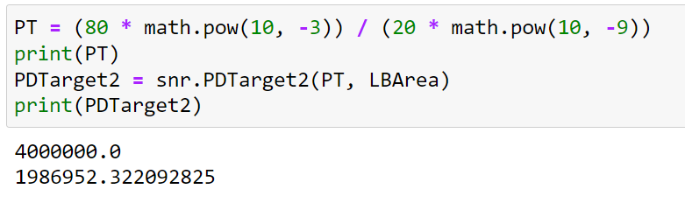

1. Power density at target location with considering the effect of atmospheric attenuation

$PDtargetA= \left[\frac{4 P_{T}}{π {(D_{T}+ ϑ_{B}R_{T})}^{2}}\right]e^{-σ_{w}(∝_{HT}R_{T})} =\left[1.987×{10}^{6}\right]× 0.712=1.4147 MW/m$

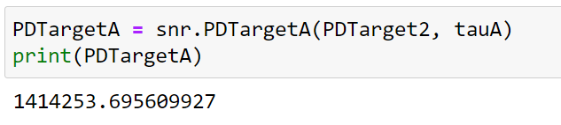

1. Power density at the target surface (target irradiance)

$$PDtargetS=\left[\frac{4 P_{T}\cos{(ϑ_{T})}}{π {(D_{T}+ ϑ_{B}R_{T})}^{2}}\right]e^{-σ_{w}(∝_{HT}R_{T})}=\left[1.4147{×10}^{6}\right] ×\cos\left(\frac{π}{12}\right)=1.3666 MW/m$$

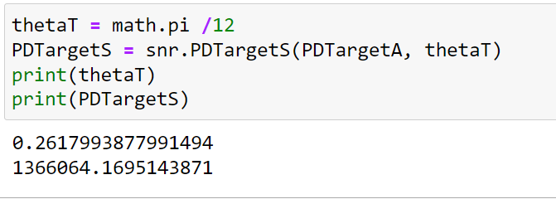

1. **Lambertian Target Reflectance**
2. Laser power density reflected from the target

$$RPDtarget= \left[\frac{4ρ P_{T}\cos{(ϑ_{T})}}{π{(D_{T}+ ϑ_{B}R_{T})}^{2}}\right]e^{-σ_{w}(∝_{HT}R_{T})}=\left[1.3666{×10}^{6}\right] ×0.3=409.96 KW/m$$

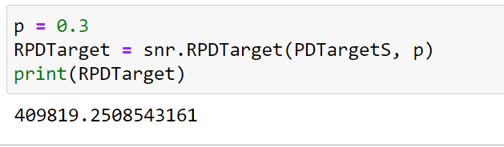

1. reflected power density per unit solid angle (target brightness)

$$TB= \left[\frac{4ρ P_{T}\cos{(ϑ_{T})}}{π^{2}{(D_{T}+ ϑ_{B}R_{T})}^{2}}\right]e^{-σ_{w}(∝_{HT}R_{T})}=\frac{\left[409.96{×10}^{3}\right]}{π}=130.49 KW/m$$

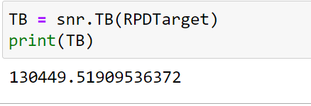

1. Power density available at the receiver location (Receiver Intensity)

Solid Angle = $\frac{A_{R}}{R_{R}^{2}}= \frac{1.52 {×10}^{-3}}{{(3000)}^{2}} =1.689{×10}^{-10}sr$

$τ_{b}= e^{-σ_{w}(∝_{HR}R_{R})}= e^{-0.17(1×3)}= 0.6$

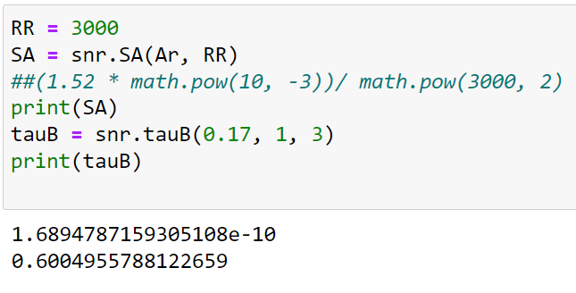

$PDReciever=\left[ \frac{A_{R}}{R_{R}^{2}}\right] \left[\frac{4A_{T}\cos{(ϑ_{R})}ρ P_{T}\cos{(ϑ_{T})}}{π^{2}{(D_{T}+ ϑ_{B}R_{T})}^{2}}\right] τ_{a} τ_{b}=\left[1.689{×10}^{-10}\right]\left[130.49{×10}^{3}×5×\cos{(\frac{2π}{5})}\right]\left[0.6\right]=2.043{×10}^{-5} W/m^{3}$?

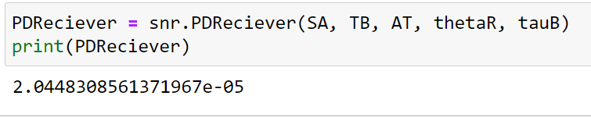

1. **Lambertian Target against the sky**

$$SNR= \frac{PDReciever}{NEE }= \frac{2.043{×10}^{-5}}{4.076×{10}^{-5}}=0.5$$

