**Task-14 CODE**

QUESTION

Perform CRUD Operation -:

1) Create Operation -:

i)On submission of your form, write onClick() function

ii) Inside function make ajax call and provide data of each field and url.

iii)With ajax url register servlet with path and make call to your servlet.

iv)Override doGet() method and save form data to path into your Crx/de.

2) Read Operation -:

i)Fetch all data from path provided using query in form data table component sling

model.

Form Data Table Component -:

3)If user click on the edit button it should take to the contact us component and the user can edit their field

4)If the user click on delete it should select particular row and it should delete that respective node in crx/de.

Answer :

**FRONT-END CODE FOR CRUD OPERATION**

**<!DOCTYPE html>**

**<html lang="en">**

**<head>**

**<meta charset="UTF-8">**

**<title>AJAX to AEM Servlet</title>**

**<script src="https://code.jquery.com/jquery-3.6.0.min.js"></script>**

**<style>**

**table {**

**width: 100%;**

**border-collapse: collapse;**

**}**

**th, td {**

**border: 1px solid orange;**

**padding: 8px;**

**text-align: left;**

**}**

**th {**

**background-color: black;**

**color: white;**

**}**

**td {**

**background-color: black;**

**color: white;**

**}**

**.edit, .delete {**

**color: orange;**

**cursor: pointer;**

**}**

**</style>**

**</head>**

**<body>**

**<form id="myForm">**

**<input type="hidden" id="rowIndex" value="">**

**<input type="text" name="param1" id="param1" placeholder="Name"><br></br>**

**<input type="text" name="param2" id="param2" placeholder="Email"><br></br>**

**<input type="text" name="param3" id="param3" placeholder="Subject"><br></br>**

**<input type="text" name="param4" id="param4" placeholder="Message"><br></br>**

**<div class="your-component" data-path="${resource.path @ context='unsafe'}"></div>**

**<button type="button" onclick="sendData()">Submit</button>**

**</form>**

**<div id="formDataTable"></div>**

**<script>**

**function sendData() {**

**const rowIndex = $("#rowIndex").val();**

**const param1 = $("#param1").val();**

**const param2 = $("#param2").val();**

**const param3 = $("#param3").val();**

**const param4 = $("#param4").val();**

**const componentPath = $(".your-component").attr("data-path");**

**console.log("Component Path:", componentPath);**

**$.ajax({**

**url: '/bin/myServlet',**

**type: 'POST',**

**data: {**

**rowIndex: rowIndex,**

**param1: param1,**

**param2: param2,**

**param3: param3,**

**param4: param4,**

**componentPath: componentPath**

**},**

**success: function(response) {**

**console.log('Response from POST:', response);**

**alert('Response: ' + response.message);**

**fetchTableData();**

**clearForm();**

**},**

**error: function(xhr, status, error) {**

**console.error('Error: ' + error);**

**}**

**});**

**}**

**function fetchTableData() {**

**const componentPath = $(".your-component").attr("data-path");**

**console.log("Fetching data from path:", componentPath);**

**$.ajax({**

**url: '/bin/myServlet',**

**type: 'GET',**

**data: { path: componentPath },**

**success: function(response) {**

**console.log('Response from GET:', response);**

**if (response.data) {**

**createTable(response.data);**

**} else {**

**console.error('No data received');**

**}**

**},**

**error: function(xhr, status, error) {**

**console.error('Error: ' + error);**

**}**

**});**

**}**

**function createTable(data) {**

**const tableContainer = document.getElementById('formDataTable');**

**tableContainer.innerHTML = '';**

**const table = document.createElement('table');**

**const headerRow = document.createElement('tr');**

**const headers = ['Name', 'Email', 'Subject', 'Message', 'Edit', 'Delete'];**

**headers.forEach(headerText => {**

**const th = document.createElement('th');**

**th.textContent = headerText;**

**headerRow.appendChild(th);**

**});**

**table.appendChild(headerRow);**

**data.forEach((item, index) => {**

**const dataRow = document.createElement('tr');**

**const nameCell = document.createElement('td');**

**nameCell.textContent = item.name;**

**dataRow.appendChild(nameCell);**

**const emailCell = document.createElement('td');**

**emailCell.textContent = item.email;**

**dataRow.appendChild(emailCell);**

**const subjectCell = document.createElement('td');**

**subjectCell.textContent = item.subject;**

**dataRow.appendChild(subjectCell);**

**const messageCell = document.createElement('td');**

**messageCell.textContent = item.message;**

**dataRow.appendChild(messageCell);**

**const editCell = document.createElement('td');**

**editCell.textContent = 'Edit';**

**editCell.className = 'edit';**

**editCell.dataset.index = index;**

**editCell.onclick = function() {**

**editRow(item, index);**

**};**

**dataRow.appendChild(editCell);**

**const deleteCell = document.createElement('td');**

**deleteCell.textContent = 'Delete';**

**deleteCell.className = 'delete';**

**deleteCell.dataset.index = index;**

**deleteCell.onclick = function() {**

**deleteRow(index);**

**};**

**dataRow.appendChild(deleteCell);**

**table.appendChild(dataRow);**

**});**

**tableContainer.appendChild(table);**

**}**

**function editRow(item, index) {**

**$("#rowIndex").val(index);**

**$("#param1").val(item.name);**

**$("#param2").val(item.email);**

**$("#param3").val(item.subject);**

**$("#param4").val(item.message);**

**}**

**function deleteRow(index) {**

**const componentPath = $(".your-component").attr("data-path");**

**$.ajax({**

**url: '/bin/myServlet',**

**type: 'POST',**

**data: {**

**rowIndex: index,**

**delete: 'true',**

**componentPath: componentPath**

**},**

**success: function(response) {**

**console.log('Response from DELETE:', response);**

**alert('Row deleted successfully');**

**fetchTableData();**

**},**

**error: function(xhr, status, error) {**

**console.error('Error: ' + error);**

**}**

**});**

**}**

**function clearForm() {**

**$("#rowIndex").val('');**

**$("#param1").val('');**

**$("#param2").val('');**

**$("#param3").val('');**

**$("#param4").val('');**

**}**

**document.addEventListener('DOMContentLoaded', function() {**

**fetchTableData();**

**});**

**</script>**

**</body>**

**</html>**

**SERVLET CODE**

package com.adobe.aem.guides.demo.core.servlets;

**import org.apache.sling.api.SlingHttpServletRequest;**

**import org.apache.sling.api.SlingHttpServletResponse;**

**import org.apache.sling.api.servlets.SlingAllMethodsServlet;**

**import org.osgi.service.component.annotations.Component;**

**import org.osgi.framework.Constants;**

**import com.google.gson.JsonArray;**

**import com.google.gson.JsonObject;**

**import javax.jcr.Node;**

**import javax.jcr.RepositoryException;**

**import javax.jcr.Session;**

**import org.apache.sling.jcr.api.SlingRepository;**

**import org.apache.sling.api.resource.ResourceResolver;**

**import org.apache.sling.api.resource.ResourceResolverFactory;**

**import org.apache.sling.api.resource.LoginException;**

**import org.apache.sling.api.resource.Resource;**

**import javax.servlet.Servlet;**

**import java.io.IOException;**

**import java.util.HashMap;**

**import java.util.Iterator;**

**import java.util.Map;**

**@Component(**

**service = { Servlet.class },**

**property = {**

**Constants.SERVICE_DESCRIPTION + "=Example Servlet",**

**"sling.servlet.paths=/bin/myServlet",**

**"sling.servlet.methods={GET, POST, DELETE}"**

**}**

**)**

**public class MyServlet extends SlingAllMethodsServlet {**

**@org.osgi.service.component.annotations.Reference**

**private SlingRepository repository;**

**@org.osgi.service.component.annotations.Reference**

**private ResourceResolverFactory resolverFactory;**

**@Override**

**protected void doGet(SlingHttpServletRequest request, SlingHttpServletResponse response) throws IOException {**

**String componentPath = request.getParameter("path");**

**ResourceResolver resourceResolver = null;**

**try {**

**// Get the resource resolver**

**Map<String, Object> param = new HashMap<>();**

**param.put(ResourceResolverFactory.SUBSERVICE, "hemanth");**

**resourceResolver = resolverFactory.getServiceResourceResolver(param);**

**// Get the resource at the specified path**

**Resource resource = resourceResolver.getResource(componentPath + "/data");**

**JsonArray dataArray = new JsonArray();**

**if (resource != null) {**

**Iterator<Resource> children = resource.listChildren();**

**while (children.hasNext()) {**

**Resource child = children.next();**

**Node childNode = child.adaptTo(Node.class);**

**if (childNode != null) {**

**JsonObject dataObject = new JsonObject();**

**dataObject.addProperty("name", childNode.getProperty("name").getString());**

**dataObject.addProperty("email", childNode.getProperty("email").getString());**

**dataObject.addProperty("subject", childNode.getProperty("subject").getString());**

**dataObject.addProperty("message", childNode.getProperty("message").getString());**

**dataArray.add(dataObject);**

**}**

**}**

**}**

**JsonObject jsonResponse = new JsonObject();**

**jsonResponse.add("data", dataArray);**

**response.setContentType("application/json");**

**response.setCharacterEncoding("UTF-8");**

**response.getWriter().write(jsonResponse.toString());**

**} catch (LoginException | RepositoryException e) {**

**e.printStackTrace();**

**JsonObject jsonResponse = new JsonObject();**

**jsonResponse.addProperty("status", "error");**

**jsonResponse.addProperty("message", e.getMessage());**

**response.setContentType("application/json");**

**response.setCharacterEncoding("UTF-8");**

**response.getWriter().write(jsonResponse.toString());**

**} finally {**

**if (resourceResolver != null) {**

**resourceResolver.close();**

**}**

**}**

**}**

**@Override**

**protected void doPost(SlingHttpServletRequest request, SlingHttpServletResponse response) throws IOException {**

**String rowIndex = request.getParameter("rowIndex");**

**String delete = request.getParameter("delete");**

**String componentPath = request.getParameter("componentPath");**

**ResourceResolver resourceResolver = null;**

**Session session = null;**

**try {**

**Map<String, Object> param = new HashMap<>();**

**param.put(ResourceResolverFactory.SUBSERVICE, "hemanth");**

**resourceResolver = resolverFactory.getServiceResourceResolver(param);**

**session = resourceResolver.adaptTo(Session.class);**

**Resource componentResource = resourceResolver.getResource(componentPath);**

**Node componentNode = componentResource.adaptTo(Node.class);**

**if (!componentNode.hasNode("data")) {**

**componentNode.addNode("data", "nt:unstructured");**

**}**

**Node dataNode = componentNode.getNode("data");**

**if (delete != null && delete.equals("true")) {**

**// Handle delete**

**if (dataNode.hasNode("item" + rowIndex)) {**

**Node itemNode = dataNode.getNode("item" + rowIndex);**

**itemNode.remove();**

**session.save();**

**JsonObject jsonResponse = new JsonObject();**

**jsonResponse.addProperty("status", "success");**

**jsonResponse.addProperty("message", "Data deleted successfully.");**

**response.setContentType("application/json");**

**response.setCharacterEncoding("UTF-8");**

**response.getWriter().write(jsonResponse.toString());**

**} else {**

**JsonObject jsonResponse = new JsonObject();**

**jsonResponse.addProperty("status", "error");**

**jsonResponse.addProperty("message", "Node not found.");**

**response.setContentType("application/json");**

**response.setCharacterEncoding("UTF-8");**

**response.getWriter().write(jsonResponse.toString());**

**}**

**} else {**

**// Handle create/update**

**String param1 = request.getParameter("param1");**

**String param2 = request.getParameter("param2");**

**String param3 = request.getParameter("param3");**

**String param4 = request.getParameter("param4");**

**Node itemNode;**

**if (rowIndex == null || rowIndex.isEmpty()) {**

**int itemIndex = 0;**

**while (dataNode.hasNode("item" + itemIndex)) {**

**itemIndex++;**

**}**

**itemNode = dataNode.addNode("item" + itemIndex, "nt:unstructured");**

**} else {**

**itemNode = dataNode.getNode("item" + rowIndex);**

**}**

**itemNode.setProperty("name", param1);**

**itemNode.setProperty("email", param2);**

**itemNode.setProperty("subject", param3);**

**itemNode.setProperty("message", param4);**

**session.save();**

**JsonObject jsonResponse = new JsonObject();**

**jsonResponse.addProperty("status", "success");**

**jsonResponse.addProperty("message", "Data stored successfully.");**

**response.setContentType("application/json");**

**response.setCharacterEncoding("UTF-8");**

**response.getWriter().write(jsonResponse.toString());**

**}**

**} catch (LoginException | RepositoryException e) {**

**e.printStackTrace();**

**JsonObject jsonResponse = new JsonObject();**

**jsonResponse.addProperty("status", "error");**

**jsonResponse.addProperty("message", e.getMessage());**

**response.setContentType("application/json");**

**response.setCharacterEncoding("UTF-8");**

**response.getWriter().write(jsonResponse.toString());**

**} finally {**

**if (session != null) {**

**session.logout();**

**}**

**if (resourceResolver != null) {**

**resourceResolver.close();**

**}**

**}**

**}**

**}**

**FORM AND TABLE CREATION**

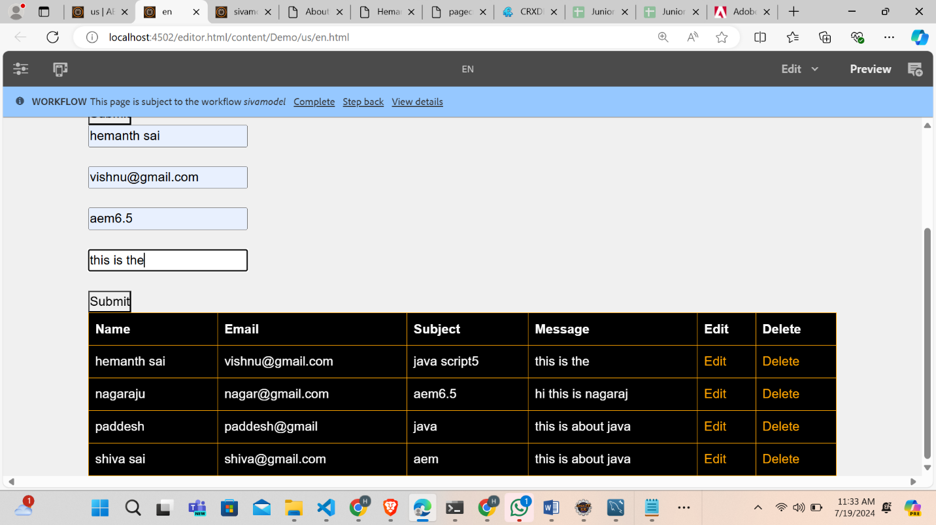

**NODE CREATION AND STORED FORM DATA**

