**TASK-1 CODE**

**QUESTION**

1- Create a component Named Header with Path field, text field, multifield (text field & Date picker) and checkbox.

 2- Render the authored field via sling model on page using HTL

1. Create a Component Named Header

**Steps:**

1. **Define the Component:**
   * In your AEM project, create a new component named "Header."
   * Define the component properties and dialog structure.
2. **Dialog Configuration:**
   * Create a dialog for the Header component.
   * Add the required fields (path field, text field, multifield with text field and date picker, checkbox) to the dialog.

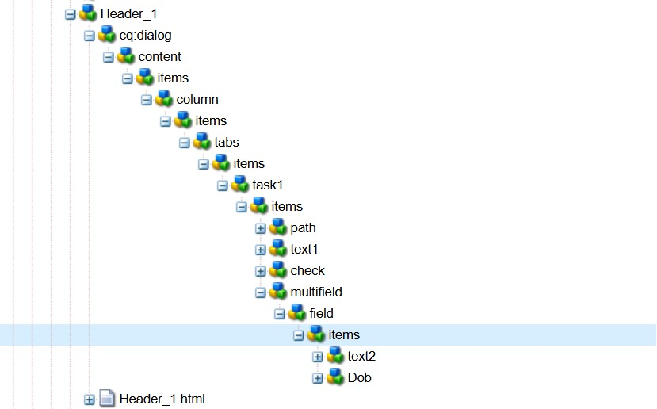

**. Render the Authored Field via Sling Model on Page Using HTL**

* **Objective:** Render the data authored in the Header component using a Sling Model and HTL (HTML Template Language).
* **Steps:**
  1. **Create a Sling Model:**
     + Develop a Sling Model to map the data from the Header component.
     + Annotate the model with @Model and map the properties.

package com.adobe.aem.guides.demo.core.models;

import java.util.List;

import javax.inject.Inject;

import org.apache.sling.api.resource.Resource;

import org.apache.sling.models.annotations.DefaultInjectionStrategy;

import org. apache.sling.models.annotations.Model;

import org. apache.sling.models.annotations.injectorspecific.ChildResource;

@Model(adaptable = Resource.class,defaultInjectionStrategy = DefaultInjectionStrategy.OPTIONAL)

public class Task_2 {

@Inject

private String pathfield;

@Inject

private String textfield;

@Inject

private String checkbox;

@ChildResource

private List<Unit>multi;

public List<Unit> getMulti() {

return multi;

}

public String getPathfield() {

return pathfield;

}

public String getTextfield() {

return textfield;

}

public String getCheckbox() {

return checkbox;

} }

Multifield model

package com.adobe.aem.guides.demo.core.models;

import javax.inject.Inject;

import org.apache.sling.api.resource.Resource;

import org.apache.sling.models.annotations.DefaultInjectionStrategy;

import org.apache.sling.models.annotations.Model;

@Model(adaptables = Resource.class,defaultInjectionStrategy = DefaultInjectionStrategy.OPTIONAL)

public class Unit {

@Inject

private String text2;

@Inject

private String dob;

public String getText2() {

return text2;

}

public String getDob() {

return dob;

} }

**Render Data Using HTL:**

* Use the Sling Model in your HTL file to render the Header component data.

<h2 class="sknv"> Header_1 component</h2>

<div data-sly-use.obj="com.adobe.aem.guides.demo.core.models.Task_2">

<h3>PathField :${obj.pathfield}</h3>

<h3 class="my">TextField :${obj.textfield}</h3>

<h3>checkBox :${obj.checkbox}</h3>

<div data-sly-list.object="${obj.multi}">

<h3>Text :${object.text2}</h3>

<h3>DateOfBirth :${object.dob}</h3>

</div>

</div>

<sly data-sly-use.clientlib="/libs/granite/sightly/templates/clientlib.html">

<sly data-sly-call="${clientlib.all @ categories='libraryclient'}"/>

</sly>