TASK-7 CODE

QUESTION

1. Write an event handler that triggers upon the publication of any page in AEM, logging the path of the published page.
2. At the Same time when the page is published Servlet has been triggered and showing the logging message.

ANSWER:

**package** com.adobe.aem.guides.demo.core.listeners;

**import** java.util.HashMap;

**import** java.util.Map;

**import** javax.jcr.Session;

**import** org.apache.sling.api.resource.LoginException;

**import** org.apache.sling.api.resource.ModifiableValueMap;

**import** org.apache.sling.api.resource.PersistenceException;

**import** org.apache.sling.api.resource.Resource;

**import** org.apache.sling.api.resource.ResourceResolver;

**import** org.apache.sling.api.resource.ResourceResolverFactory;

**import** org.osgi.service.component.annotations.Component;

**import** org.osgi.service.component.annotations.Reference;

**import** org.osgi.service.event.Event;

**import** org.osgi.service.event.EventConstants;

**import** org.osgi.service.event.EventHandler;

**import** org.slf4j.Logger;

**import** org.slf4j.LoggerFactory;

**import** com.day.cq.replication.ReplicationAction;

@Component(service = EventHandler.**class**, immediate = **true**,

property = {

EventConstants.***EVENT_TOPIC*** + "=" + ReplicationAction.***EVENT_TOPIC***

}

)

**public** **class** HemanthHandlerJuly **implements** EventHandler {

**private** **static** **final** Logger ***log*** = LoggerFactory.*getLogger*(HemanthHandlerJuly.**class**);

@Reference

**private** WorkflowService workflowService;

@Reference

**private** ResourceResolverFactory resolverFactory;

@Override

**public** **void** handleEvent(Event event) {

***log***.info("Handle my trigger");

handleReplicationEvent(event);

triggerServlet(event);

}

**private** **void** handleReplicationEvent(Event event) {

ReplicationAction action = ReplicationAction.*fromEvent*(event);

String path = action.getPath();

***log***.info("Content activated at path: {}", path);

}

private void triggerServlet(Event event) {

// String servletUrl = "http://localhost:4502/bin/demohandle"; // Replace with your servlet URL

// try (CloseableHttpClient httpClient = HttpClients.createDefault()) {

// HttpGet request = new HttpGet(servletUrl);

// try (CloseableHttpResponse response = httpClient.execute(request)) {

// log.info("Servlet triggered with status: {}", response.getStatusLine().getStatusCode());

// log.info("servlet triggered sucessfully");

// }

// } catch (IOException e) {

// log.error("Error triggering servlet", e);

//     }

    // }

}

**Published Path**

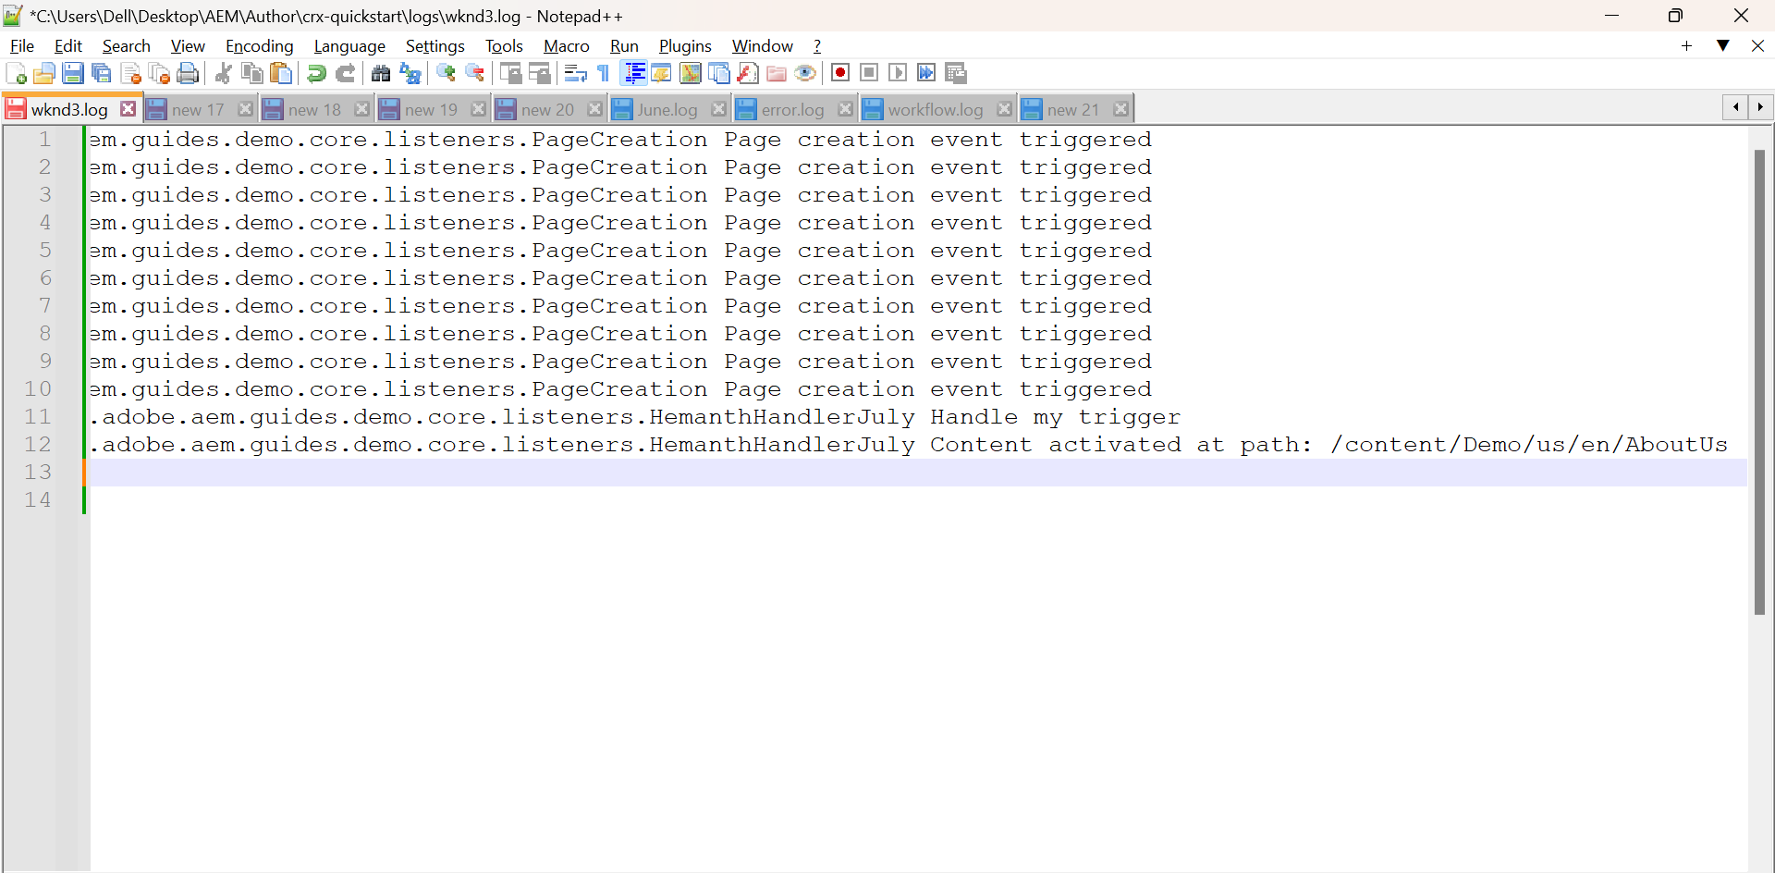

**Published Page**

