**Task-11 CODE**

QUESTION

1) When you create any page in the project, you should trigger the event handler. After that, you should trigger the workflow, and it should add the Expirydate property to that page's jcr:content, with the value being the current date and time.

**ANSWER :**

**EVENT HANDLER FOR CREATING PAGE WORKFLOW STARTED**

**package** com.adobe.aem.guides.demo.core.listeners;

**import** java.util.HashMap;

**import** java.util.Map;

**import** javax.jcr.Session;

**import** org.apache.sling.api.resource.LoginException;

**import** org.apache.sling.api.resource.Resource;

**import** org.apache.sling.api.resource.ResourceResolver;

**import** org.apache.sling.api.resource.ResourceResolverFactory;

**import** org.osgi.service.component.annotations.Component;

**import** org.osgi.service.component.annotations.Reference;

**import** org.osgi.service.event.Event;

**import** org.osgi.service.event.EventConstants;

**import** org.osgi.service.event.EventHandler;

**import** org.slf4j.Logger;

**import** org.slf4j.LoggerFactory;

**import** com.day.cq.workflow.WorkflowException;

**import** com.day.cq.workflow.WorkflowService;

**import** com.day.cq.workflow.WorkflowSession;

**import** com.day.cq.workflow.exec.WorkflowData;

**import** com.day.cq.workflow.model.WorkflowModel;

@Component(service = EventHandler.**class**, immediate = **true**,

property = {

EventConstants.***EVENT_TOPIC*** + "=org/apache/sling/api/resource/Resource/ADDED"

}

)

**public** **class** PageCreation **implements** EventHandler {

**private** **static** **final** Logger ***log*** = LoggerFactory.*getLogger*(PageCreation.**class**);

@Reference

**private** WorkflowService workflowService;

@Reference

**private** ResourceResolverFactory resolverFactory;

@Override

**public** **void** handleEvent(Event event) {

***log***.info("Page creation event triggered");

handleResourceAddedEvent(event);

}

**private** **void** handleResourceAddedEvent(Event event) {

String path = (String) event.getProperty("path");

// log.info("Resource added at path: {}", path);

ResourceResolver resourceResolver = **null**;

**try** {

Map<String, Object> param = **new** HashMap<>();

param.put(ResourceResolverFactory.***SUBSERVICE***, "hemanth");

resourceResolver = resolverFactory.getServiceResourceResolver(param);

Resource resource = resourceResolver.getResource(path);

**if** (resource != **null** && resource.isResourceType("cq:Page")) {

***log***.info("Page created at path: {}", path);

startWorkflow(path);

}

} **catch** (LoginException e) {

***log***.error("Error obtaining resource resolver", e);

} **finally** {

**if** (resourceResolver != **null**) {

resourceResolver.close();

}

}

}

**private** **void** startWorkflow(String payloadPath) {

Map<String, Object> param = **new** HashMap<>();

param.put(ResourceResolverFactory.***SUBSERVICE***, "hemanth");

**try** (ResourceResolver resolver = resolverFactory.getServiceResourceResolver(param)) {

Session session = resolver.adaptTo(Session.**class**);

WorkflowSession workflowSession = workflowService.getWorkflowSession(session);

String workflowModelPath = "/var/workflow/models/HemanthModel"; // Replace with your workflow model path

WorkflowModel workflowModel = workflowSession.getModel(workflowModelPath);

WorkflowData workflowData = workflowSession.newWorkflowData("JCR_PATH", payloadPath);

workflowSession.startWorkflow(workflowModel, workflowData);

***log***.info("Workflow started for payload: {}", payloadPath);

} **catch** (LoginException e) {

***log***.error("LoginException while starting workflow", e);

} **catch** (WorkflowException e) {

***log***.error("WorkflowException while starting workflow", e);

} **catch** (Exception e) {

***log***.error("Exception while starting workflow", e);

}

}

}

**ADD PROPERTY THROUGH WORKFLOW**

**package workflow;**

**import java.util.Calendar;**

**import java.util.HashMap;**

**import java.util.Map;**

**import javax.jcr.Node;**

**import javax.jcr.Session;**

**import org.apache.sling.api.resource.LoginException;**

**import org.apache.sling.api.resource.PersistenceException;**

**import org.apache.sling.api.resource.ResourceResolver;**

**import org.apache.sling.api.resource.ResourceResolverFactory;**

**import org.osgi.service.component.annotations.Component;**

**import org.osgi.service.component.annotations.Reference;**

**import org.slf4j.Logger;**

**import org.slf4j.LoggerFactory;**

**import com.adobe.granite.workflow.WorkflowSession;**

**import com.adobe.granite.workflow.exec.WorkItem;**

**import com.adobe.granite.workflow.exec.WorkflowProcess;**

**import com.adobe.granite.workflow.metadata.MetaDataMap;**

**@Component(service = WorkflowProcess.class, property = {"process.label=Page Created"})**

**public class PagecreatedWorkflow implements WorkflowProcess {**

**private static final Logger log = LoggerFactory.getLogger(PagecreatedWorkflow.class);**

**@Reference**

**private ResourceResolverFactory resolverFactory;**

**@Override**

**public void execute(WorkItem workItem, WorkflowSession workflowSession, MetaDataMap metaDataMap) {**

**String payloadPath = workItem.getWorkflowData().getPayload().toString();**

**ResourceResolver resourceResolver = null;**

**try {**

**// Using service user to obtain resource resolver**

**Map<String, Object> param = new HashMap<>();**

**param.put(ResourceResolverFactory.SUBSERVICE, "hemanth");**

**resourceResolver = resolverFactory.getServiceResourceResolver(param);**

**Session session = resourceResolver.adaptTo(Session.class);**

**Node pageNode = session.getNode(payloadPath);**

**if (pageNode != null && pageNode.hasNode("jcr:content")) {**

**Node contentNode = pageNode.getNode("jcr:content");**

**Calendar currentDate = Calendar.getInstance();**

**contentNode.setProperty("expired", currentDate);**

**session.save();**

**log.info("Property 'expired' added to jcr:content of page at {}", payloadPath);**

**} else {**

**log.warn("jcr:content node not found for page at {}", payloadPath);**

**}**

**} catch (Exception e) {**

**log.error("Error adding property to jcr:content of page at {}", payloadPath, e);**

**throw new RuntimeException(e);**

**} finally {**

**if (resourceResolver != null) {**

**resourceResolver.close();**

**}**

**}}}**

**WORKFLOW PROCESS STEP**

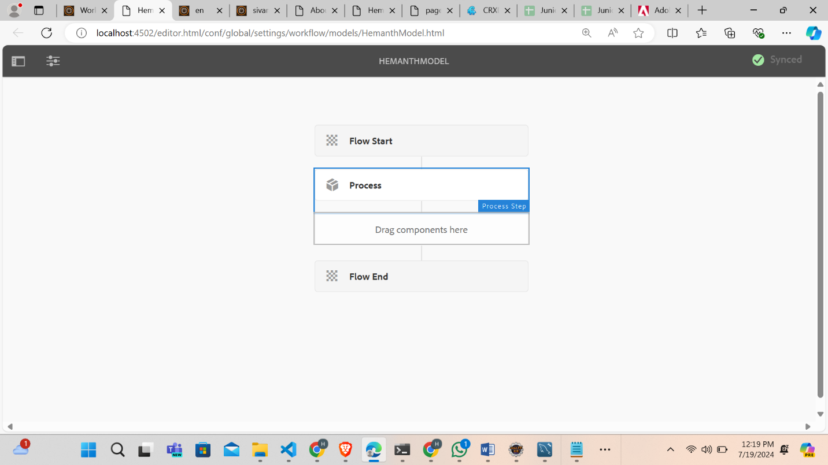

**ADD PROPERTY ON CRXDE**

