**Task-9 CODE**

QUESTION

When you publish the page? And it will trigger the event handler and display the logs, after which you should trigger the workflow. then start the workflow automatically.

Create a workflow that includes both a process and a participant step.

**Description:**

When a user publishes a page, the administrator should receive an email notification.

**ANSWER:**

**HANDLER CODE**

**package** com.adobe.aem.guides.demo.core.listeners;

**import** java.util.HashMap;

**import** java.util.Map;

**import** javax.jcr.Session;

**import** org.apache.sling.api.resource.LoginException;

**import** org.apache.sling.api.resource.ModifiableValueMap;

**import** org.apache.sling.api.resource.PersistenceException;

**import** org.apache.sling.api.resource.Resource;

**import** org.apache.sling.api.resource.ResourceResolver;

**import** org.apache.sling.api.resource.ResourceResolverFactory;

**import** org.osgi.service.component.annotations.Component;

**import** org.osgi.service.component.annotations.Reference;

**import** org.osgi.service.event.Event;

**import** org.osgi.service.event.EventConstants;

**import** org.osgi.service.event.EventHandler;

**import** org.slf4j.Logger;

**import** org.slf4j.LoggerFactory;

**import** com.day.cq.replication.ReplicationAction;

**import** com.day.cq.workflow.WorkflowException;

**import** com.day.cq.workflow.WorkflowService;

**import** com.day.cq.workflow.WorkflowSession;

**import** com.day.cq.workflow.exec.WorkflowData;

**import** com.day.cq.workflow.model.WorkflowModel;

@Component(service = EventHandler.**class**, immediate = **true**,

property = {

EventConstants.***EVENT_TOPIC*** + "=" + ReplicationAction.***EVENT_TOPIC***

}

)

**public** **class** HemanthHandlerJuly **implements** EventHandler {

**private** **static** **final** Logger ***log*** = LoggerFactory.*getLogger*(HemanthHandlerJuly.**class**);

@Reference

**private** WorkflowService workflowService;

@Reference

**private** ResourceResolverFactory resolverFactory;

@Override

**public** **void** handleEvent(Event event) {

***log***.info("Handle my trigger");

handleReplicationEvent(event);

}

**private** **void** handleReplicationEvent(Event event) {

ReplicationAction action = ReplicationAction.*fromEvent*(event);

String path = action.getPath();

***log***.info("Content activated at path: {}", path);

startWorkflow(path);

// addPropertyToPage(path);

}

**private** **void** startWorkflow(String payloadPath) {

Map<String, Object> param = **new** HashMap<>();

param.put(ResourceResolverFactory.***SUBSERVICE***, "hemanth");

**try** (ResourceResolver resolver = resolverFactory.getServiceResourceResolver(param)) {

Session session = resolver.adaptTo(Session.**class**);

WorkflowSession workflowSession = workflowService.getWorkflowSession(session);

String workflowModelPath = "/var/workflow/models/sivamodel"; // Replace with your workflow model path

WorkflowModel workflowModel = workflowSession.getModel(workflowModelPath);

WorkflowData workflowData = workflowSession.newWorkflowData("JCR_PATH", payloadPath);

workflowSession.startWorkflow(workflowModel, workflowData);

***log***.info("Workflow started for payload: {}", payloadPath);

} **catch** (LoginException e) {

***log***.error("LoginException while starting workflow", e);

} **catch** (WorkflowException e) {

***log***.error("WorkflowException while starting workflow", e);

} **catch** (Exception e) {

***log***.error("Exception while starting workflow", e);

}

}

**private** **void** addPropertyToPage(String pagePath) {

Map<String, Object> param = **new** HashMap<>();

param.put(ResourceResolverFactory.***SUBSERVICE***, "hemanth");

**try** (ResourceResolver resolver = resolverFactory.getServiceResourceResolver(param)) {

String jcrContentPath = pagePath + "/jcr:content";

Resource resource = resolver.getResource(jcrContentPath);

**if** (resource != **null**) {

ModifiableValueMap properties = resource.adaptTo(ModifiableValueMap.**class**);

**if** (properties != **null**) {

properties.put("changed", **true**);

resolver.commit();

***log***.info("Property 'changed' set to true for: {}", jcrContentPath);

}

} **else** {

***log***.warn("Resource not found at path: {}", jcrContentPath);

}

} **catch** (LoginException e) {

***log***.error("LoginException while adding property", e);

} **catch** (PersistenceException e) {

***log***.error("PersistenceException while adding property", e);

} **catch** (Exception e) {

***log***.error("Exception while adding property", e);

}

}

}

**WORKFLOW PROCESS CODE**

package workflow;

import org.osgi.service.component.annotations.Component;

import org.osgi.service.component.annotations.Reference;

import org.slf4j.Logger;

import org.slf4j.LoggerFactory;

import com.adobe.aem.guides.demo.core.service.EmailService;

import com.adobe.granite.workflow.WorkflowSession;

import com.adobe.granite.workflow.exec.WorkItem;

import com.adobe.granite.workflow.exec.WorkflowProcess;

import com.adobe.granite.workflow.metadata.MetaDataMap;

@Component(service = WorkflowProcess.class, property = {"process.label=Send Email Process"})

public class Workflow implements WorkflowProcess {

private static final Logger log = LoggerFactory.getLogger(Workflow.class);

@Reference

private EmailService emailService;

@Override

public void execute(WorkItem workItem, WorkflowSession workflowSession, MetaDataMap args) {

try {

log.info("this is process step by hemanth");

String pagePath = workItem.getWorkflowData().getPayload().toString();

emailService.sendEmail("hemanth.nellori@gmail", "Page Published", "A page has been published: " + pagePath);

} catch (Exception e) {

e.printStackTrace();

}

}

}

**SERVICE CODE**

**package** com.adobe.aem.guides.demo.core.service;

**import** org.osgi.service.component.annotations.Component;

**import** javax.mail.*;

**import** javax.mail.internet.*;

**import** java.util.Properties;

@Component(immediate = **true**, service = EmailService.**class**)

**public** **class** EmailService {

**public** **void** sendEmail(String to, String subject, String body) **throws** MessagingException {

String from = "hnellori@gmail.com";

**final** String username = "hemanth";

**final** String password = "hemanth$123456";

String host = "smtp.example.com";

Properties props = **new** Properties();

props.put("mail.smtp.auth", "true");

props.put("mail.smtp.starttls.enable", "true");

props.put("mail.smtp.host", host);

props.put("mail.smtp.port", "465");

Session session = Session.*getInstance*(props, **new** javax.mail.Authenticator() {

**protected** PasswordAuthentication getPasswordAuthentication() {

**return** **new** PasswordAuthentication(username, password);

}

});

Message message = **new** MimeMessage(session);

message.setFrom(**new** InternetAddress(from));

message.setRecipients(Message.RecipientType.***TO***, InternetAddress.*parse*(to));

message.setSubject(subject);

message.setText(body);

Transport.*send*(message);

}

}

**EMAIL TEST SERVLET CODE**

**package** com.adobe.aem.guides.demo.core.servlets;

**import** java.util.Properties;

**import** javax.mail.Authenticator;

**import** javax.mail.Message;

**import** javax.mail.MessagingException;

**import** javax.mail.PasswordAuthentication;

**import** javax.mail.Session;

**import** javax.mail.Transport;

**import** javax.mail.internet.InternetAddress;

**import** javax.mail.internet.MimeMessage;

**public** **class** Email {

**public** **static** **void** main(String[] args) {

// SMTP server details

String smtpHost = "smtp.gmail.com"; // Replace with your SMTP server

**int** smtpPort = 587; // Replace with the port of your SMTP server

**final** String username = "hemanthsainellori@gmail.com"; // Replace with your email address

**final** String password = "yofmzgflukuqojtr"; // Replace with your email password

// Sender's email address

String fromEmail = "hemanthsainellori@gmail.com"; // Replace with your email address

// Recipient's email address

String toEmail = "hnellori@gmail.com"; // Replace with recipient's email address

// Set properties

Properties props = **new** Properties();

props.put("mail.smtp.auth", "true");

props.put("mail.smtp.starttls.enable", "true");

props.put("mail.smtp.host", smtpHost);

props.put("mail.smtp.port", smtpPort);

// Create session

Session session = Session.*getInstance*(props, **new** Authenticator() {

**protected** PasswordAuthentication getPasswordAuthentication() {

**return** **new** PasswordAuthentication(username, password);

}

});

**try** {

// Create a default MimeMessage object

Message message = **new** MimeMessage(session);

// Set From: header field of the header

message.setFrom(**new** InternetAddress(fromEmail));

// Set To: header field of the header

message.setRecipients(Message.RecipientType.***TO***, InternetAddress.*parse*(toEmail));

// Set Subject: header field

message.setSubject("Testing JavaMail");

// Now set the actual message

message.setText("Hello, this is a test message from JavaMail.");

// Send message

Transport.*send*(message);

System.***out***.println("Email sent successfully!");

} **catch** (MessagingException e) {

**throw** **new** RuntimeException(e);

}

}

}

**WORKFLOWMODEL**

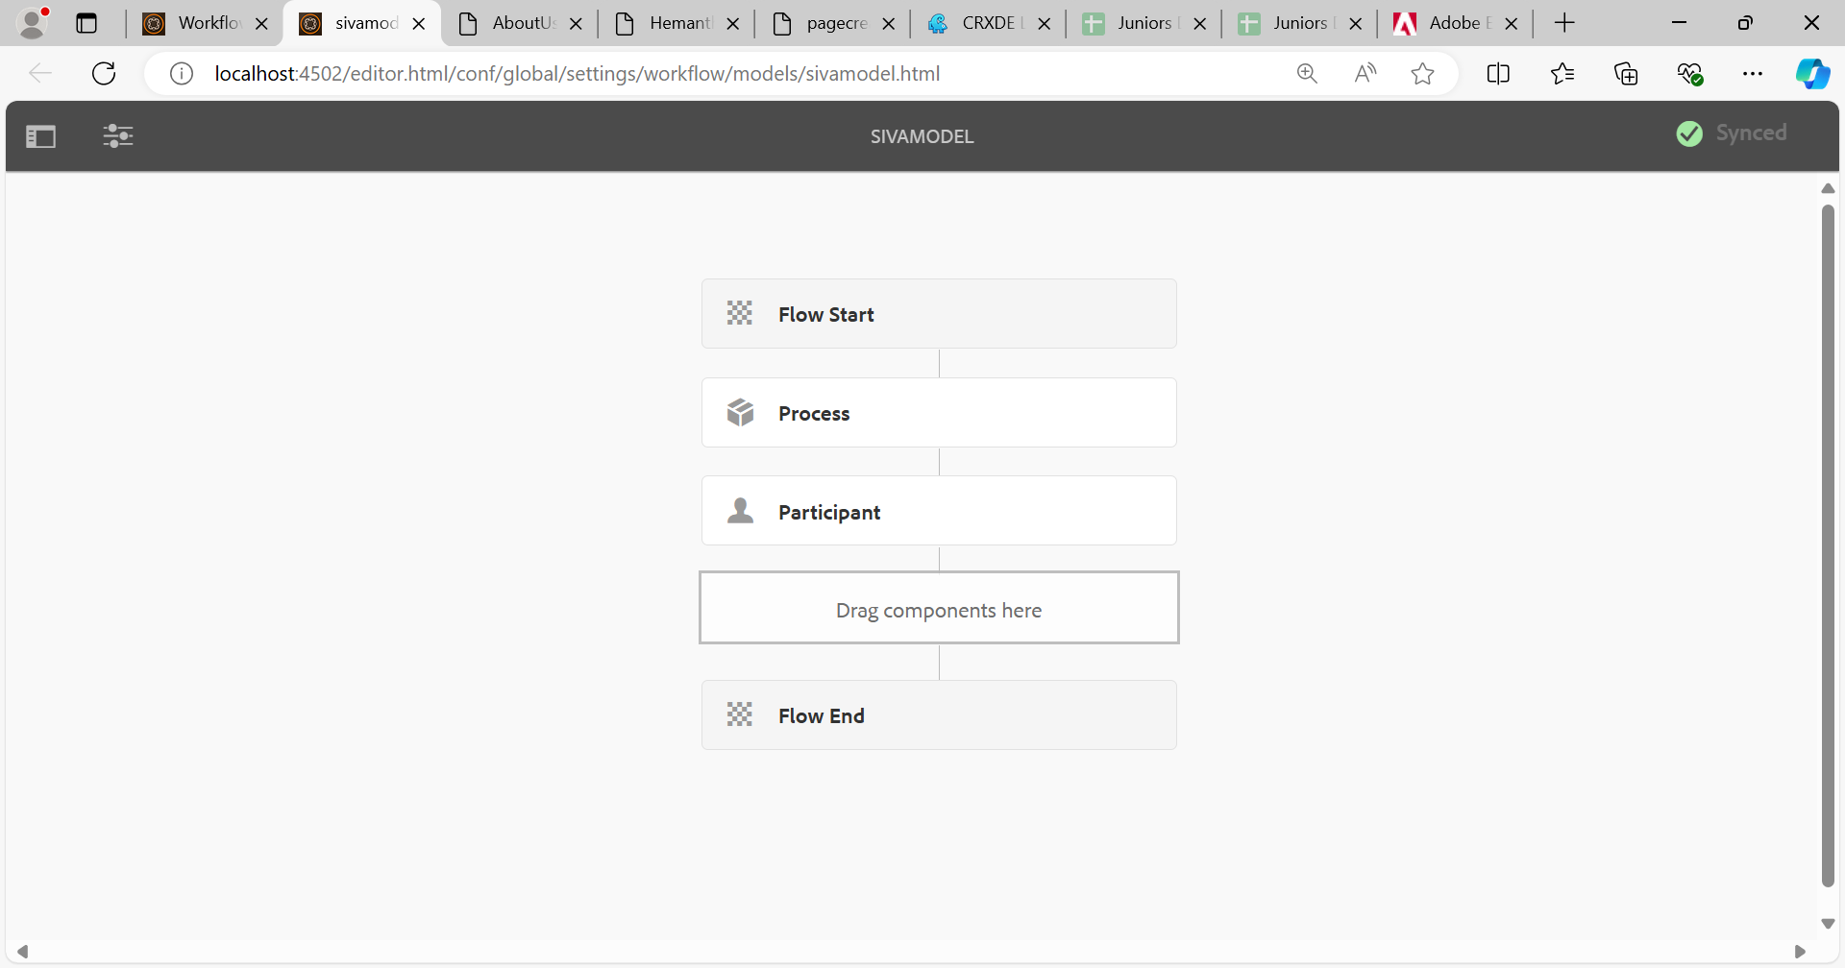

**WORKFLOWMODEL PROCESS STEP** 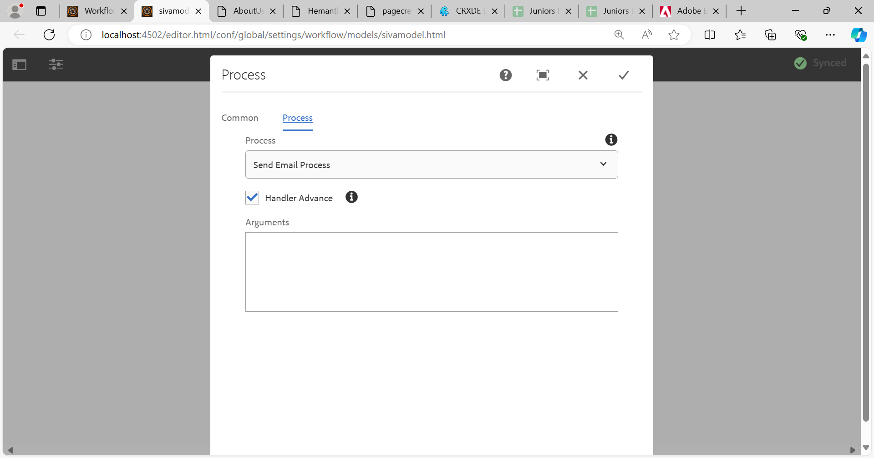

**WORKFLOW PARTICIPANT STEP**

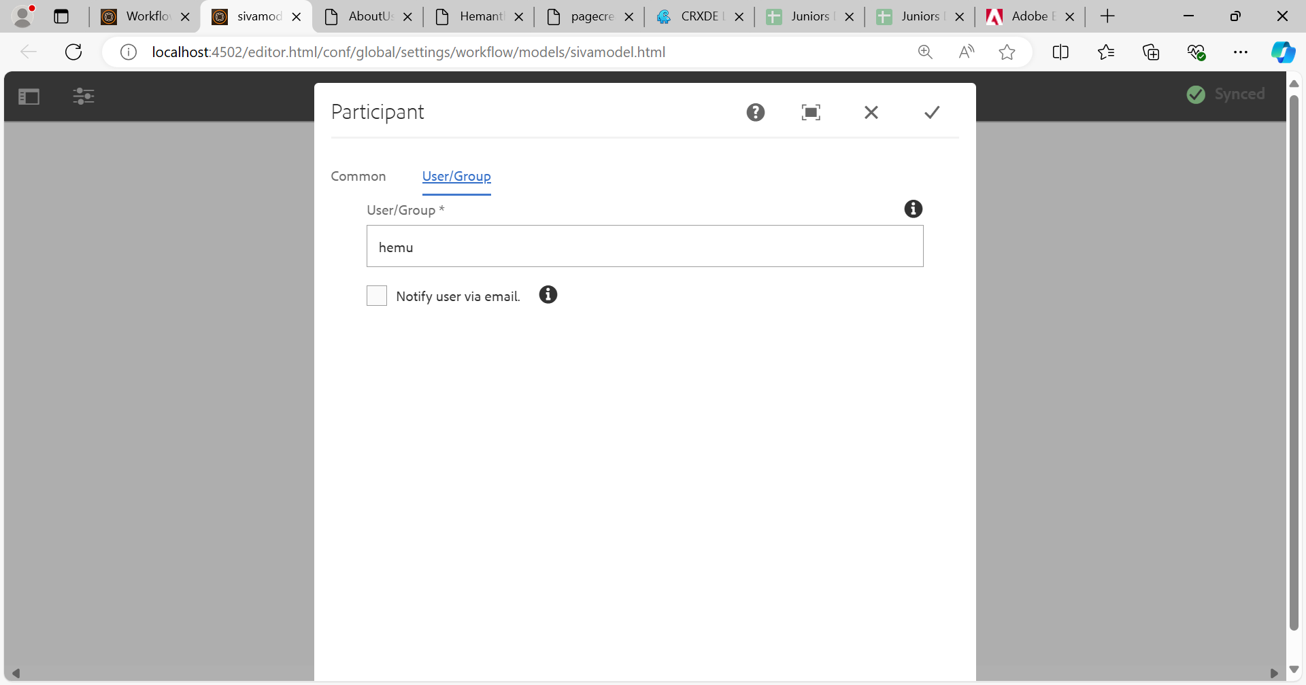

**DQ CQ MAIL SERVICE**

