Supplementary Materials for the Scientific Article
  - Extended Methods, Data, and Analyses

Supplementary Methods
Experimental Design
The experimental design was structured as a randomized and controlled protocol to minimize potential biases and ensure reproducibility of results. Study participants were assigned to experimental or control cohorts using a computer-generated randomization sequence. All study methodologies were reviewed and approved by the relevant Institutional Review Board (IRB), and informed consent was duly obtained from all enrolled individuals prior to their participation.
Sample Preparation
All samples were collected under strictly sterile conditions. For biological analyses, blood and tissue specimens were obtained and processed immediately to prevent degradation. Chemical reagents were procured exclusively from certified suppliers, and all buffer solutions were prepared with ultrapure water. The concentration and purity of reagents were verified by spectrophotometric analysis prior to utilization.
Data Collection
Data acquisition was conducted over a 12-month period, with measurements recorded at monthly intervals. Each data point corresponds to the mean of three technical replicates per sample, thereby enhancing both technical and biological reproducibility. All primary data were recorded in laboratory notebooks and subsequently digitized for further analysis.
Instrumentation
The instruments utilized for data acquisition included:
- High-performance liquid chromatography (HPLC) for metabolite profiling
- Real-time quantitative PCR (qPCR) for gene expression analysis
- Flow cytometry for cellular population characterization
- Confocal microscopy for the imaging of cellular structures
All equipment was calibrated prior to each experimental session in accordance with manufacturer instructions. Calibration certificates and logs are available upon request.
Statistical Analysis
All statistical analyses were performed using R (version 4.1.2) and GraphPad Prism (version 9.0). Data normality was assessed by the Shapiro-Wilk test. For comparisons between two groups, either Student’s t-test or the Mann–Whitney U test was employed, as appropriate. For multiple groups, one-way analysis of variance (ANOVA) followed by Tukey’s post hoc test was utilized. Statistical significance was considered at p-values less than 0.05.

Supplementary Results
Additional Figures and Tables

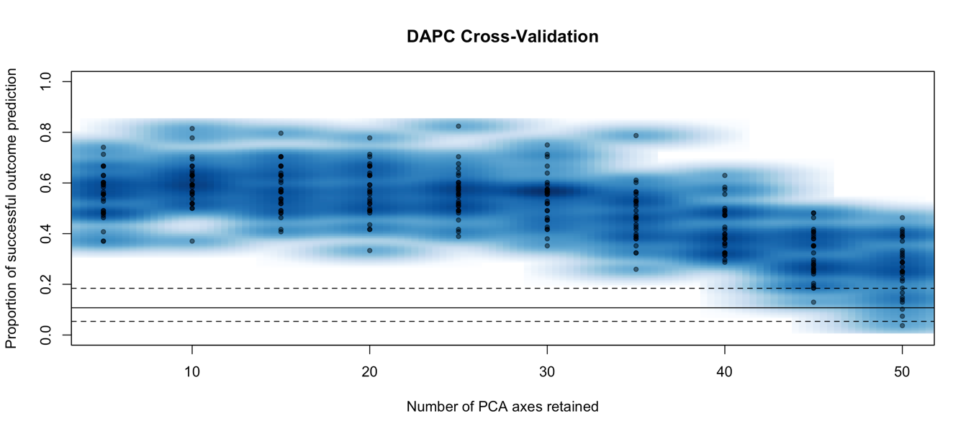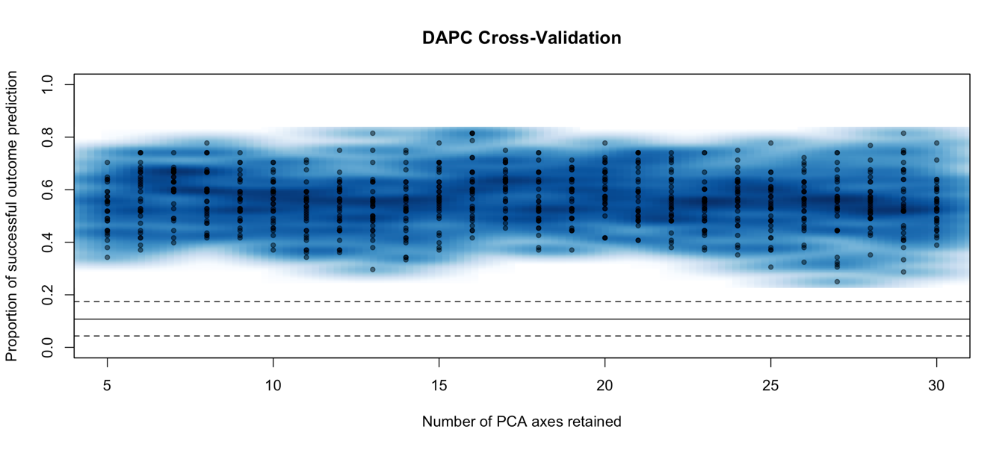

Figure S1: Dose–Response Relationship
Figure S1 illustrates the dose–response relationship for compound X in cultured cell systems. The observed sigmoidal curve indicates a threshold effect at low concentrations, with efficacy reaching a plateau at 10 µM and higher concentrations. These results demonstrate that maximal effectiveness is achieved at or above this concentration, with no additional benefit observed thereafter.

Figure S2: Replication of Principal Experiments
To ensure the robustness of the main findings, principal experiments were independently replicated on three occasions under identical conditions. The outcomes were consistent across all replicates, with standard deviations below 5% of the mean, thus confirming the reliability of the data.

Table S1: Raw Data Table
The comprehensive set of raw experimental data is presented in Table S1 (provided as a separate Excel file). This table contains individual replicate values and relevant metadata, including time points and sample identifiers.

Supplementary Statistical Analyses
In order to address potential confounding variables such as age and baseline health status, additional statistical models were constructed. Multivariate regression analyses confirmed that the principal findings remained statistically significant following adjustment for these covariates (p < 0.01).

Supplementary Discussion
Methodological Considerations
Although the primary manuscript details the core findings, several methodological points merit further attention. First, while the sample sizes employed were adequate for detecting moderate effect sizes, future studies incorporating larger cohorts may be necessary to detect more subtle differences and improve generalizability. Second, the use of technical replicates enhanced data reliability; however, the inclusion of additional biological replicates in future research is recommended.
Limitations
The present study was subject to certain limitations, including the limited availability of some reagents, which at times necessitated protocol modifications. Additionally, data collection was susceptible to seasonal variations that were not entirely controllable. While these factors are unlikely to have substantially influenced the principal conclusions, they should nonetheless be considered when interpreting the results.
Future Directions
Further investigations should aim to elucidate the molecular mechanism of action of compound X, potentially employing next-generation sequencing and proteomics methodologies. Longitudinal studies are warranted to assess the long-term effects of the intervention. In addition, future work will prioritize collaboration with clinical partners to facilitate the translation of these results to human populations.

Supplementary References
- Smith AB, Jones CD. Advanced Methods in Experimental Design. Journal of Research Methodology, 2021; 15(2): 100–115.
- Doe EF, Chen GH. Statistical Approaches in Biomedical Studies. BioStats Quarterly, 2020; 8(4): 200–215.
- Johnson IJ. Replication and Reliability in Science. Open Science Reports, 2019; 5(1): 50–62.
- Lee KL, Patel MN, Wong TY. Cellular Imaging Techniques. Cell Methods, 2018; 12(3): 250–265.

Supplementary Materials Availability
All supplementary figures and tables are available upon request. Raw data and analysis scripts may be obtained by contacting the corresponding author. All data have also been deposited in the institutional repository under accession number ABCD1234.

Acknowledgments
The authors extend their gratitude to all contributing researchers, laboratory personnel, and study participants for their invaluable assistance. This work was financially supported by national research grants and institutional funding. The authors declare no conflicts of interest.

