## Making Products Count: Data Science for Product Managers

**NLP Analysis of CGM for Diabetes -   
Are customers satisfied with current available CGMs?**Xi Yan (xiyan), Wanying Zhang (wanyingz), Tiffany Huang (thhuang)

**Executive Summary** Three products are important for diabetes patients to manage their disease status:

Continuous Glucose Monitor, Insulin Pump, and Data-Recording/Reading APP. To   
 increase user satisfaction, the CGM company should focus on product accuracy,   
 compatibility with the insulin app, and the UI of the APP. Customers expect to see   
 the CGM function in the apple watch. This function may be achieved[1]. CGM   
 companies should consider how to compete with Apple or cooperate with them.

1. **Introduction**

Diabetes is a chronic disease that can lead to cardiovascular disease, kidney failure, renal complications, and even death. According to the Centers for Disease Control (CDC) research, 37.3 million people have diabetes (11.3% of the US population) and 96 million (38% of the US population) have prediabetes [2]. To manage the disease, it is important for patients to monitor their blood sugar level closely to prevent possible complications.

Patients can use self-monitoring of blood glucose (SMBG) or a continuous glucose monitor (CGM) to check their blood sugar. One of the disadvantages of SMBGis that it requires finger pricking. CGM, which analyzes blood sugar from sensors inserted under the skin, has become a popular alternative. The advantage of the CGM includes the real-time, dynamic information about the speed and direction of glucose levels. Therefore, users can easily identify what kind of food or habits that spike blood sugar and then they can manage their health better. Most CGM has a warning system to alert users of abnormal sugar levels. And may also interact with insulin pumps that enable automation of insulin dosing if the users are hyperglycemic. The features of CGMs improve people’s comfort of life, reducing the anxiety associated with the changes in glucose concentration, and enable more effective control of their health.

1. **Problem Statement**

Nevertheless, many people still remain skeptical of CGM’s safety and accuracy. This project was conducted to assess if users are satisfied with current CGMs on the market.

1. **Project Workflow**

This project consists of 5 phases. The first phase is to tidy the dataset by eliminating columns that do not contribute to the project. The second phase is to use natural language processing modules to process text data. The third phase is the initial exploratory data analysis. The fourth and the final phases consist of general CGM and product-related CGM analysis. Following is a flowchart of the project workflow.

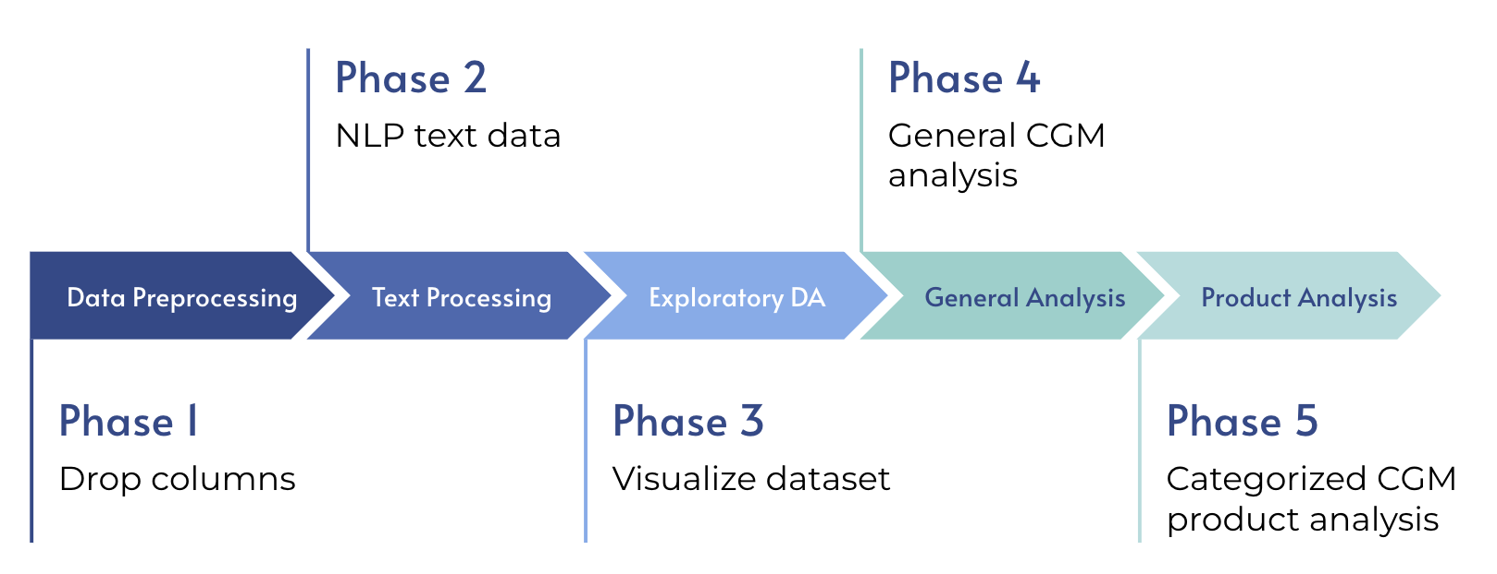

*Fig. 1 Project workflow*

1. **Data Source**

The dataset, “Diabetes Continuous Glucose Monitoring - Data Export”, is an excel file consists of 63 columns and 37844 rows. This dataset contains social media posts information such as post ID, text, title, author, source, sentiment, etc.

Upon the initial dataset reading, we discover that there are 42 columns that contain more than 90 percent of missing value. For example, dozens of columns’ names beginning with “LexisNexis” are mostly empty. The text column is the column that the project should focus on, where it contains emojis, hashtags, and links.

1. **Data pre-processing**

The data pre-processing step is standard. Following is a chart that displays the flow of data preprocessing step.

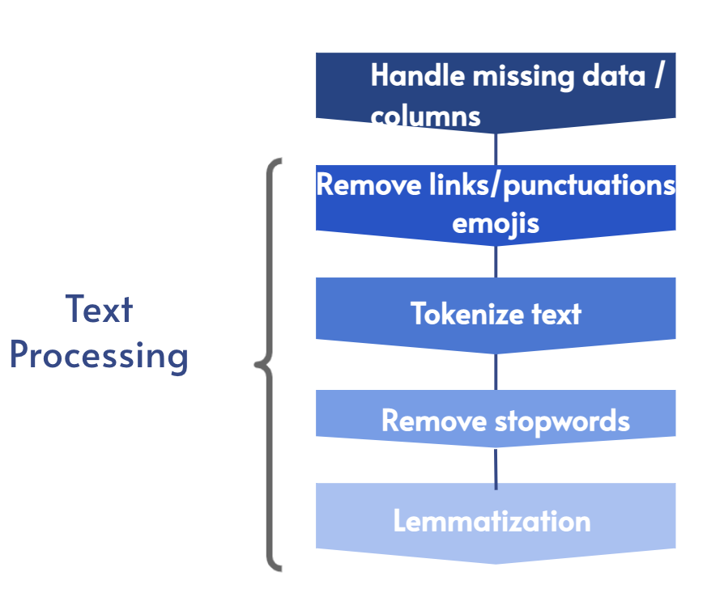

*Fig. 2 Workflow of text data processing step*

After reading the excel file, we check the percentage of missing values in each column, if missing values exceed 90% of the entire column, then we drop the column. Later we find that column 'Positive Objects' and 'Negative Objects’, although do not exceed 90%, have a sufficiently large portion of missing values, therefore we drop these two columns as well.

Then, we process text file. We find that the ‘title’ column also contains text information where we think there are values to consider them as text as well, although not every row contains title. In this case, we fill the empty cell from the ‘title’ column with string “empty title”. Next, we concatenate the ‘Sound Bite Text’ column with the ‘title’ column and treat it as the text data we need to process during this step.

The text processing steps are, for each value of the text column, first, remove links that contains strings characters such as “www”. Second, remove punctuations such as comma, period, exclamation point, etc. Third, remove emojis by encoding the text in ascii format and decoding them. Fourth, we tokenize the text using whitetokenizer from package nltk, during the process of tokenization, we also remove stopwords such as “is, am, very” in the function using the stopword dictionary provided by package nltk as well. Last, we use workLemmatizer from package nltk to lematize the tokens.

We think that these 6 steps can let the text data contain most of the useful information and eliminate the meaningless information.

1. **Result**

**Exploratory Data Analysis**

The dataset not only includes text columns, but also columns we find interesting and hoping to see if they can contribute to our analysis and result. In this exploratory data analysis part, we examine two columns, ‘source type’ and ‘sentiment’.

First, we make a bar plot for the ‘source type’ column.

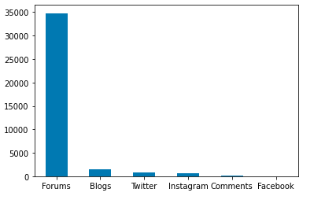

*Fig. 3. Data distribution of source type*

From this plot, we can see that the count of forum posts dominates the total number of posts, which indicates that this dataset is imbalance and heavily skewed with forum posts. Therefore, we decide not to further split and analyze each source type but instead treat all of the posts, regardless of the source type, as a whole.

Second, we create a stacked bar chart for the ‘sentiment’ column.

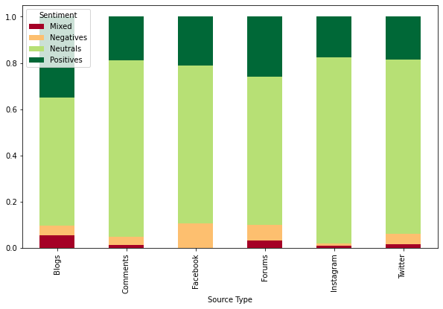

*Fig. 4 Sentiment distribution across source types*

One interesting insight we find in this stacked bar chart is that people generally speak positively about CGM across every type of the forum. However, in this column, we are aware that there are sentiments defined as “mixed”. We cannot retrieve the description of how this sentiment column is categorized, hence we do not know the logistic behind how the “mixed” sentiment is formed. Therefore, we decide not to rely on the ‘sentiment’ column in the further steps of the project.

**General Product Analysis**

**Expectations**

To figure out the patients’ expectation on CGM. Firstly, since the whole text dataset contains different various of expressions and sentiments, we should filter those we think the patients’ are talking about expectations. We create a list that contains words that express the sense of expectation, such as, “expect”, “want”, “hope”, etc. Then, we filter out the text that has any token matches our expectation word list.

The initial approach we take on the analysis of the text is to create word clouds for different positions of word. We use package spacy to tag the position for each of the token. Then, we filter to extract the count of nouns, verbs, and adjectives using counter. The following graph is word cloud of noun generated from the result.

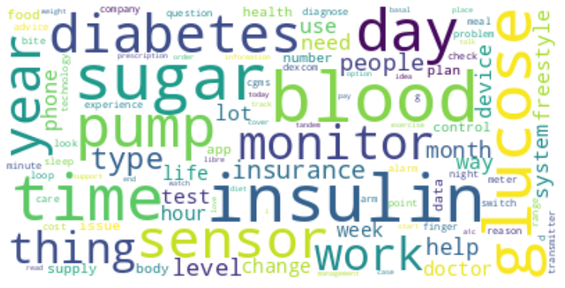

*Fig. 5 Word cloud of noun*

In this case, as we can see, there are two major problems associated with the word cloud. The first one is that single word does not express any meanings. For example, we are not able to comprehend what “insulin” is refering to although it appears as the most frequent word from the word cloud. Secondly, we need to eliminate the words that do not contribute to the analysis, such as “diabetes”, “doctor”, “supply”, etc.

As a result, we do not think the word cloud is a viable analysis to our project as it lacks interpretability. Instead, for the next steps, we use the CountVectorizor function from tfvectorizer to group words into grams. In this general CGM analysis, we use tri-grams as it is a perfect balance between interpretation and bias.

After generating the tri-gram from the count vectorizer, we also create a list of stop words that should not be in the analysis, from the output, we select the tri-grams that look interesting and refer back to the original post manually. The output is shown in below.

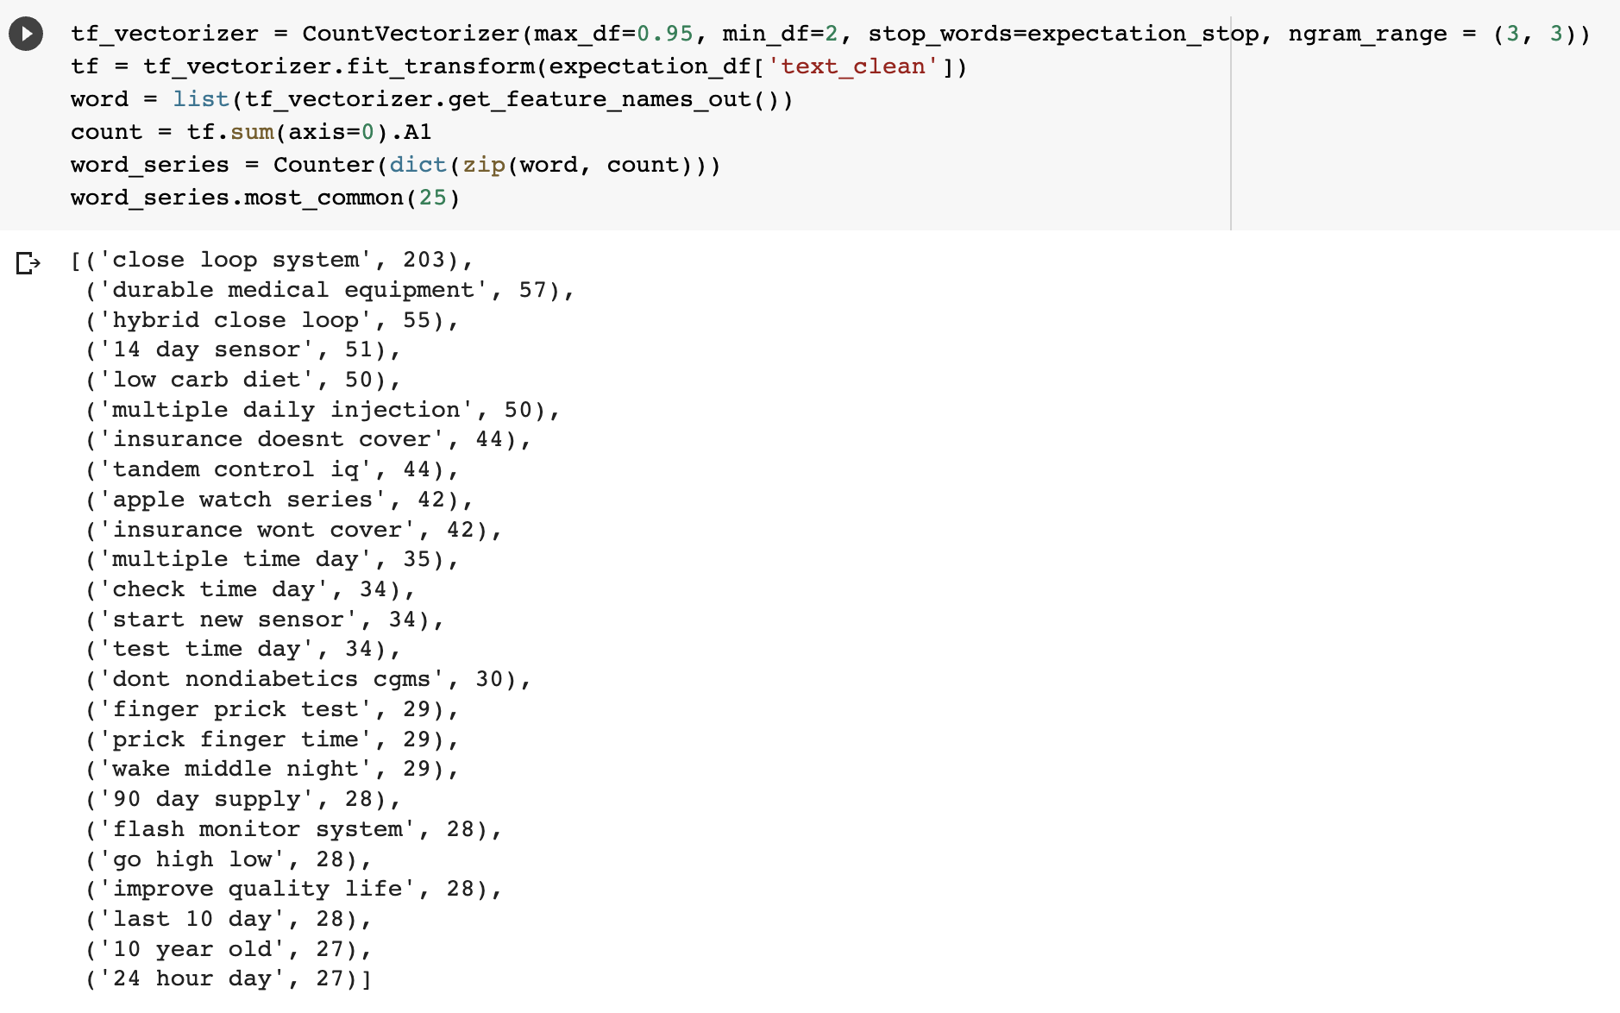

*Fig. 6 Output result of the tri-grams words*

Upon evaluation, we find that people are most expecting several things:

1. Closed Loop System in lieu with CGM to better control patients’ health condition.
2. Patients want the CGM to be listed as Durable Medical Equipment by the health supplier, where they can save more money in this way by letting health insurance to cover the cost.
3. Patients are hoping for future roll out of CGM app compatibility / blood sugar monitor on next generation Apple Watch.

**Knowledge Gap**

To know what is the knowledge gap for the patients, as the previous procedure, we filter words that express confusion in the dataset, such as “confuse”, “unclear”, “misunderstand”, etc. After this step and filtering out the stopwords, we get the result very similar to the previous expectation tri-gram.

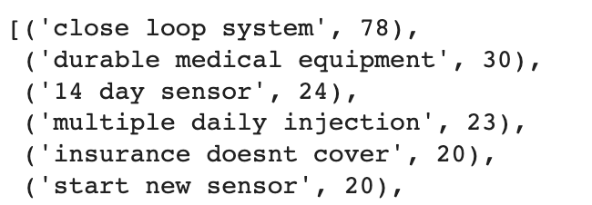

*Fig. 7 Output result of knowledge gap analysis*

Upon evaluation, the “Close loop system” and “Durable Medical Equipment” remain on top of the frequencies as patients express knowledge gap on which brand and insulin pump support closed loop system. Patients also want to know which specific medical supplier cover CGM as Durable Medical Equipment.

**Benefit and Unmet Needs**

For the benefit and unmet needs portion, we decide to perform sentiment analysis using sentiment modules Vader and Textblob. The reason behind this is we want to set thresholds based on sentiment analysis score. For the sentiment that are on the top 10 percent of the score distribution, we consider that patients must have praised the benefit of the CGM, vice versa, if the sentiment scores for post are at the bottom 10 percent, that means patients are complaining for unmet needs. The following graph shows the distribution of sentiment between 2 modules.

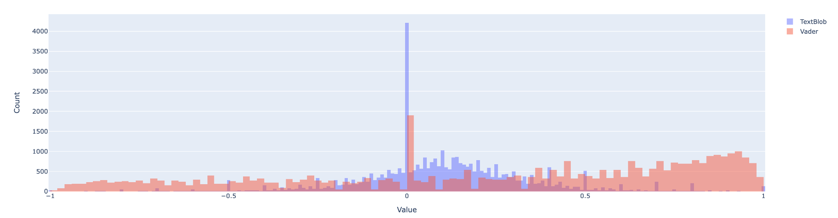

*Fig. 8 Distribution of sentiment analyzed by TextBlob and Vador modules*

After we filter the top 10 percent sentiment score data for both of the module, we perform a cross evaluation to look for commonalities between these two outputs. We find that the most important benefit of CGM for both of the output is continuous glucose monitor, which is exactly CGM, this seems very intuitive, but this is the reason why people use it and discuss about it. It stops people from spending years of time pricking finger to monitor blood sugar.

For unmet needs, we filter the bottom 10 percent of sentiment score data for both of the module. Combining both of the most negative results from textblob and vader, we find these unmet needs from patients:

1. Closed loop system - although a lot of patients would want to use insulin pump for better health monitor, the FDA had not approved many close loop system to commercial use. This technology is still in the early stages which has potential of many improvements.
2. Accuracy - many patients complaints there are false low/high on monitoring blood sugar levels using cgm. An accurate equipment is the top need from all of the patients who use CGM.
3. Software update - CGM companies did not fulfill the software update demand for the CGM devices. People are actually developing their own softwares, these works should have done by CGMcompanies.

**CGM product-related analysis**

We mainly focus on the Dexcom and Freestyle Libre companies so the dataset has been categorized into four groups. And from the following bar plot, we can see the data is quite imbalanced. Dexcom has about 4 times more posts than Freestyle Libre and nearly one thirds of data did not discuss either Dexcom or Freestyle Libre. Therefore, in the future, we may want to collect more balanced data and take more companies under consideration and analysis.

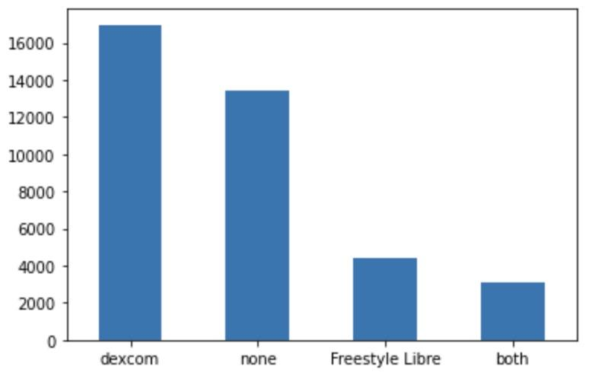

*Fig. 9 Data distribution for company categories*

1. **Dexcom**

**Dexcom Features**

We use the same methods that were used in the general product analysis to detect the main features. First, we start with one word cloud but realize it doesn’t give us much information. So we next try the 3-gram analysis and the results are shown below. The most important feature is definitely the continuous glucose monitoring itself. On top of that, Dexcom has integrated with Tandem Tslim x2 Insulin Pump which work together as closed loop systems. The Dexcom G6 can be wearable for up to 10 days and the insulin pump can hold up to 300 units of insulin. Dexcom also has its own app that can pair with sensors to see the glucose levels, and share the data with family and healthcare providers. And users can set up their own target values as thresholds for alerting functionality.

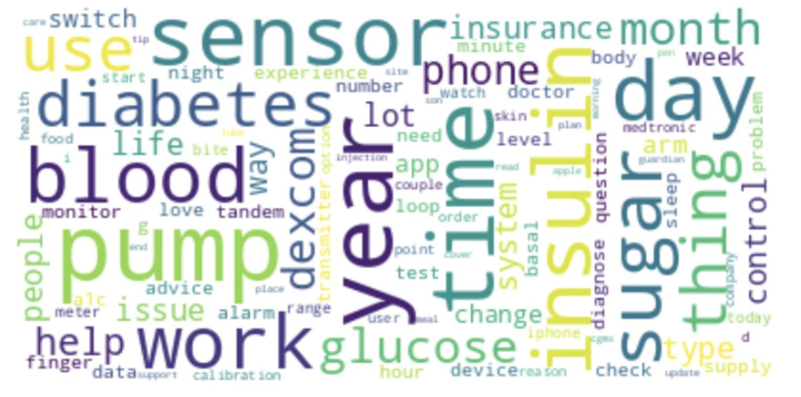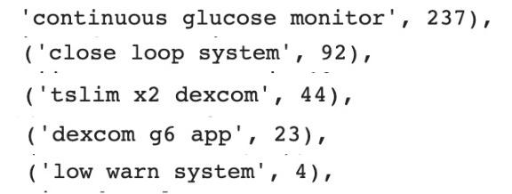  
*Fig. 10 word cloud for feature Fig. 11 Top 5 most frequent 3-word phrase*

**Praise**

To obtain user’s positive feedback toward Dexcom products, we extract texts from the positive sentiment group and do the 3-word count again. We find that customers really appreciate and highly recommend getting them since the CGMs make their life easy. Then, we use the same method but with 6-gram analysis to try to detect more insights. And we find that CGM really relieve people from abusing their finger and people don’t have a hard time adjust the products.

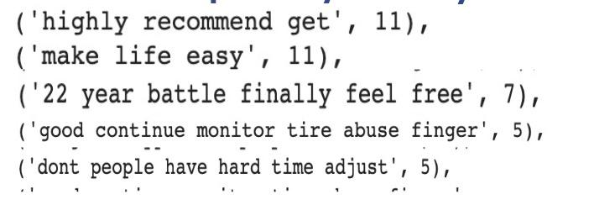

*Fig. 12 Top 5 most frequent phrase from positive sentiments*

Afterwards, we go back to the original data to verify our findings. For example, there is a post ‘Diagnosed 2018 in my twenties, I use a tandem pump and dexcom G6. I can’t express how much it has changed my life for the better. SIGNIFICANTLY helped to lower my A1c and just made my overall life easier.’

**Complaints**

For the negative opinions, we use the negative sentiments as indicator to dig in. The result is as follows. The major complaints are about the app. It seems like the app requires users to update on their own but clearly the instructions are difficult to follow. Many people complained that they couldn't find the widget. Also, the app connection has issues, particularly not working well with SAMSUNG galaxy note. Besides the app, sensors have bluetooth instability as well. Since Dexcom sensors can only last for 14 days, users have to pay more for those replacements. Not every insurance will cover the entire cost, so it becomes a concern for some consumers. Maybe Dexcom can try to make sensors last longer. The last but not least complaint is about inaccurate reading. Some people reflected that the CGMs usually give false low blood glucose value. It’s actually a significant issue since it can directly affect how much insulin the users will get and it may harm their health.

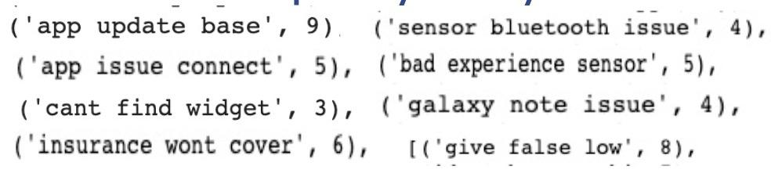

*Fig. 13 Top 8 most frequent negative phrases*

1. **Freestyle Libre**

Freestyle Libre features, praise, and complaints are identified using words frequence analysis and topic modeling method. Freestyle Libre-realted and diabetes-related common words ('cgm', 'diabetes', 'blood', 'glucose',' sugar', 'continuous', 'freestyle', 'libre', 'monitoring','pump','1','2','14','insulin', 'tslim') were removed from the dataset. Before conducting the analysis, text labeled with category = “Freestyle Libre are divided to 4 subsets by sentiment column values (“positive”, “negative”, “mixed”, “neutral”). Below is an example of how we process top words and topic analysis result.

a. Top words analysis  
 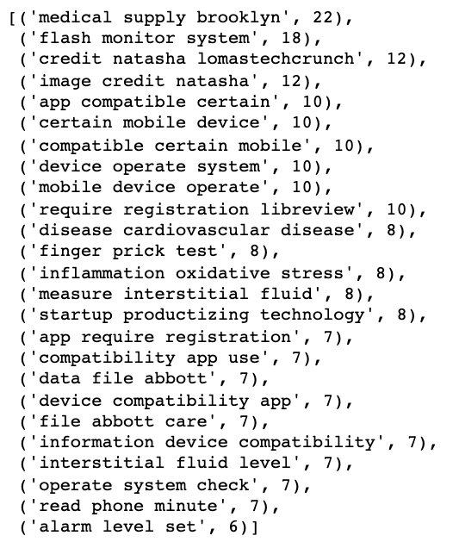

*Fig. 14 top 25 common words result retrieved from Freestyle Libre sentiment = positive text.*

We tried different n_gram parameters to obtain the Top 25 common words from different sentiment subsets. We will read through the output and identify features, praises, and complaints. The above figure is an example of how we process the output result.

*Table 1 result of identified Frestyle Libre features and prais*

| Identified Features Libre | Identified Praise |
| --- | --- |
| * flash monitor system * app compatible * mobile device operate * app requires registration * read phone minute * alarm level set | - We can see the name Natasha in the output. Natasha is using Freestyle Libre to manage her diabetes and bring positive comment to the product[3].  - Disease management: some  disease terms were mentioned in  the text. It may link to disease Management (more supporting data are retrieved in the later analysis) |

B. Topic modeling

We tried different n_gram and num_topic combinations to obtain different outputs and summarized the topic by human interpretation. In the following sample, we obtained the below conclusion:

Topic 0 - Freestyle sensor is easy to insert; it is a life-change product,

Topic 1 - The product is compatible with the app; the user can set the alarm level

|  |  |
| --- | --- |

*Fig. 15 Topic modeling result retrieved from Fressstyle Libre sentiment = positive text (n_gram = 3, num_topic = 5)* **Features**

Following the aforementioned data analysis methods, we analyzed the data from 4 different sentiment data subsets and identified the following features:

1. Flash monitor system - let patient check their sugar levels without finger pricking
2. Freestyle Libre App - read/record data in the user's phone
3. Alarm level set - alert the patient if the glucose level is too high or low
4. Wearable device
5. Continuous gloucoses monitor
6. Compatible with an insulin pump (Medtronic)

**Praise**

Praises were concluded from the positive sentiment data subset analysis result.1. Fairly accurate  
 2. Compatible with an app, easy to read the data

2. Good for health management, including chronic disease monitoring

3. Painless when inserting the sensor, even the needle phobia can use the   
 product

4. Affordable

To verify the result, we will return to raw data and use keywords to identify relevant texts. For information we cannot verify from the data, we will search online to confirm our findings.

It is estimated that patients need to pay $200 per month for the Freestyle Libre

products and $300 for the Dexcom G6. This result confirms our finding that

People appreciated Freestyle Libre for its affordable price.

**Complaints**

Complaints were concluded from the negative sentiment data subset analysis   
 result.

1. Inaccurate reading when a new sensor is replaced
2. app slow and unresponsive - some users also complained the app will not response suddenly
3. Non-recyclable material - the material is not recyclable. Users feel bad when changing the material

4. Backwards technology device - Medtronic 770G - we found people complaint about the compatible insulin pump and had negative feedback to the Freestyle Libre CGM

The non-recyclable material complaint is the comment we didn’t not expect.  
The raw text is as below:

wow and I thought the freestyle libre has a lot of waste So much trash for just one infusion and cgm change. Anyone else feel bad about the amount of non recyclable trash that comes with trying to stay alive?

**Overall sentiment Regarding Dexcom and Freestyle Libre CGM**

The original sentiment classification has 4 distinct values, positive, negative, neutral, and mixed. The issue of categorical classification is it may simplify the information. For example, we are not able to distinguish very positive and less positive from the original sentiment column. Therefore, we decide to apply TextBlob and Vader for sentiment analysis.   
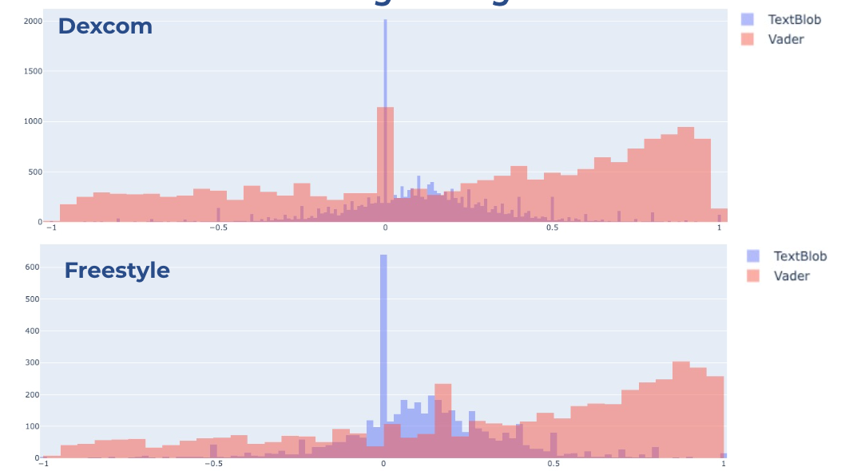

*Fig. 15 overall sentiment of Dexcom and Freestyle Libre CGM products*

The result shows that users had neutral to positive sentiments for Dexcom products. People using Freestyle Libre seem to have a higher positive sentiment. However, this result is analyzed from an imbalance dataset. There might be bias exist in this dataset.

**Comparison of Dexcom and Freestyle Libre CGM products***Table. 2 Comparison between Dexcom and Freestyle Libre CGMs*

| **Company** | **Features** | **Complaints** |
| --- | --- | --- |
| **Dexcom & Freestyle Libre** | * Continues Glucose System * Close loop system (Compatible with insulin pump) * Blood sugar warning system * Compatible with App | * App issue - unresponsive - unfriendly UI * Inaccurate reading |
| **Dexcom** | (Based on our analysis, Freestyle Libre and Dexcom hold common features) | * Compatible issue with Galaxy Note * costly |
| **Freestyle Libre** | * Sensor issue * Non-recyclable material * Medtronic 770G  - backward technology |

Our analysis didn’t include a praises comparison since the praise conclusion was generated from the imbalance database. Although the complaint was also retrieved from the same dataset, this information is still meaningful for the company to improve its products.

Dexcom and Freestyle Libre have the similar product feature profile. They have the same complaint regarding app issues and inaccuracy reading. Dexcom and Freestyle Libre are leading companies in the CGM area. Their common complaints also reflect customers’ expectations and unmet needs. Companies need to provide CGM with accurate reading and UI friendly APP to improve users’ satisfaction.

Besides the common issue, Dexcom also needs to improve its compatibility with Galaxy Note phones. Price is a big market challenge for Dexcom CGM. As Dexcom and Freestyle Libre have similar product features, the price will be the key decision consideration for the customer.

The sensor is the most urgent issue for the Freestyle Libre product. Inaccurate data reading will not only decrease users’ confidence in the product, but it will also danger user’s life if they cannot be aware of the abnormal blood sugar level and take corresponding actions timely. Some of the Freestyle Libre complaints are related to the insulin pump - Medtronic 770G. Freestyle Libre company should consider finding new compatible insulin pumps, or they might lose the customer. Non-recycle material is also an issue that Freestyle Libre company can focus on. If the company is able to replace the original non-recyclable material with the environment-friendly one, it may also benefit the company's image.

1. **Challenge**Data imbalance is the biggest challenge in this analysis. This issues us difficulties in comparing Dexcom and Freestyle Libre CGM products fairly. Dexcom has almost 4 times more data in this dataset than Freestyle Libre. There are likely unrevealed Freestyle Libre praises and complaints. Freestyle Libre should conduct market research to collect more data to have a more comprehensive product analysis.
2. **Summary**Based on our analysis, we provide the following recommendation to the general CGM companies and specific recommendations to Dexcom and Freestyle Libre.  
     
   **General recommendation**

1. CGM Accuracy is important for a diabetes patient to monitor their glucose value. The user raises a complaint if the reading value is inaccurate. Moreover, the inaccurate reading may lead to a lifethrenting event. CGM company should prioritize these features in the improvement plan.

2. APP design & operation smoothness affect users’ product satisfaction levels.

Although APP is a supporting system, it can make users annoyed if they are

not able to read the value.

3. Users expect to have a closed loop system cooperate with the CGM system.   
 CGM companies should carefully pick their business partner or consider to   
 expand the business into the insulin pump market.

4. Users expect to see the CGM function on the Apple watch. CGM companies

should focus on their APP design more or consider the opportunity to

cooperate with Apple.

**Specific recommendation to Dexcom**  
1. Provide clear APP user instructions

2. Improve Bluetooth connectivity

3. Increase compatibility with Android phones

Compared with reducing the price to resolve the costly complaint, the above recommendations are easier to achieve and can positively affect customers' satisfication.

**Specific recommendation to Freestyle Libre**1. Prioritize the sensor issue to resolve inaccurate reading

2. Cooperate with different insulin pump companies

3. Replace the consumable items with the recyclable material

4. Collect more user data to obtain a more comprehensive market research result

**Work Distribution  
Xi Yan :** Data pre-processing, general CGM analysis, presentation, report writing

**Wanying Zhang :** Data pre-processing, Dexcom CGM analysis, presentation, report writing

**Tiffany Huang :**Data pre-processing, Freestyle Libre CGM analysis, presentation, report writing

1. [“Apple Watch Creeps Closer to Adding Glucose Tracking: Bloomberg,” accessed March 3, 2023, https://www.fiercebiotech.com/medtech/apples-long-desired-glucose-tracking-reportedly-proof-concept-stage-bloomberg.](https://www.zotero.org/google-docs/?KQCfn4)
2. [“National Diabetes Statistics Report | Diabetes | CDC,” June 29, 2022, https://www.cdc.gov/diabetes/data/statistics-report/index.html.](https://www.zotero.org/google-docs/?mQLEiQ)
3. [Rachel Duffell, “Joanna and Natasha Hotung On How CGM Is Changing The Lives Of Diabetics,” Tatler Asia, accessed March 3, 2023, https://www.tatlerasia.com/the-scene/people-parties/joanna-and-natasha-hotung-youth-diabetes-action.](https://www.zotero.org/google-docs/?dGu4vz)