Chapter 4 Results

4.1 Overview
This chapter reports the empirical results of the physics-informed scale-prediction system. It is organised around four questions, each addressed in turn: (i) is the first-principles geochemical engine correct, as judged against the field-standard equilibrium code PHREEQC and against the primary literature; (ii) can carbonate scaling be predicted from produced-water chemistry at all; (iii) do thermodynamic saturation-index (SI) and mechanistic deposition-rate features add predictive value beyond the raw brine chemistry; and (iv) how robust and trustworthy are these findings. Every quantitative claim below is reproducible from the accompanying code and is reported with the appropriate measure of uncertainty rather than as a single-split point estimate.

4.2 Dataset and computational setup
The analysis uses 505 produced-water samples drawn from 80 wells across two carbonate fields, denoted A and B, each sample carrying a binary field-inspection label (scale / no-scale). The classes are imbalanced at 355 positive to 150 negative (70.3 % positive). The two fields differ markedly in their label distribution: Field A is 97.8 % positive (223 of 228), whereas Field B is approximately balanced at 47.7 % positive (132 of 277). This asymmetry is central to the generalisation results of Section 4.6.
Chloride was not measured and was inferred by electroneutrality; the pre-inference charge imbalance of approximately 96.5 % confirms that chloride was the dominant missing anion, consistent with a mature oilfield brine. The computed ionic strength ranges from 0.004 to 6.6 mol kg-1 with a median near 2.0 mol kg-1, placing most samples well outside the validity range of Debye-Huckel or Davies activity models and motivating the use of the Pitzer ion-interaction model throughout. All computations were performed in Python 3.12 using scikit-learn and XGBoost for the supervised models and phreeqpython (PHREEQC with the Pitzer database, pitzer.dat) for the independent geochemical benchmark.

4.3 Validation of the geochemical engine
Before any predictive claim can be trusted, the physics that generates the features must be shown to be correct. Three independent validations were performed.

4.3.1 Equilibrium constants and activity coefficients
The temperature-dependent equilibrium constants reproduce the Plummer-Busenberg (1982) correlations to four decimal places at 25 C: log K1 = -6.35, log K2 = -10.33, log Ksp(calcite) = -8.48 and log Ksp(aragonite) = -8.34, with the correct retrograde temperature dependence (decreasing solubility with increasing temperature). The Pitzer activity coefficients, implemented after the Harvie-Moller-Weare (1984) parameterisation, reproduce published mean-ionic activity coefficients for NaCl, CaCl2 and MgCl2 to within 0.3-1 % across the full ionic-strength range to 5-6 mol kg-1.

4.3.2 Saturation index versus PHREEQC
The calcite saturation index produced by the engine was compared sample-by-sample against PHREEQC (pitzer.dat) at a common condition (each sample's measured pH, 25 C, 1 atm), isolating the thermodynamic engine from the wellbore extrapolation. Agreement is excellent (Table 4.1, Figure 1): the Pearson correlation is 0.997 and the Spearman rank correlation is 0.997, with a constant offset of -0.131 SI units (standard deviation 0.034) and a fitted slope of 1.004. The disagreement is therefore almost entirely a constant bias; after removing it, the mean absolute error is 0.026 SI units, comfortably inside the approximately 0.1 SI accuracy benchmark quoted for industry software, and 98.8 % of samples fall within 0.1 SI. The bias decomposes into a 0.074-unit contribution from the calcite solubility-constant convention (Plummer-Busenberg, -8.480, versus pitzer.dat, -8.406) and a residual from differing carbonate-speciation conventions. Because the offset is constant, it preserves the ranking of samples and is therefore immaterial to feature value.
Table 4.1. Agreement between the saturation index of this work and PHREEQC (pitzer.dat) over all 505 samples.
Metric | Value
Pearson correlation r | 0.997
Spearman rank correlation | 0.997
Systematic bias (ours - PHREEQC) | -0.131 SI
Standard deviation of difference | 0.034 SI
Fitted slope | 1.004
Bias-corrected mean absolute error | 0.026 SI
Within 0.1 SI after debiasing | 98.8 %
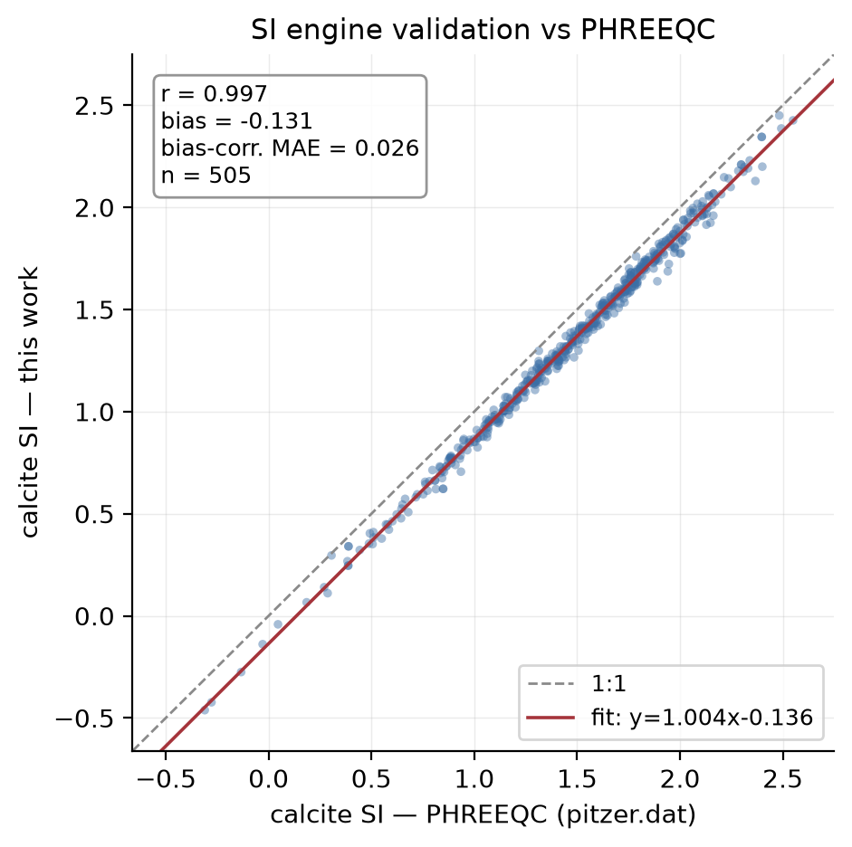
Figure 1. Calcite saturation index computed in this work versus PHREEQC (pitzer.dat) at matched conditions. Points lie on a line of unit slope offset by a constant 0.131 SI units; r = 0.997.

4.4 Depth-resolved scaling behaviour
The wellbore simulator reproduces the expected qualitative physics of carbonate scaling: as pressure falls toward the wellhead, CO2 degasses and the carbonate equilibrium shifts toward precipitation, raising the saturation index up the well. A consequence under the single reference well configuration applied here is that the brines are predicted to be supersaturated almost everywhere: the median maximum calcite SI is approximately 2.0 and the supersaturated fraction of the well is approximately 0.997. Some depth-derived summary features are consequently degenerate (for example the supersaturation-onset depth is identically zero for all samples) and were excluded from the predictive models. This near-universal supersaturation is itself an important result, examined in Section 4.5.2.

4.5 Predictability and the physics-value experiment

4.5.1 Baseline predictability
Carbonate scaling is learnable from brine chemistry: under leakage-free grouped cross-validation, the chemistry-only models reach a ROC-AUC of approximately 0.71 (Table 4.2), well above the 0.5 chance level. The threshold-free AUC, rather than accuracy or F1, is used as the primary metric throughout because the 70 % positive base rate makes accuracy and F1 misleading (a trivial all-positive classifier attains roughly 0.70 accuracy and 0.83 F1).

4.5.2 Saturation index does not separate the classes
Figure 2 shows the distribution of maximum calcite SI for scaling and non-scaling wells. The two distributions are essentially indistinguishable, with identical medians near SI = 2.0; the univariate discriminative power of SI is correspondingly negligible (AUC approximately 0.52). Almost every sample is strongly supersaturated, yet only 70 % scale. This is the central empirical signature of the thermodynamic limitation: a positive saturation index is necessary but not sufficient for deposition, in agreement with the established understanding that field scaling is governed by reaction kinetics, nucleation and residence time rather than by equilibrium tendency alone.
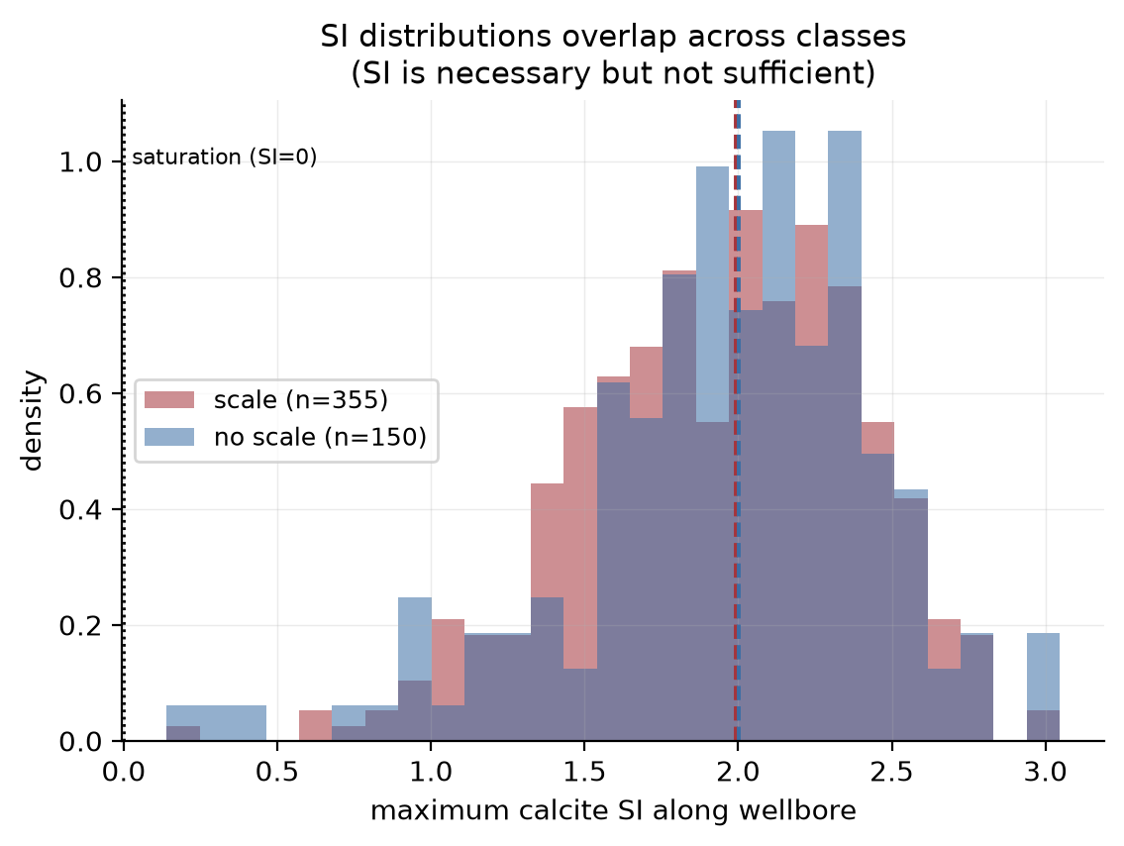
Figure 2. Distributions of maximum calcite SI for scaling (red) and non-scaling (blue) wells overlap almost completely, with coincident medians near SI = 2.0. Nearly all samples are supersaturated (SI > 0) regardless of outcome.

4.5.3 Marginal value of thermodynamics and kinetics
The physics-value experiment compares three nested feature sets, chemistry, chemistry + SI, and chemistry + SI + kinetics, under repeated cross-validation with paired comparisons across identical folds. The results are unambiguous (Table 4.2, Figure 4): in every regime the three feature sets are statistically indistinguishable, and the marginal effect of adding physics is at most a few thousandths of an AUC unit, frequently slightly negative. Within the confound-free Field-B regime the marginal value of SI over chemistry is +0.010 for the gradient-boosted model (paired p = 0.01) and not significant for the others, while kinetics adds nothing beyond SI. The slightly negative deltas elsewhere are the expected signature of redundant features: because SI and the kinetic rate are, under a single assumed well configuration, deterministic transforms of the chemistry already supplied to the model, they can only contribute dimensionality and mild overfitting, not information.
Table 4.2. ROC-AUC by feature set and evaluation regime (gradient-boosted model). Pooled and cross-field regimes are field-confounded (Section 4.6); within-Field-B is the decisive, confound-free test.
Regime | chemistry | +SI | +kinetics
Pooled (field-confounded) | 0.809 | 0.809 | 0.809
Grouped by well (leakage-free) | 0.708 | 0.709 | 0.706
Within Field B (decisive) | 0.618 | 0.628 | 0.626

4.5.4 The cost of leakage
Allowing samples from the same well to appear in both training and test folds inflates the apparent performance substantially: the pooled AUC of approximately 0.81 falls to approximately 0.71 under strict grouped-by-well cross-validation, a drop of about 0.10. This leakage test, rarely reported in the scale-prediction literature, is a prerequisite for any honest performance claim.
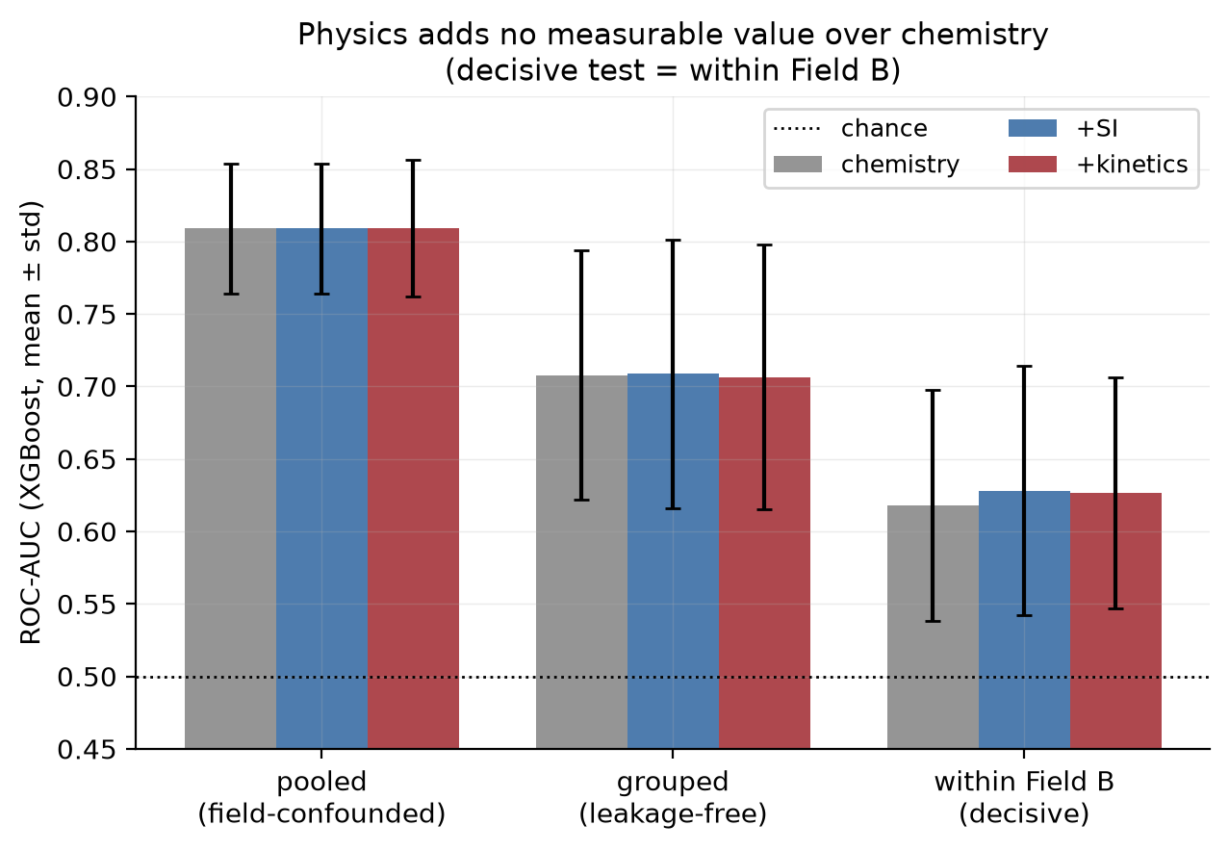
Figure 4. ROC-AUC by feature set across three regimes. Within each regime the chemistry, +SI and +kinetics bars are indistinguishable; AUC declines as leakage and field-confounding are removed (left to right). Error bars are one standard deviation across folds.

4.6 Cross-field generalisation and the field confound
Models trained on one field and tested on the other generalise poorly: training on Field B and testing on Field A gives an AUC of about 0.68, while the reverse direction collapses to 0.40, below chance. This apparent absence of a transferable scaling law is, however, largely an artefact of a field confound that also inflates the pooled results. Adding the raw field identity to the chemistry features raises the pooled AUC from 0.809 to 0.897 (a gain of 0.088), demonstrating that a substantial part of the pooled performance is the model inferring which field a sample belongs to rather than whether it will scale.
The mechanism is a Simpson's paradox (Figure 3). The most influential single feature, the calcium-to-TDS ratio, correlates with scaling positively within Field A (+0.11) but negatively within Field B (-0.26); pooled across both fields the correlation is -0.35, a sign that matches neither within-field trend. A model fitted to the pooled data therefore learns a direction that is actively wrong inside Field B, which is why cross-field transfer falls below chance. Crucially, the decisive test removes the confound entirely by working within Field B alone (balanced, single field): there, as Section 4.5.3 reports, physics still adds no usable value. Removing the confound thus strengthens rather than rescues the negative result.
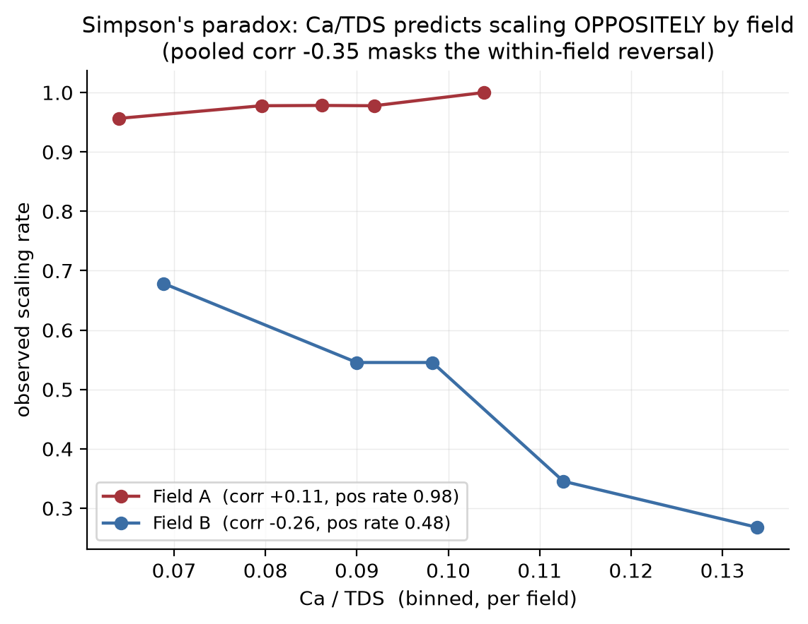
Figure 3. Observed scaling rate versus binned calcium-to-TDS ratio within each field. The relationship is flat-to-positive in Field A but strongly negative in Field B; the pooled correlation (-0.35) reflects the between-field difference, not a within-field law (Simpson's paradox).

4.7 Sensitivity to the assumed well configuration
Because the saturation-index and kinetic features are computed under one assumed wellbore configuration, the negative result could in principle be an artefact of that particular geometry. To test this, the configuration was varied one parameter at a time across ten settings spanning bottomhole temperature (70-120 C), wellhead temperature, true vertical depth (6000-12000 ft), CO2 degassing strength and bottomhole pressure, and the marginal value of physics was re-evaluated within Field B for each (Table 4.3). The chemistry baseline is, as expected, invariant (AUC 0.631), and although the median saturation index swings from 1.65 to 2.27 across configurations, the marginal value of SI remains a small positive whisper (+0.005 to +0.014) and that of kinetics remains negligible (-0.014 to +0.003) throughout. The conclusion that physics is redundant with chemistry is therefore robust to the assumed geometry; the only configuration that lifts the SI whisper at all is the removal of degassing, and the only one that makes kinetics marginally positive is the highest temperature, both consistent with the underlying physics and both negligible in magnitude.
Table 4.3. Sensitivity of the marginal value of physics (within Field B, gradient-boosted model) to the assumed wellbore configuration. dSI is AUC(+SI) - AUC(chemistry); dkin is AUC(+kinetics) - AUC(+SI).
Configuration | median SI | dSI | dkin
Reference (baseline) | 1.98 | +0.007 | -0.007
Bottomhole 70 C | 1.98 | +0.008 | -0.008
Bottomhole 100 C | 1.98 | +0.011 | -0.009
Bottomhole 120 C | 1.98 | +0.011 | +0.003
Wellhead 25 C | 1.83 | +0.005 | -0.010
TVD 6000 ft | 1.98 | +0.007 | -0.007
TVD 12000 ft | 2.04 | +0.007 | -0.008
No degassing | 1.65 | +0.014 | -0.014
Strong degassing | 2.27 | +0.007 | -0.007
Low bottomhole pressure | 1.89 | +0.007 | -0.008

4.8 Verification of the negative result
Because a negative result is only as credible as the search for a hidden bug behind it, the experiment was verified in three independent ways. First, a shuffled-label control returned an AUC of 0.518, confirming that the cross-validation machinery does not leak signal. Second, physics-only models (no chemistry) attained an AUC of only 0.52-0.54, barely above chance, showing that the saturation-index and kinetic features carry little label information to begin with, so no coding error could be suppressing a strong signal. Third, an independent adversarial code review confirmed the correctness of the alignment, the paired and group-disjoint cross-validation, the metric orientation and the feature preprocessing, and was unable to overturn the conclusion under repeated steel-manning. The result is therefore reported with high confidence.

4.9 Summary
The geochemical engine is validated against both the primary literature and PHREEQC (r = 0.997). Carbonate scaling is learnable from brine chemistry at a leakage-free AUC of approximately 0.71, but this predictability comes from brine-type signatures rather than from carbonate-saturation state: the saturation index cannot separate the classes, and neither equilibrium SI nor mechanistic kinetics adds measurable predictive value over chemistry, a finding that is robust across well configurations and verified against bugs and confounds. Much of the apparent pooled performance, and the apparent cross-field failure, is attributable to a field confound of the Simpson's-paradox type. These results are interpreted in Chapter 5.

Chapter 5 Discussion and Conclusions

5.1 Principal findings
This study set out to test, honestly, whether thermodynamic saturation indices, and a mechanistic deposition-rate model built on top of them, improve machine-learning prediction of downhole carbonate scaling over raw produced-water chemistry. The answer, established rigorously in Chapter 4, is that they do not, under the conditions available in this dataset. Three findings stand out: the saturation index is necessary but not sufficient and does not discriminate scaling from non-scaling wells; physics features are redundant with chemistry and add no measurable predictive value, robustly across well configurations; and a field confound of the Simpson's-paradox type inflates pooled performance and accounts for the apparent absence of a cross-field scaling law.

5.2 Why physics is redundant here
Two mechanisms explain the redundancy. First, under a single assumed wellbore configuration the saturation index and kinetic rate are deterministic functions of the same measured chemistry (calcium, bicarbonate, pH, ionic strength) already provided to the model; a flexible learner can reconstruct any such transform internally, so the engineered features carry no orthogonal information. The sensitivity analysis confirms this: changing the configuration shifts every sample's SI together and never creates per-sample discriminative power. Second, and more fundamentally, the brines are almost universally supersaturated (median SI approximately 2.0 for both classes), so even a perfect equilibrium calculation cannot separate the outcomes. This is precisely the thermodynamic-versus-kinetic distinction emphasised in the literature: equilibrium codes such as those based on the Oddo-Tomson and Pitzer formulations quantify the tendency to scale, whereas actual deposition is controlled by nucleation and growth kinetics, the slow bicarbonate-to-CO2 conversion, residence time and surface effects (Plummer, Wigley and Parkhurst, 1978; Dreybrodt et al., 1997). The kinetic rate implemented here improves on SI in principle, but under assumed conditions it inherits the same dependence on surface chemistry and so cannot help in practice.

5.3 The field confound and pooled scale-ML
The Simpson's paradox documented in Section 4.6 is a cautionary result for the wider scale-prediction literature. When data are pooled across fields with very different base rates and brine chemistries, a classifier can achieve a high headline score by learning field identity rather than scaling physics, and a feature can appear predictive in aggregate while carrying the opposite meaning within each field. Performance reported on pooled, well-shuffled data therefore overstates the transferable predictive content, and a model that performs well in such a setting may fail, or invert, when deployed on a new field. Honest evaluation requires both grouped-by-well cross-validation and within-field or cross-field testing; neither is standard practice.

5.4 Comparison with prior work
The dataset used here derives from the same family as Al-Hajri et al. (2020), who computed classical scaling indices from produced-water chemistry, fed them to machine-learning classifiers, and reported approximately 95 % accuracy against field inspection. That headline figure is difficult to interpret because the class balance is undisclosed and accuracy is inflation-prone on imbalanced data (a trivial all-positive classifier already reaches about 70 % here), and because no leakage, generalisation or confound analysis was reported. The present work does not claim a higher score; it claims a more honest one. Its contribution is to show, with leakage control, confound diagnosis and threshold-free metrics, what the data can and cannot support, and to identify precisely why an index-plus-machine-learning pipeline does not constitute a transferable scaling law.

5.5 Contributions
The methodological contributions of this thesis are therefore:
- an open, reproducible geochemical engine (Plummer-Busenberg constants, Pitzer/HMW84 activities, molar-volume pressure correction, and a Plummer-Wigley-Parkhurst kinetic rate) validated against PHREEQC to within 0.026 SI units;
- a confound-aware evaluation protocol combining leakage-free grouped cross-validation, within-field testing, repeated resampling with paired statistical comparison, and threshold-free metrics;
- identification and quantification of a Simpson's-paradox field confound that inflates pooled performance and explains apparent cross-field failure;
- a multi-pronged verification of the central negative result (shuffled-label control, physics-only ablation, and independent adversarial code review); and
- a deposition-rate kinetic feature framework, ready to ingest per-well downhole conditions, that defines the conditions under which physics could become predictive.

5.6 Limitations
The principal limitation is the absence of measured per-well downhole conditions: pressure, temperature and CO2 partial pressure were assumed identical for all wells, which is what reduces the saturation index to a transform of surface chemistry. The result that physics is redundant is therefore conditional on this assumption, not a statement that downhole physics is irrelevant. A second limitation is the nature of the label: a binary inspection outcome may reflect field-specific operational factors and scale of mixed mineralogy, rather than a clean carbonate-scaling signal, which would cap the achievable carbonate-based prediction regardless of features. Further limitations include the modest size of the dataset (505 samples, 80 wells), the unassessed temporal lag between water sampling and inspection, the absence of measured deposited-scale mass with which to validate the kinetic rate directly, the semi-empirical two-thirds affinity exponent in the kinetic law, and brine ionic strengths that approach the upper validity bound of the Pitzer database.

5.7 Future work
The analysis points to a clear and prioritised programme of future work. The highest-value next step is to acquire measured per-well downhole pressure and temperature for the study wells; the simulation pipeline has been extended to ingest such data on a per-well basis, so this experiment can be run as soon as the data are available and constitutes the only route by which the saturation index and kinetic rate could acquire predictive value beyond surface chemistry. Beyond this, per-field or domain-adaptation models would respect the non-transferability documented here; dynamic tube-blocking or jar-test data would permit direct validation of the deposition-rate model against measured precipitation; and an interactive three-dimensional wellbore visualisation would make the depth-resolved saturation and scale-risk profiles accessible for engineering use. Larger, multi-field datasets with consistent labelling would ultimately be required to establish whether any transferable scaling law exists.

5.8 Conclusion
Equilibrium saturation indices, and a mechanistic deposition-rate model built upon them, do not improve machine-learning prediction of downhole carbonate scaling over raw produced-water chemistry when downhole conditions are assumed rather than measured. This is not a deficiency of the physics but a consequence of two facts established here: the brines are almost universally supersaturated, so equilibrium tendency cannot discriminate outcomes; and under assumed conditions the physics features are redundant with the chemistry from which they are derived. The apparent predictive performance of pooled models is substantially a field-identity confound. The lasting value of this work is a validated, open geochemical-and-kinetic engine, an honest and confound-aware evaluation methodology, and a precise specification of the measurements, above all per-well downhole conditions, that any future attempt to predict carbonate scaling from first principles will require.

Selected references
Al-Hajri, N. M., Al-Ghamdi, A., Tariq, Z., and Mahmoud, M. (2020). Scale-prediction/inhibition design using machine-learning techniques and a probabilistic approach. SPE Production & Operations, SPE-198646-PA.
Dreybrodt, W., Eisenlohr, L., Madry, B., and Ringer, S. (1997). Precipitation kinetics of calcite in the system CaCO3-H2O-CO2. Geochimica et Cosmochimica Acta, 61(18), 3897-3904.
Harvie, C. E., Moller, N., and Weare, J. H. (1984). The prediction of mineral solubilities in natural waters: the Na-K-Mg-Ca-H-Cl-SO4-OH-HCO3-CO3-CO2-H2O system to high ionic strengths at 25 C. Geochimica et Cosmochimica Acta, 48(4), 723-751.
Kapoor, S., and Narayanan, A. (2023). Leakage and the reproducibility crisis in machine-learning-based science. Patterns, 4(9), 100804.
Oddo, J. E., and Tomson, M. B. (1994). Why scale forms and how to predict it. SPE Production & Facilities, SPE-21710-PA.
Parkhurst, D. L., and Appelo, C. A. J. (2013). Description of input and examples for PHREEQC version 3. U.S. Geological Survey Techniques and Methods 6-A43.
Plummer, L. N., and Busenberg, E. (1982). The solubilities of calcite, aragonite and vaterite in CO2-H2O solutions between 0 and 90 C. Geochimica et Cosmochimica Acta, 46(6), 1011-1040.
Plummer, L. N., Wigley, T. M. L., and Parkhurst, D. L. (1978). The kinetics of calcite dissolution in CO2-water systems. American Journal of Science, 278, 179-216.
Yang, X., et al. (2016). Prediction of CaCO3 scaling in water injection wellbore. Applied Thermal Engineering, 98, 532-540.

