

AMERICAN INTERNATIONAL UNIVERSITY-BANGLADESH (AIUB)
Faculty of Engineering
Bachelor of Science in Electrical and Electronic Engineering (EEE) BAE 2101: Computer Aided Design and Drafting

Experiment # 07: Drawing the proper electric Fittings and Fixture Layout based on a Civil plan using AutoCAD software and understanding BNBC.

Objective: To familiarize students with proper understanding of drawing electric fittings and fixture distribution based on civil planning using AutoCAD software. Moreover, the another objective of this experiment is the practical safeguarding of persons, and of buildings and their contents from electrical hazards. The experiment also constitutes minimum standards for electric wiring and equipment installed within or on public and private buildings and other premises.

Instructions to be followed while designing

- Fittings and Fixture Layout
  - First of all, place all the Switchboards (SB) accordingly. Note carefully the direction of door openings for this issue. Locations of SB for ‘Toilets’, ‘Stores’, ‘Kitchens’ should be outside of the room (where people are not supposed to stay for long or at night.)

  - Provide sufficient number of lights and fans for each room. If the room is fairly large then provide multiple fans, lights and even multiple SBs.

  - Every toilet and kitchen should have exhaust fans. Select suitable places for exhaust fans.

  - Provide sufficient number of switched socket outlets on both SBs and distant from the SBs. Each SB around the living rooms should have at least one socket outlet. Kitchens may have a distant socket for wall mounted fans, toilets should have distant socket for electric razors, hair driers etc.

  - Each living room should have distant switched socket at skirting level for TV with cable TV connectivity.

  - Fair amount of telephone connectivity options should be allocated.

  - Calling Bell (CB) position should be wisely chosen. It should be placed near the common place and distant from the bedroom (if possible).

  - SDB and MDB positioning should be wise. MDB needs to be monitored by the meter- readers so, it should be placed in an easily accessible place where sufficient lighting arrangement is ensured.

  - The symbols to be used for Fittings and Fixture Layout are rather flexible. You can define your own symbols. You must also attach the ‘Legend’ which would suggest the meanings that your symbols carry.
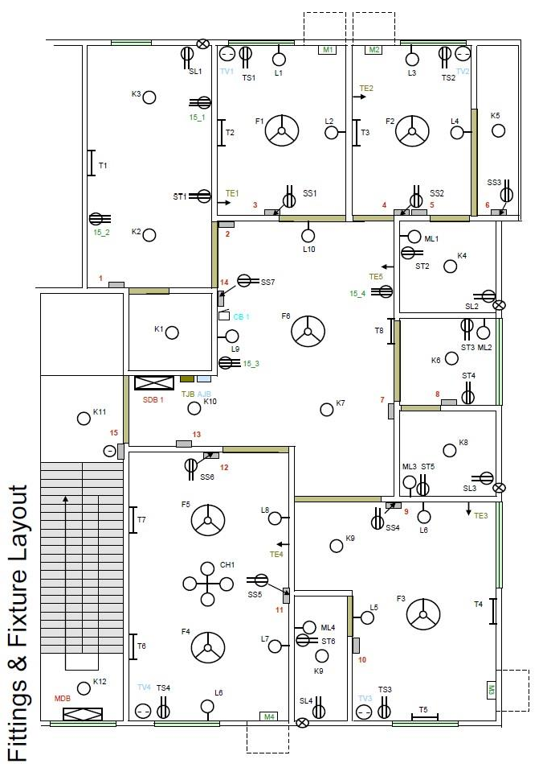

Sample Drawing:

The symbols to be used for Fittings and Fixture Layout

F – Fan L – Light
T – Tube Light
K – One Kind of Light TV – Television
TE – Telephone M – Motor
CH – Hanging Light ML – Multiple Light CB – Circuit Breaker SB – Switch Board
SS – Switch Board Socket ST – Two Pin Socket
SL – Skirting Level Socket TS – TV Socket
15_1 – 3 Pin Socket (15 A)
TJB – Telephone Junction Board; AJB – Antenna Junction Board C1, C2…. – No of Cables; 1,2,3……… - no of SB
SDB – Sub Distribution Board, MDB – Main Distribution Board,

Codes:

- For residential occupancy, the minimal guidelines given in Table 1 shall be used to determine the required number of 15 A switch socket outlets, when actual requirements cannot be ascertained.

Table 1: Minimum Number of 15A Socket Outlets [1]

Location | No. of Switch Socket Outlets
Bedroom | 1
Living room | 1
Drawing room | 1
Dining room | 1
Kitchen | 2
Bathroom | -
Verandah | 1
For refrigerator | 1
For air-conditioner | one for each

- Table 2 gives the recommended areas to be served by different sizes of ceiling fans where the height of fan blades is at 2.5 m above the finished floor level.

Table 2: Recommended Fan Sizes in Rooms [1]

Room Area (m2) | Fan Sweep
Up to 6 | 915 mm
Over 6 to 9 | 1220 mm
Over 9 to 12 | 1442 mm

- In estimating the electrical load, the ratings shown in Table 3 shall be taken unless actual values are known or specified.

Table 3: Load Estimates for Different Fittings/Fixtures [1]

Type of Fitting/Fixture | Ratings in Watts
Incandescent lamps | 100
Fluorescent lamp with accessories
- Nominal length 600 mm | 20
- Nominal length 1200 mm | 40
Ceiling fans and table fans | 70
Exhaust and pedestal fans | 90
5A socket outlets | 200
15A socket outlets | 1000

- Table 4 shows minimum generator room area requirements for different sizes of generators.

Table 4: Area Requirements for Standby Generator Room

Capacity (kW) | Area (m2)
1 x 25 | 20
1 x 48 | 24
1 x 100 | 30
1 x 150 | 36
1 x 300 | 48
1 x 500 | 56

Discussion and Conclusion:

Interpret the findings and determine the extent to which the experiment was successful in complying with the goal that was initially set. Discuss any mistake you might have made while conducting the designing and describe ways the study could have been improved.

References:
- Kristen S. Kurland, “AutoCAD 2004, 2D Training Manual”.
- Bob McFarlane, “Beginning AutoCAD 2004”.
- David Byrnes and Mark Middlebrook, “AutoCAD 2007 For Dummies”.
- Bangladesh National Building Code (BNBC) – 1993, part 8.

ADDITIONAL:
- How to do Create Block and put in Layout

https://www.youtube.com/watch?v=b4jLXz9YRdE

https://www.youtube.com/watch?v=7Atuw1s5ujM

- How to create AutoCAD Drawing Template:

https://www.youtube.com/watch?v=ouT8g-hwp8A

- Reset AutoCAD settings to bring lost toolbars
https://www.youtube.com/watch?v=xv9x-wcPiNQ

