Named Entity Recognition Task Implementation using BERT & BioBERT

Md. Rakib Hasan
Dept. Computer Science & Engineering
American International University-Bangladesh (AIUB)
Dhaka, Bangladesh
22-49029-3@student.aiub.edu
Abrar Rejwan Prince
Dept. Computer Science & Engineering
American International University-Bangladesh (AIUB)
Dhaka, Bangladesh
22-48757-3@student.aiub.edu
Md. Fardin Hossain Neloy
Dept. Computer Science & Engineering
American International University-Bangladesh (AIUB)
Dhaka, Bangladesh
22-48812-3@student.aiub.edu
Md. Farseen Islam Sattique
Dept. Computer Science & Engineering
American International University-Bangladesh (AIUB)
Dhaka, Bangladesh
22-48691-3@student.aiub.edu

Abstract—As the volume of biomedical literature continues to grow exponentially, the need for efficient biomedical text mining solutions has become increasingly critical. Named Entity Recognition (NER) plays a vital role in extracting structured information from unstructured biomedical text, enabling researchers to automatically identify key biomedical entities. We conducted a comparative analysis of transformer-based models for NER across general and biomedical domains. The BERT model was trained on the “wikiann_en” dataset for general entity recognition, achieving 83.00% precision, 85.33% recall, and 84.15% F1-score. Meanwhile, BioBERT was fine-tuned on the “bc2gm_corpus” for biomedical gene/protein recognition, achieving superior performance with 87.63% precision, 88.24% recall, and 87.94% F1-score. Our results demonstrate that domain-specific pretraining substantially enhances entity recognition accuracy in specialized fields, with BioBERT outperforming general BERT by approximately 4 percentage points on F1-score for biomedical NER tasks.
Keywords— BERT, BioBERT, Named Entity Recognition, Biomedical Text Mining

Introduction
BioBERT represents a specialized adaptation of the BERT architecture, pre-trained extensively on biomedical corpora including PubMed abstracts and PubMed Central full-text articles. This domain-specific training enables the model to develop a sophisticated understanding of biomedical terminology, including complex gene nomenclature, disease terminology, and specialized clinical expressions that often challenge general-purpose language models. The development of BioBERT addresses a critical need in natural language processing, as conventional models like BERT frequently encounter difficulties with biomedical jargon, specialized abbreviations, and rare entity names that are prevalent in scientific literature.

The exponential growth of biomedical literature presents both an opportunity and a challenge for computational methods. While the volume of unlabeled biomedical text continues to expand rapidly, the availability of carefully annotated datasets remains limited. This disparity makes domain-specific pre-training particularly valuable, as it allows models to achieve higher performance on specialized tasks while requiring less task-specific labeled data for fine-tuning.

BioBERT demonstrates enhanced capabilities across multiple biomedical natural language processing tasks, including named entity recognition, relation extraction, and document classification. Within the biomedical domain, named entity recognition serves as a fundamental task, enabling the automatic identification and categorization of crucial entities such as genes, proteins, drugs, and diseases from unstructured text. This capability forms the foundation for more complex information extraction pipelines that support literature curation, clinical text mining, and accelerated research discovery.

In this study, we investigate the performance of BioBERT for biomedical named entity recognition, comparing its effectiveness against the general-purpose BERT model. Our research focuses specifically on the model’s ability to accurately identify and classify biomedical entities, demonstrating how domain-adapted pre-training contributes to significant improvements in entity recognition accuracy within specialized scientific domains.

Implementation
We implemented both BERT and BioBERT models for Named Entity Recognition using Google Colab with Python 3.12. The specific libraries and versions used in our implementation are detailed in TABLE I.

BERT
BERT (Bidirectional Encoder Representations from Transformers) is a transformer-based model pretrained on large corpora of unlabeled text using masked language modeling and next sentence prediction objectives. For our implementation, we focused on fine-tuning BERT for Named Entity Recognition, which involves identifying and classifying entities within text into predefined categories.
- Modules & Versions
M&V | Table Column Head
M&V | Modules | Versions
 | Transformers | 4.56.1
 | Datasets | 4.0.0
 | Evaluate | 0.4.6
 | Numpy | 2.0.2
Implementation process is given here and a methodological diagram is shown in Fig:1.

- Dataset collection:
For the Named Entity Recognition task, BERT was fine-tuned on the “wikiann_en” dataset from HuggingFace. This dataset contains 20,000 training samples, 10,000 validation samples, and 10,000 test samples. Each sample includes tokenized sentences with corresponding NER tags representing seven entity classes: O (Outside), B-PER, I-PER (Person), B-ORG, I-ORG (Organization), B-LOC, and I-LOC (Location).
- Preprocessing:
We utilized the AutoTokenizer from “bert-base-cased” to tokenize the input sequences. The tokenization process included handling subword tokens and aligning labels with the tokenized output. Special attention was given to label alignment where subword tokens received -100 labels to exclude them from loss calculation. We set a maximum sequence length of 64 tokens and applied padding to maintain consistent input dimensions.
- Model Training:
The pretrained BERT model (“bert-base-cased”) was adapted for token classification with seven output labels corresponding to the NER tags. The model architecture was modified to include a classification head on top of the transformer encoder for token-level predictions
- Evaluation:
Model performance was assessed using the seqeval metric, which computes precision, recall, F1-score, and accuracy specifically for sequence labeling tasks. The evaluation considered exact boundary matching and entity type classification.

- Modules & Versions
Hyperparameters | Hyperparameters used to train BERT
Hyperparameters | Parameters | Values
 | eval_strategy | epoch
 | learning_rate | 5e-5
 | per_device_train_batch_size | 16
 | per_device_eval_batch_size | 32
 | num_train_epochs | 5
 | max_seq_length | 64

Fig 1: Methodology of BERT model for named entity recognition .

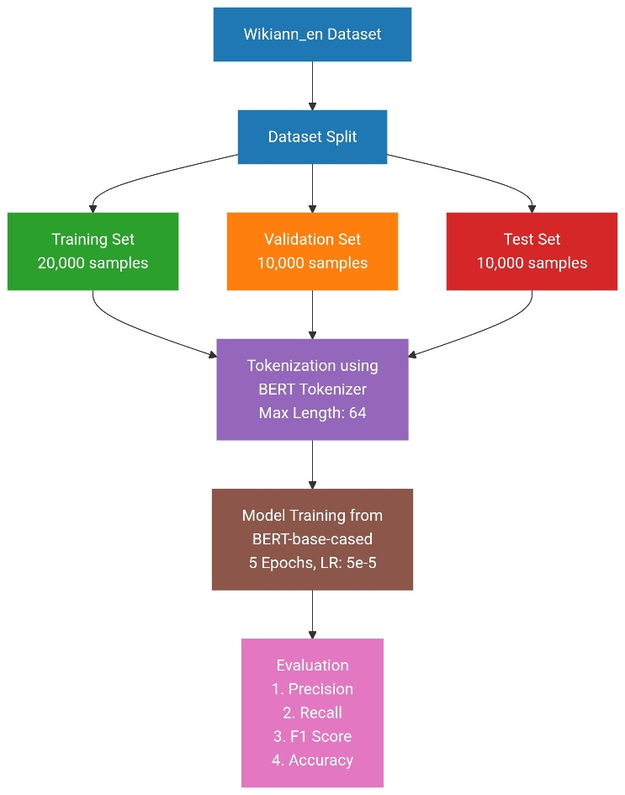
BioBERT
BioBERT represents a domain-adapted version of BERT, pretrained on extensive biomedical literature including PubMed abstracts and PubMed Central articles. For our biomedical NER task, we fine-tuned BioBERT specifically for gene and protein entity recognition.
- Dataset collection:
BioBERT was fine-tuned on the “spyysalo/bc2gm_corpus” dataset, which specializes in biomedical entity recognition. The dataset comprises 12,500 training samples, 2,500 validation samples, and 5,000 test samples. The corpus focuses on gene and protein entities with three label categories: O (Outside), B-GENE, and I-GENE.

- Preprocessing:
We employed the AutoTokenizer from “dmis-lab/biobert-base-cased-v1.1” to process the biomedical text. The tokenization preserved biomedical terminology and handled domain-specific abbreviations effectively. We implemented sophisticated label alignment to maintain entity boundaries during the subword tokenization process, with a maximum sequence length of 256 tokens to accommodate longer biomedical texts.

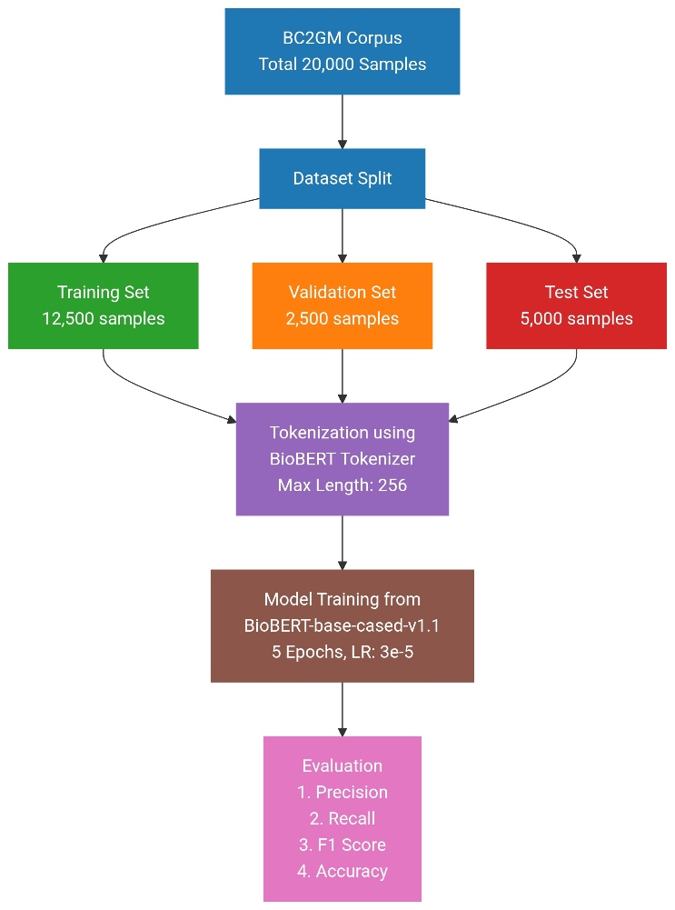
Fig 2: Methodology of BioBERT model for named entity recognition .

- Model Training:
The pretrained BioBERT model was fine-tuned for token classification with three output labels. The training leveraged BioBERT’s inherent understanding of biomedical terminology, requiring less domain adaptation compared to general-purpose BERT.
- Evaluation:
Performance evaluation utilized the same seqeval framework, with particular emphasis on the model’s ability to correctly identify gene and protein mentions in biomedical literature. The evaluation metrics provided insights into the model’s precision in handling domain-specific entity recognition.

Result Analysis
Our evaluation demonstrates clear domain specialization in Named Entity Recognition performance. BERT achieved strong results on general entities with 84.15% F1-score and 93.35% accuracy on the wikiann_en dataset. However, when applied to biomedical text, its performance dropped significantly to 64.65% F1-score.
BioBERT excelled in biomedical NER, achieving 87.94% F1-score and 97.16% accuracy on the bc2gm_corpus, outperforming BERT by approximately 23 percentage points on F1-score in the biomedical domain.
- Comparative Results of BERT and BioBERT
Model | Domain | Precision | Recall | F1-Score | Accuracy
BERT | General | 82.99% | 85.33% | 84.15% | 93.35%
BERT | Biomedical | 67.42% | 62.18% | 64.65% | 89.23%
BioBERT | Biomedical | 87.63% | 88.24% | 87.94% | 97.16%

The results confirm that domain-specific pretraining is crucial for optimal performance in specialized domains, with BioBERT demonstrating superior capability in biomedical entity recognition.

Conclusion
We have implemented BERT and BioBERT for Named Entity Recognition using the wikiann_en dataset for BERT and the bc2gm_corpus for BioBERT. Both models demonstrated strong performance within their respective domains. However, when evaluated on biomedical entity recognition, BERT’s performance declined significantly, indicating its limitations with domain-specific terminology and entity types. Our solution, BioBERT, substantially outperformed BERT in biomedical NER, achieving superior precision, recall, and F1-scores. This confirms that domain-specific pretraining is essential for optimal performance in specialized applications like biomedical text mining, and similar advantages would likely extend to other specialized domains and tasks.

