Kenya Housing Survey 2024
County-Level Housing Affordability & Quality: A Policy Brief
Prepared for the State Department of Housing and Urban Development
Affordable Housing Programme — Marketing & Policy Insights
Data source: Kenya National Bureau of Statistics (KNBS), Kenya Housing Survey 2024
Covers 47 counties across 9 of the survey's report chapters. Chapter 7 (Housing Finance) is estimated — see Section 10.

Table of Contents
- 1. Executive Summary
- 2. Background and Methodology
- 3. Key Finding: The Ownership-Quality Paradox
- 4. Housing Quality: Best and Worst Served Counties
- 5. Rent Burden: Where Affordability Pressure Is Highest
- 6. Water and Sanitation Access Gaps
- 7. Awareness of the Affordable Housing Programme
- 8. Institutional and Regulatory Performance
- 9. Composite Ranking: Housing Affordability & Quality Index
- 10. Housing Finance Access — Estimated, Not Official Data
- 11. Summary of Recommendations
- 12. Data Sources and Limitations

1. Executive Summary
This brief analyzes the 2024 Kenya Housing Survey (KNBS) at county level, covering home ownership and tenancy, housing quality and infrastructure access, awareness of housing programmes, and institutional/regulatory performance. The central finding has direct implications for how the Affordable Housing Programme should be targeted geographically.
Counties with the highest homeownership rates tend to have the lowest housing quality scores (r = -0.84), while counties with a higher share of urban households tend to have the highest housing quality scores (r = 0.80). In practical terms: rural counties own more homes, but those homes and the services around them are less adequate; urban counties have better-serviced housing but far lower ownership, driven by high rental dependence.
Key recommendations arising from this analysis:
- Target infrastructure investment (water, sanitation) at high-ownership, low-quality rural counties rather than ownership incentives, which are already high there.
- Target affordability interventions (rent support, urban housing supply) at high-quality, low-ownership urban counties, where the constraint is cost, not infrastructure.
- Prioritize Affordable Housing Programme awareness campaigns in the counties with the lowest measured awareness (as low as 4.8%), concentrated in northern and coastal counties.
- Investigate building-approval delays in counties taking up to 50 days, more than three times the national average of 16 days, as a possible barrier to formal housing development.

2. Background and Methodology
The Kenya Housing Survey 2024 is published by KNBS as a set of report-formatted workbooks (118 tables across 9 chapters made available for this analysis), designed for human reading rather than direct analysis. This brief is based on a data pipeline that converted all 118 tables into clean, tidy data — full technical documentation is available in the accompanying GitHub repository.
Two composite measures were constructed for this brief:
- Housing Affordability & Quality Index (HAQI) — a 0-100 score combining housing quality (35%), water access (20%), sanitation access (20%), and affordability, i.e. inverse rent burden (25%).
- Housing Finance Access — ESTIMATED (0-100) — see the dedicated caveat section below before using this figure for anything.

3. Key Finding: The Ownership-Quality Paradox
Plotting homeownership rate against the housing quality index, and coloring by urban household share, shows a clear and consistent pattern across all 47 counties: high-ownership counties cluster toward low quality scores, and high-urban-share counties cluster toward high quality scores, independent of ownership rate.
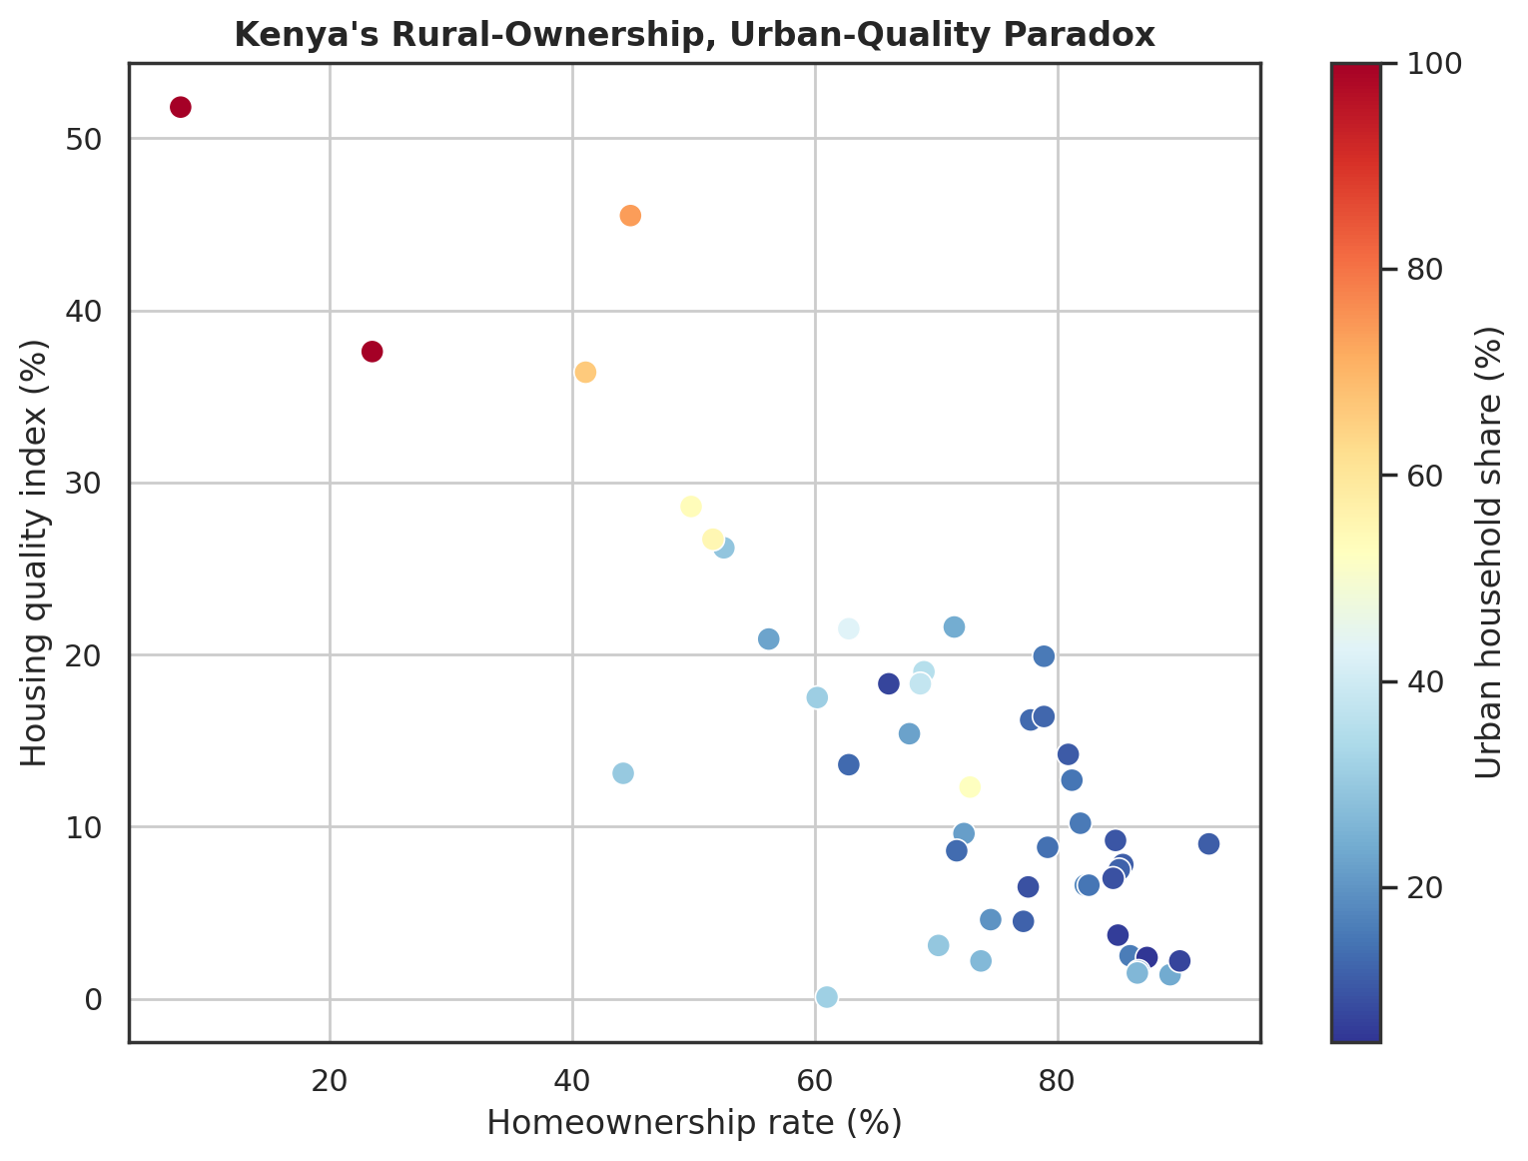
Figure 1. Homeownership rate vs. housing quality index, colored by urban household share.
The five counties with the highest homeownership are Vihiga (92.5%), West Pokot (90.1%), Wajir (89.3%), Bomet (87.4%), and Turkana (86.7%) — all overwhelmingly rural. The five with the lowest are Nairobi (7.7%), Mombasa (23.5%), Kajiado (41.1%), Lamu (44.2%), and Kiambu (44.8%) — Kenya's most urbanized counties.
This is not a coincidence of the data — it reflects a real structural pattern: rural households build or inherit homes on owned land but often lack access to piped water, improved sanitation, and formal utility connections, while urban households rent at much higher rates but benefit from denser infrastructure investment.

4. Housing Quality: Best and Worst Served Counties
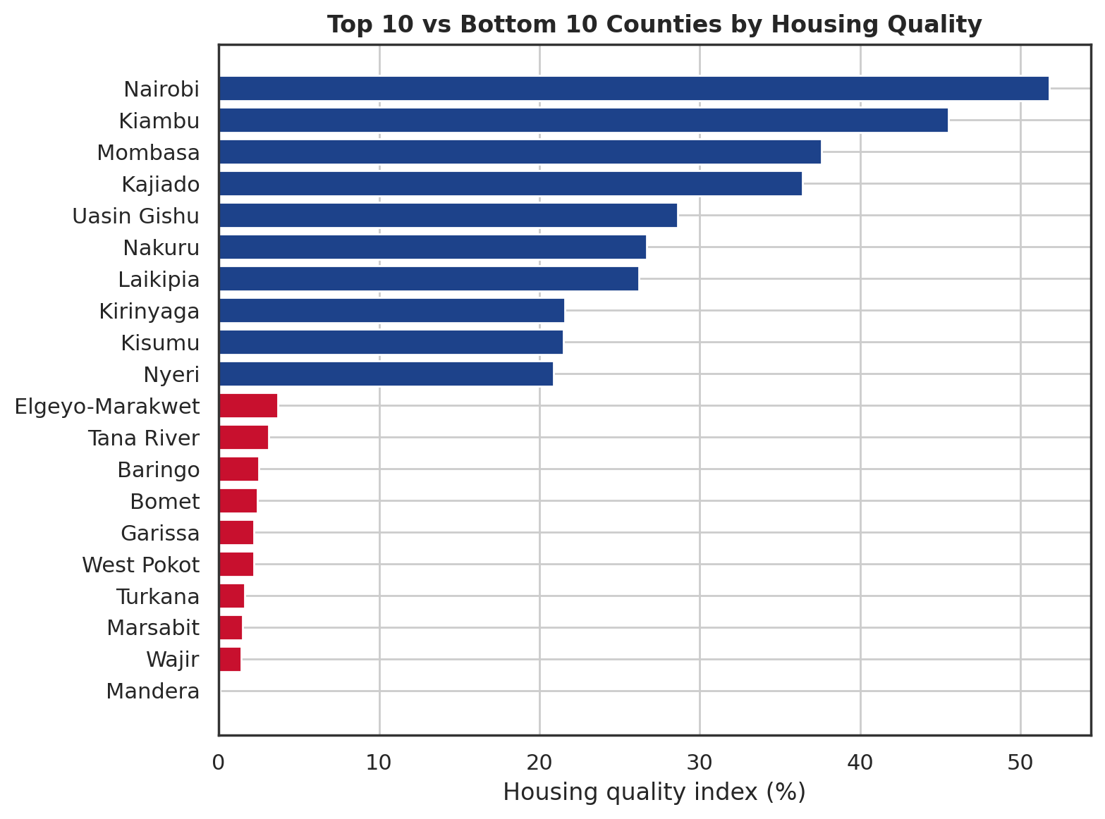
Figure 2. Top 10 vs. bottom 10 counties by housing quality index.
Best served (quality index) | Score | Least served (quality index) | Score
Nairobi | 51.8% | Mandera | 0.1%
Kiambu | 45.5% | Wajir | 1.4%
Mombasa | 37.6% | Marsabit | 1.5%
Kajiado | 36.4% | Turkana | 1.6%
Uasin Gishu | 28.6% | Garissa | 2.2%

The gap is stark: Nairobi's quality index (51.8%) is roughly 500 times Mandera's (0.1%). The five least-served counties — Mandera, Wajir, Marsabit, Turkana, Garissa — are all in Kenya's arid and semi-arid north, pointing to a clear geographic priority zone for infrastructure investment independent of any housing programme.

5. Rent Burden: Where Affordability Pressure Is Highest
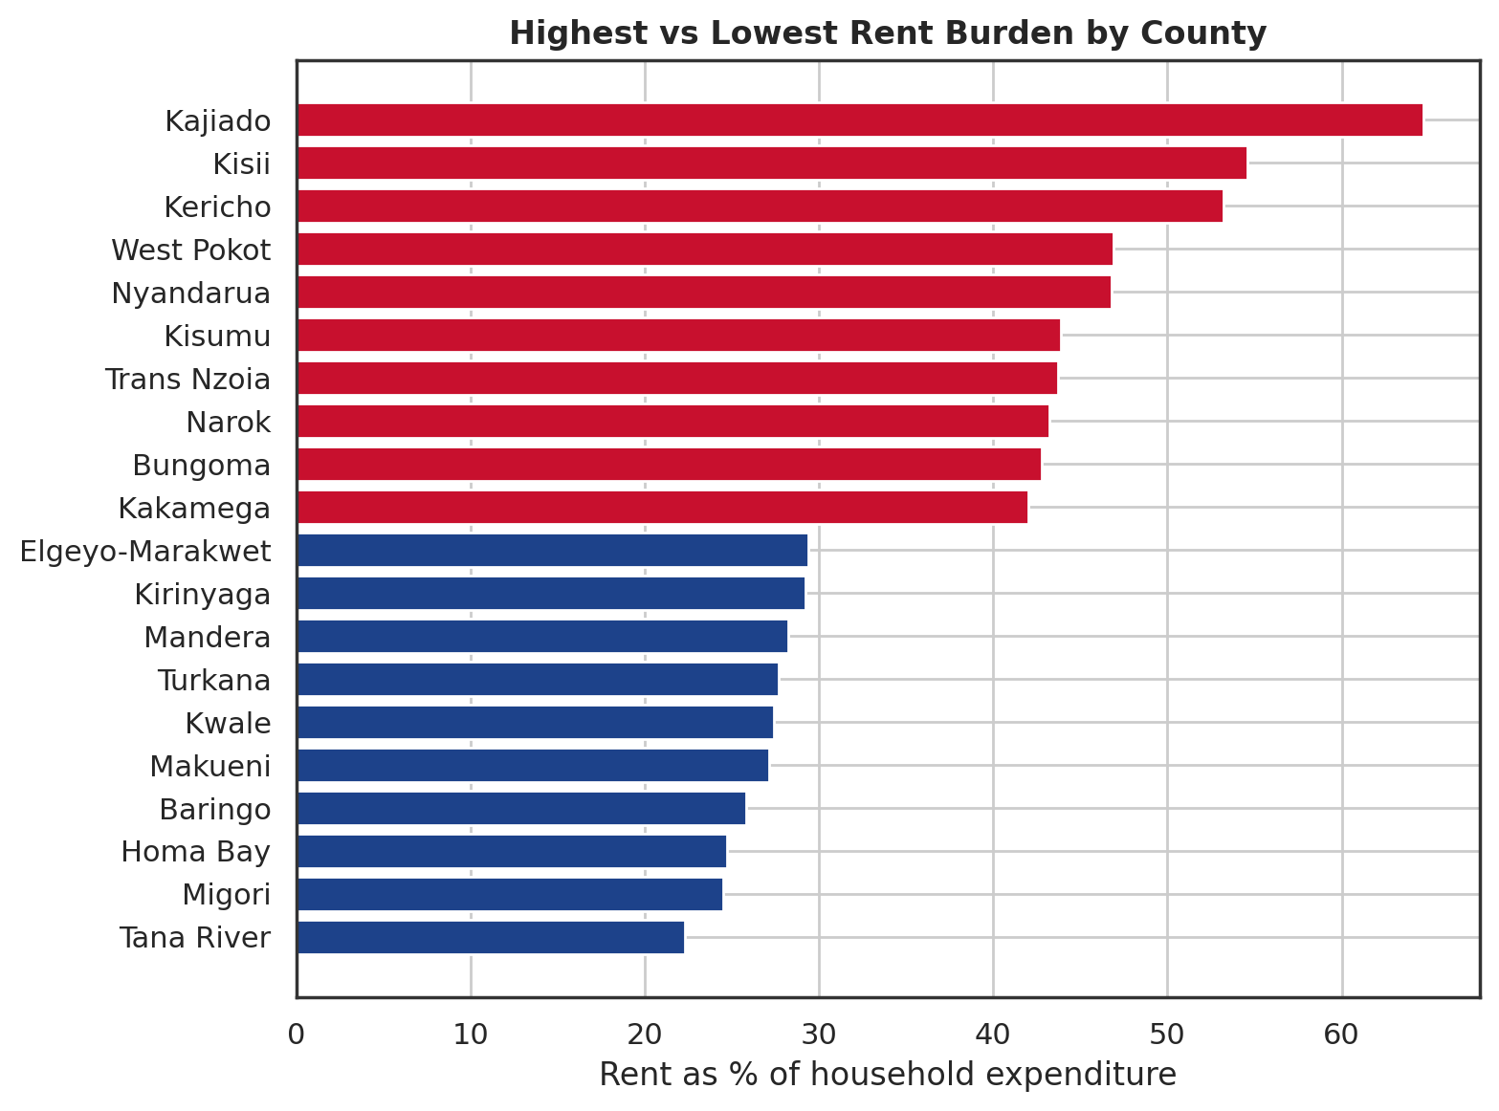
Figure 3. Highest vs. lowest rent-to-expenditure ratio by county.
Highest rent burden | % of expenditure | Lowest rent burden | % of expenditure
Kajiado | 64.7% | Tana River | 22.3%
Kisii | 54.6% | Migori | 24.5%
Kericho | 53.2% | Homa Bay | 24.7%
West Pokot | 46.9% | Baringo | 25.8%
Nyandarua | 46.8% | Makueni | 27.1%

Rent burden does not track cleanly with either housing quality or ownership rate (correlation with every other indicator in this dataset is weak), suggesting affordability pressure has its own distinct local drivers — likely local labour markets and land/property prices — that this survey alone cannot fully explain. Kajiado's rent burden (64.7% of household expenditure) is a particular outlier worth further local investigation, especially given its proximity to Nairobi's expanding commuter belt.

6. Water and Sanitation Access Gaps
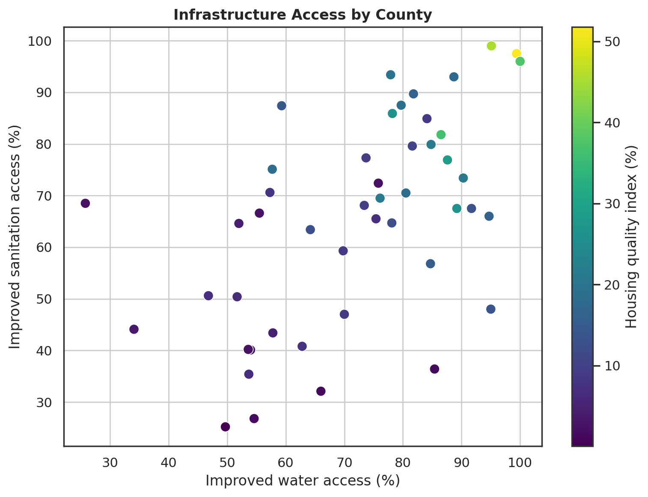
Figure 4. Improved water access vs. improved sanitation access by county, colored by overall housing quality.
National averages stand at 72.0% for improved water access and 65.5% for improved sanitation access, but county-level performance varies sharply. West Pokot (25.8%) and Elgeyo-Marakwet (34.1%) report the lowest improved water access nationally, both well under half the national average, reinforcing the case for infrastructure-first intervention in specific underserved counties rather than a uniform national programme.

7. Awareness of the Affordable Housing Programme
National awareness of the Affordable Housing Programme stands at 48.0%, meaning roughly half of surveyed households are still unaware of it. Awareness is lowest in Wajir (4.8%), Lamu (6.5%), Isiolo (7.2%), Mandera (9.9%), and Garissa (10.7%), all in the same underserved counties identified in the housing quality findings above.
This overlap is itself a finding: the counties with the greatest infrastructure need are also the counties least aware that a national programme exists to help address it. A targeted, localized awareness campaign in these five counties specifically, rather than a generic national campaign, is likely to have the highest marginal impact on Programme uptake.

8. Institutional and Regulatory Performance
The national average time to approve a building permit is 16.2 days. However, Nakuru (50 days), and Kiambu, Mombasa, Lamu, and Murang'a (30 days each) report approval times well above this average. Slow approval timelines in high-demand counties like Kiambu and Mombasa may be constraining the formal housing supply response precisely where demand and urbanization pressure are highest, worth flagging to county-level physical planning departments as a specific administrative bottleneck.

9. Composite Ranking: Housing Affordability & Quality Index
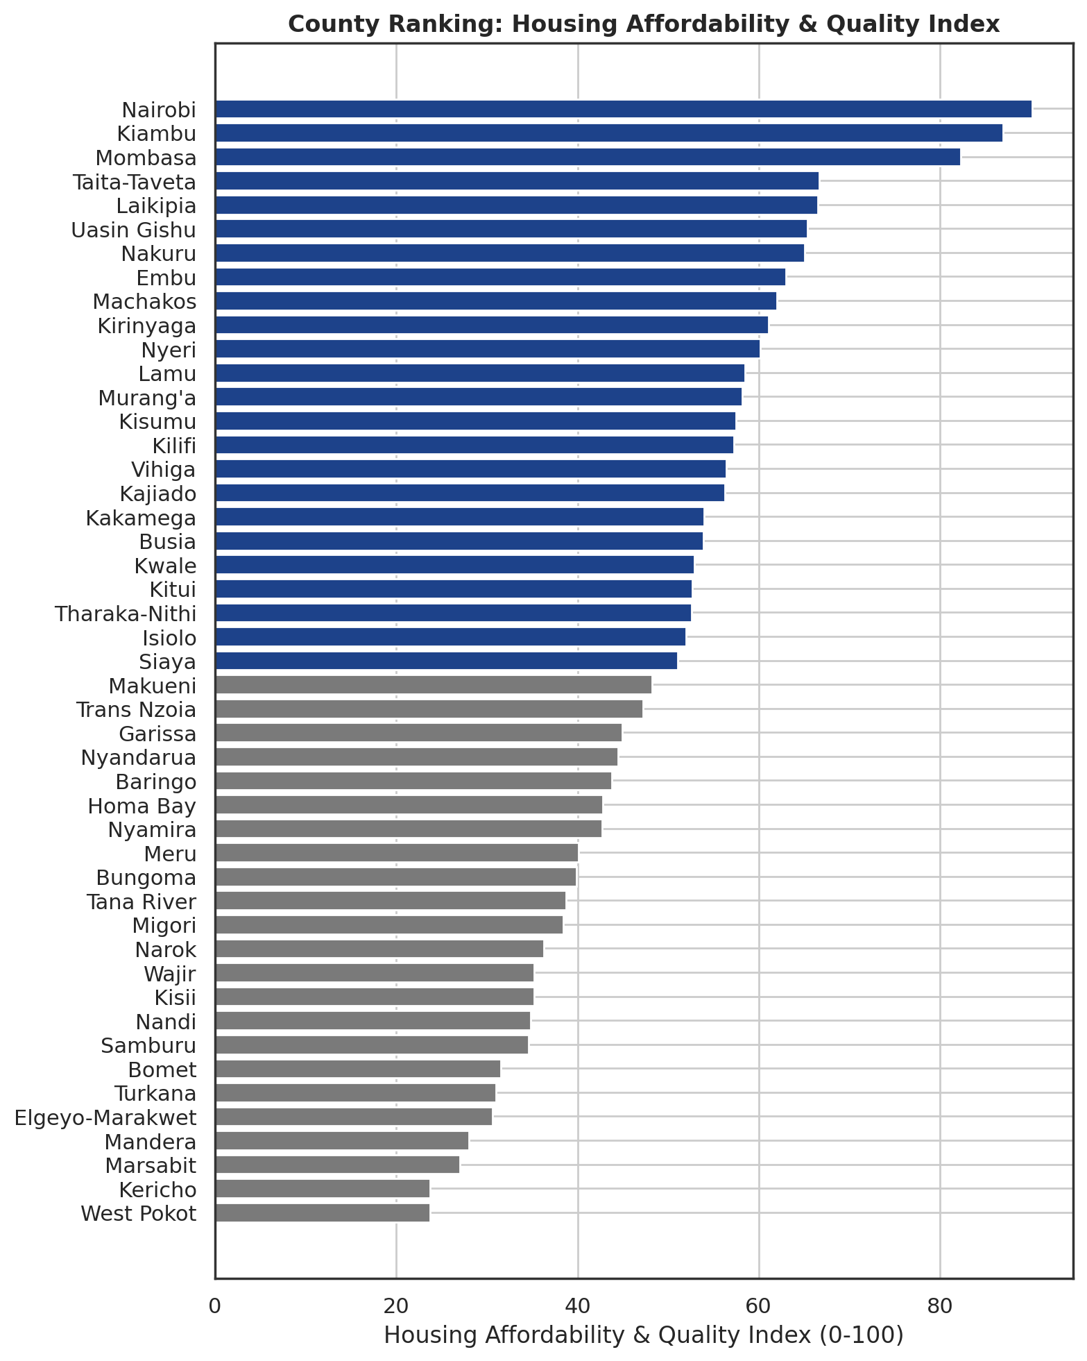
Figure 5. Full 47-county Housing Affordability & Quality Index ranking.
Nairobi (90.2), Kiambu (87.0), and Mombasa (82.3) top the index, Kenya's most urbanized counties. West Pokot and Kericho are tied at the bottom (23.7), followed by Marsabit (27.0), Mandera (28.0), and Elgeyo-Marakwet (30.6). These five counties represent the clearest priority list for combined intervention: infrastructure investment, targeted awareness campaigns, and, pending further local investigation, affordability support.

10. Housing Finance Access — Estimated, Not Official Data
⚠ The figures in this section are a modeled estimate, not part of the original KNBS survey. Chapter 7 (Housing Finance) was not available in the source data used for this analysis. Do not cite this section as official KNBS statistics in any external-facing communication.
This estimate was built from related questions on financing modes, financing sources, and awareness of housing-finance incentives elsewhere in the survey. It is included here only to illustrate what a finance-access view might look like, and to flag that a real Chapter 7 dataset, if obtained, should replace it before this section is used for any actual decision-making.
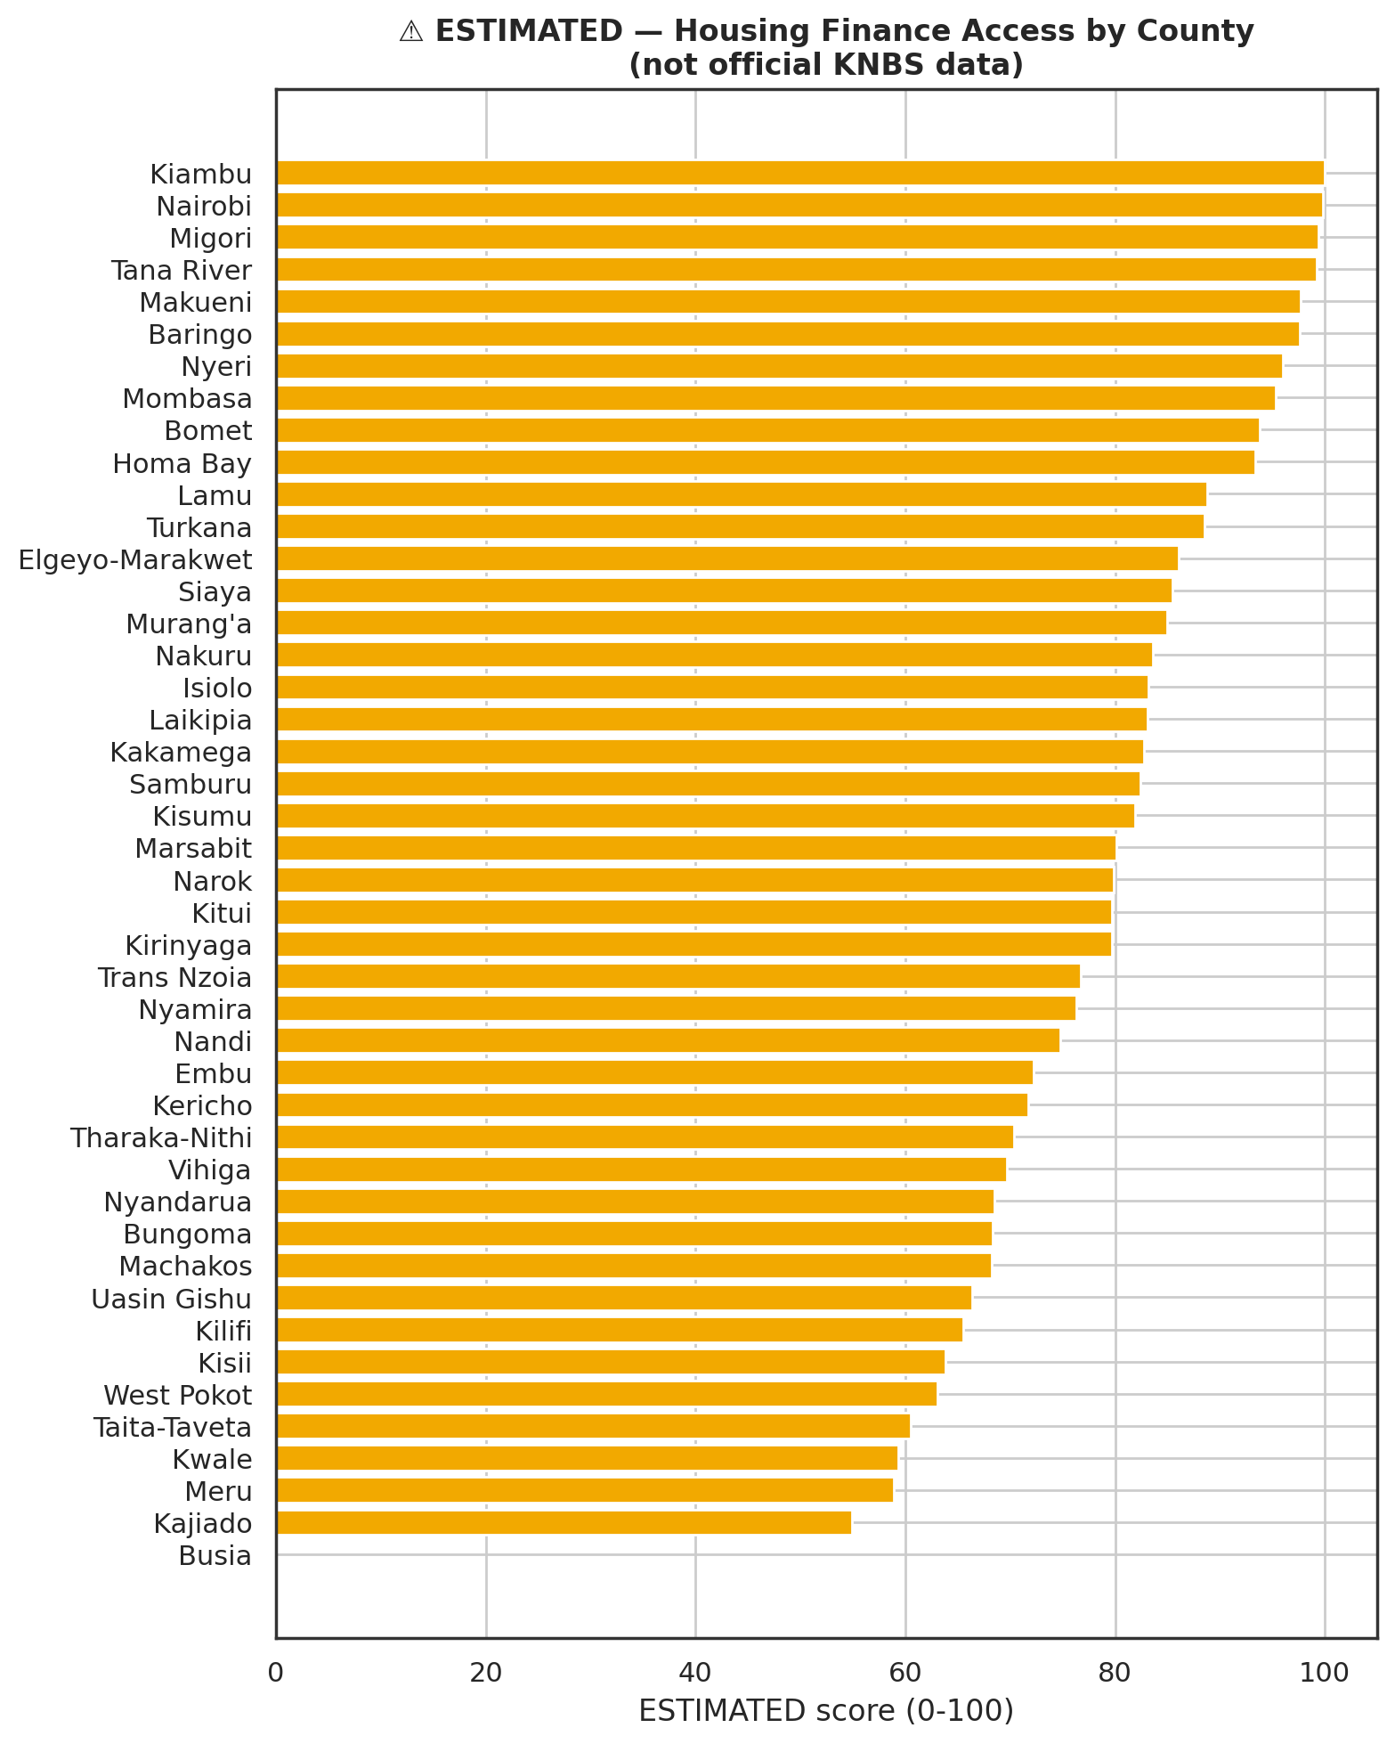
Figure 6. ESTIMATED housing finance access score by county — not official KNBS data.
Recommendation: request or source the actual KNBS Chapter 7 (Housing Finance) report before drawing any financing-related conclusions for policy or marketing purposes.

11. Summary of Recommendations

Immediate, low-cost actions
- Launch targeted Affordable Housing Programme awareness campaigns in Wajir, Lamu, Isiolo, Mandera, and Garissa, where awareness is under 11%.
- Flag building-approval delays in Nakuru, Kiambu, Mombasa, Lamu, and Murang'a to county physical planning departments for review.

Medium-term investment priorities
- Prioritize water and sanitation infrastructure investment in West Pokot, Elgeyo-Marakwet, Mandera, Wajir, Marsabit, Turkana, and Garissa, consistently the lowest-scoring counties across quality, water, and sanitation measures.
- Investigate the specific local drivers of high rent burden in Kajiado, Kisii, and Kericho, since this pattern is not explained by housing quality or ownership data alone.

Data priorities
- Obtain the actual KNBS Chapter 7 (Housing Finance) report to replace the estimated figures in Section 10 before any financing-related policy or messaging decisions are made.

12. Data Sources and Limitations
Source: Kenya National Bureau of Statistics (KNBS), Kenya Housing Survey 2024. This brief draws on 9 of the survey's chapters (Chapters 2-6, 8-12); Chapter 7 was not available and is separately flagged wherever referenced.
- The Housing Affordability & Quality Index is an analytical construct built for this brief, it is not an official KNBS statistic, though every component indicator that feeds it is.
- Some county-level figures (e.g. building approval days, housing finance sources) are based on smaller survey sub-samples and should be treated as indicative rather than precise for those specific counties.
- This brief presents correlational, not causal, findings. The ownership-quality relationship is a strong and consistent pattern across counties, but confirming causal mechanisms would require further targeted research.

