U.S. School District Finance
Revenue, Spending & Funding Equity - FY2012
Prepared by Nelson Wasike
Data source: U.S. Census Bureau, Annual Survey of School System Finances (F-33)
11,173 unified school districts across 50 states and the District of Columbia.
Table of Contents
1. Executive Summary 3
2. Data Source and Methodology 4
Cleaning steps 4
3. Finding: Per-Pupil Spending Varies Nearly 4x Across States 5
4. Finding: Funding Source Predicts Spending Level 6
5. District-Level Distribution 7
6. Data Quality Note: The Tiny-District Outlier Problem 8
7. Conclusions and Implications 9
8. Data Sources and Limitations 10

1. Executive Summary
This report analyses school district finance data from the U.S. Census Bureau's FY2012 Annual Survey of School System Finances (F-33), covering 11,173 unified school districts across every state and the District of Columbia. The analysis focuses on per-pupil revenue and spending, and on how a state's mix of local, state, and federal funding relates to its overall resource level.
Per-pupil revenue varies dramatically by state - from $7,321 in Idaho to $28,197 in the District of Columbia, a gap of nearly 4x. This variation is not random: states that rely more heavily on local funding (largely property-tax based) tend to spend substantially more per pupil, while states relying more heavily on federal funding tend to spend substantially less. This is consistent with federal education aid functioning as compensatory support for lower-resource systems, rather than a general source of abundance.
A specific data-quality issue was identified and handled directly: a small number of special-education service cooperatives, serving as few as 7 students, report per-pupil figures exceeding $1,000,000 -mathematically correct given their budgets and enrolment, but not meaningful for comparison against ordinary school districts. These were excluded from district-level comparisons rather than left in to distort the picture.

2. Data Source and Methodology
Source: U.S. Census Bureau, Annual Survey of School System Finances (F-33), Fiscal Year 2012 - 18,373 raw school system records.

Cleaning steps
- Census codes missing or not-applicable values as small negative numbers (-1, -2, -3, -9) rather than blank cells - every such code was converted to a proper missing value before any calculation, so it could not be silently averaged in as a real dollar figure.
- Restricted to unified elementary-secondary school districts (SCHLEV = "03") - the raw file also includes elementary-only, secondary-only, and non-operating education agencies, which are not comparable to a full K-12 district on a per-pupil basis.
- State-level per-pupil figures were calculated as (state total dollars) ÷ (state total enrolled pupils) - not as an average of each district's own ratio, which would let a tiny district's number count as much as a major city district.

3. Finding: Per-Pupil Spending Varies Nearly 4x Across States
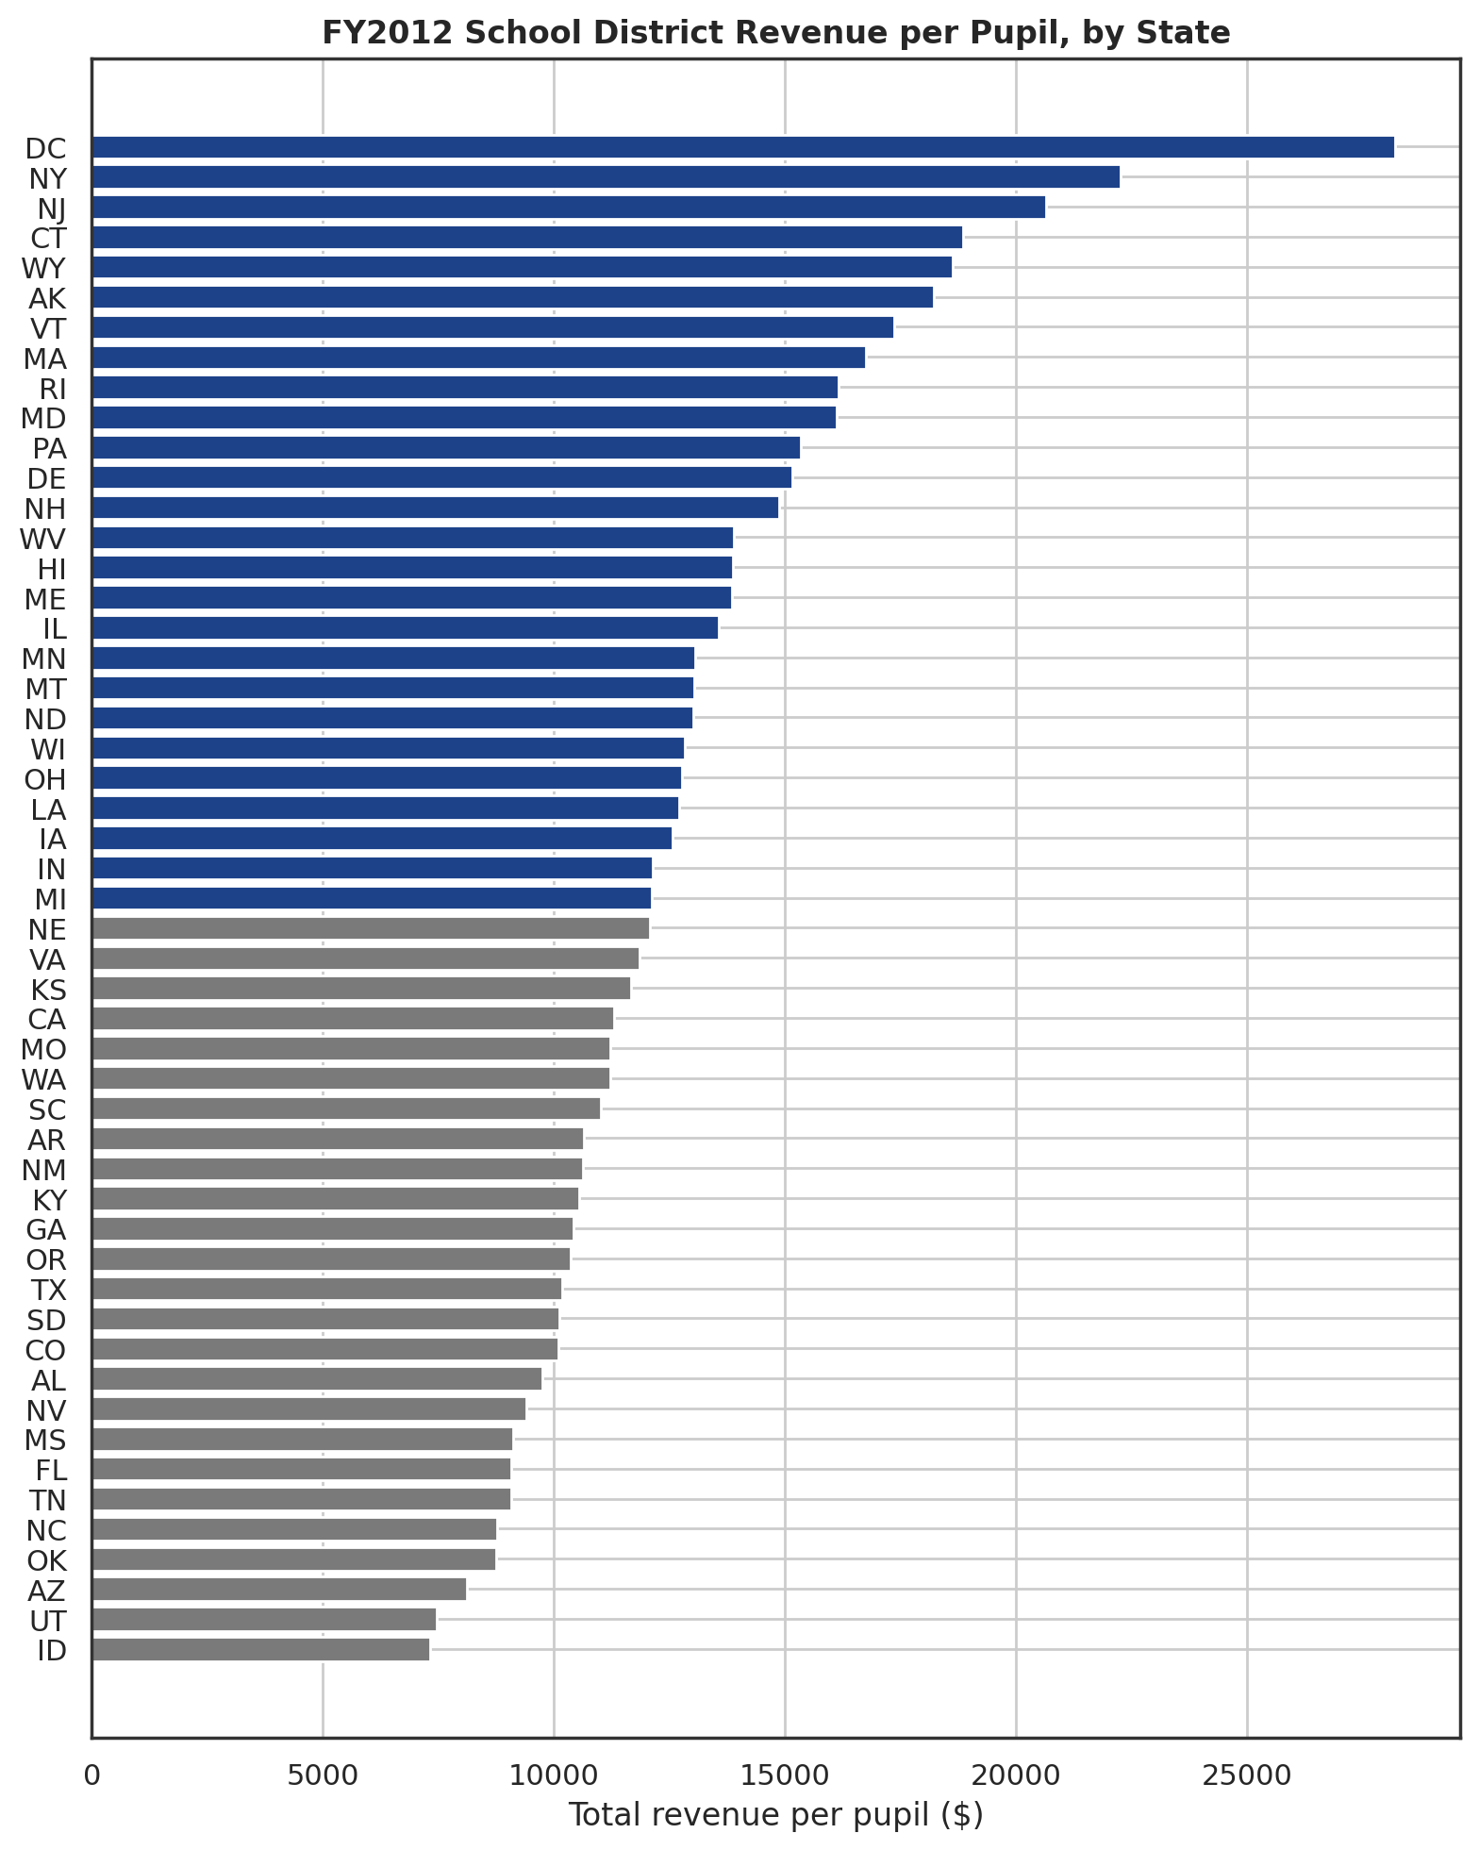
Figure 1. FY2012 total revenue per pupil, by state.
Highest spending | $/pupil | Lowest spending | $/pupil
District of Columbia | $28,197 | Idaho | $7,321
New York | $22,251 | Utah | $7,453
New Jersey | $20,651 | Arizona | $8,106
Connecticut | $18,849 | Oklahoma | $8,756
Wyoming | $18,616 | North Carolina | $8,770
Table 1. Highest Spending and Lowest Spending States per pupil
The national average across states is $12,904 per pupil, but this average obscure the scale of the underlying gap: a student in the District of Columbia is, on average, backed by roughly 3.9 times the funding of a student in Idaho.
.

4. Finding: Funding Source Predicts Spending Level
Correlating each state's revenue mix against its overall per-pupil spending shows a clear and consistent pattern:
Revenue source | Correlation with $/pupil
Local revenue share | +0.36
State revenue share | -0.28
Federal revenue share | -0.45
Table 2. Correlation between money spent per pupil vs Local revenue share, State Revenue share and Federal Revenue share
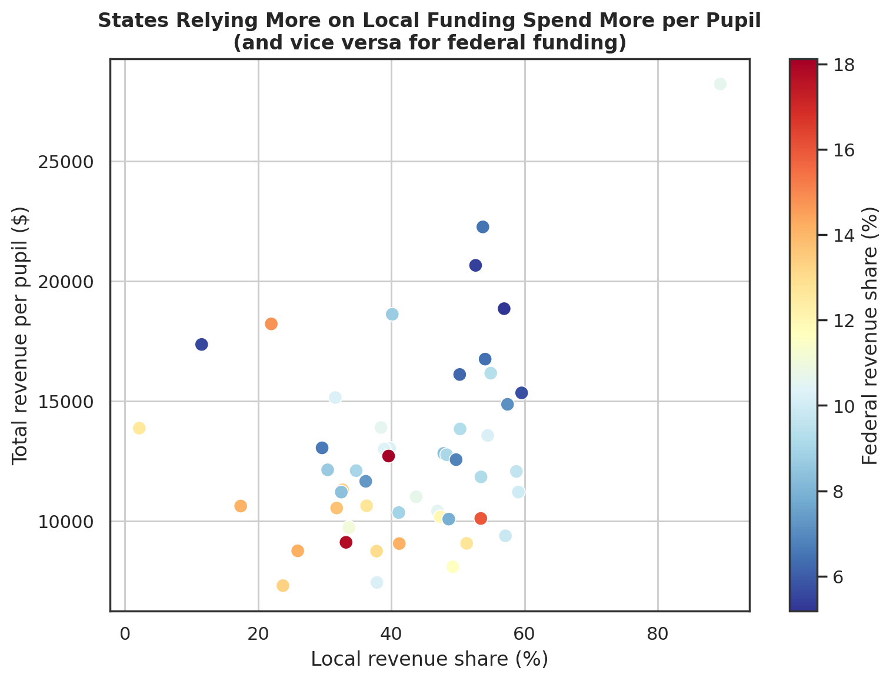
Figure 2. Local revenue share vs. total revenue per pupil, coloured by federal revenue share.
States that lean more heavily on local funding (largely local property taxes) spend more per pupil overall; states that lean more heavily on federal funding spend less. This is a well-documented pattern in U.S. education finance: federal programs such as Title I and IDEA are targeted, compensatory aid aimed at lower-resource districts, so a high federal share is generally a symptom of limited overall resources rather than a source of overall abundance.

5. District-Level Distribution
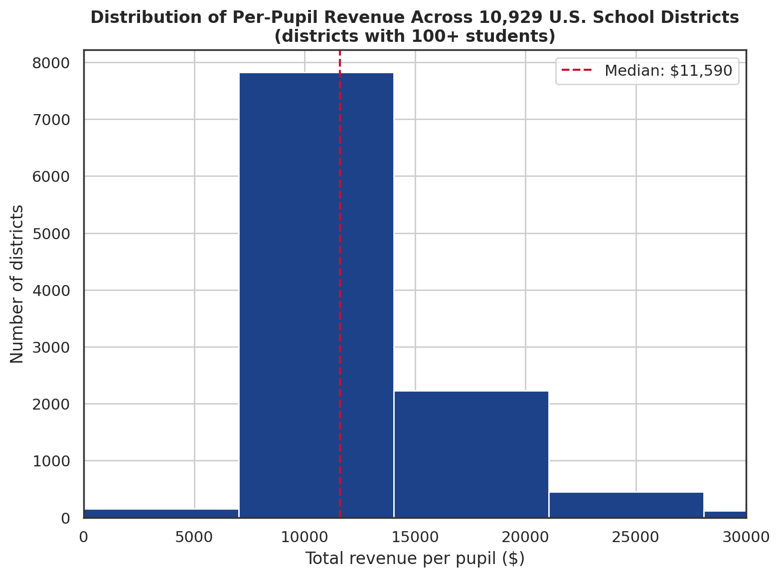
Figure 3. Distribution of per-pupil revenue across 10,929 U.S. school districts (100+ enrolment).
At the individual district level (restricted to districts with 100 or more students, for comparability - see Section 6), the median district spends $11,590 per pupil, with the middle 50% of districts (the interquartile range) falling between $9,874 and $14,396. The state-level pattern in Section 4 holds at the district level too: spending is concentrated well below the state-level average of $12,904, reflecting that a small number of very high-spending districts and states pull the state-level average upward relative to the typical district a student actually attends.

6. Data Quality Note: The Tiny-District Outlier Problem
A small number of special-education service cooperatives serve very small enrolments - as few as 7 students in one case - while reporting substantial regional service budgets. Divided by such a small enrolment figure, this produces per-pupil numbers over $1,000,000, which are mathematically correct but not meaningful for comparison against an ordinary comprehensive school district.
- 244 of the 11,173 cleaned districts have fewer than 100 enrolled students.
- These were excluded specifically from district-level comparisons and charts (Section 5), using a 100-student minimum enrolment threshold.
- They remain fully present in the underlying processed data file - nothing was silently discarded from the dataset itself, only from the specific comparisons where they would mislead.
- State-level figures (Sections 3-4) are unaffected by this issue, since they are calculated from state totals rather than from an average of district-level ratios.

7. Conclusions and Implications
- Per-pupil funding inequality across states is substantial and structural - tied to how each state's school funding system is built, particularly its reliance on local property-tax revenue versus state or federal funding.
- A high federal funding share should be read as an indicator of underlying resource scarcity in a state's education system, not evaluated as if it were a sign of strong federal investment producing high overall spending.
- Any cross-district or cross-state comparison of education spending should explicitly account for enrolment size, since very small specialized districts can produce per-pupil figures that are technically accurate but analytically misleading if left unfiltered.
- Further work could extend this analysis across multiple fiscal years to determine whether the local-vs-federal funding relationship identified here in FY2012 is a stable, structural pattern or one that shifts over time.

8. Data Sources and Limitations
Source: U.S. Census Bureau, Annual Survey of School System Finances (F-33), Fiscal Year 2012.
- This report presents correlational findings, not causal ones. The local-funding/federal-funding relationship with overall spending is a strong, well-documented pattern, but this dataset alone cannot establish the underlying causal mechanisms.
- Figures reflect FY2012 only; funding patterns and relative state rankings may have shifted in more recent fiscal years not covered by this analysis.
- Per-pupil figures are based on total revenue and expenditure divided by total enrolment (membership), and do not adjust for regional cost-of-living differences, which can meaningfully affect what a given dollar amount actually buys in different parts of the country.

