Winter Olympics Athlete Policy Report
Athlete Health Standards & National Delegation Equity — Sochi 2014
Prepared by Nelson Wasike
Data: 2,606-athlete Winter Olympics roster, 83 nations, 15 sports

TABLE OF CONTENTS
1. Executive Summary 3
2. Data Source and Methodology 4
Cleaning steps 4
3. Policy Area A: Athlete Health — BMI Patterns by Sport 5
4. Data Quality Note: The Figure Skating / Curling Weight Gap 6
5. Policy Area B: National Delegation Equity 7
6. Age Profile by Sport 9
7. Policy Recommendations 10
Athlete health 10
Delegation equity 10
Further analysis 10
8. Data Sources and Limitations 11

1. Executive Summary
This report analyzes a 2,606-athlete Winter Olympics roster (83 nations, 15 sports) to examine two policy-relevant questions: whether athlete body composition varies in ways that raise health concerns by sport, and how equitably Olympic participation is distributed across competing nations.
Ski Jumping's average athlete BMI (19.4) sits at the edge of the World Health Organization's underweight threshold (18.5), consistent with long-documented concerns in the sport about weight-cutting for aerodynamic advantage - concerns significant enough that the International Ski Federation has previously introduced BMI-linked equipment regulations. Bobsleigh sits at the opposite extreme (BMI 27.5), reflecting the sport's need for explosive power and mass.
On delegation equity: 18 of 83 competing nations sent exactly one athlete, while the three largest delegations (United States, Canada, Russia) alone account for 22.8% of all athletes, and the ten largest account for 53.9% - over half the entire roster from just 12% of participating nations.
A specific data quality issue is flagged directly: weight data is completely missing for 100% of Figure Skating and Curling athletes — a structural recording gap, not random missingness - meaning no BMI-based conclusion can be drawn for either sport.

2. Data Source and Methodology
Source: Winter Olympics athlete roster (Sochi 2014), 2,606 athletes across 83 nations and 15 sports, with name, sport, nationality, age, weight, and height recorded per athlete.

Cleaning steps
- A small number of athletes are listed with two sports in a single cell (e.g. "Cross-Country Skiing,Biathlon") - these were split into one row per sport, so a dual-discipline athlete is correctly counted in both sports rather than forming a fake combined category.
- BMI was calculated directly from each athlete's own recorded weight and height (kg / m²) - never estimated or imputed where either value was missing.
- Country-level delegation counts use unique athletes, not sport-rows, so a two-sport athlete is not counted twice toward their nation's total.

3. Policy Area A: Athlete Health - BMI Patterns by Sport
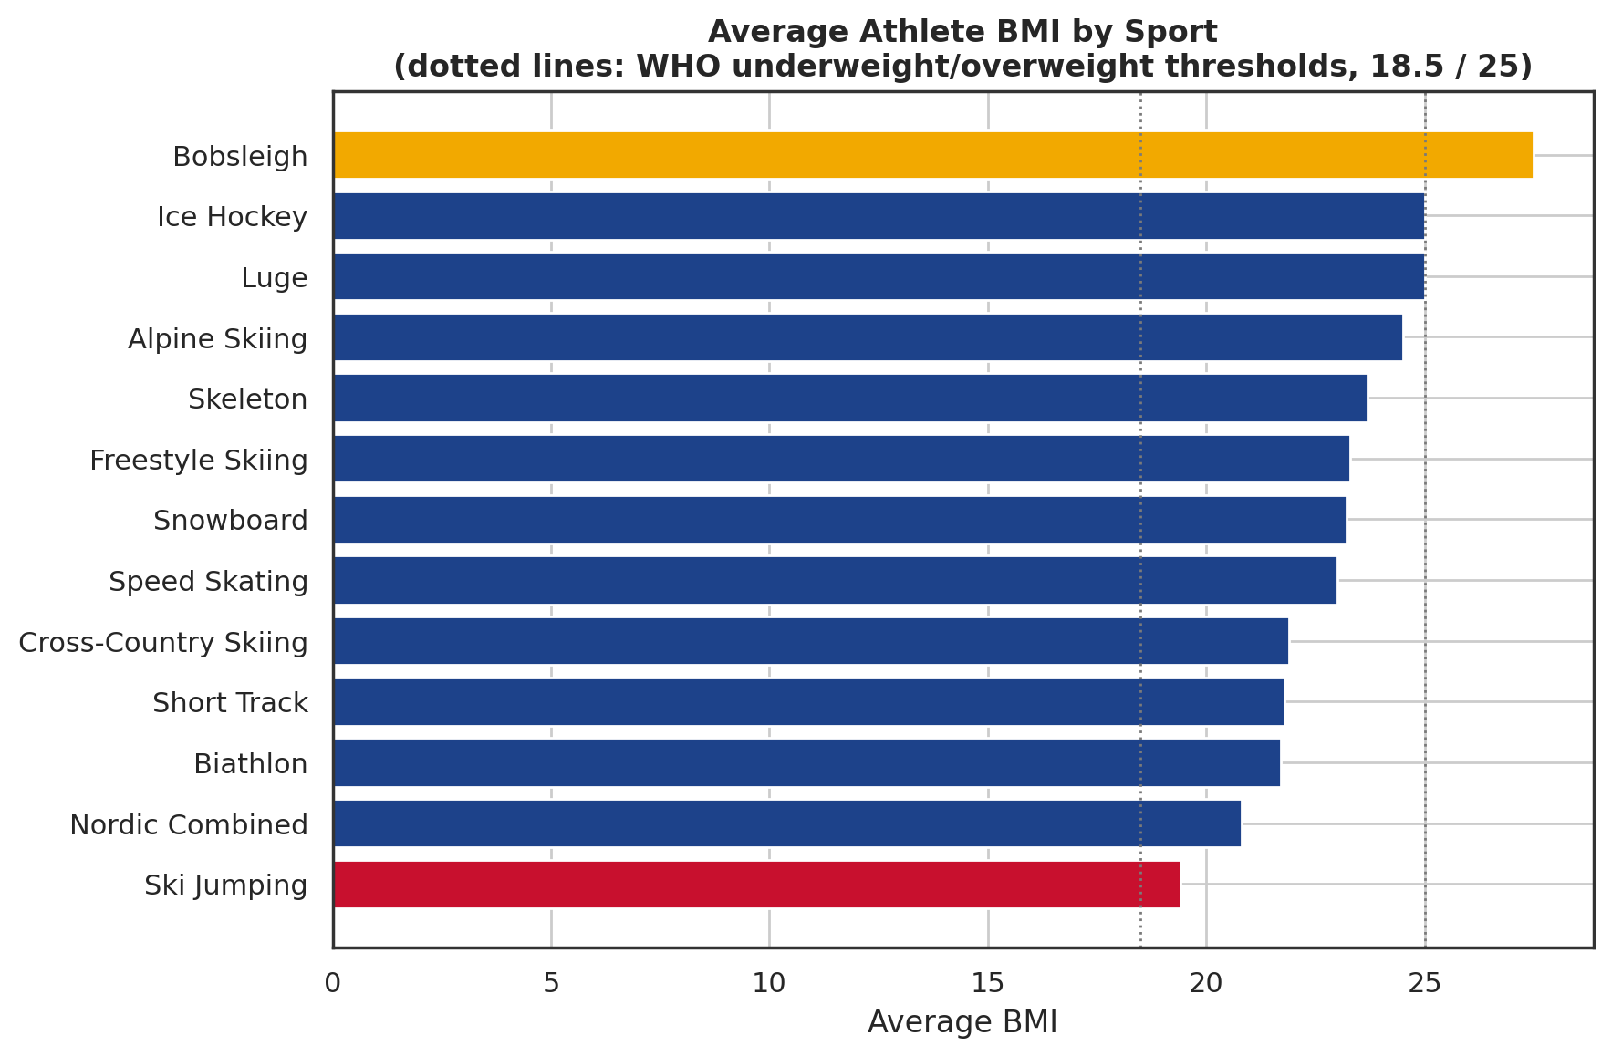
Figure 1. Average athlete BMI by sport, with WHO underweight (18.5) and overweight (25) reference lines.
Lowest average BMI | BMI | Highest average BMI | BMI
Ski Jumping | 19.4 | Bobsleigh | 27.5
Nordic Combined | 20.8 | Ice Hockey | 25.0
Biathlon | 21.7 | Luge | 25.0

Ski Jumping's average BMI of 19.4 is not itself below the WHO underweight threshold of 18.5 - but as a whole-sport average, it implies a substantial share of individual ski jumpers fall below that line. This is not a novel finding: it reflects a well-documented pattern in the sport, where a lower body weight provides a genuine aerodynamic advantage during flight, historically incentivizing unhealthy weight-cutting practices among competitors. This is significant enough that the sport's governing body has previously tied ski length limits to athlete BMI, specifically to reduce the incentive to lose weight unsafely.
Bobsleigh's high average BMI (27.5) reflects the opposite physical demand: explosive power during the push-start phase and the benefit of mass when combined with the sled favor larger, more muscular athletes, which is a healthy, sport-appropriate pattern rather than a cause for concern.

4. Data Quality Note: The Figure Skating / Curling Weight Gap
100% of Figure Skating athletes (146 of 146) and 100% of Curling athletes (99 of 99) have missing weight data. No BMI conclusion is possible for either sport.
Weight is missing for 326 athletes overall (12.5% of the roster) - but this is not randomly distributed. Two sports, Figure Skating and Curling, account for 245 of those 326 missing values (75%), and every single athlete in both sports is missing this field. This points to a structural gap in how weight was recorded for these two disciplines specifically, rather than incidental non-response scattered across the roster.
- No inference should be drawn about Figure Skating or Curling athletes' body composition from this dataset - the absence of data is not evidence of anything about the sport itself.
- Any future data collection effort should specifically verify whether weight is being recorded for these two disciplines, since the current gap makes them invisible to any health-monitoring analysis built on this kind of roster data.

5. Policy Area B: National Delegation Equity
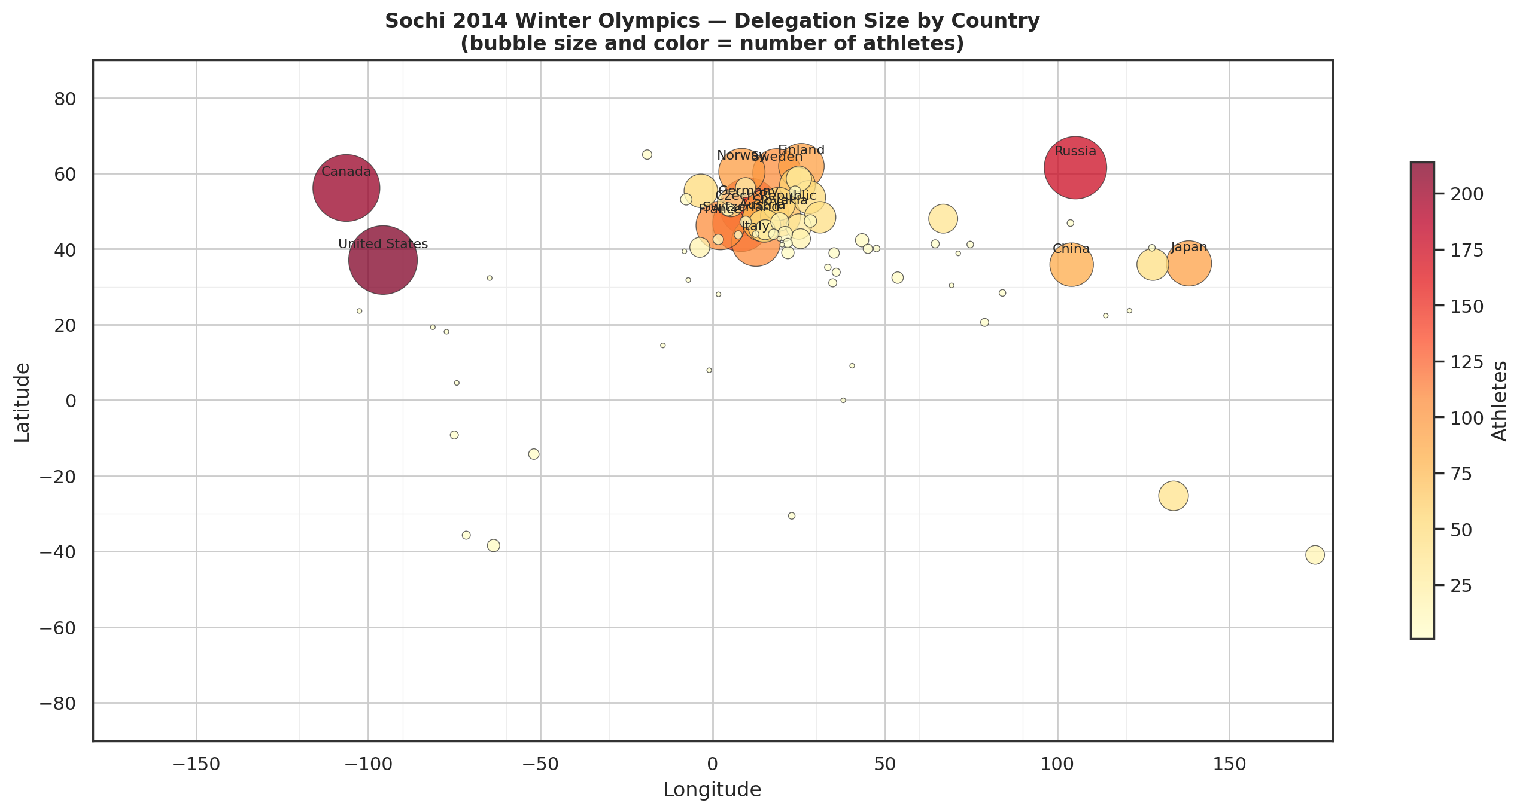
Figure 2. Delegation size by country — bubble size and color both encode athlete count.
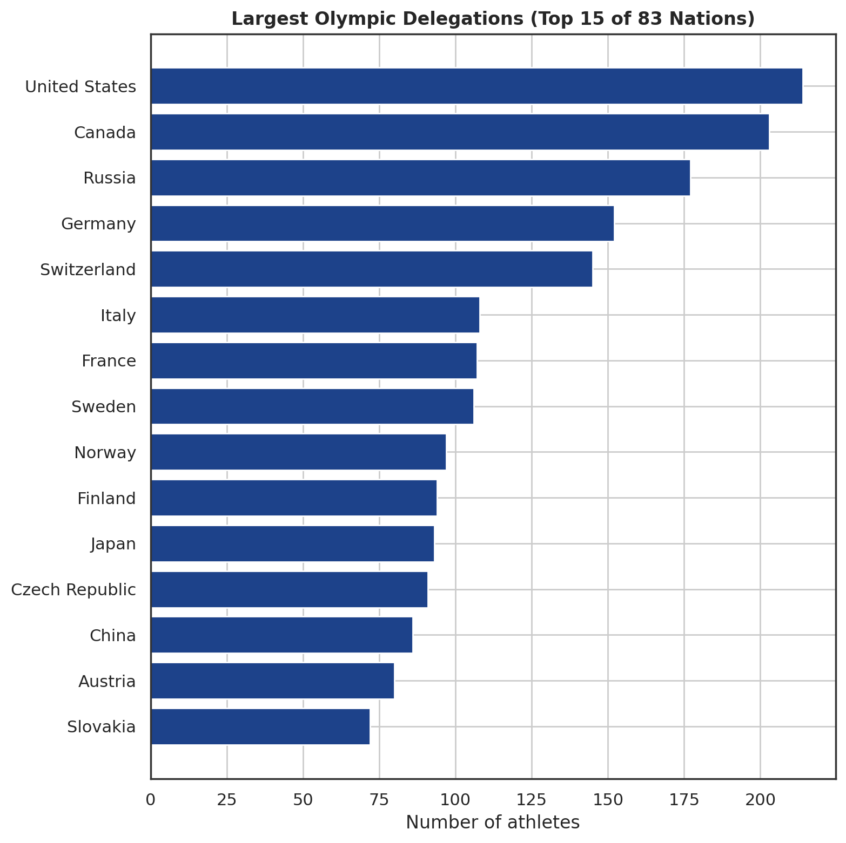
Figure 3. The 15 largest national delegations.
Participation is heavily concentrated: the United States (214 athletes) and Canada (203) alone represent roughly 16% of the entire roster. The three largest delegations (adding Russia, 177) account for 22.8%, and the ten largest account for 53.9% - over half of all Olympic athletes came from just 10 of the 83 competing nations.
At the other end, 18 nations sent exactly one athlete each: Albania, Algeria, Bermuda, Cayman Islands, Chinese Taipei, Colombia, Ethiopia, Ghana, Hong Kong, Kenya, Mexico, Montenegro, Morocco, Pakistan, Portugal, Senegal, Tajikistan, and Jamaica. Several of these represent historically significant "first Winter Olympian" moments for nations with limited winter-sport infrastructure - genuinely meaningful participation despite minimal delegation size.

6. Age Profile by Sport
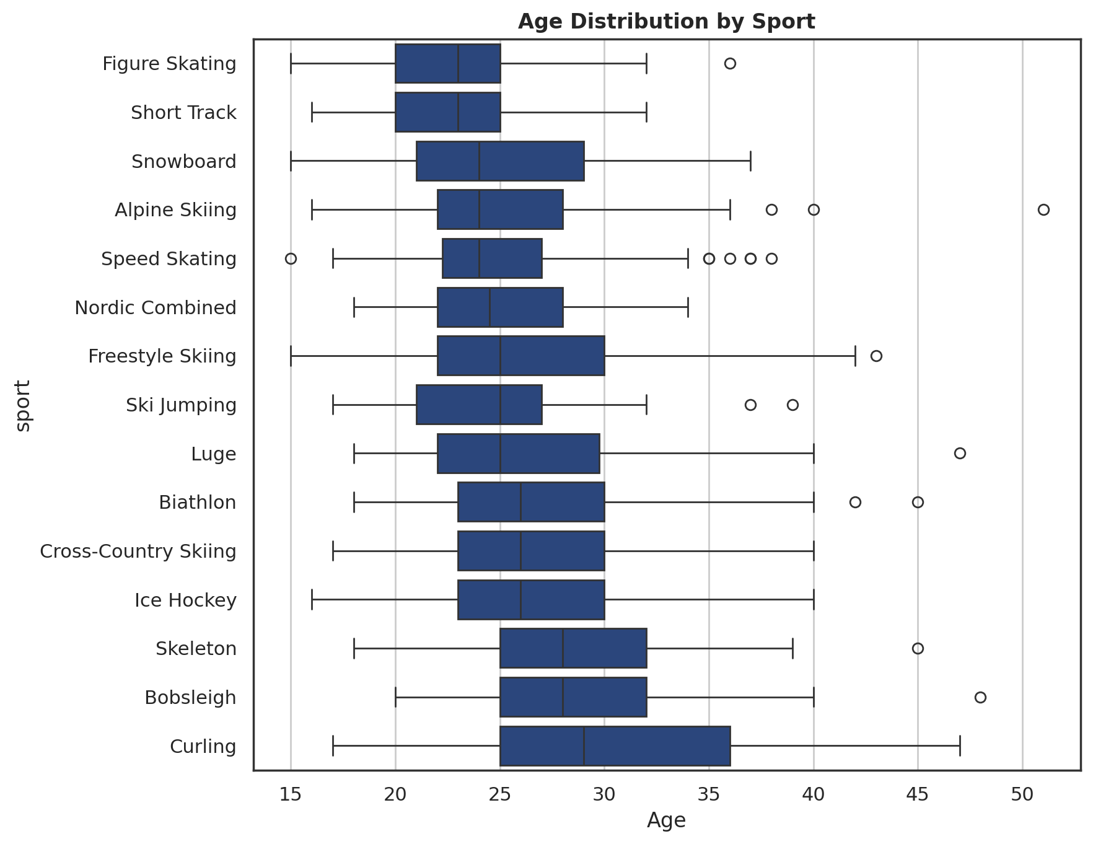
Figure 4. Age distribution by sport.
Age patterns are broadly consistent with each sport's physical demands and typical career arc: technically demanding, youth-favoring disciplines skew younger, while sports rewarding accumulated experience and composure - such as Curling - skew older. This pattern is informative for athlete development pipeline planning: a national federation investing in a younger-skewing sport should expect a shorter competitive window per athlete and plan development pipelines accordingly.

7. Policy Recommendations

Athlete health
- Maintain and periodically review BMI-linked safety regulations in Ski Jumping specifically, given the sport's documented history of weight-related health risk.
- Close the Figure Skating and Curling weight-data gap in future data collection, so athlete health patterns in these sports are not permanently invisible to monitoring efforts.

Delegation equity
- Continue and expand targeted development support (e.g. Olympic Solidarity-style programs) toward nations with minimal winter-sport delegations, particularly those without extensive winter-sport infrastructure.
- Recognize single-athlete delegations as meaningful participation milestones in program messaging, not merely as statistical outliers.

Further analysis
- Extend this analysis across multiple Winter Games to determine whether the BMI-by-sport and delegation-concentration patterns found here are stable, structural features of winter sport or specific to this one Games.

8. Data Sources and Limitations
Source: 2,606-athlete Winter Olympics roster sample dataset (Sochi 2014).
- This report presents descriptive and correlational patterns, not causal claims — the BMI-by-sport pattern reflects known physical demands of each sport, not a claim that the sport itself causes any particular health outcome.
- No gender field is present in this dataset, so no gender-based analysis was possible or attempted.
- No performance or medal data is present, so this report cannot speak to competitive outcomes — only to demographic and health-adjacent patterns.
- Figures reflect a single Winter Games; delegation sizes and BMI patterns may differ in other years or under different qualification rules.

