Team X

Repository Link: <https://github.com/Nelson18-W/1_TeamX3.git>

| Thahsin Raisha | raishat@my.yorku.ca | Lab04 Section B |
| --- | --- | --- |
| Nelson Wong | nelson18@my.yorku.ca | Lab04 Section B |
| Sheraz Ahmad | sheraz22@my.yorku.ca | Lab04 Section B |

Guess the number

Our program will generate a random number between a defined range, then the user will input a number within the range given, trying to guess what number the computer generated. The user will be notified if their guess is correct or not, the goal for them is to guess as many correctly in a row. If the user inputs an invalid entry, they will be notified of that as well. There will be difficulty levels, guessing numbers between 1-5, 1-10, 1-20, and 1-50.

Requirements

1. The program will have an input box where users can enter their guess
2. The program will have a difficulty level button where the user can change the difficulty level
3. The program will have an enter button the user must press to enter their guess
4. The program will have an output box to let the user know whether their guess is right or not
5. If the user enters an invalid input the program will let the user know
6. The program will have a clear button to reload the program fresh, clearing the history of the scoreboard
7. The program will display a separate scoreboard that has the number of wrong guesses and right guesses
8. The program will display the total number of guess attempts the user has made
9. The program will a input box where the user can input a name per time they play the game, to be displayed with the score
10. The program will have an option for the user to pick what background colour they want from a drop down menu (blue, red, green etc)
11. A button that allows the user to receive a hint at the expense of some of their score points
12. A button that allows the user to guess the same number again.
13. A button that allows the user to set the size of the text to be bigger or smaller.
14. The program will have a button that pops out the instructions if the user clicks it

-One page version

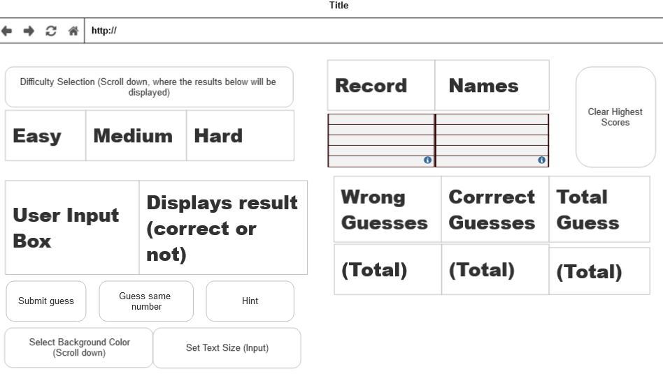

One-page Version

