# SpringCore_Maven

## Exercise 1: Configuring a Basic Spring Application:

**Scenario:**

Your company is developing a web application for managing a library. You need to use the Spring Framework to handle the backend operations.

**BookService.java:**

package com.Library.service;

import com.Library.repository.BookRepository;

public class BookService {

private BookRepository bookRepository;

public void setBookRepository(BookRepository bookRepository) {

this.bookRepository = bookRepository;

}

public void addBook(String bookName) {

System.out.println("Adding book in service: " + bookName);

bookRepository.saveBook(bookName);

}

}

**BookRepository.java:**

package com.Library.repository;

public class BookRepository {

public void saveBook(String bookName) {

System.out.println("Book '" + bookName + "' saved to the repository.");

}

}

**applicationContext.xml:**

<?xml version="1.0" encoding="UTF-8"?>

<beans xmlns="http://www.springframework.org/schema/beans"

xmlns:xsi="http://www.w3.org/2001/XMLSchema-instance"

xsi:schemaLocation="

http://www.springframework.org/schema/beans

http://www.springframework.org/schema/beans/spring-beans.xsd ">

<bean id="bookRepository" class="com.Library.repository.BookRepository" />

<bean id="bookService" class="com.Library.service.BookService">

<property name="bookRepository" ref="bookRepository" />

</bean>

</beans>

**LibrayManagementApplication.java:**

package com.Library.LibrayManagement;

import com.Library.service.BookService;

import org.springframework.context.ApplicationContext;

import org.springframework.context.support.ClassPathXmlApplicationContext;

public class LibrayManagementApplication {

public static void main(String[] args) {

ApplicationContext context =new ClassPathXmlApplicationContext("applicationContext.xml");

BookService bookService = (BookService) context.getBean("bookService");

bookService.addBook("Spring in Action");

}

}

## Output:

## 

## Exercise 2: Implementing Dependency Injection:

**Scenario:**

In the library management application, you need to manage the dependencies between the BookService and BookRepository classes using Spring's IoC and DI.

**LibrayManagementApplication.java:**

package com.Library.LibrayManagement;

import com.Library.service.BookService;

import org.springframework.context.ApplicationContext;

import org.springframework.context.support.ClassPathXmlApplicationContext;

public class LibrayManagementApplication {

public static void main(String[] args) {

ApplicationContext context = newClassPathXmlApplicationContext("applicationContext.xml");

BookService bookService = (BookService) context.getBean("bookService")

bookService.addBook("Effective Java");

}

}

**BookRepository.java:**

package com.Library.repository;

public class BookRepository {

public void saveBook(String bookName) {

System.out.println("Book '" + bookName + "' saved to the repository.");

}

}

**BookService.java:**

package com.Library.service;

import com.Library.repository.BookRepository;

public class BookService {

private BookRepository bookRepository;

public void setBookRepository(BookRepository bookRepository) {

this.bookRepository = bookRepository;

}

public void addBook(String bookName) {

System.out.println("Service: Adding book -> " + bookName);

bookRepository.saveBook(bookName);

}

}

**applicationContext.xml:**

<?xml version="1.0" encoding="UTF-8"?>

<beans xmlns="http://www.springframework.org/schema/beans"

xmlns:xsi="http://www.w3.org/2001/XMLSchema-instance"

xsi:schemaLocation="

http://www.springframework.org/schema/beans

http://www.springframework.org/schema/beans/spring-beans.xsd ">

<bean id="bookRepository" class="com.Library.repository.BookRepository" />

<bean id="bookService" class="com.Library.service.BookService">

<property name="bookRepository" ref="bookRepository" />

</bean>

</beans>

## Output:

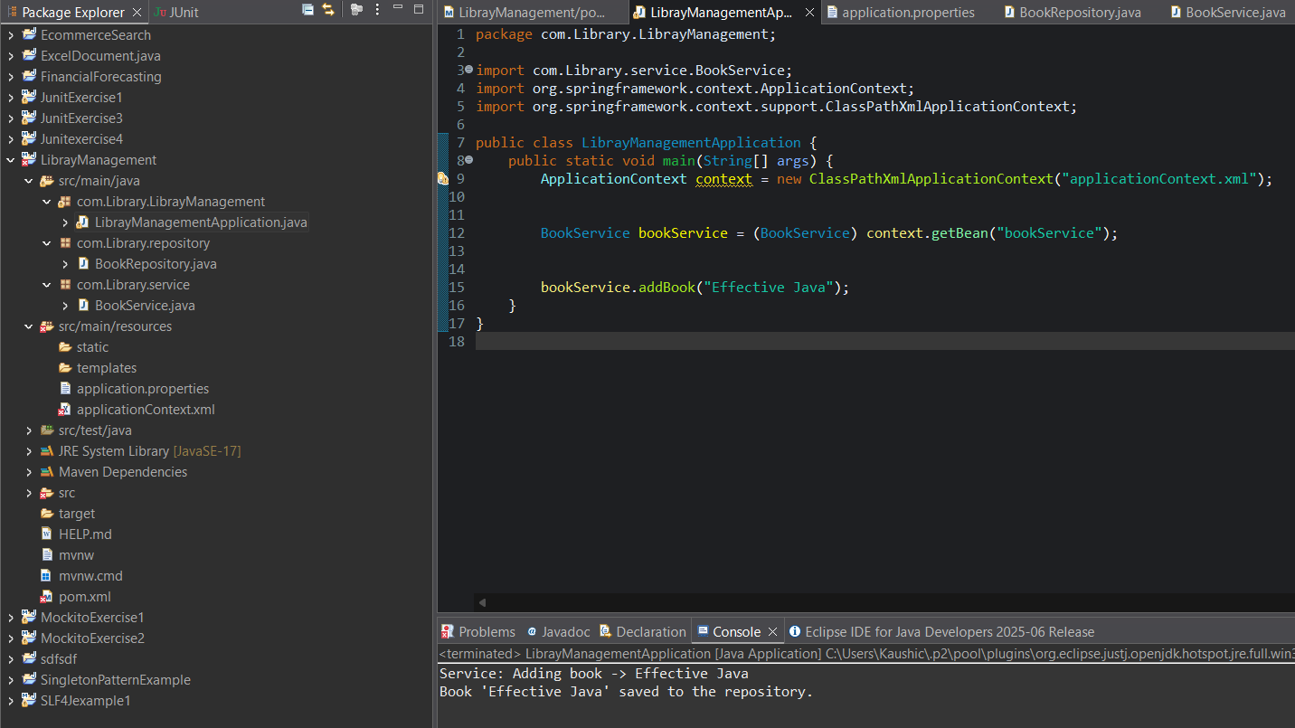

## Exercise 4: Creating and Configuring a Maven Project:

**Scenario:**

You need to set up a new Maven project for the library management application and add Spring dependencies.

**Pom.xml:**

<project xmlns="http://maven.apache.org/POM/4.0.0"

xmlns:xsi="http://www.w3.org/2001/XMLSchema-instance"

xsi:schemaLocation="http://maven.apache.org/POM/4.0.0 https://maven.apache.org/xsd/maven-4.0.0.xsd">

<modelVersion>4.0.0</modelVersion>

<groupId>Librarys</groupId>

<artifactId>LibraryManagement1</artifactId>

<version>0.0.1-SNAPSHOT</version>

<properties>

<java.version>1.8</java.version>

</properties>

<dependencies>

<dependency>

<groupId>org.springframework</groupId>

<artifactId>spring-core</artifactId>

<version>5.3.36</version>

</dependency>

<dependency>

<groupId>org.springframework</groupId>

<artifactId>spring-context</artifactId>

<version>5.3.36</version>

</dependency>

<dependency>

<groupId>org.springframework</groupId>

<artifactId>spring-aspects</artifactId>

<version>5.3.36</version>

</dependency>

<dependency>

<groupId>org.aspectj</groupId>

<artifactId>aspectjweaver</artifactId>

<version>1.9.21</version>

</dependency>

<dependency>

<groupId>org.springframework</groupId>

<artifactId>spring-webmvc</artifactId>

<version>5.3.36</version>

</dependency>

<dependency>

<groupId>junit</groupId>

<artifactId>junit</artifactId>

<version>4.13.2</version>

<scope>test</scope>

</dependency>

</dependencies>

<build>

<plugins>

<plugin>

<artifactId>maven-compiler-plugin</artifactId>

<version>3.8.1</version>

<configuration>

<source>1.8</source>

<target>1.8</target>

</configuration>

</plugin>

</plugins>

</build>

</project>

## Output:

