Select Your Operating System (OS):
Choose an operating system that best suits your preferences and project requirements. Download and Install Windows 11. https://www.microsoft.com/software-download/windows11
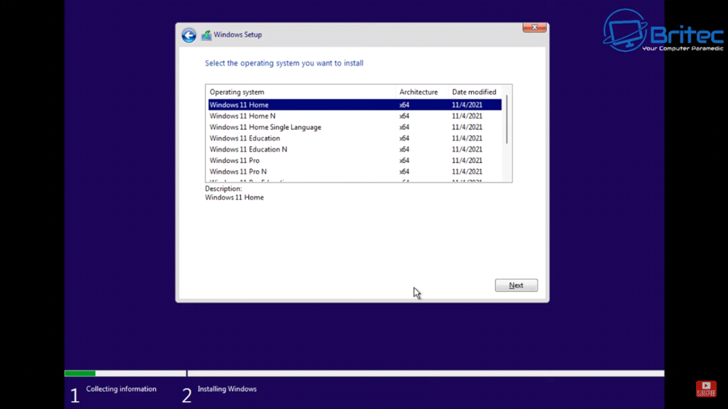

Install a Text Editor or Integrated Development Environment (IDE):
Select and install a text editor or IDE suitable for your programming languages and workflow. Download and Install Visual Studio Code. https://code.visualstudio.com/Download
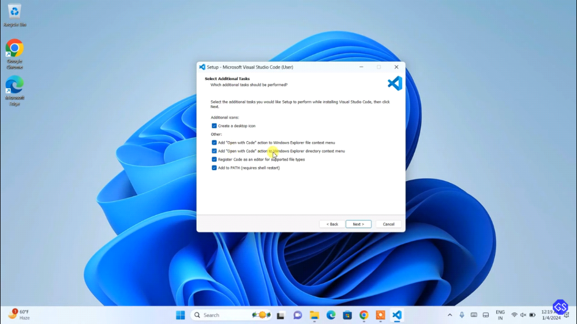

Set Up Version Control System:
Install Git and configure it on your local machine. Create a GitHub account for hosting your repositories. Initialize a Git repository for your project and make your first commit. https://github.com
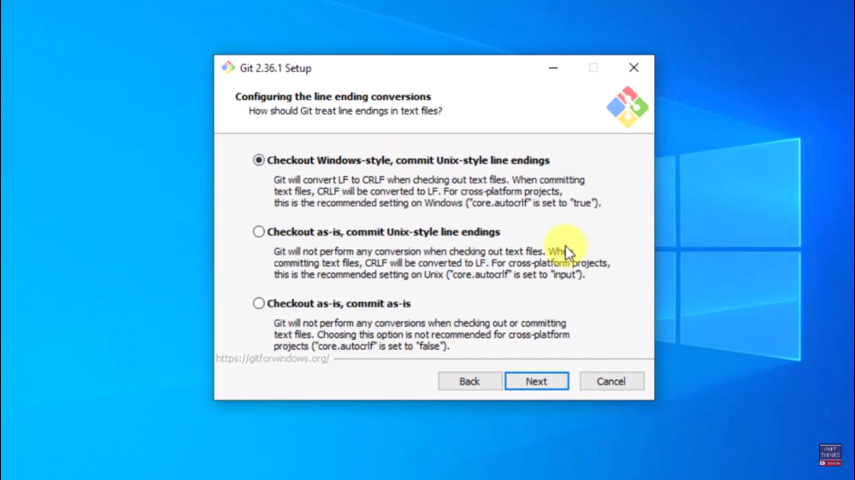

Install Necessary Programming Languages and Runtimes:
Instal Python from http://wwww.python.org programming language required for your project and install their respective compilers, interpreters, or runtimes. Ensure you have the necessary tools to build and execute your code.
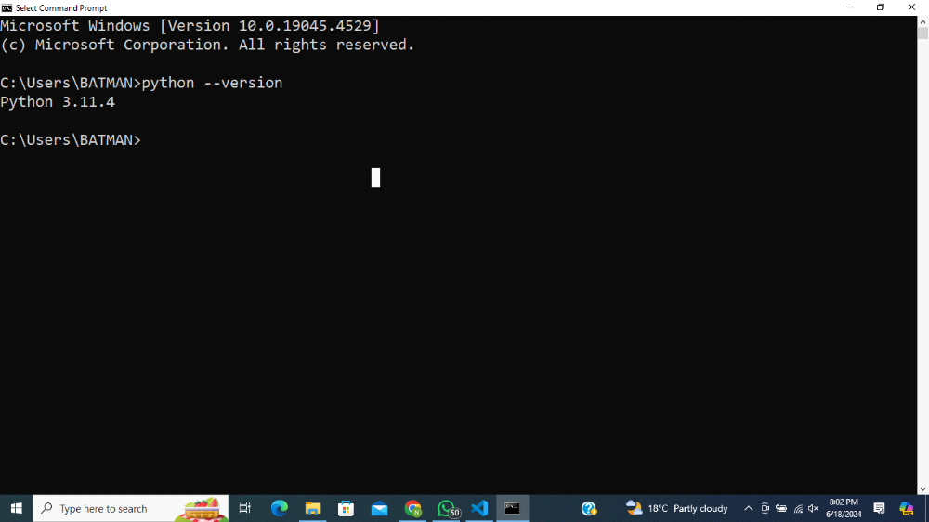

Install Package Managers:
If applicable, install package managers like pip (Python).
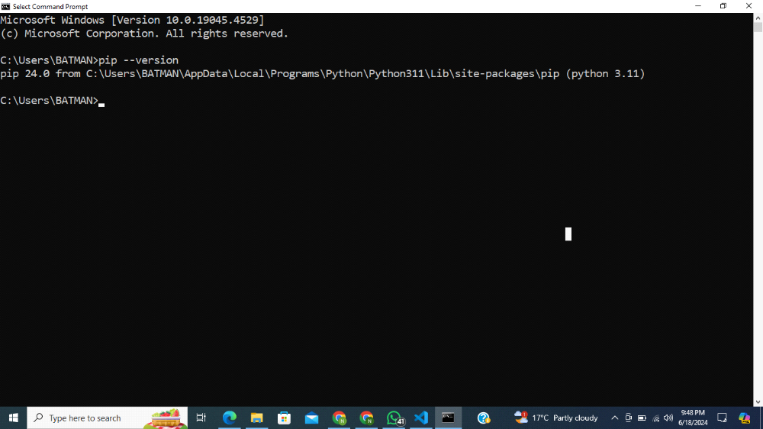

Configure a Database (MySQL):
Download and install MySQL database. https://dev.mysql.com/downloads/windows/installer/5.7.html

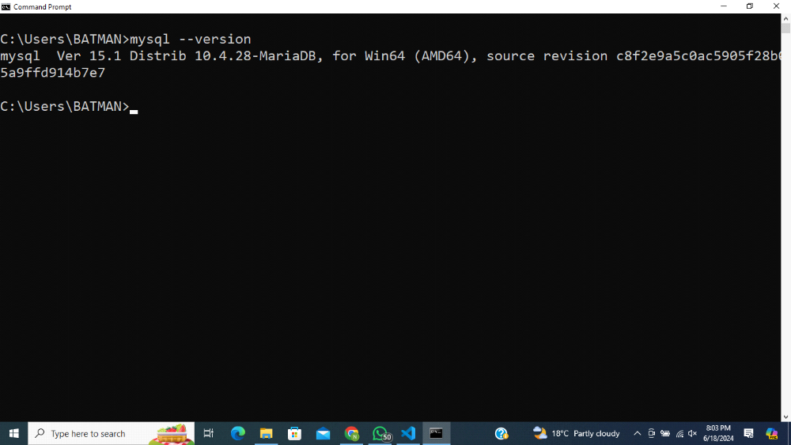

Set Up Development Environments and Virtualization (Optional):
Consider using virtualization tools like Docker or virtual machines to isolate project dependencies and ensure consistent environments across different machines.
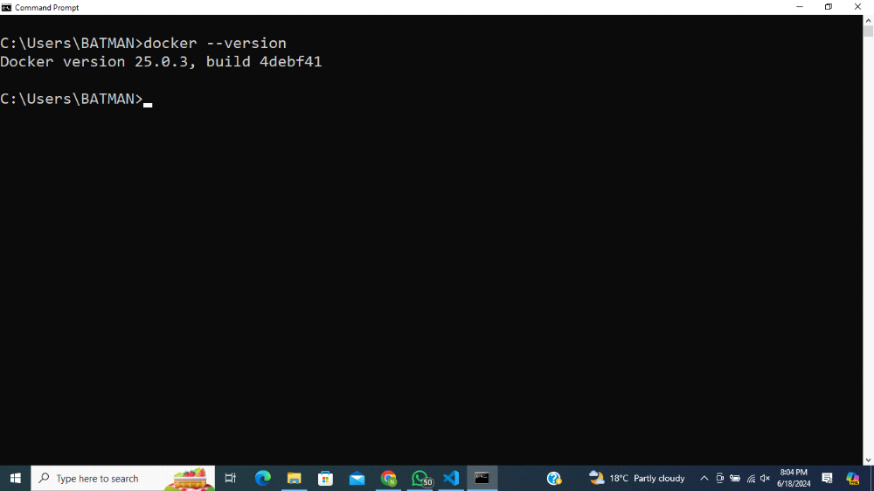

Explore Extensions and Plugins:
Explore available extensions, plugins, and add-ons for your chosen text editor or IDE to enhance functionality, such as syntax highlighting, linting, code formatting, and version control integration.
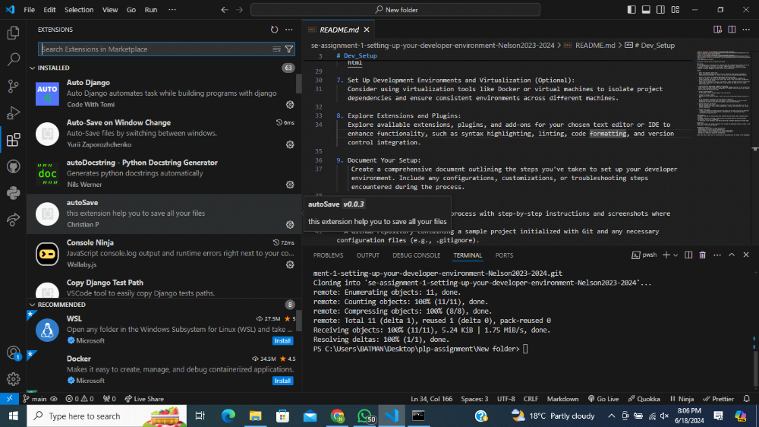

Create a comprehensive document outlining the steps you've taken to set up your developer environment. Include any configurations, customizations, or troubleshooting steps encountered during the process.
1. Python Installation
Step-by-Step Installation
Download Python:

Go to the official Python website: python.org
Download the latest version suitable for your operating system.
Install Python:

Run the installer.
Ensure you check the option "Add Python to PATH."
Follow the installation wizard to complete the setup.
Verify Installation:

Open a terminal or command prompt.
Run the command: python --version or python3 --version
You should see the installed Python version.
Customizations and Configurations
pip Installation: pip is the package installer for Python.

It comes pre-installed with Python. To check, run: pip --version
To upgrade pip: python -m pip install --upgrade pip
Virtual Environments:

Create a virtual environment: python -m venv myenv
Activate the virtual environment:
On Windows: myenv\Scripts\activate
On macOS/Linux: source myenv/bin/activate
2. Git Installation
Step-by-Step Installation
Download Git:

Go to the official Git website: git-scm.com
Download the latest version for your operating system.
Install Git:

Run the installer.
Follow the installation wizard. You can use the default settings.
Verify Installation:

Open a terminal or command prompt.
Run the command: git --version
You should see the installed Git version.
Configurations
Set Up Global Configurations:

Set your username: git config --global user.name "Your Name"
Set your email: git config --global user.email "your.email@example.com"
Check Configuration:

Run: git config --list
3. Visual Studio Code (VS Code) Installation
Step-by-Step Installation
Download VS Code:

Go to the official VS Code website: code.visualstudio.com
Download the latest version for your operating system.
Install VS Code:

Run the installer.
Follow the installation wizard. You can use the default settings.
Verify Installation:

Open VS Code.
You should see the welcome screen.
Configurations and Customizations
Extensions:

Install useful extensions like Python, GitLens, Prettier, Live Server, etc.
Settings:

Open Settings (File > Preferences > Settings).
Customize according to your preference (e.g., theme, font size, auto-save).
Troubleshooting
Common Issues:
If VS Code is not opening, try reinstalling.
Ensure system PATH includes the path to VS Code executable.
4. MySQL Installation
Step-by-Step Installation
Download MySQL:

Go to the official MySQL website: mysql.com
Download the MySQL Installer for your operating system.
Install MySQL:

Run the installer.
Choose the setup type (typically "Developer Default").
Follow the installation wizard and configure the server as needed (root password, user accounts, etc.).
Verify Installation:

Open a terminal or command prompt.
Run the command: mysql --version
You should see the installed MySQL version.
Configurations and Customizations
MySQL Workbench:

Download and install MySQL Workbench from the MySQL website.
Use it for database management and queries.
Environment Variables:

Add the MySQL bin directory to the system PATH for easier command-line access.
Troubleshooting
Common Issues:
Ensure the MySQL service is running.
Check the firewall settings if you cannot connect remotely.
5. Live Server Installation for VS Code
Step-by-Step Installation
Install Live Server Extension:

Open VS Code.
Go to Extensions (View > Extensions).
Search for "Live Server" and install it.
Usage:

Open your HTML file in VS Code.
Right-click the HTML file and select "Open with Live Server."
Your default browser should open, displaying your web page.
Customizations and Configurations
Settings:
Configure Live Server settings in VS Code settings (File > Preferences > Settings > Extensions > Live Server Config).
Customize options like port number, browser, etc.
Troubleshooting
Common Issues:
Ensure no other service is running on the same port.
If Live Server doesn't start, try restarting VS Code or reinstalling the extension.

